[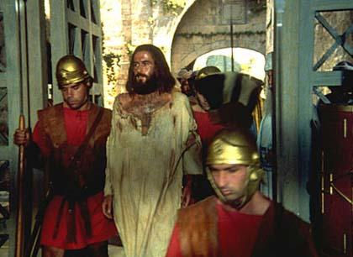](http://www.hilm.ru/films/iisus/scr_008.jpg)

[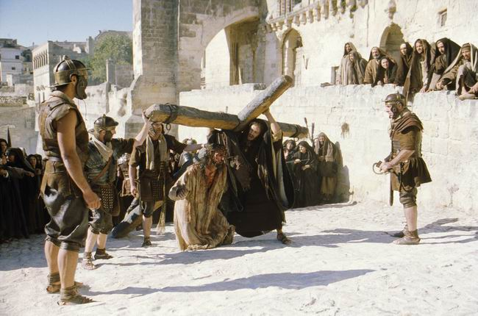](http://www.opoka.org.pl/biblioteka/P/PK/pasja17.jpg)

[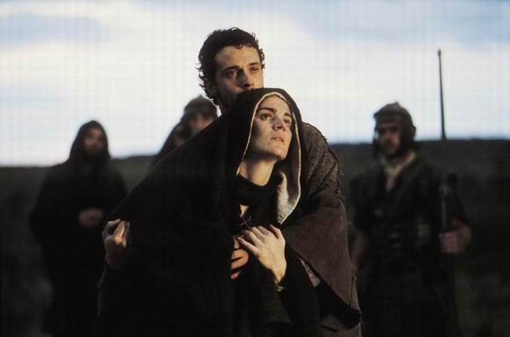](http://www.opoka.org.pl/biblioteka/P/PK/pasja8.jpg)

[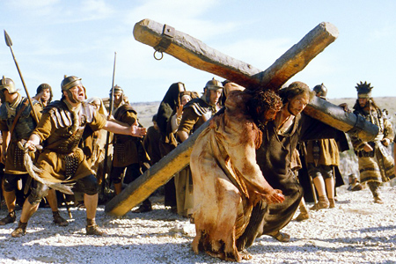](http://www.talks.su/images/strastnaya3.jpg)

[](http://www.hilm.ru/films/iisus/scr_007.jpg)

[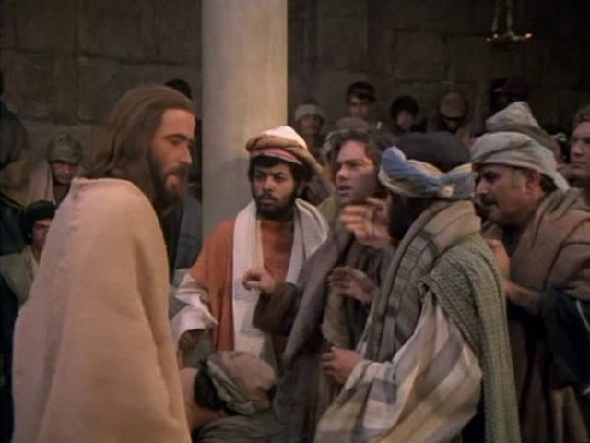](http://media7.fast-torrent.ru/media/photologue/photos/iisus_scen_0.672615998693.jpg)

[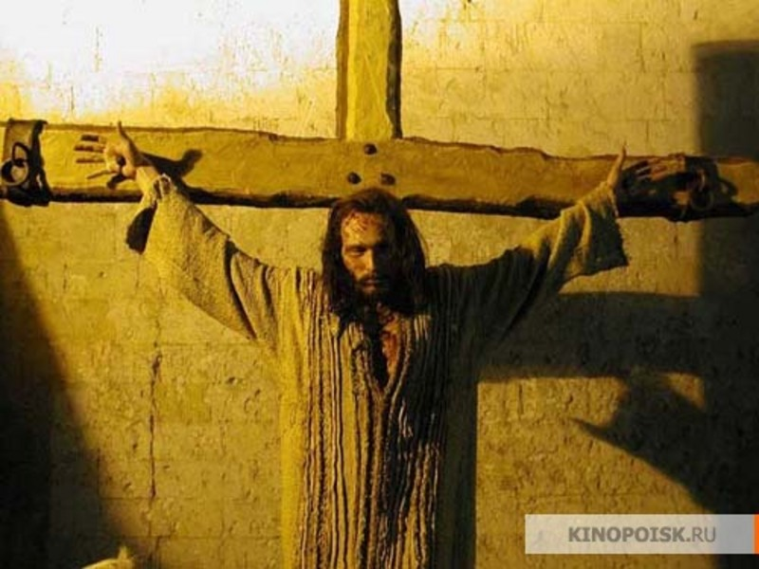](http://dircash-promost.com/sc/b/38494_15593.jpg)

[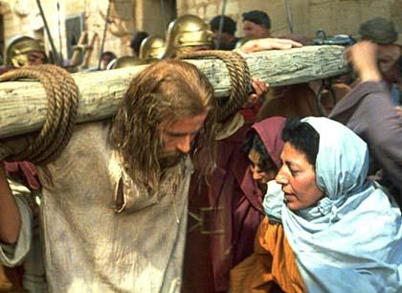](http://www.hilm.ru/films/iisus/scr_004.jpg)

[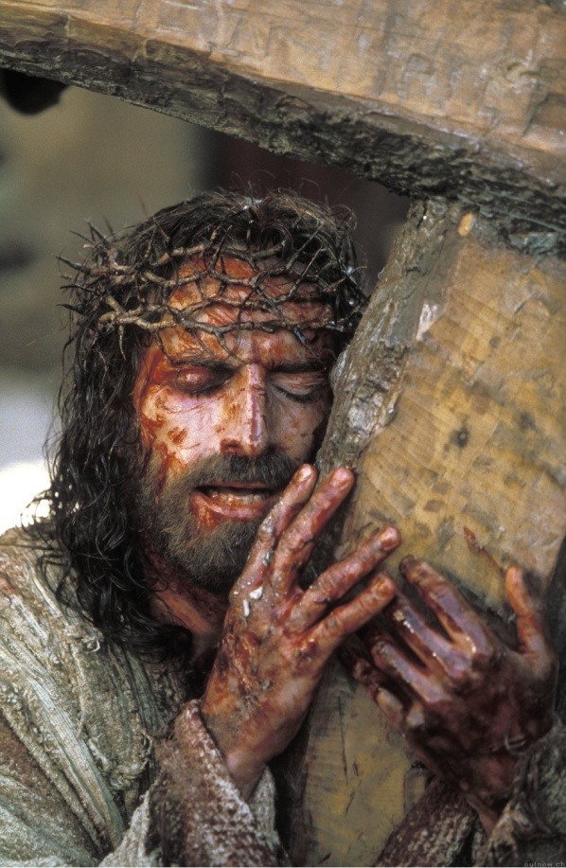](http://danuttanase.files.wordpress.com/2009/06/foto-din-film1.jpg)

[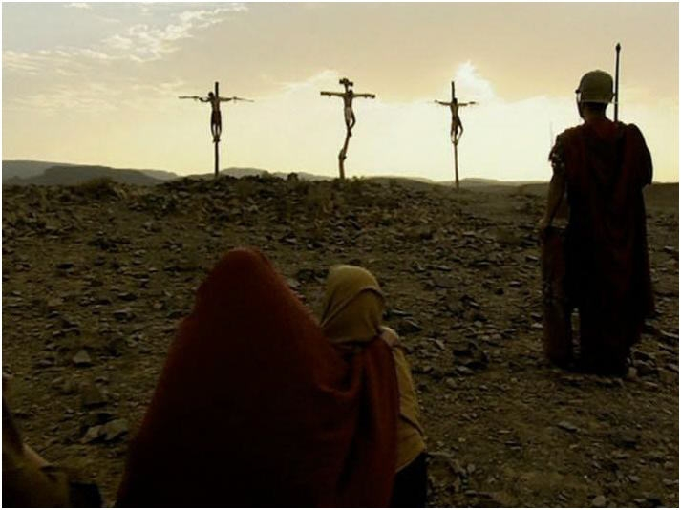](http://distrib.data.cod.ru/photos/a/f/0/441d5a3fc6901ed163e083936b4730fa.jpg)

[](http://i045.radikal.ru/0801/c4/615ca6bfa203.jpg)

[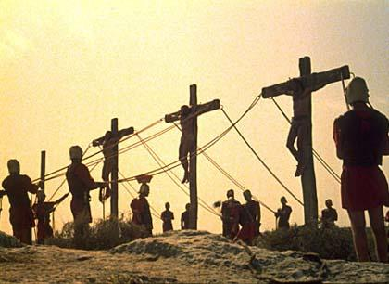](http://www.hilm.ru/films/iisus/scr_003.jpg)

[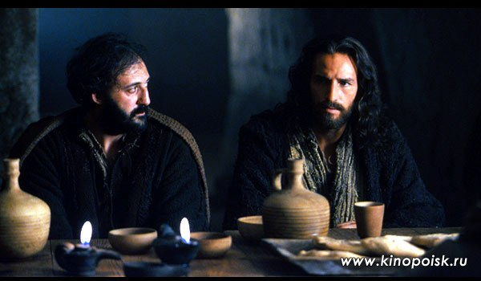](http://jcs-mossoveta.narod.ru/Obzory/Passion/37.jpg)

[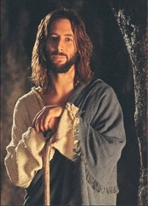](http://u.jimdo.com/www21/o/sf22476db992b3719/img/ia6d70a5e80fe6c1b/1278963699/std/image.jpg)[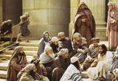](http://www.hilm.ru/films/evangelie-ot-ioanna/scr_007.jpg)

[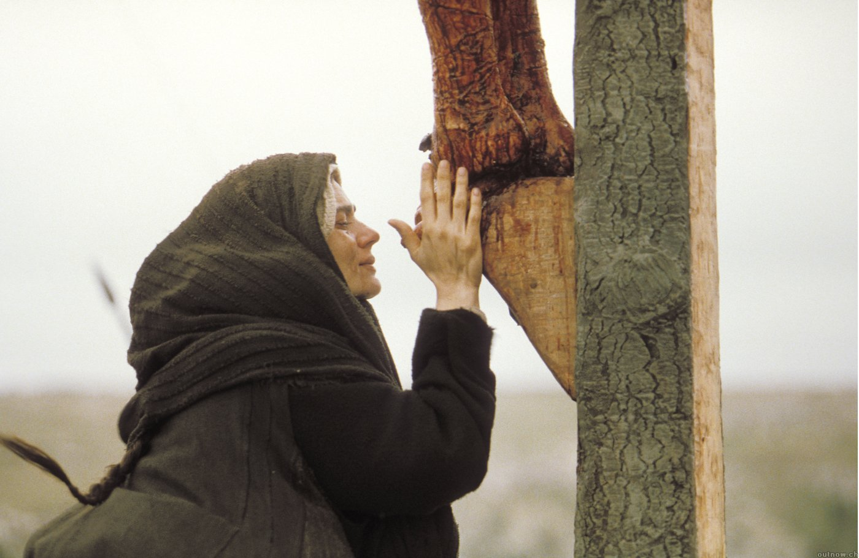](http://www.spiritlessons.com/images/passion_of_Christ/Passion_of_the_Christ_39.jpg)

[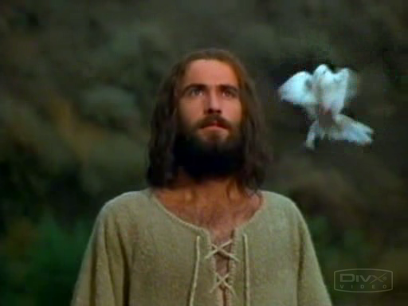](http://img84.imageshack.us/img84/4269/jesus01019735mf6.png)

[](http://media7.fast-torrent.ru/media/photologue/photos/iisus_scen_0.672615998693.jpg)[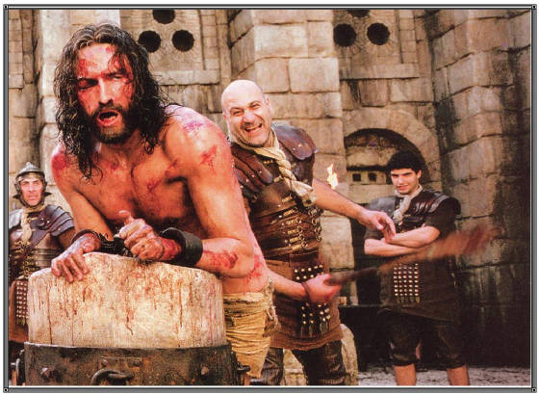](http://mysite.verizon.net/vzeuzary/sitebuildercontent/sitebuilderpictures/.pond/File_PassionMovie_whipped3.jpg.w560h409.jpg)

[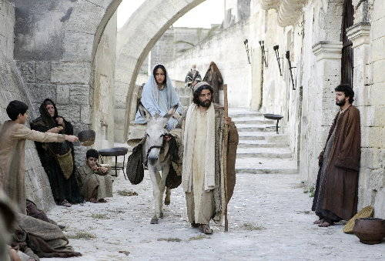](http://0.tqn.com/d/movies/1/7/p/7/O/nativitystorypic6.jpg)

[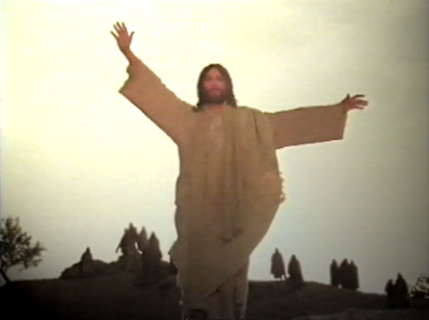](http://www.excerptsofinri.com/images/471lazarus.jpg)

[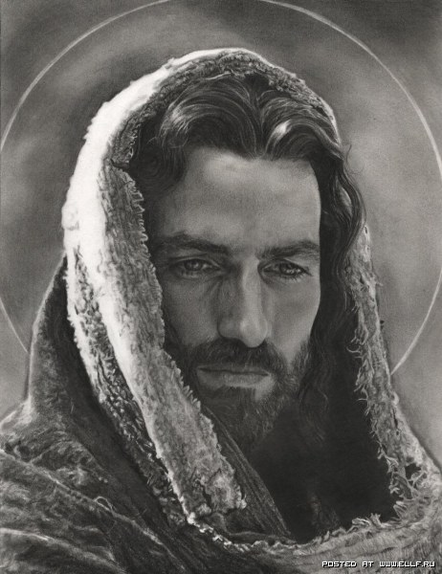](http://www.ellf.ru/uploads/posts/2009-04/thumbs/1240843847_6.jpg)

[](http://stat17.privet.ru/lr/0a0d5f0f6deba860798d46882ad33d3a)

[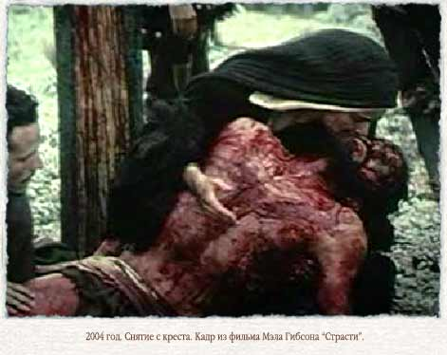](http://www.krotov.info/pictures/mashiah/21/2004gi115_34.jpg)

[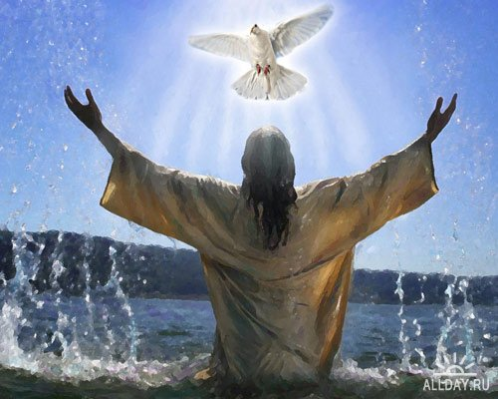](http://allday.ru/uploads/posts/1208282999_pashafon2.jpg)

[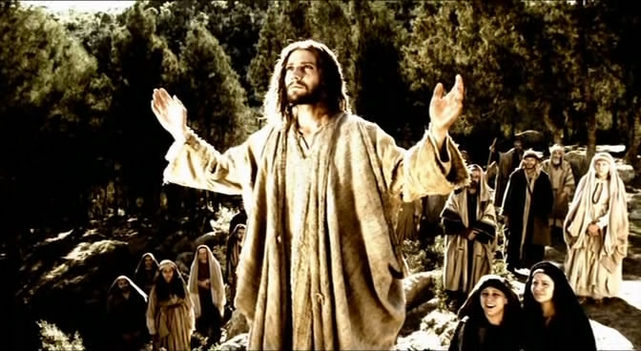](http://kino.a42.ru/images/9719/4-3.jpg)

[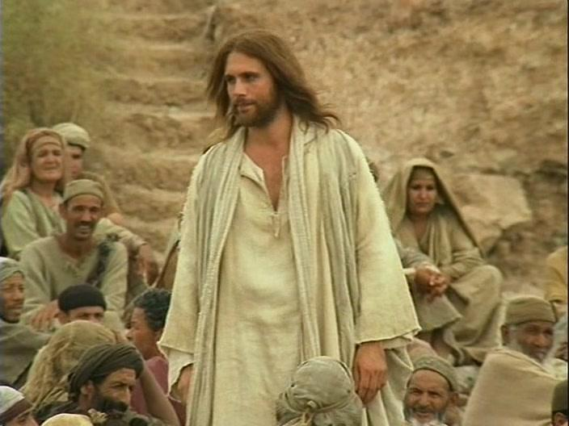](http://dcp.sovserv.ru/media/images/2/3/b/218122.JPG)

[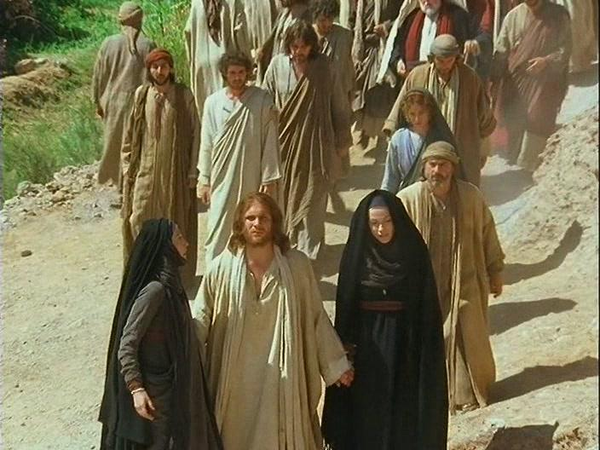](http://dcp.sovserv.ru/media/images/1/c/9/218126.JPG)

[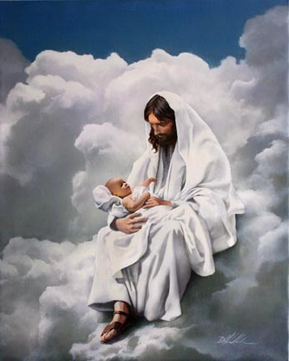](http://www.playcast.ru/uploads/2006/11/24/121586.jpg)

[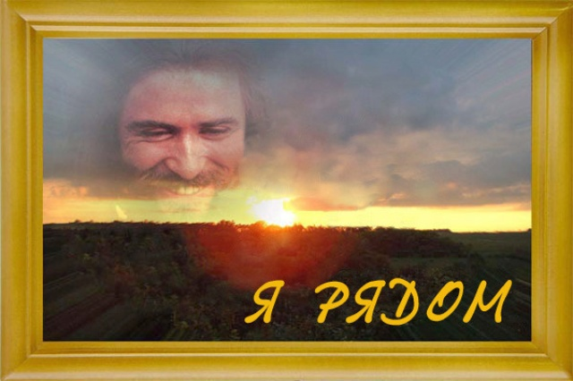](http://mylove.ru/m/237d8de6b4aca43e45622f6713e5999e_14a4e08e37c6d810be58334e6bf8f662)

[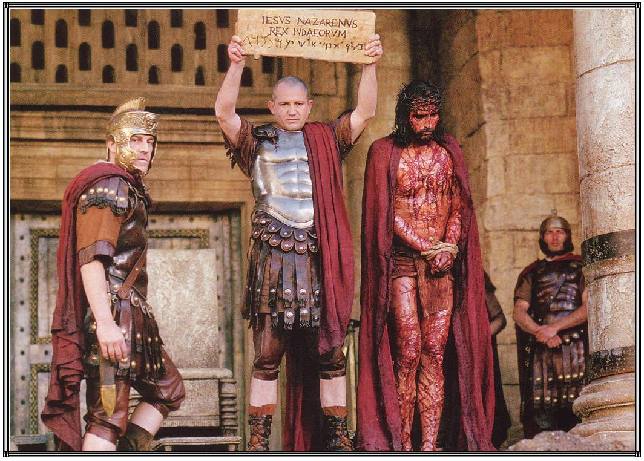](http://www.spiritlessons.com/images/File_PassionMovie_TheMan.jpg)

[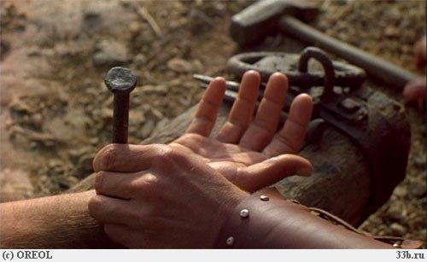](http://a18002.rimg.info/icon/1886985000c405b00d5b89b9da041285f3842e757f.jpg)

[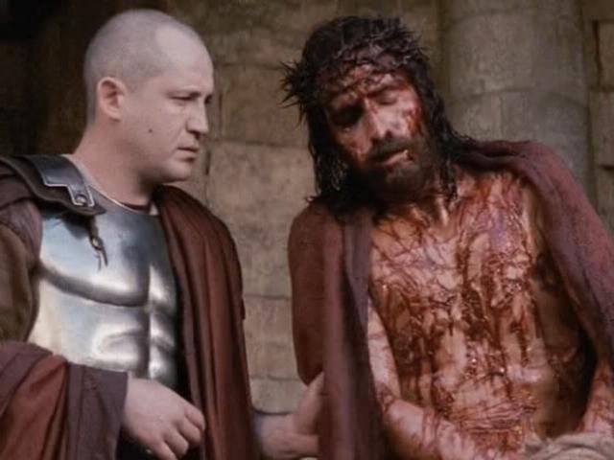](http://st-alexandr.at.ua/_nw/3/25581.jpg)