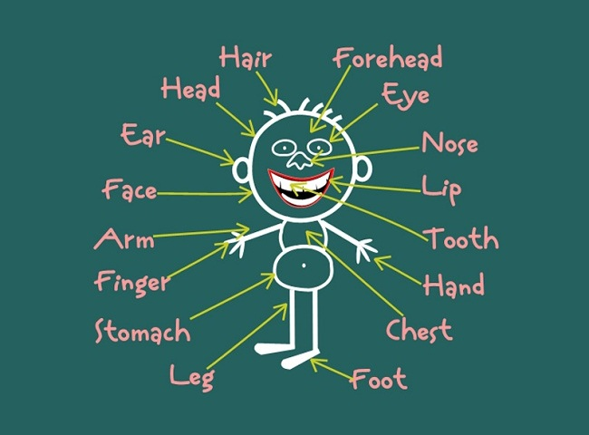
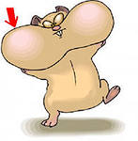
Make a Face

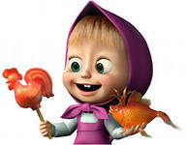
Make a face.
Make a face.
Make a face.
Make a face.
Put on the nose.
Put on the nose.
Put on the ears.
Put on the ears.
Put on the mouth.
Put on the mouth.
Put on the eyes.
Put on the eyes.
Make a face.
Make a face.
Make a face.
Make a face.
Put on the eyebrows.
Put on the eyebrows.
Put on the cheeks.
Put on the cheeks.
Put on the hair.
Put on the hair.
Put on the tongue!
Put on the tongue!

Слова с переводом и транскрипцией
слово | транскрипция | перевод
nose | [nəuz] | нос
ear | [iə] | ухо
mouth | [mauθ] | рот
eye | [ai] | глаз
eyebrow | ['aibrau] | бровь
cheek | [tʃi:k] | щека
hair | [hɛə] | волосы
tongue | [tʌŋ] | язык
make | [meik] | делать
face | [feis] | лицо
make | [meik] | делать

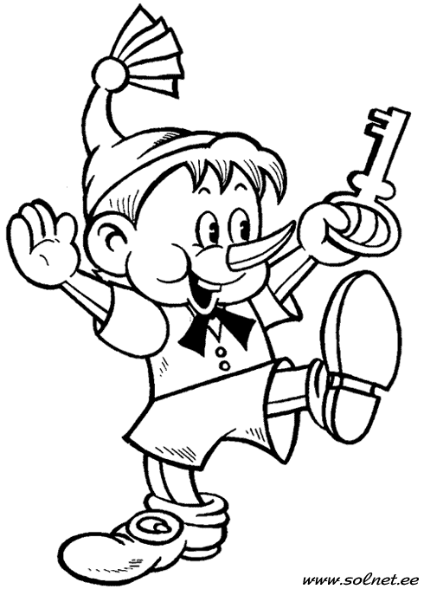
Colour and write.

He’s got……..hair.
He’s got ……..nose.
He’s got ………eyes.
He’s got ……..ears.
He’s got …….mouth.
He’s got ……..cheeks.
Colout and write.

Colour and write.
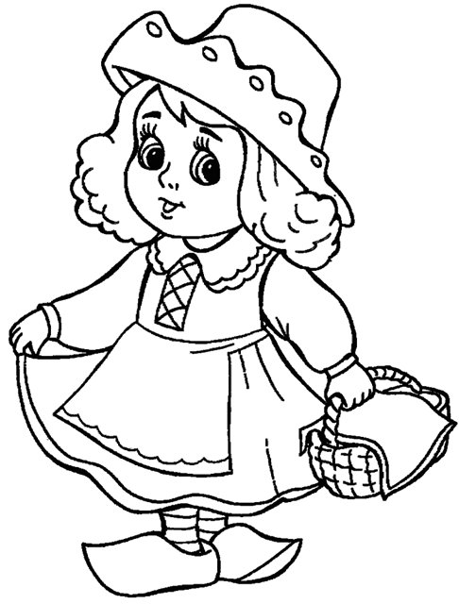

She’s got……..hair.
She’s got ……..nose.
She’s got ………eyes.
She’s got ……..ears.
She’s got …….mouth.
She’s got …..cheeks.

