**6 form.Hobbies**

I. Name the hobbies in the picture. For example: **playING** football

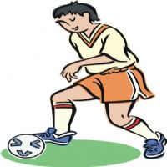    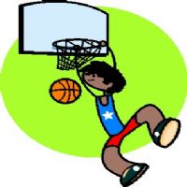      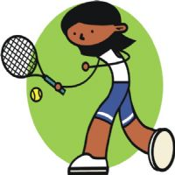      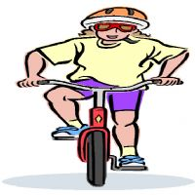       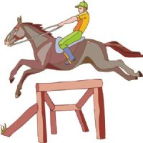

1______________________ 2___________________________3________________________ 4____________________ 5_____________________

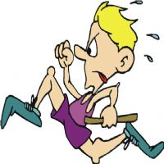          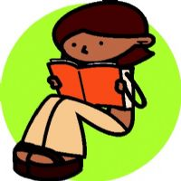                        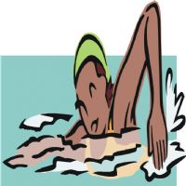

6 7 8 9 10

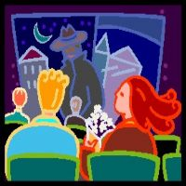                                           

11_______________________12_____________________________13__________________________14___________________

|  |  |
| --- | --- |
|  |  |

**Tenses: Present Perfect**

1. Look! The rain has already stopped.
2. I have just washed my car. Now it’s clean.
3. Mike has broken his leg. He is in hospital.
4. We have already visited this museum.
5. My Mum has just cooked dinner.
6. Dad has given up smoking . Now he feels better.
7. Our football team has won the match.
8. The workers have just painted the house.
9. Look! I have received a letter from Jack!

**Read the text and fill the gaps with prepositions**

This is the story … (1) a ghost. He lives in the beautiful Canterville Castle . Mr. Otis and his family live there, too. The ghost has got big red eyes, grey hair, a long nose, thin legs and a white face. He thinks he's very frightening. But nobody is afraid … (2) him.

The ghost is very sad and unhappy. He cries in his room … (3) the tower. Mr. Otis' daughter, Virginia feels sorry … (4) him and wants to help him. The ghost tells her … (5) his problem. He can only rest when a girl … (6) blond hair helps him and the almond tree has flowers.

Virginia and the ghost go … (7) a wall. The Otis family looks for Virginia in the rooms, … (8) the beds, behind the doors, on the roof. They finally see her sitting … (9) the almond tree. They look  … (10) and notice that the almond tree has   
flowers. Virginia and the ghost can finally rest. Now they are happy.

**1. A )** at **B)** of **C)** by

**2. A )** of **B)** about **C)** in

**3. A )** for **B)** along **C)** in

**4. A )** with **B)** for **C)** at

**5. A )** in **B)** about **C)** for

**6. A )** with **B)** of **C)** in

**7. A )** next **B)** in **C)** through

**8. A )** above **B)** under **C)** of

**9. A )** by **B)** next **C)** along

**10. A )** for **B)** down **C)** up

**Tenses:Choose the correct answer**

**1.** Who's that girl? … .

**A)** Is Betty **B)** It's Jane **C)** She's a pupil

**2.** Whose dolls are these? They're … .

**A)** of the baby **B)** the baby's **C)** the babies

**3.** In his free time he likes … with his friend.

**A)** playing **B)** play **C)** plays

**4.** I … my homework because I left my book in school.

**A)** can't to do **B)** can't do **C)** don't make

**5.** Is your sister's … than yours?

**A)** hair more long **B)** more long hair **C)** hair longer

**6.** What's Peter like? He … .

**A)** is very well **B)** likes football **C)** is very nice

**7.** … the room!

**A)** Not to go into **B)** Don't going to **C)** Don't go into

**8.** … these three girls do you know?

**A)** How many **B)** Which of **C)** What of

**9.** Last week John … his leg.

**A)** fell and broke **B)** felt and broke **C)** fallen and broken

**10.** How long does it take to … to Moscow ?

**A)** get **B)** arrive **C)** make

**Fill in: eat-a sweet-time, tooth, for their lunch, a lot of, slices, foreigners, drink.**

1. The British have a sweet ………..
2. A lot of people in England eat sandwiches …………..
3. There are …….. sandwich shops in London.
4. The English ….. a lot of tea.
5. Some ……… don’t like English tea.
6. For the British, any time is ……….
7. Each sandwich has two thin ….. of bread.

**Выбери глагол в нужной форме**

1. I …. This book yesterday.
2. Have read
3. Will read
4. Read
5. Tomorrow they …. help me to set the table
6. Help
7. Will help
8. Helped
9. Look! The children ….. with the puppy.
10. Are playing
11. Played
12. Play
13. Every year I …. special presents for my little nephews.
14. Will buy
15. Buy
16. Have bought

**Выбери нужную форму возвратного местоимения (myself, yourself/ves, himself, herself, themselves, ourselves)**

1. I saw …. in the mirror.
2. Jack is absent today. He burnt …..
3. We enjoyed …. at the party.
4. My friends made a ship ….. .
5. Mary promised …. to keep fit.
6. We set the table …..

**?She … milk now.**

+is drinking

-drinking

-drink

-drinks

?**He … at the airport tomorrow.**

-arrive

-will arrival

+will arrive

-will arriver

?**He … the passport control yet.**

+hasn’t passed

-has passed

-has pass

-have passed

**?They … the tickets 2 days ago .**

+bought

-didn’t bought

-have bought

-has bought

?**Paul … TV when his mother … into the room.**

-watch … came

-watched …come

-watching … came

+was watching … came

?**She … coffee while he … a newspaper**.

+was drinking … was reading

-drinking … reading

-was drinking … read

-drinking …read

**?The children were playing chess.**

-today

+yesterday at this time

-at 4 o’clock tomorrow

? **Who came to the airport?**

-she came

+she did

-she is

-she

**?Did they take many ... ?**

-Water

-Food

+sweets