Цели и задачи:
1.Практические: использование приобретенных знаний по определенным темам в заданиях, предложенных учителем.
2.Образовательные: построение монологических высказываний о трудностях в изучении английского языка, о положительных чертах характеров одноклассников; повторение пройденной лексики; восприятие и понимание текста-загадки на слух; употребление в речи сослагательного наклонения; чтение отрывка из пьесы без предварительной подготовки; чтение стихотворения с выражением.
3.Развивающие: умение творчески и ответственно подходить к выполнению предложенных заданий.
4.Воспитательные: научить учащихся уважительно относиться к одноклассникам и к учреждению в котором они обучаются.

ХОД УРОКА

Начало урока

T: Good mоrning, everybody! Let’s start our lesson. Today we’ll brush up what we’ve learnt while studying different topics. You can see the names of the topics on the board.

Основная часть

T: The English language. In our lyceum you study various aspects of English. Саn
you tell me what they are?
P: Oral practice, grammar,home reading, listening.
T: On the blackboard you can see our aims in class. Which is the most difficult
aspect for you and why do you find it difficult?
(teacher asks 4 pupils)
T:Now let’s check your memory. It’s certainly impossible to remember everything
you’ve learned, so don’t get upset if you forget something. On the table there are
10 cards with different tasks. Choose 1 and do the task.
(Pupils choose cards and do the tasks)

Tasks:
1)Turn the pancake____________, please (off, out, over)
2)Suddenly 10_______________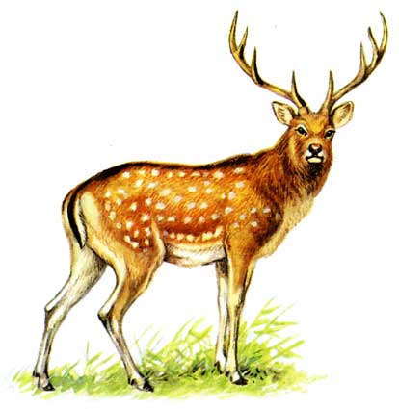ran out of the forest.

3)To let the cat out of the bag
- to tell people a secret
- to do something that makes people angry
- to do something in a nervous or excited way

4) «Speaking verb» m - m - - e
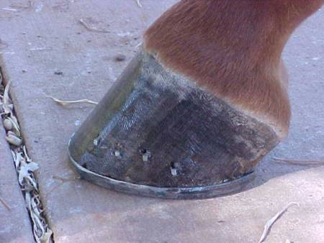
5) Claw

Paw

Hoof

6) Good quality (nasty, fussy, patient, greedy, spiteful)

7) A swarm
A pack of birds
A bunch
A flock

8) hair (gold /golden)

9)
1) terrific
Ta 2) dad
3) thank you
10) I simply can’t imagine why
High and eye sound like_______.
We have food and blood and wood
And yet we rhyme should with________.

T: Our great friends «books» help us to study and of course they help us to study English. You all read a lot, because you study in Gumanitarniy litsei. I think Pasha is a bookworm. I wonder, Pasha, when do you find time to read and what type of books do you prefer?

(Pasha answers the question)

Физкультминутка:

На раз – поднять глаза вверх, на два – смотреть прямо, на три – потупить взор книзу, на четыре – смотреть прямо, 8 раз.

T: Some of you get an adjective. Tell us which book this adjective can characterize. Try to give the name of the book in English.

(Teacher gives out the cards with the adjectives)
P₁
P₂
P₃
P₄

T: Dina has prepared a very short summary of a book. Please try to guess what book she is speaking about.

(Dina retells the plot)

T: Lots of plays in theatres are based on different novels, stories, etc. Are there any theatre – goers in our class? Who is fond of going to the theatre?
P₁

T: I think someway we are all actors, because most people are imaginative and creative. Three of you, that is Sasha, Pasha and Masha get a piece from a play which you know. They will act it. Sasha, you are actor A, Pasha you are В and Masha is C. Take some time to look the piece through. You must act like real
actors. Other pupils are to guese which play is being acted.

(Three pupils look through the text)

T: While your classmates are getting ready we’ll move to the next topic “People”.
In the textbook it was called “It takes many kinds to make the world”. We spoke about how greatly people differ from one another. Well, what about us? It was your homework to tell us what good qualities your classmates have, which, for example other pupils don’t have.

(Some pupils describe their classmates)

T: Now let’s watch the performance.

A-Teacher B-Pupil C-Pupil’s mother
A: So, here is a problem for you to solve: three of us are walking down the road.
B (writing): three of us

A: Suddenly we see three hundred roubles.
B (writing): three hundred roubles…
A: We must divide the money. Think, how much each of us gets?
B: 3 multiplied by 3 is 3. Zero multiplied by 1 is zero.
C: What do I hear? The money must be divided?
B: Yeah. I must divide three hundred roubles… by 3.
C: The teacher is lying, my darling. If you find money, don’t share it with anybody. Take it all yourself! Don’t study this stupid science!
B: Give me something else to solve.
A: As you please, your honour. Write down the next problem: you pay me 10 roubles а year for teaching you.
B: 10 roubles а year…
A: Well, now you’re paying for nothing, but if you learnt some things,you could give me another 10 roubles.
B: another 10 roubles.
A: How much a year would I get then?
B: Zero and zero is zero. One and one…
C: Don’t waste your time, dear. I’m not going to raise his salary. He doesn’t deserve it. Science is torture for you. Why count if there’s no money? If money comes, we’ll count it ourselves without your teacher. And we’ll be able to count it very,very,very,ve-e-e-e-ry well!!!
(Answer: Fonvisin “Young oaf” – “Недоросль”)
T: Can you guess what play it is?

(Pupils try to guess the name of the play)

T:We’ve just tried to find some good qualities in our classmates. Such wonderful people are here in one class. Together you can do a lot. I’d like to read a philosophical kind of text to you. Listen, please and then answer the question “What is in this black bag?”

Some of them are black, some are white. They can also be brown and pink. But they all live together side by side. They live in peace and agreement. Some are always busy, the others are waiting for their turn. Though, looking at it more widely, they are all equal. Some are straight and round, the others are pointed. But they all know what their task is. Some are very beautiful, some have strange names. But each of them is absolutely unique. If you use them separately they won’t be bright. But together they are able to create a great work of art. How much we can learn from just… (Answer : a box of crayons)

(Pupils try to guess the riddle)

T: That’s right. You are like this box of crayons.
You, such wonderful pupils go to a wonderful school called Gumanitarniy litsei. But still I think that you would like to change something. So, if you were the headmaster what would you change?

P₁
P₂
P₃

T: Let us tell our guests about our school.

(Pupils recite a poem)

“Some”

We go to an unusual school.
For some it’s bad, for some it’s cool.
Some go because of their own will
And some have quid to pay the bill
Some study here and can’t say “no”,
Cause their parents make them go.

Some rules we follow,
Some we break.
We study hard
And our heads ache.
For some it’s their cup of tea:
For me and me and me and me.

The uniform I hate to wear,
But I some subjects cannot bear.
We aren’t allowed to have hair loose.
This school for me is like a noose.

Some teachers grumble,
Some are kind.
But on the whole we do not mind.
We have our own exciting world.
And we’ve got boys, and we’ve got girls.

School’s just a part of our life.
In it we’re bees in a small hive.
It’s cosy, warm, it’s quite O.K.
In it’s own schooly – jolly way.

We like our class,
We are good mates.
We’ve got our loves,
We’ve got our hates.
So let our school live and prosper.
Some really want it, some don’t care.

Завершающий этап.

T: The bell has gone. Thank you for the lesson. I hope everybody has enjoyed it. See you on Wednesday.

Литература.
1.О.В. Афанасьева, И.В. Михеева «Английский язык 7 класс».
2.Д.И. Фонвизин «Недоросль»
3. «Загадки народов мира» О.Н. Бутакова

