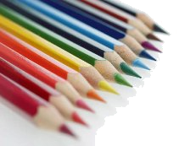

ТЕЛО
___________________________________________________
_____________________________________________________________________________________
__________________________________________________________________________________
___________________________________________________________________
____________________________________________________________________________________________________

ТЕЛО
_________________________________________________
______________________________________________________

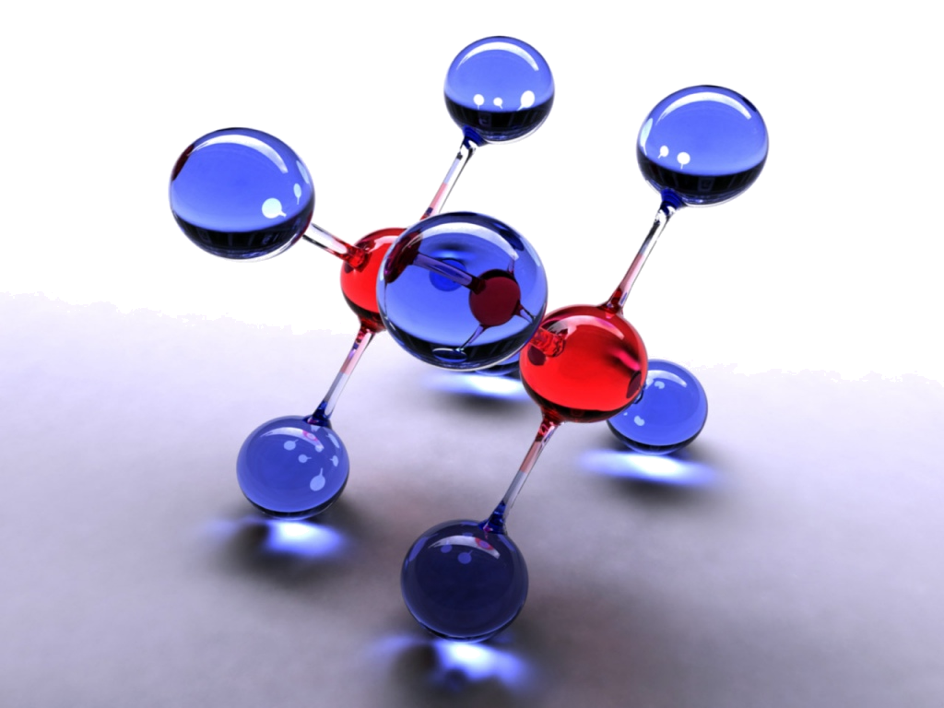
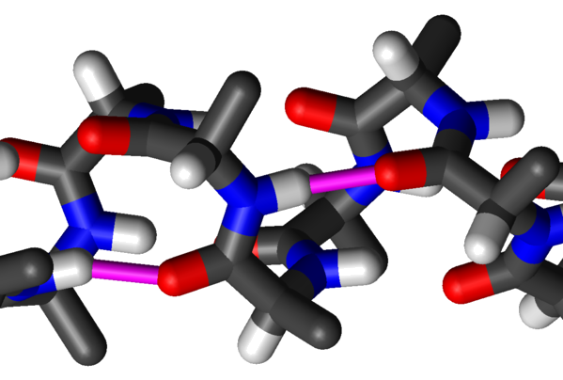
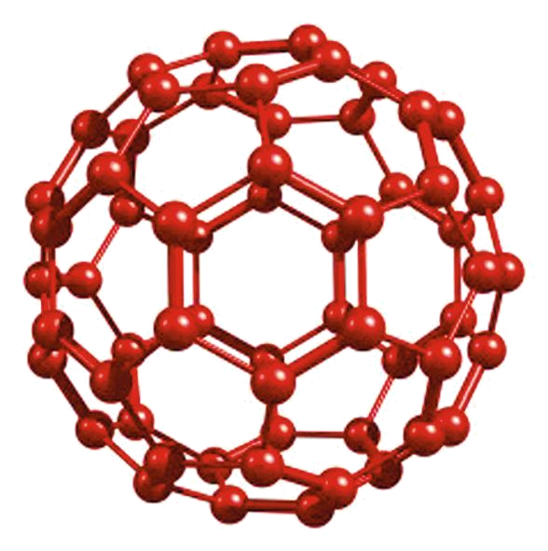
№ | тело | вещество | частицы

___________________________________________________________________
___________________________________________________________________
___________________________________________________________________
___________________________________________________________________
___________________________________________________________________
___________________________________________________________________

