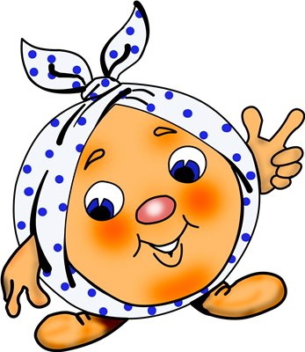**The Roll**

AUTHOR: Once upon a time there lived the grandfather and the grandmother. They lived happily and friendly in a very old house. They had no children and the grandpa asked the grandma to bake some roll.

GRANDPA: Can you bake some roll for us?

GRANDMA: OK. But there is no flour.

GRANDPA: Wipe the shelves carefully.

AUTHOR: The grandma did everything and baked the roll.

GRANDMA: Look, grandpa. Come on. What a good roll!

GRANDPA: It is lovely.

AUTHOR: They loved their roll but one day it ran away. The roll was running and running and then he saw a HARE.

HARE: Hello. I’m a hare. I’m grey and white. Who are you?

ROLL: I’m the roll.

HARE: I want to eat you.

ROLL: Oh no. Don’t eat me.

I’m running from grandma

I’m running from grandpa

To the forest far away

Catch adventure day by day.

AUTHOR: The roll was running and running and saw a WOLF (grey and hungry), BEAR (brown and strong), HEDGEHOG (small and black), SQUIRREL (red and fast), OWL (wise), SNAKE (long and green), BIRD. (TOMTIT) (small and grey), FOX.

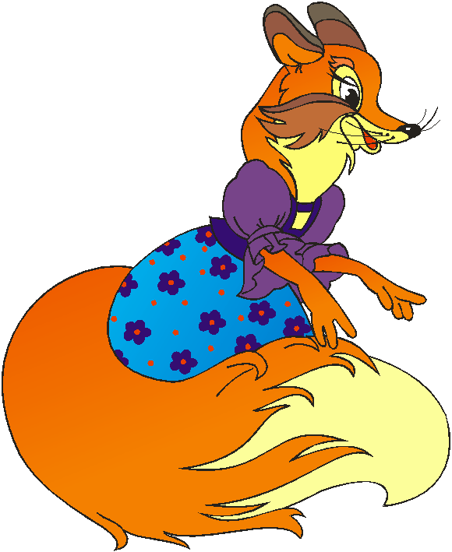FOX: Hello, dear. I’m a fox. Who are you?

…

FOX: You are so nice and funny. I want to be your friend.

ROLL: I will sing to you.

FOX: I can’t hear you. Come closer.

ROLL: OK.

…

AUTHOR: So the cunning fox ate the roll and ran away.