**Технические эскизы брюк**

[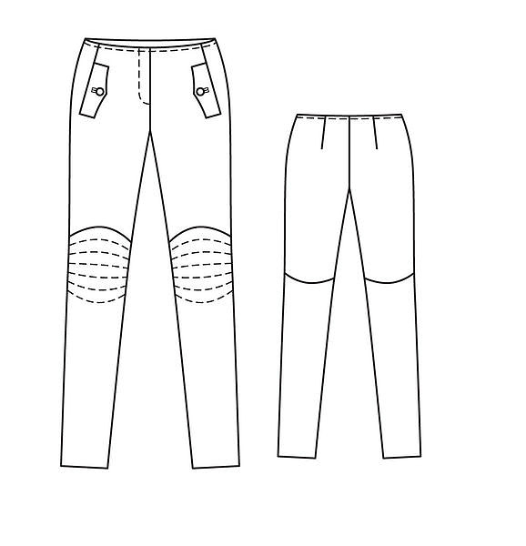](http://images.yandex.ru/yandsearch?text=%D1%82%D0%B5%D1%85%D0%BD%D0%B8%D1%87%D0%B5%D1%81%D0%BA%D0%B8%D0%B5%20%D1%8D%D1%81%D0%BA%D0%B8%D0%B7%D1%8B%20%D0%B1%D1%80%D1%8E%D0%BA&fp=0&pos=6&uinfo=ww-1076-wh-614-fw-851-fh-448-pd-1.25&rpt=simage&img_url=http://www.burdastyle.ru/gfx/00/07/33/a5/technicalSketch-0yffqac_jpg/thumb_140x188_11.jpg) [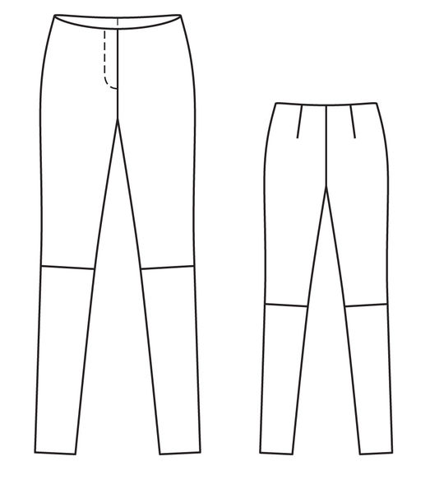](http://images.yandex.ru/yandsearch?text=%D1%82%D0%B5%D1%85%D0%BD%D0%B8%D1%87%D0%B5%D1%81%D0%BA%D0%B8%D0%B5%20%D1%8D%D1%81%D0%BA%D0%B8%D0%B7%D1%8B%20%D0%B1%D1%80%D1%8E%D0%BA&fp=0&pos=7&uinfo=ww-1076-wh-614-fw-851-fh-448-pd-1.25&rpt=simage&img_url=http://www.burdastyle.ru/gfx/00/0b/74/fd/technicalSketch-1hkdjuv_jpg/thumb_140x188_11.jpg) [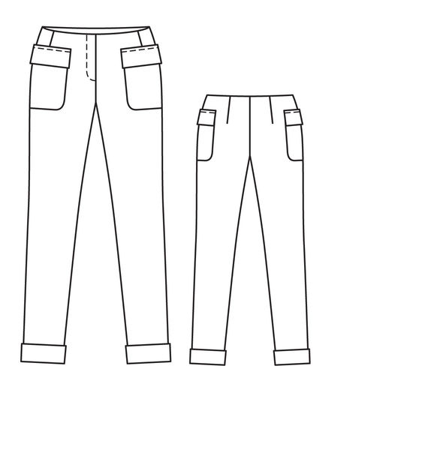](http://images.yandex.ru/yandsearch?p=1&text=%D1%82%D0%B5%D1%85%D0%BD%D0%B8%D1%87%D0%B5%D1%81%D0%BA%D0%B8%D0%B5%20%D1%8D%D1%81%D0%BA%D0%B8%D0%B7%D1%8B%20%D0%B1%D1%80%D1%8E%D0%BA&fp=1&pos=49&uinfo=ww-1076-wh-614-fw-851-fh-448-pd-1.25&rpt=simage&img_url=http://www.burdastyle.ru/gfx/00/07/34/6b/technicalSketch-1tlpvmj_jpg/thumb_140x188_11.jpg)

рис.1 рис. 2 рис. 3

[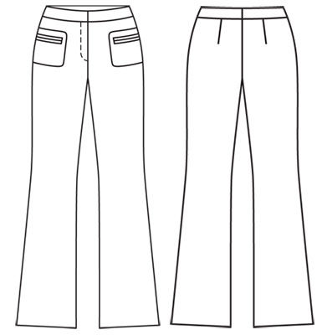](http://images.yandex.ru/yandsearch?p=1&text=%D1%82%D0%B5%D1%85%D0%BD%D0%B8%D1%87%D0%B5%D1%81%D0%BA%D0%B8%D0%B5%20%D1%8D%D1%81%D0%BA%D0%B8%D0%B7%D1%8B%20%D0%B1%D1%80%D1%8E%D0%BA&fp=1&pos=33&uinfo=ww-1076-wh-614-fw-851-fh-448-pd-1.25&rpt=simage&img_url=http://www.burdastyle.ru/gfx/00/00/1c/9e/technicalSketch-06pduis_jpg/thumb_140x188_11.jpg) [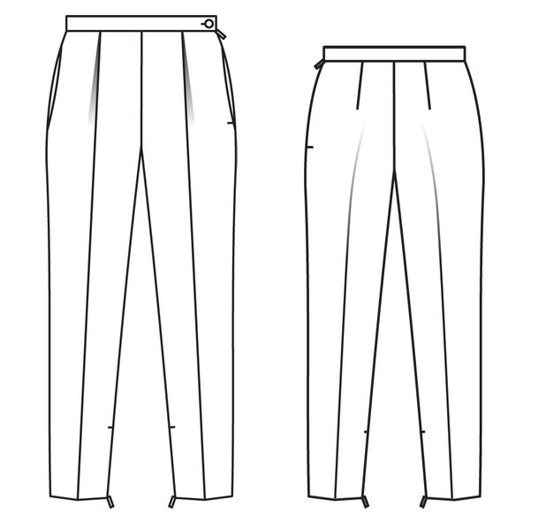](http://images.yandex.ru/yandsearch?text=%D1%82%D0%B5%D1%85%D0%BD%D0%B8%D1%87%D0%B5%D1%81%D0%BA%D0%B8%D0%B5%20%D1%8D%D1%81%D0%BA%D0%B8%D0%B7%D1%8B%20%D0%B1%D1%80%D1%8E%D0%BA&fp=0&pos=24&uinfo=ww-1076-wh-614-fw-851-fh-448-pd-1.25&rpt=simage&img_url=http://www.burdastyle.ru/gfx/00/0c/a9/8d/technicalSketch-0qoa854_jpg/thumb_140x188_11.jpg) [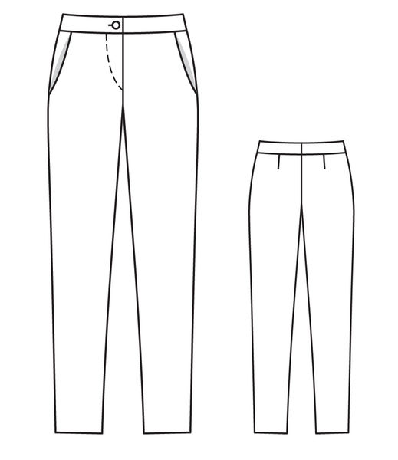](http://images.yandex.ru/yandsearch?p=2&text=%D1%82%D0%B5%D1%85%D0%BD%D0%B8%D1%87%D0%B5%D1%81%D0%BA%D0%B8%D0%B5%20%D1%8D%D1%81%D0%BA%D0%B8%D0%B7%D1%8B%20%D0%B1%D1%80%D1%8E%D0%BA&fp=2&pos=63&uinfo=ww-1076-wh-614-fw-851-fh-448-pd-1.25&rpt=simage&img_url=http://www.burdastyle.ru/gfx/00/0d/72/b5/technicalSketch-0deyfu9_jpg/thumb_140x188_11.jpg)

рис.4 рис. 5 рис. 6

[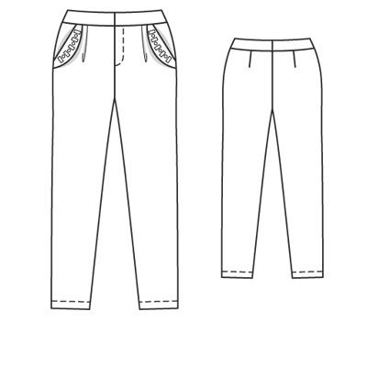](http://images.yandex.ru/yandsearch?text=%D1%82%D0%B5%D1%85%D0%BD%D0%B8%D1%87%D0%B5%D1%81%D0%BA%D0%B8%D0%B5%20%D1%8D%D1%81%D0%BA%D0%B8%D0%B7%D1%8B%20%D0%B1%D1%80%D1%8E%D0%BA&fp=0&pos=22&uinfo=ww-1076-wh-614-fw-851-fh-448-pd-1.25&rpt=simage&img_url=http://www.burdastyle.ru/gfx/00/02/cc/5b/technicalSketch-0x7msno_jpg/thumb_140x188_11.jpg) [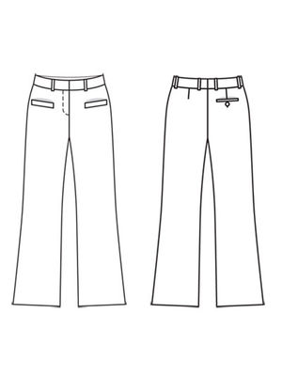](http://images.yandex.ru/yandsearch?p=1&text=%D1%82%D0%B5%D1%85%D0%BD%D0%B8%D1%87%D0%B5%D1%81%D0%BA%D0%B8%D0%B5%20%D1%8D%D1%81%D0%BA%D0%B8%D0%B7%D1%8B%20%D0%B1%D1%80%D1%8E%D0%BA&fp=1&pos=48&uinfo=ww-1076-wh-614-fw-851-fh-448-pd-1.25&rpt=simage&img_url=http://www.burdastyle.ru/gfx/00/00/1f/08/technicalSketch-0mqrdp3_jpg/thumb_140x188_11.jpg) [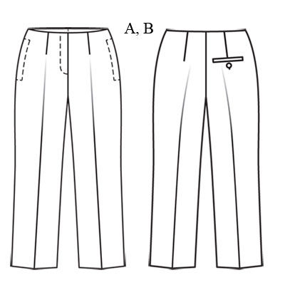](http://images.yandex.ru/yandsearch?p=3&text=%D1%82%D0%B5%D1%85%D0%BD%D0%B8%D1%87%D0%B5%D1%81%D0%BA%D0%B8%D0%B5%20%D1%8D%D1%81%D0%BA%D0%B8%D0%B7%D1%8B%20%D0%B1%D1%80%D1%8E%D0%BA&fp=3&pos=97&uinfo=ww-1076-wh-614-fw-851-fh-448-pd-1.25&rpt=simage&img_url=http://www.burdastyle.ru/gfx/00/01/9c/16/technicalSketch-0hyds1m_jpg/thumb_800x600_10.jpg)

рис.7 рис. 8 рис. 9

[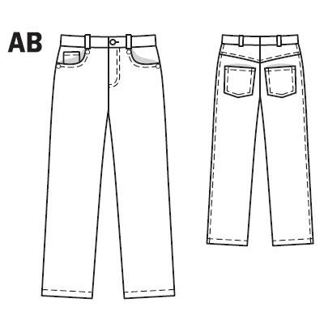](http://images.yandex.ru/yandsearch?p=1&text=%D1%82%D0%B5%D1%85%D0%BD%D0%B8%D1%87%D0%B5%D1%81%D0%BA%D0%B8%D0%B5%20%D1%8D%D1%81%D0%BA%D0%B8%D0%B7%D1%8B%20%D0%B1%D1%80%D1%8E%D0%BA&fp=1&pos=41&uinfo=ww-1076-wh-614-fw-851-fh-448-pd-1.25&rpt=simage&img_url=http://www.burdastyle.ru/gfx/00/01/4d/8b/technicalSketch-1pe0tcp_jpg/thumb_140x188_11.jpg) [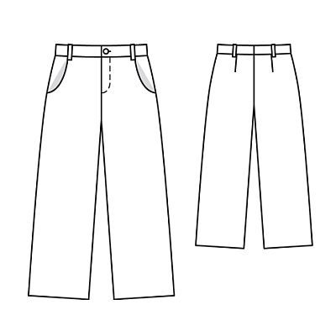](http://images.yandex.ru/yandsearch?p=1&text=%D1%82%D0%B5%D1%85%D0%BD%D0%B8%D1%87%D0%B5%D1%81%D0%BA%D0%B8%D0%B5%20%D1%8D%D1%81%D0%BA%D0%B8%D0%B7%D1%8B%20%D0%B1%D1%80%D1%8E%D0%BA&fp=1&pos=57&uinfo=ww-1076-wh-614-fw-851-fh-448-pd-1.25&rpt=simage&img_url=http://www.burdastyle.ru/gfx/00/00/22/d5/technicalSketch-1d6ccng_jpg/thumb_140x188_11.jpg) [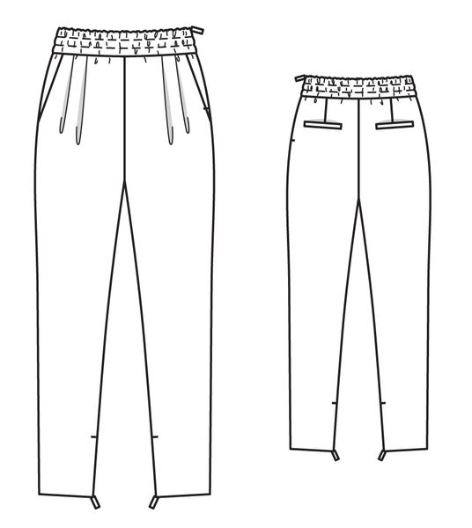](http://images.yandex.ru/yandsearch?p=2&text=%D1%82%D0%B5%D1%85%D0%BD%D0%B8%D1%87%D0%B5%D1%81%D0%BA%D0%B8%D0%B5%20%D1%8D%D1%81%D0%BA%D0%B8%D0%B7%D1%8B%20%D0%B1%D1%80%D1%8E%D0%BA&fp=2&pos=65&uinfo=ww-1076-wh-614-fw-851-fh-448-pd-1.25&rpt=simage&img_url=http://www.burdastyle.ru/gfx/00/0b/66/09/technicalSketch-16btxtx_jpg/thumb_800x600_10.jpg)

рис.10 рис. 11 рис. 12

[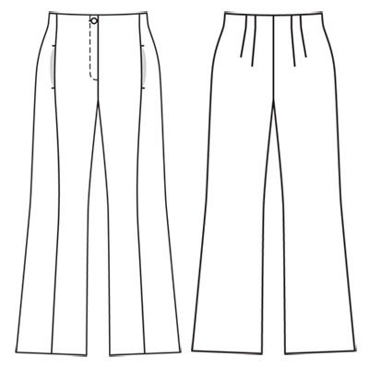](http://images.yandex.ru/yandsearch?p=4&text=%D1%82%D0%B5%D1%85%D0%BD%D0%B8%D1%87%D0%B5%D1%81%D0%BA%D0%B8%D0%B5%20%D1%8D%D1%81%D0%BA%D0%B8%D0%B7%D1%8B%20%D0%B1%D1%80%D1%8E%D0%BA&fp=4&pos=140&uinfo=ww-1076-wh-614-fw-851-fh-448-pd-1.25&rpt=simage&img_url=http://www.burdastyle.ru/gfx/00/00/1d/c5/technicalSketch-070o7vr_jpg/thumb_800x600_10.jpg) [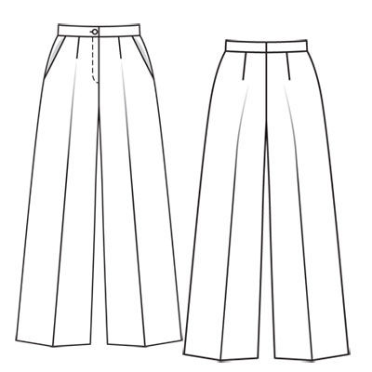](http://images.yandex.ru/yandsearch?p=5&text=%D1%82%D0%B5%D1%85%D0%BD%D0%B8%D1%87%D0%B5%D1%81%D0%BA%D0%B8%D0%B5%20%D1%8D%D1%81%D0%BA%D0%B8%D0%B7%D1%8B%20%D0%B1%D1%80%D1%8E%D0%BA&fp=5&pos=169&uinfo=ww-1076-wh-614-fw-851-fh-448-pd-1.25&rpt=simage&img_url=http://www.burdastyle.ru/gfx/00/01/97/20/technicalSketch-1p1f5k3_jpg/thumb_800x600_10.jpg)

рис.13 рис. 14

[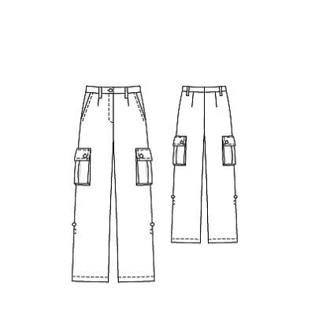](http://images.yandex.ru/yandsearch?p=4&text=%D1%82%D0%B5%D1%85%D0%BD%D0%B8%D1%87%D0%B5%D1%81%D0%BA%D0%B8%D0%B5%20%D1%8D%D1%81%D0%BA%D0%B8%D0%B7%D1%8B%20%D0%B1%D1%80%D1%8E%D0%BA&fp=4&pos=124&uinfo=ww-1076-wh-614-fw-851-fh-448-pd-1.25&rpt=simage&img_url=http://www.burdastyle.ru/gfx/00/00/29/5f/technicalSketch-12u02cl_jpg/thumb_800x600_10.jpg) [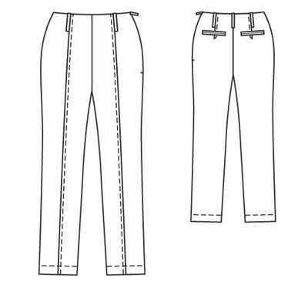](http://images.yandex.ru/yandsearch?p=5&text=%D1%82%D0%B5%D1%85%D0%BD%D0%B8%D1%87%D0%B5%D1%81%D0%BA%D0%B8%D0%B5%20%D1%8D%D1%81%D0%BA%D0%B8%D0%B7%D1%8B%20%D0%B1%D1%80%D1%8E%D0%BA&fp=5&pos=154&uinfo=ww-1076-wh-614-fw-851-fh-448-pd-1.25&rpt=simage&img_url=http://www.burdastyle.ru/gfx/00/02/ae/4c/technicalSketch-21evesy_jpg/thumb_800x600_10.jpg) [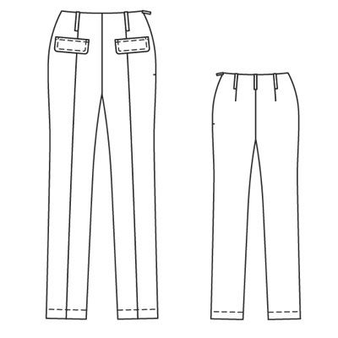](http://images.yandex.ru/yandsearch?p=6&text=%D1%82%D0%B5%D1%85%D0%BD%D0%B8%D1%87%D0%B5%D1%81%D0%BA%D0%B8%D0%B5%20%D1%8D%D1%81%D0%BA%D0%B8%D0%B7%D1%8B%20%D0%B1%D1%80%D1%8E%D0%BA&fp=6&pos=194&uinfo=ww-1076-wh-614-fw-851-fh-448-pd-1.25&rpt=simage&img_url=http://www.burdastyle.ru/gfx/00/02/ac/bf/technicalSketch-0g2qvm7_jpg/thumb_800x600_10.jpg)

рис.15 рис. 16 рис. 17

[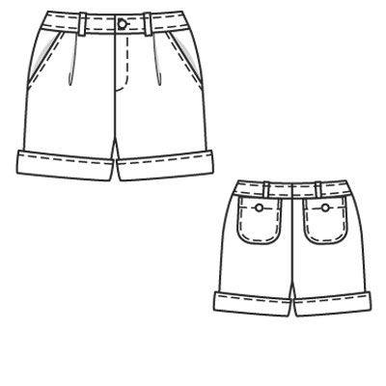](http://images.yandex.ru/yandsearch?p=5&text=%D1%82%D0%B5%D1%85%D0%BD%D0%B8%D1%87%D0%B5%D1%81%D0%BA%D0%B8%D0%B5%20%D1%8D%D1%81%D0%BA%D0%B8%D0%B7%D1%8B%20%D0%B1%D1%80%D1%8E%D0%BA&fp=5&pos=164&uinfo=ww-1076-wh-614-fw-851-fh-448-pd-1.25&rpt=simage&img_url=http://www.burdastyle.ru/gfx/00/02/cc/60/technicalSketch-07v3gsg_jpg/thumb_140x188_11.jpg) [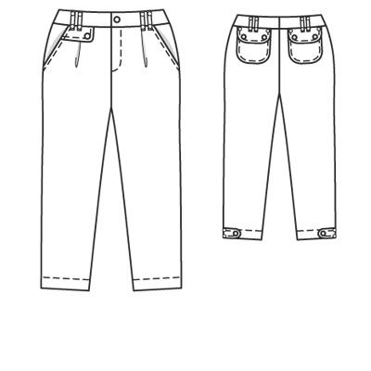](http://images.yandex.ru/yandsearch?p=5&text=%D1%82%D0%B5%D1%85%D0%BD%D0%B8%D1%87%D0%B5%D1%81%D0%BA%D0%B8%D0%B5%20%D1%8D%D1%81%D0%BA%D0%B8%D0%B7%D1%8B%20%D0%B1%D1%80%D1%8E%D0%BA&fp=5&pos=153&uinfo=ww-1076-wh-614-fw-851-fh-448-pd-1.25&rpt=simage&img_url=http://www.burdastyle.ru/gfx/00/02/cc/59/technicalSketch-147rjv1_jpg/thumb_800x600_10.jpg)

рис.18 рис. 19

[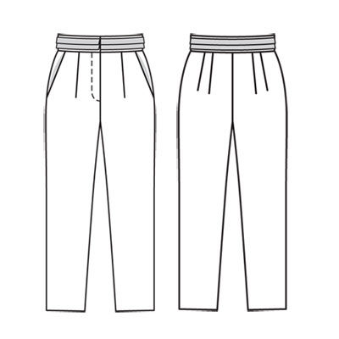](http://images.yandex.ru/yandsearch?p=6&text=%D1%82%D0%B5%D1%85%D0%BD%D0%B8%D1%87%D0%B5%D1%81%D0%BA%D0%B8%D0%B5%20%D1%8D%D1%81%D0%BA%D0%B8%D0%B7%D1%8B%20%D0%B1%D1%80%D1%8E%D0%BA&fp=6&pos=182&uinfo=ww-1076-wh-614-fw-851-fh-448-pd-1.25&rpt=simage&img_url=http://www.burdastyle.ru/gfx/00/00/23/90/technicalSketch-1wgusd8_jpg/thumb_800x600_10.jpg) [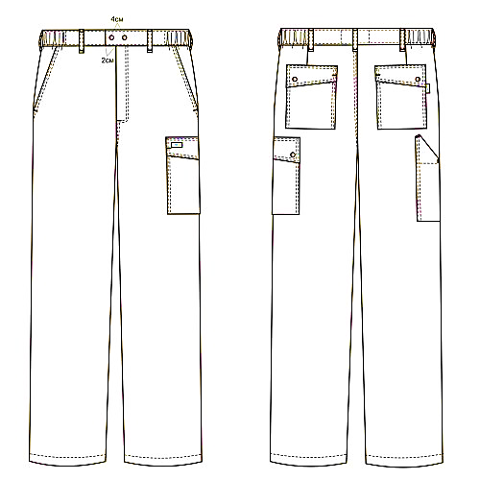](http://images.yandex.ru/yandsearch?p=1&text=%D1%82%D0%B5%D1%85%D0%BD%D0%B8%D1%87%D0%B5%D1%81%D0%BA%D0%B8%D0%B5%20%D1%8D%D1%81%D0%BA%D0%B8%D0%B7%D1%8B%20%D0%B1%D1%80%D1%8E%D0%BA&pos=34&uinfo=ww-1076-wh-490-fw-851-fh-448-pd-1.25&rpt=simage&img_url=http://www.roba-spb.ru/images/cataloge/Bruki/207t1.gif)

рис.20 рис. 21