**Технические эскизы женских блуз**

**[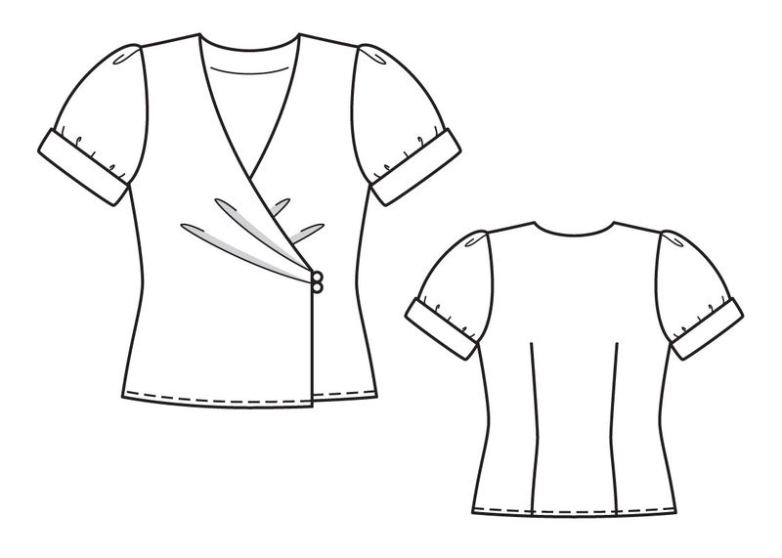](http://images.yandex.ru/yandsearch?source=wiz&uinfo=sw-1345-sh-651-fw-1120-fh-448-pd-1&p=1&text=%D1%82%D0%B5%D1%85%D0%BD%D0%B8%D1%87%D0%B5%D1%81%D0%BA%D0%B8%D0%B9%20%D1%8D%D1%81%D0%BA%D0%B8%D0%B7%20%D0%BE%D0%B4%D0%B5%D0%B6%D0%B4%D1%8B&noreask=1&pos=44&rpt=simage&lr=2&img_url=http://www.burdastyle.ru/gfx/00/08/0c/36/technicalSketch-13l6bm4_jpg/thumb_140x188_11.jpg)[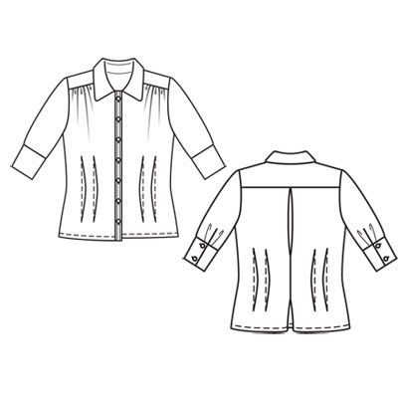](http://images.yandex.ru/yandsearch?p=1&text=%D1%82%D0%B5%D1%85%D0%BD%D0%B8%D1%87%D0%B5%D1%81%D0%BA%D0%B8%D0%B9%20%D1%8D%D1%81%D0%BA%D0%B8%D0%B7%20%D0%B1%D0%BB%D1%83%D0%B7%D1%8B&pos=50&uinfo=sw-1345-sh-651-fw-1120-fh-448-pd-1&rpt=simage&img_url=http://www.burdastyle.ru/gfx/00/00/1d/6a/technicalSketch-073o4m8_jpg/thumb_140x188_11.jpg)**

**Мод. 1 Мод. 2**

**[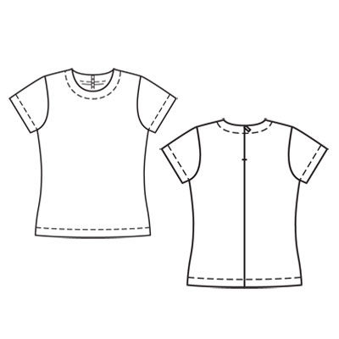](http://images.yandex.ru/yandsearch?source=wiz&uinfo=sw-1345-sh-651-fw-1120-fh-448-pd-1&p=3&text=%D1%82%D0%B5%D1%85%D0%BD%D0%B8%D1%87%D0%B5%D1%81%D0%BA%D0%B8%D0%B9%20%D1%8D%D1%81%D0%BA%D0%B8%D0%B7%20%D0%BE%D0%B4%D0%B5%D0%B6%D0%B4%D1%8B&noreask=1&pos=114&rpt=simage&lr=2&img_url=http://www.burdastyle.ru/gfx/00/00/23/94/technicalSketch-0iq56nx_jpg/thumb_800x600_10.jpg) [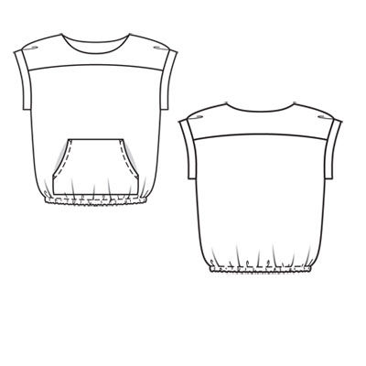](http://images.yandex.ru/yandsearch?text=%D1%82%D0%B5%D1%85%D0%BD%D0%B8%D1%87%D0%B5%D1%81%D0%BA%D0%B8%D0%B5%20%D1%8D%D1%81%D0%BA%D0%B8%D0%B7%D1%8B%20%D0%B1%D0%BB%D1%83%D0%B7&pos=0&rpt=simage&lr=2&noreask=1&source=wiz&uinfo=sw-1345-sh-651-fw-1120-fh-448-pd-1&img_url=http://www.burdastyle.ru/gfx/00/00/1d/f3/technicalSketch-1algwv4_jpg/thumb_800x600_10.jpg)**

**Мод. 3 Мод. 4**

**[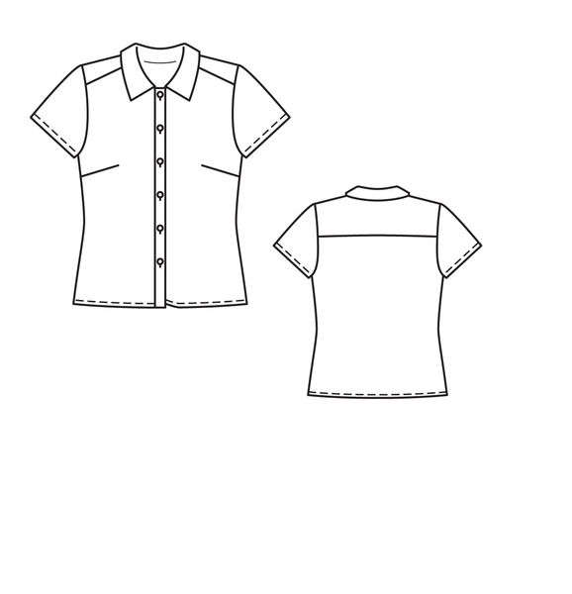](http://images.yandex.ru/yandsearch?source=wiz&text=%D1%82%D0%B5%D1%85%D0%BD%D0%B8%D1%87%D0%B5%D1%81%D0%BA%D0%B8%D0%B5%20%D1%8D%D1%81%D0%BA%D0%B8%D0%B7%D1%8B%20%D0%B1%D0%BB%D1%83%D0%B7&noreask=1&pos=11&rpt=simage&lr=2&uinfo=sw-1345-sh-651-fw-1120-fh-448-pd-1&img_url=http://www.burdastyle.ru/gfx/00/08/32/45/technicalSketch-03eb7kg_jpg/thumb_800x600_10.jpg) [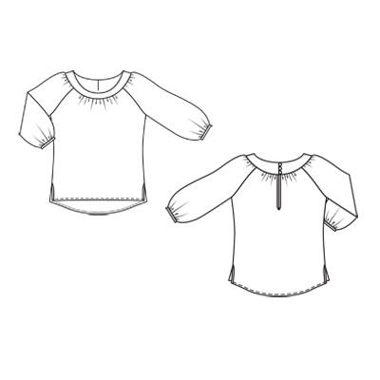](http://images.yandex.ru/yandsearch?source=wiz&text=%D1%82%D0%B5%D1%85%D0%BD%D0%B8%D1%87%D0%B5%D1%81%D0%BA%D0%B8%D0%B5%20%D1%8D%D1%81%D0%BA%D0%B8%D0%B7%D1%8B%20%D0%B1%D0%BB%D1%83%D0%B7&noreask=1&pos=12&rpt=simage&lr=2&uinfo=sw-1345-sh-651-fw-1120-fh-448-pd-1&img_url=http://www.burdastyle.ru/gfx/00/00/20/16/technicalSketch-1yn34bi_jpg/thumb_800x600_10.jpg)**

**Мод. 5 Мод. 6**

**[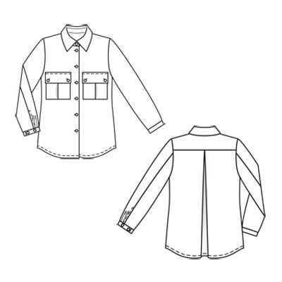](http://images.yandex.ru/yandsearch?source=wiz&uinfo=sw-1345-sh-651-fw-1120-fh-448-pd-1&p=2&text=%D1%82%D0%B5%D1%85%D0%BD%D0%B8%D1%87%D0%B5%D1%81%D0%BA%D0%B8%D0%B5%20%D1%8D%D1%81%D0%BA%D0%B8%D0%B7%D1%8B%20%D0%B1%D0%BB%D1%83%D0%B7&noreask=1&pos=61&rpt=simage&lr=2&img_url=http://www.burdastyle.ru/gfx/00/01/97/47/technicalSketch-014h0kc_jpg/thumb_140x188_11.jpg) [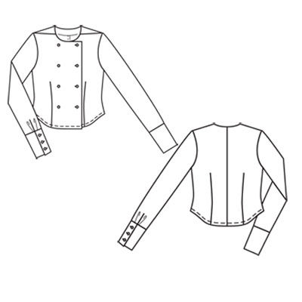](http://images.yandex.ru/yandsearch?source=wiz&uinfo=sw-1345-sh-651-fw-1120-fh-448-pd-1&p=2&text=%D1%82%D0%B5%D1%85%D0%BD%D0%B8%D1%87%D0%B5%D1%81%D0%BA%D0%B8%D0%B5%20%D1%8D%D1%81%D0%BA%D0%B8%D0%B7%D1%8B%20%D0%B1%D0%BB%D1%83%D0%B7&noreask=1&pos=76&rpt=simage&lr=2&img_url=http://www.burdastyle.ru/gfx/00/01/a0/69/technicalSketch-1e0s5v6_jpg/thumb_140x188_11.jpg)**

**Мод. 7 Мод. 8**

**[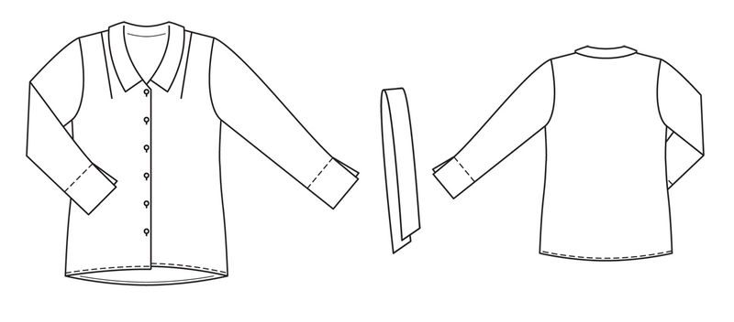](http://images.yandex.ru/yandsearch?source=wiz&uinfo=sw-1345-sh-651-fw-1120-fh-448-pd-1&p=3&text=%D1%82%D0%B5%D1%85%D0%BD%D0%B8%D1%87%D0%B5%D1%81%D0%BA%D0%B8%D0%B5%20%D1%8D%D1%81%D0%BA%D0%B8%D0%B7%D1%8B%20%D0%B1%D0%BB%D1%83%D0%B7&noreask=1&pos=94&rpt=simage&lr=2&img_url=http://www.burdastyle.ru/gfx/00/0b/75/8b/technicalSketch-21x32ig_jpg/thumb_800x600_10.jpg)**

**Мод. 9**

**[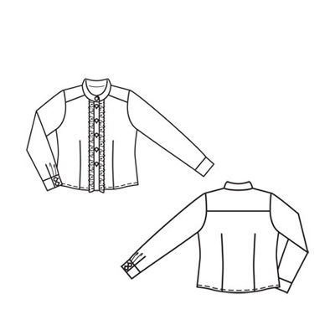](http://images.yandex.ru/yandsearch?source=wiz&uinfo=sw-1345-sh-651-fw-1120-fh-448-pd-1&p=3&text=%D1%82%D0%B5%D1%85%D0%BD%D0%B8%D1%87%D0%B5%D1%81%D0%BA%D0%B8%D0%B5%20%D1%8D%D1%81%D0%BA%D0%B8%D0%B7%D1%8B%20%D0%B1%D0%BB%D1%83%D0%B7&noreask=1&pos=102&rpt=simage&lr=2&img_url=http://www.burdastyle.ru/gfx/00/01/97/e5/technicalSketch-15wnf1d_jpg/thumb_140x188_11.jpg)**

**[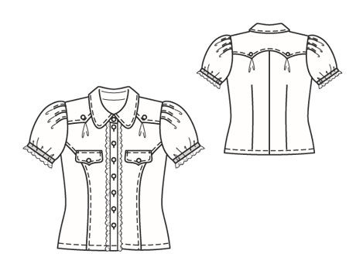](http://images.yandex.ru/yandsearch?source=wiz&uinfo=sw-1345-sh-651-fw-1120-fh-448-pd-1&p=3&text=%D1%82%D0%B5%D1%85%D0%BD%D0%B8%D1%87%D0%B5%D1%81%D0%BA%D0%B8%D0%B5%20%D1%8D%D1%81%D0%BA%D0%B8%D0%B7%D1%8B%20%D0%B1%D0%BB%D1%83%D0%B7&noreask=1&pos=98&rpt=simage&lr=2&img_url=http://www.burdastyle.ru/gfx/00/02/cb/6a/technicalSketch-10l8h7y_jpg/thumb_140x188_11.jpg)**

**Мод. 10 Мод. 11**

**[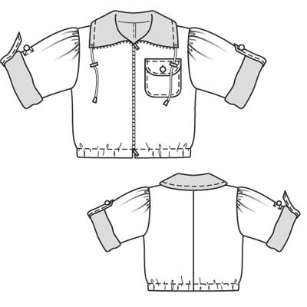](http://images.yandex.ru/yandsearch?source=wiz&uinfo=sw-1345-sh-651-fw-1120-fh-448-pd-1&p=3&text=%D1%82%D0%B5%D1%85%D0%BD%D0%B8%D1%87%D0%B5%D1%81%D0%BA%D0%B8%D0%B5%20%D1%8D%D1%81%D0%BA%D0%B8%D0%B7%D1%8B%20%D0%B1%D0%BB%D1%83%D0%B7&noreask=1&pos=108&rpt=simage&lr=2&img_url=http://www.burdastyle.ru/gfx/00/02/cb/d5/technicalSketch-1vpams7_jpg/thumb_140x188_11.jpg)[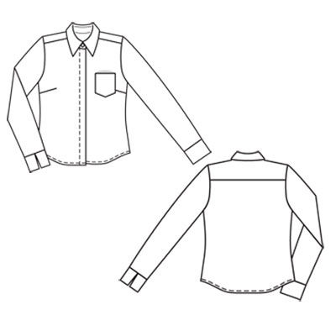](http://images.yandex.ru/yandsearch?source=wiz&uinfo=sw-1345-sh-651-fw-1120-fh-448-pd-1&p=4&text=%D1%82%D0%B5%D1%85%D0%BD%D0%B8%D1%87%D0%B5%D1%81%D0%BA%D0%B8%D0%B5%20%D1%8D%D1%81%D0%BA%D0%B8%D0%B7%D1%8B%20%D0%B1%D0%BB%D1%83%D0%B7&noreask=1&pos=129&rpt=simage&lr=2&img_url=http://www.burdastyle.ru/gfx/00/00/1f/49/technicalSketch-298itfi_jpg/thumb_140x188_11.jpg)**

**Мод. 12 Мод. 13**

[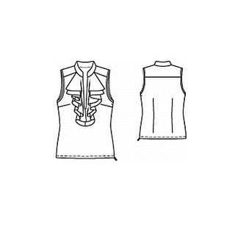](http://images.yandex.ru/yandsearch?text=%D1%82%D0%B5%D1%85%D0%BD%D0%B8%D1%87%D0%B5%D1%81%D0%BA%D0%B8%D0%B5%20%D1%8D%D1%81%D0%BA%D0%B8%D0%B7%D1%8B%20%D0%B1%D0%BB%D1%83%D0%B7&fp=0&pos=5&uinfo=ww-1076-wh-521-fw-851-fh-448-pd-1.25&rpt=simage&img_url=http://www.burdastyle.ru/gfx/00/00/25/c3/technicalSketch-0upoyku_jpg/thumb_130x178_11.jpg)[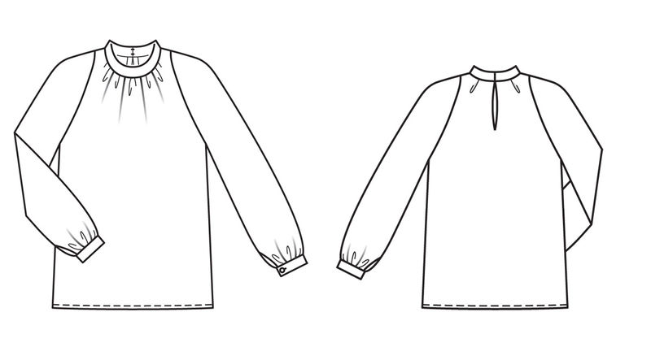](http://images.yandex.ru/yandsearch?p=5&text=%D1%82%D0%B5%D1%85%D0%BD%D0%B8%D1%87%D0%B5%D1%81%D0%BA%D0%B8%D0%B5%20%D1%8D%D1%81%D0%BA%D0%B8%D0%B7%D1%8B%20%D0%B1%D0%BB%D1%83%D0%B7&fp=5&pos=171&uinfo=ww-1076-wh-521-fw-851-fh-448-pd-1.25&rpt=simage&img_url=http://www.burdastyle.ru/gfx/00/0e/58/46/technicalSketch-09cames_jpg/thumb_800x600_10.jpg)

**Мод. 14 Мод. 15**

**[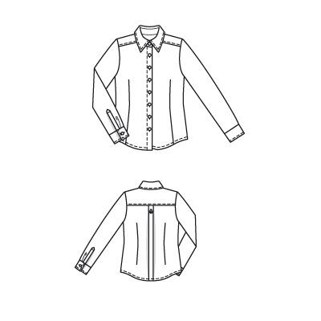](http://images.yandex.ru/yandsearch?source=wiz&uinfo=sw-1345-sh-651-fw-1120-fh-448-pd-1&p=4&text=%D1%82%D0%B5%D1%85%D0%BD%D0%B8%D1%87%D0%B5%D1%81%D0%BA%D0%B8%D0%B5%20%D1%8D%D1%81%D0%BA%D0%B8%D0%B7%D1%8B%20%D0%B1%D0%BB%D1%83%D0%B7&noreask=1&pos=134&rpt=simage&lr=2&img_url=http://www.burdastyle.ru/gfx/00/03/25/33/technicalSketch-0c8mwxo_jpg/thumb_140x188_11.jpg)**[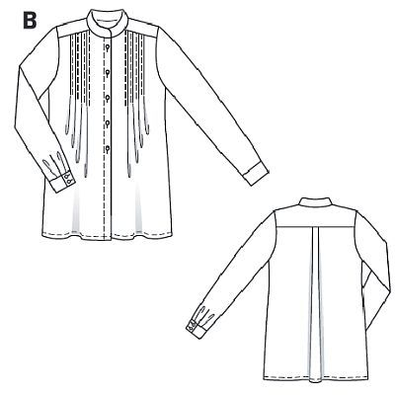](http://images.yandex.ru/yandsearch?p=1&text=%D1%82%D0%B5%D1%85%D0%BD%D0%B8%D1%87%D0%B5%D1%81%D0%BA%D0%B8%D0%B5%20%D1%8D%D1%81%D0%BA%D0%B8%D0%B7%D1%8B%20%D0%B1%D0%BB%D1%83%D0%B7&fp=1&pos=45&uinfo=ww-1076-wh-521-fw-851-fh-448-pd-1.25&rpt=simage&img_url=http://www.burdastyle.ru/gfx/00/00/29/fa/technicalSketch-26krbyg_jpg/thumb_800x600_10.jpg)

**Мод. 16 Мод. 17**