Технические эскизы демисизонных пальто

[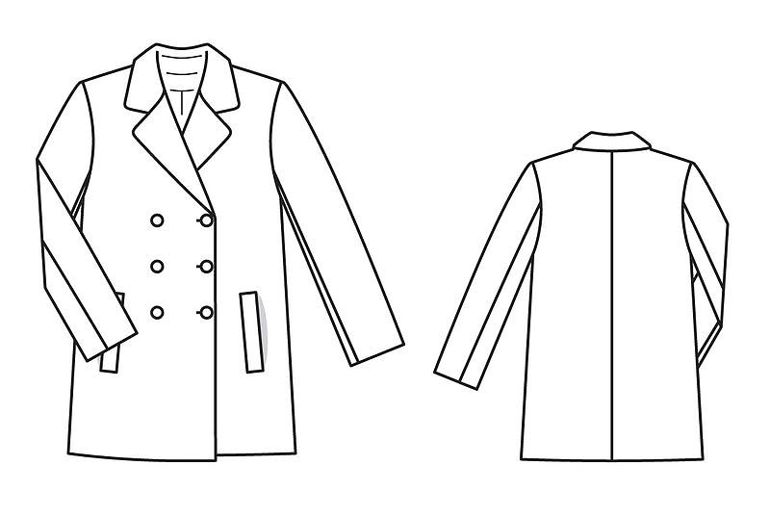](http://images.yandex.ru/yandsearch?p=1&text=%D1%82%D0%B5%D1%85%D0%BD%D0%B8%D1%87%D0%B5%D1%81%D0%BA%D0%B8%D0%B9%20%D1%8D%D1%81%D0%BA%D0%B8%D0%B7%20%D0%BE%D0%B4%D0%B5%D0%B6%D0%B4%D1%8B&fp=1&pos=37&uinfo=ww-1076-wh-521-fw-851-fh-448-pd-1.25&rpt=simage&img_url=http://www.burdastyle.ru/gfx/00/0b/75/ca/technicalSketch-1sgmwxo_jpg/thumb_800x600_10.jpg) [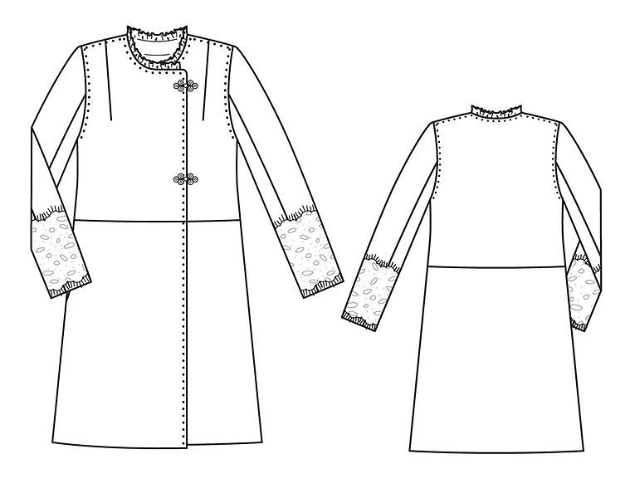](http://images.yandex.ru/yandsearch?p=2&text=%D1%82%D0%B5%D1%85%D0%BD%D0%B8%D1%87%D0%B5%D1%81%D0%BA%D0%B8%D0%B9%20%D1%8D%D1%81%D0%BA%D0%B8%D0%B7%20%20%D0%BF%D0%B0%D0%BB%D1%8C%D1%82%D0%BE&fp=2&pos=62&uinfo=ww-1076-wh-521-fw-851-fh-448-pd-1.25&rpt=simage&img_url=http://www.burdastyle.ru/gfx/00/0c/6f/96/technicalSketch-28kf5ta_jpg/thumb_800x600_10.jpg)

Рис. 1 Рис. 2

[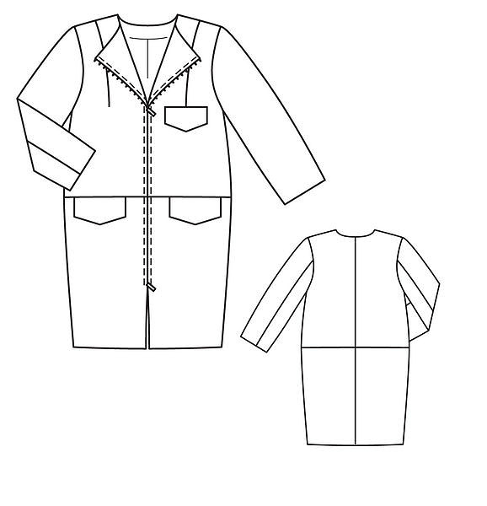](http://images.yandex.ru/yandsearch?text=%D1%82%D0%B5%D1%85%D0%BD%D0%B8%D1%87%D0%B5%D1%81%D0%BA%D0%B8%D0%B9%20%D1%8D%D1%81%D0%BA%D0%B8%D0%B7%20%D0%BF%D0%B0%D0%BB%D1%8C%D1%82%D0%BE&fp=0&pos=10&uinfo=ww-1076-wh-521-fw-851-fh-448-pd-1.25&rpt=simage&img_url=http://www.burdastyle.ru/gfx/00/07/34/0d/technicalSketch-1vfwrid_jpg/thumb_140x188_11.jpg) [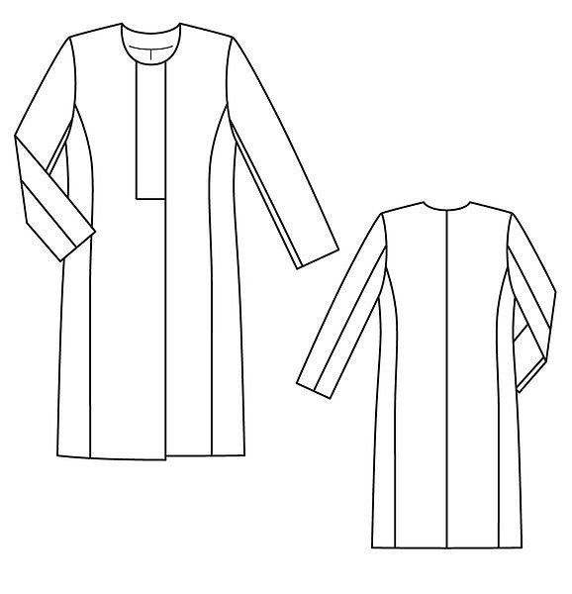](http://images.yandex.ru/yandsearch?p=2&text=%D1%82%D0%B5%D1%85%D0%BD%D0%B8%D1%87%D0%B5%D1%81%D0%BA%D0%B8%D0%B9%20%D1%8D%D1%81%D0%BA%D0%B8%D0%B7%20%20%D0%BF%D0%B0%D0%BB%D1%8C%D1%82%D0%BE&fp=2&pos=67&uinfo=ww-1076-wh-521-fw-851-fh-448-pd-1.25&rpt=simage&img_url=http://www.burdastyle.ru/gfx/00/0c/91/31/technicalSketch-023equ8_jpg/thumb_800x600_10.jpg)

Рис. 3 Рис. 4

[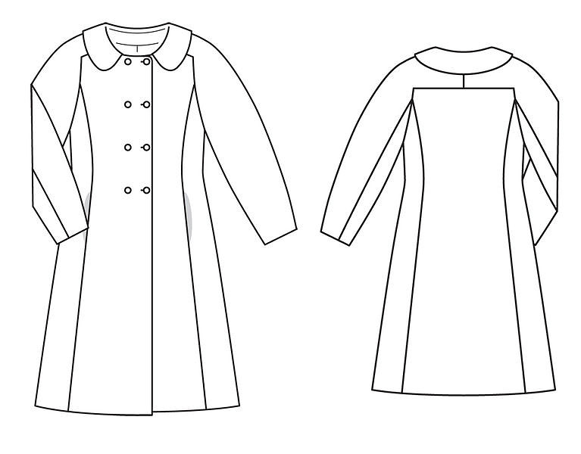](http://images.yandex.ru/yandsearch?p=2&text=%D1%82%D0%B5%D1%85%D0%BD%D0%B8%D1%87%D0%B5%D1%81%D0%BA%D0%B8%D0%B9%20%D1%8D%D1%81%D0%BA%D0%B8%D0%B7%20%20%D0%BF%D0%B0%D0%BB%D1%8C%D1%82%D0%BE&fp=2&pos=61&uinfo=ww-1076-wh-521-fw-851-fh-448-pd-1.25&rpt=simage&img_url=http://www.burdastyle.ru/gfx/00/0c/a5/27/technicalSketch-0yp9r09_jpg/thumb_800x600_10.jpg) [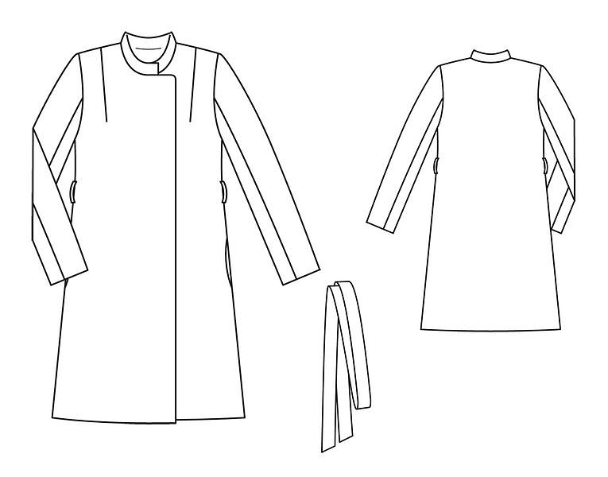](http://images.yandex.ru/yandsearch?p=2&text=%D1%82%D0%B5%D1%85%D0%BD%D0%B8%D1%87%D0%B5%D1%81%D0%BA%D0%B8%D0%B9%20%D1%8D%D1%81%D0%BA%D0%B8%D0%B7%20%20%D0%BF%D0%B0%D0%BB%D1%8C%D1%82%D0%BE&fp=2&pos=62&uinfo=ww-1076-wh-521-fw-851-fh-448-pd-1.25&rpt=simage&img_url=http://www.burdastyle.ru/gfx/00/0c/72/01/technicalSketch-12xo552_jpg/thumb_800x600_10.jpg)

Рис. 5 Рис. 6

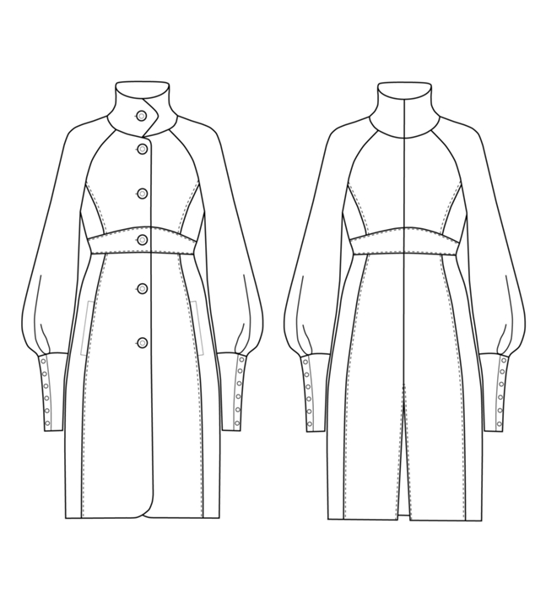 [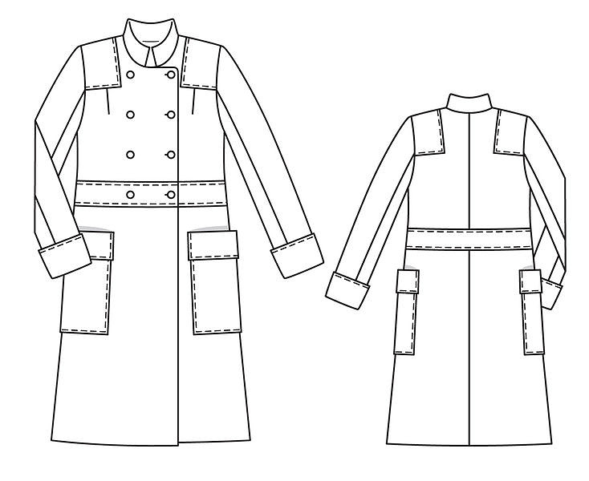](http://images.yandex.ru/yandsearch?p=2&text=%D1%82%D0%B5%D1%85%D0%BD%D0%B8%D1%87%D0%B5%D1%81%D0%BA%D0%B8%D0%B9%20%D1%8D%D1%81%D0%BA%D0%B8%D0%B7%20%20%D0%BF%D0%B0%D0%BB%D1%8C%D1%82%D0%BE&fp=2&pos=62&uinfo=ww-1076-wh-521-fw-851-fh-448-pd-1.25&rpt=simage&img_url=http://www.burdastyle.ru/gfx/00/0c/78/34/technicalSketch-1xmwey4_jpg/thumb_800x600_10.jpg)

Рис. 7 Рис. 8

[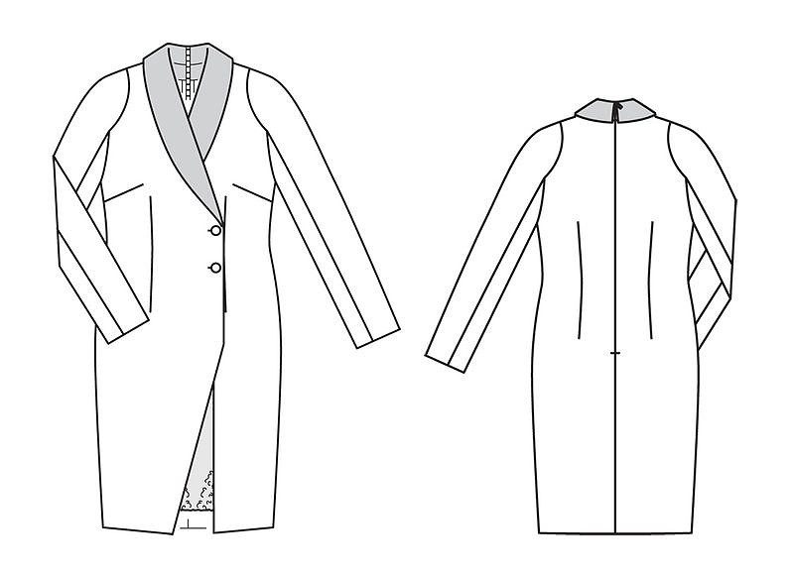](http://images.yandex.ru/yandsearch?p=2&text=%D1%82%D0%B5%D1%85%D0%BD%D0%B8%D1%87%D0%B5%D1%81%D0%BA%D0%B8%D0%B9%20%D1%8D%D1%81%D0%BA%D0%B8%D0%B7%20%20%D0%BF%D0%B0%D0%BB%D1%8C%D1%82%D0%BE&fp=2&pos=62&uinfo=ww-1076-wh-521-fw-851-fh-448-pd-1.25&rpt=simage&img_url=http://www.burdastyle.ru/gfx/00/0c/70/35/technicalSketch-0qt6dd6_jpg/thumb_800x600_10.jpg) [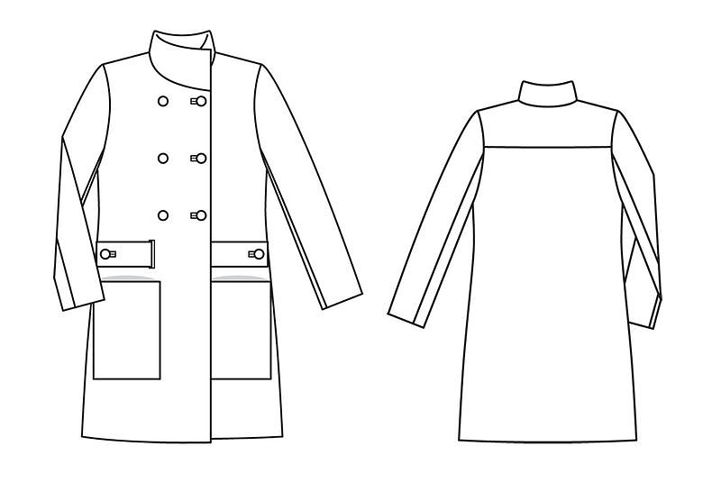](http://images.yandex.ru/yandsearch?p=3&text=%D1%82%D0%B5%D1%85%D0%BD%D0%B8%D1%87%D0%B5%D1%81%D0%BA%D0%B8%D0%B9%20%D1%8D%D1%81%D0%BA%D0%B8%D0%B7%20%20%D0%BF%D0%B0%D0%BB%D1%8C%D1%82%D0%BE&fp=3&pos=100&uinfo=ww-1076-wh-521-fw-851-fh-448-pd-1.25&rpt=simage&img_url=http://www.burdastyle.ru/gfx/00/0b/65/f8/technicalSketch-1h5dka4_jpg/thumb_800x600_10.jpg)

Рис. 9 Рис. 10

[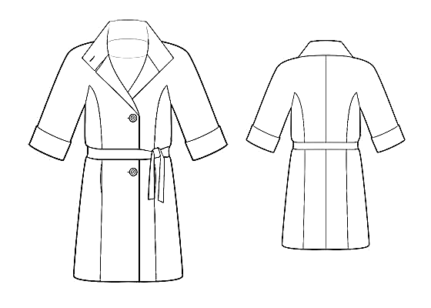](http://images.yandex.ru/yandsearch?text=%D1%82%D0%B5%D1%85%D0%BD%D0%B8%D1%87%D0%B5%D1%81%D0%BA%D0%B8%D0%B9%20%D1%8D%D1%81%D0%BA%D0%B8%D0%B7%20%D0%BF%D0%B0%D0%BB%D1%8C%D1%82%D0%BE&pos=2&uinfo=ww-1076-wh-490-fw-851-fh-448-pd-1.25&rpt=simage&img_url=http://www.leko-mail.net/t/5834.jpg)[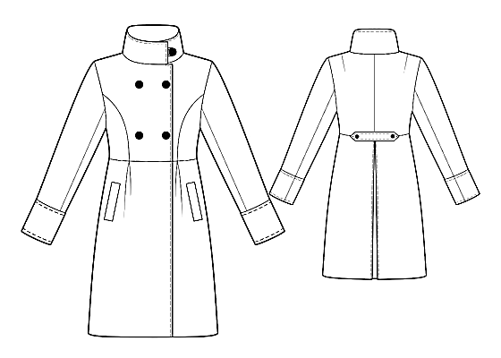](http://images.yandex.ru/yandsearch?p=2&text=%D1%82%D0%B5%D1%85%D0%BD%D0%B8%D1%87%D0%B5%D1%81%D0%BA%D0%B8%D0%B9%20%D1%8D%D1%81%D0%BA%D0%B8%D0%B7%20%D0%BF%D0%B0%D0%BB%D1%8C%D1%82%D0%BE&pos=65&uinfo=ww-1076-wh-490-fw-851-fh-448-pd-1.25&rpt=simage&img_url=http://www.leko-mail.net/t/4192.jpg)

Рис.11 Рис. 12