Технические эскизы жакетов на подкладке [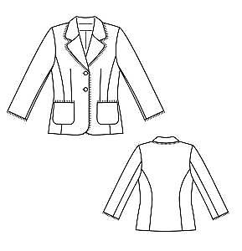](http://images.yandex.ru/yandsearch?source=wiz&fp=0&text=%D1%82%D0%B5%D1%85%D0%BD%D0%B8%D1%87%D0%B5%D1%81%D0%BA%D0%B8%D0%B9%20%D1%8D%D1%81%D0%BA%D0%B8%D0%B7%20%D0%B6%D0%B5%D0%BD%D1%81%D0%BA%D0%BE%D0%B3%D0%BE%20%D0%B6%D0%B0%D0%BA%D0%B5%D1%82%D0%B0&noreask=1&pos=13&lr=2&rpt=simage&uinfo=ww-1076-wh-521-fw-851-fh-448-pd-1.25&img_url=http://club.season.ru/uploads/post/19858/253/post-19858-1362373253_thumb.jpg) [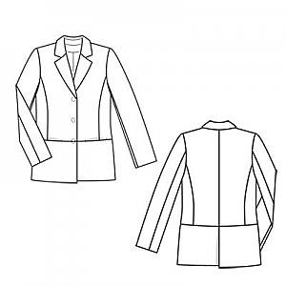](http://images.yandex.ru/yandsearch?source=wiz&fp=0&text=%D1%82%D0%B5%D1%85%D0%BD%D0%B8%D1%87%D0%B5%D1%81%D0%BA%D0%B8%D0%B9%20%D1%8D%D1%81%D0%BA%D0%B8%D0%B7%20%D0%B6%D0%B5%D0%BD%D1%81%D0%BA%D0%BE%D0%B3%D0%BE%20%D0%B6%D0%B0%D0%BA%D0%B5%D1%82%D0%B0&noreask=1&pos=2&lr=2&rpt=simage&uinfo=ww-1076-wh-521-fw-851-fh-448-pd-1.25&img_url=http://www.burdastyle.ru/gfx/00/01/b1/87/technicalSketch-03qsfa8_jpg/thumb_140x188_11.jpg)

Рис. 1 Рис. 2

[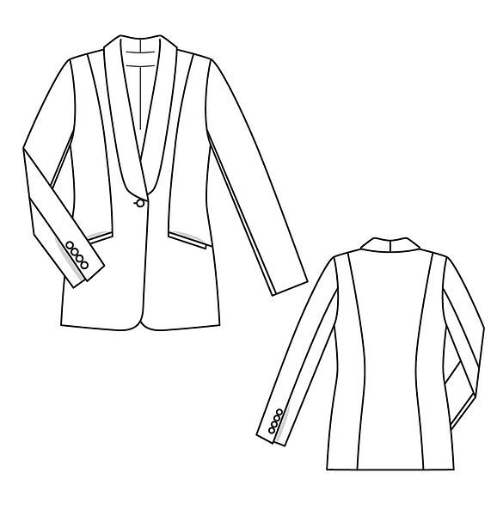](http://images.yandex.ru/yandsearch?p=4&text=%D1%8D%D1%81%D0%BA%D0%B8%D0%B7%20%D0%B6%D0%B0%D0%BA%D0%B5%D1%82%D0%B0&fp=4&pos=147&uinfo=ww-1076-wh-521-fw-851-fh-448-pd-1.25&rpt=simage&img_url=http://www.burdastyle.ru/gfx/00/08/0c/60/technicalSketch-1161bdv_jpg/thumb_140x188_11.jpg) [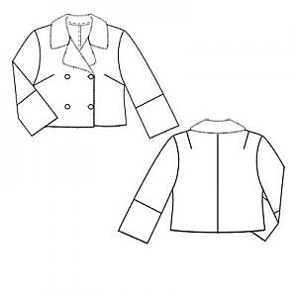](http://images.yandex.ru/yandsearch?source=wiz&fp=5&uinfo=ww-1076-wh-521-fw-851-fh-448-pd-1.25&p=5&text=%D1%82%D0%B5%D1%85%D0%BD%D0%B8%D1%87%D0%B5%D1%81%D0%BA%D0%B8%D0%B9%20%D1%8D%D1%81%D0%BA%D0%B8%D0%B7%20%D0%B6%D0%B5%D0%BD%D1%81%D0%BA%D0%BE%D0%B3%D0%BE%20%D0%B6%D0%B0%D0%BA%D0%B5%D1%82%D0%B0&noreask=1&pos=178&rpt=simage&lr=2&img_url=http://club.season.ru/uploads/post/33763/796/post-33763-1348076796_thumb.jpg)

Рис. 3 Рис. 4

[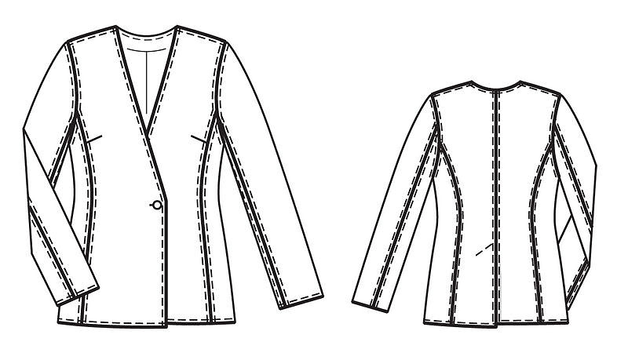](http://images.yandex.ru/yandsearch?source=wiz&fp=15&uinfo=ww-1076-wh-521-fw-851-fh-448-pd-1.25&p=15&text=%D1%82%D0%B5%D1%85%D0%BD%D0%B8%D1%87%D0%B5%D1%81%D0%BA%D0%B8%D0%B9%20%D1%8D%D1%81%D0%BA%D0%B8%D0%B7%20%D0%B6%D0%B5%D0%BD%D1%81%D0%BA%D0%BE%D0%B3%D0%BE%20%D0%B6%D0%B0%D0%BA%D0%B5%D1%82%D0%B0&noreask=1&pos=468&rpt=simage&lr=2&img_url=http://www.burdastyle.ru/gfx/00/0b/74/a2/technicalSketch-0xbdfmi_jpg/thumb_800x600_10.jpg)[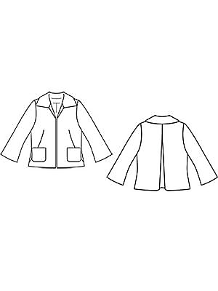](http://images.yandex.ru/yandsearch?source=wiz&fp=1&uinfo=ww-1076-wh-490-fw-851-fh-448-pd-1.25&p=1&text=%D1%82%D0%B5%D1%85%D0%BD%D0%B8%D1%87%D0%B5%D1%81%D0%BA%D0%B8%D0%B9%20%D1%8D%D1%81%D0%BA%D0%B8%D0%B7%20%D0%B6%D0%B5%D0%BD%D1%81%D0%BA%D0%BE%D0%B3%D0%BE%20%D0%B6%D0%B0%D0%BA%D0%B5%D1%82%D0%B0&noreask=1&pos=53&rpt=simage&lr=2&img_url=http://www.burdastyle.ru/gfx/00/00/19/87/technicalSketch-1kwvnbq_jpg/thumb_140x188_11.jpg)

Рис. 5 Рис. 6

[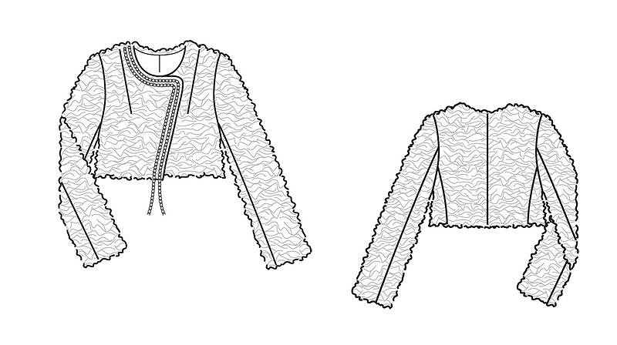](http://images.yandex.ru/yandsearch?source=wiz&fp=3&uinfo=ww-1076-wh-490-fw-851-fh-448-pd-1.25&p=3&text=%D1%82%D0%B5%D1%85%D0%BD%D0%B8%D1%87%D0%B5%D1%81%D0%BA%D0%B8%D0%B9%20%D1%8D%D1%81%D0%BA%D0%B8%D0%B7%20%D0%B6%D0%B5%D0%BD%D1%81%D0%BA%D0%BE%D0%B3%D0%BE%20%D0%B6%D0%B0%D0%BA%D0%B5%D1%82%D0%B0&noreask=1&pos=97&rpt=simage&lr=2&img_url=http://www.burdastyle.ru/gfx/00/0a/cd/f7/technicalSketch-00ves7o_png/thumb_800x600_10.jpg) [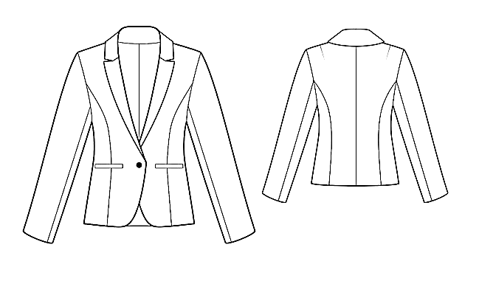](http://images.yandex.ru/yandsearch?p=2&text=%D1%82%D0%B5%D1%85%D0%BD%D0%B8%D1%87%D0%B5%D1%81%D0%BA%D0%B8%D0%B5%20%D1%8D%D1%81%D0%BA%D0%B8%D0%B7%D1%8B%20%D0%B6%D0%B0%D0%BA%D0%B5%D1%82%D0%BE%D0%B2%20%D0%BD%D0%B0%20%D0%BF%D0%BE%D0%B4%D0%BA%D0%BB%D0%B0%D0%B4%D0%BA%D0%B5&pos=77&uinfo=ww-1076-wh-490-fw-851-fh-448-pd-1.25&rpt=simage&img_url=http://www.leko-mail.net/t/4162.jpg)

Рис. 7 рис. 8

[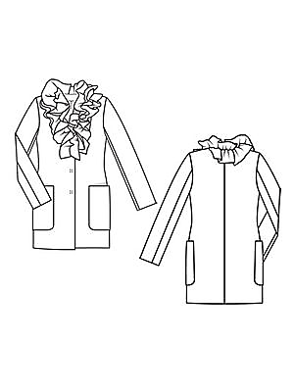](http://images.yandex.ru/yandsearch?text=%D1%82%D0%B5%D1%85%D0%BD%D0%B8%D1%87%D0%B5%D1%81%D0%BA%D0%B8%D0%B5%20%D1%8D%D1%81%D0%BA%D0%B8%D0%B7%D1%8B%20%D0%B6%D0%B0%D0%BA%D0%B5%D1%82%D0%BE%D0%B2%20%D0%BD%D0%B0%20%D0%BF%D0%BE%D0%B4%D0%BA%D0%BB%D0%B0%D0%B4%D0%BA%D0%B5&pos=3&uinfo=ww-1076-wh-490-fw-851-fh-448-pd-1.25&rpt=simage&img_url=http://www.burdastyle.ru/gfx/00/00/19/d9/technicalSketch-11bsmhv_jpg/thumb_140x188_11.jpg) [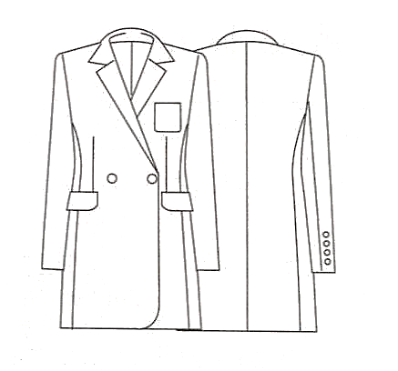](http://images.yandex.ru/yandsearch?p=1&text=%D1%82%D0%B5%D1%85%D0%BD%D0%B8%D1%87%D0%B5%D1%81%D0%BA%D0%B8%D0%B5%20%D1%8D%D1%81%D0%BA%D0%B8%D0%B7%D1%8B%20%D0%B6%D0%B0%D0%BA%D0%B5%D1%82%D0%BE%D0%B2%20%D0%BD%D0%B0%20%D0%BF%D0%BE%D0%B4%D0%BA%D0%BB%D0%B0%D0%B4%D0%BA%D0%B5&pos=30&uinfo=ww-1076-wh-490-fw-851-fh-448-pd-1.25&rpt=simage&img_url=http://www.happy-giraffe.ru/upload/userfiles/images/2012/03/19/06180934.jpg)

Рис. 9 рис. 10

[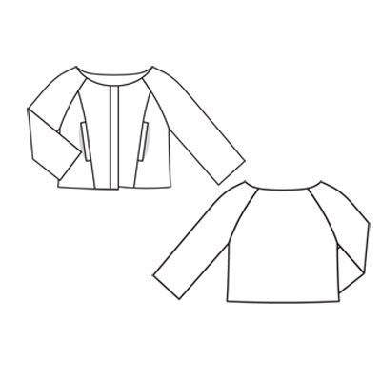](http://images.yandex.ru/yandsearch?source=wiz&fp=5&uinfo=ww-1076-wh-490-fw-851-fh-448-pd-1.25&p=5&text=%D1%82%D0%B5%D1%85%D0%BD%D0%B8%D1%87%D0%B5%D1%81%D0%BA%D0%B8%D0%B9%20%D1%8D%D1%81%D0%BA%D0%B8%D0%B7%20%D0%B6%D0%B5%D0%BD%D1%81%D0%BA%D0%BE%D0%B3%D0%BE%20%D0%B6%D0%B0%D0%BA%D0%B5%D1%82%D0%B0&noreask=1&pos=172&rpt=simage&lr=2&img_url=http://www.burdastyle.ru/gfx/00/00/24/00/technicalSketch-1rj99iu_jpg/thumb_800x600_10.jpg) [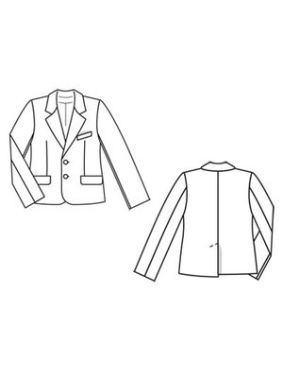](http://images.yandex.ru/yandsearch?source=wiz&fp=2&uinfo=ww-1076-wh-490-fw-851-fh-448-pd-1.25&p=2&text=%D1%82%D0%B5%D1%85%D0%BD%D0%B8%D1%87%D0%B5%D1%81%D0%BA%D0%B8%D0%B9%20%D1%8D%D1%81%D0%BA%D0%B8%D0%B7%20%D0%B6%D0%B5%D0%BD%D1%81%D0%BA%D0%BE%D0%B3%D0%BE%20%D0%B6%D0%B0%D0%BA%D0%B5%D1%82%D0%B0&noreask=1&pos=67&rpt=simage&lr=2&img_url=http://www.burdastyle.ru/gfx/00/00/19/93/technicalSketch-1sre57k_jpg/thumb_140x188_11.jpg)

Рис. 11 рис. 12