**XVIII**

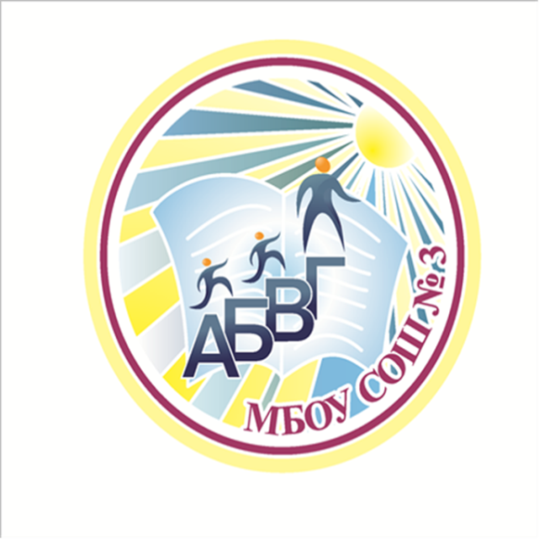 **Городской фестиваль иностранных языков**

**«Спорт. Олимпийский игры в Сочи»**

**Сценарий выступления команды учащихся**

**10-11 классов МБОУ «СОШ №3»**

**Руководитель: Черкасова Т. В.**

**Бийск**

**2014**

**1 участник: *(за кулисами)***

It was the year 2012…

It was London…

And it was hot… because of summer, and competition, because of the Olympic Games…

It was the year 2014…

It was Sochi…

And it was hot, despite winter and snow, because of the Olympic Games…

The audience sat in unbreathing astonishment, thousands of people watched them, yelled and hoped…We are sure that everyone wants to be in good shape, be fit and healthy, be in a good temper…

School №3 presents…

***Спортивный выход всех участников (музыка, акробатические номера)***

**Катя:**

No, no, no! We didn’t agree that it will be in such a way! What have you imagined! Do you really think sport is above all?! And what about study, lessons, and finally books! Just listen! ***(сначала все прислушиваются, но постепенно начинают скучать, отворачиваться и т. д.)***

"Except a living man there is nothing more wonderful than a book!" Any book is a wonderful thing! Just imagine – it may seem that it’s just paper pages with a cover and letters inside, sometimes with pictures. But the moment you start reading a book the whole new world opens to you! New characters, scenes, lives, events. It’s like real life in miniature. So, a book is truly one of the greatest inventions of man. We learn so many things by reading books. And it’s really a pity that people ***(указывает на всех)*** started to read less.. I’m personally fond of reading books.

**2 участник:**

***(подходит, хлопает по плечу)***

But I’m personally fond of the proverb "Health is above wealth." One of the first duties we owe to ourselves is to keep our bodies in perfect health.

**Катя:**

I would like to point out that it is quite hard to imagine our life without books. Moreover, books are our constant friends at different stages of life. Reading can help us to grow spiritually. ***(возвышенно)***

**3 участник:**

If your body suffers from any disorder, your mind suffers with it, and you are unable to make much progress in knowledge, and you are unfit.

**Катя:**

As a matter of fact, people who read a lot always have advantage over people who read less. I am deeply convinced that books are real treasures of wisdom.

**4 участник:**

I think that exercise is necessary to keep the body in perfect condition. People consider sports to help in getting good health.

**5 участник:**

Physical training gives a lot of energy, develop muscles, makes people strong, quick and healthy.

**1 участник:**

Just think about the physical benefits (feeling fit, sleeping better, the chance of living a more active life),

**2 участник:**

psychological benefits (self-discipline and respect, a sense of personal achievement, relaxation, getting rid of aggression),

**3 участник:**

and the social advantages (meeting people with the same interests, the team spirit).

**Катя:**

As for me, books have been an essential part of my life for as long as I can remember. On the other hand, I agree with what you just said.

**4 участник:**

Realy? If you think that physical fitness and health are important you are to go in for sports.

**Катя:**

As far as I can see, moderation in eating and drinking, reasonable hours of labour and study, enough sleeping time lay the foundations for health and long healthy happy life.

**5 участник:**

Old and young on our planet dream to be happy!

Old and young on our planet dream to be healthy!

**6 участник:**

And there is an only way out

And you have to decide what to choose!

No fate but what we make!

**1 участник:**

Look how wonderful the word is! How much interesting it offers to you!

**2 участник:**

Physical culture schools are open for you!

**Катя:**

Libraries are waiting for you! They will absorb you with interesting books!

**3 участник:**

Just look around, open your eyes!

**4 участник:**

Think, solve and choose a healthy lifestyle!

**5 участник:**

Leta sound mind be in a sound body!