\_\_\_\_\_\_\_\_\_\_\_\_\_\_\_\_\_\_\_\_\_\_\_\_\_\_\_

\_\_\_\_\_\_\_\_\_\_\_\_\_\_\_\_\_\_\_\_\_\_\_\_\_\_\_\_\_\_\_\_\_\_\_\_\_\_\_\_\_\_\_\_\_\_\_\_\_\_\_\_\_\_\_\_\_\_\_\_\_\_\_\_\_\_\_\_

\_\_\_\_\_\_\_\_\_\_\_\_\_\_\_\_\_\_\_\_\_\_\_\_\_\_\_\_\_\_\_\_\_\_\_\_\_\_\_\_\_\_\_\_\_\_\_\_\_\_\_\_\_\_\_\_\_\_\_\_\_\_\_\_\_\_\_\_

\_\_\_\_\_\_\_\_\_\_\_\_\_\_\_\_\_\_\_\_\_\_\_\_\_\_\_\_\_\_\_\_\_\_\_\_\_\_\_\_\_\_\_\_\_\_\_\_\_\_\_\_\_\_\_\_\_\_\_\_\_\_\_\_\_\_\_\_

\_\_\_\_\_\_\_\_\_\_\_\_\_\_\_\_\_\_\_\_\_\_\_\_\_\_\_\_\_\_\_\_\_\_\_\_\_\_\_\_\_\_\_\_\_\_\_\_\_\_\_\_\_\_\_\_\_\_\_\_\_\_\_\_\_\_\_\_

\_\_\_\_\_\_\_\_\_\_\_\_\_\_\_\_\_\_\_\_\_\_\_\_\_\_\_\_\_\_\_\_\_\_\_\_\_\_\_\_\_\_\_\_\_\_\_\_\_\_\_\_\_\_\_\_\_\_\_\_\_\_\_\_\_\_\_\_

\_\_\_\_\_\_\_\_\_\_\_\_\_\_\_\_\_\_\_\_\_\_\_\_\_\_\_\_\_\_\_\_\_\_\_\_\_\_\_\_\_\_\_\_\_\_\_\_\_\_\_\_\_\_\_\_\_\_\_\_\_\_\_\_\_\_\_\_

\_\_\_\_\_\_\_\_\_\_\_\_\_\_\_\_\_\_\_\_\_\_\_\_\_\_\_\_\_\_\_\_\_\_\_\_\_\_\_\_\_\_\_\_\_\_\_\_\_\_\_\_\_\_\_\_\_\_\_\_\_\_\_\_\_\_\_\_\_\_\_\_\_\_\_\_\_\_\_\_\_\_\_\_\_\_\_\_\_\_\_\_\_\_\_\_\_\_\_\_\_\_\_\_\_\_\_\_\_\_\_\_\_\_\_\_\_\_\_\_\_\_\_\_\_\_\_\_\_\_\_\_\_\_\_\_\_\_\_\_\_\_\_\_\_\_\_\_\_\_\_\_\_\_\_\_\_\_\_\_\_\_\_\_\_\_\_\_\_\_\_\_\_\_\_\_\_\_\_\_\_\_\_\_\_\_\_\_\_\_\_\_\_\_\_\_\_\_\_\_\_\_\_\_\_\_\_\_\_\_\_\_\_\_\_\_\_\_\_\_\_\_\_\_\_\_\_\_\_\_\_\_\_\_\_\_\_\_\_\_\_\_\_\_\_\_\_\_\_\_\_\_\_\_\_\_\_\_\_\_\_\_\_\_\_\_\_\_\_\_\_\_\_\_\_\_\_\_\_\_\_\_\_\_\_\_\_\_\_\_\_\_\_\_\_\_\_\_\_\_\_\_\_\_\_\_\_\_\_\_\_\_\_\_\_\_\_\_\_\_\_\_\_\_\_\_\_\_\_\_\_\_\_\_\_\_\_\_\_\_\_\_\_\_\_\_\_\_\_\_\_\_\_\_\_\_\_\_\_\_\_\_\_\_\_\_\_\_\_\_\_\_\_\_\_\_\_\_\_\_\_\_\_\_\_\_\_\_\_\_\_\_\_\_\_\_\_\_\_\_\_\_\_\_\_\_\_\_\_\_\_\_\_\_\_\_\_\_\_\_\_\_\_\_\_\_\_\_\_\_\_\_\_\_\_\_\_\_\_\_\_\_\_\_\_\_\_\_\_\_\_\_\_\_\_\_\_\_\_\_\_\_\_\_\_\_\_\_\_\_\_\_\_\_\_\_\_\_\_\_\_\_\_\_\_\_\_\_\_\_\_\_\_\_\_\_\_\_\_\_\_\_\_\_\_\_\_\_\_\_\_\_\_\_\_\_\_\_\_\_\_\_\_\_\_\_\_\_\_\_\_\_\_\_\_\_\_\_\_\_\_\_\_\_\_\_\_\_\_\_\_\_\_\_\_\_\_\_\_\_\_\_\_\_\_\_\_\_\_\_\_\_\_\_\_\_\_\_\_\_\_\_\_\_\_\_\_\_\_\_\_\_\_\_\_\_\_\_\_\_\_\_\_\_\_\_\_\_\_\_\_\_\_\_\_\_\_\_\_\_\_\_\_\_\_\_\_\_\_\_\_\_\_\_\_\_\_\_\_\_\_\_\_\_\_\_\_\_\_\_\_\_\_\_\_\_\_\_\_\_\_\_\_\_\_\_\_\_\_\_\_\_\_\_\_\_\_\_\_\_\_\_\_\_\_\_\_\_\_\_\_\_\_\_\_\_\_\_\_\_\_\_\_\_\_\_\_\_\_\_\_\_\_\_\_\_\_\_\_\_\_\_\_\_\_\_\_\_\_\_\_\_\_\_\_\_\_\_\_\_\_\_\_\_\_\_\_\_\_\_\_\_\_\_\_\_\_\_\_\_\_\_\_\_\_\_\_\_\_\_\_\_\_\_\_\_\_\_\_\_\_\_\_\_\_\_\_\_\_\_\_\_\_\_\_\_\_\_\_\_\_\_\_\_\_\_\_\_\_\_\_\_\_\_\_\_\_\_\_\_\_\_\_\_\_\_\_\_\_\_\_\_\_\_\_\_\_\_\_\_\_\_\_\_\_\_\_\_\_\_\_\_\_\_\_\_\_\_\_\_\_\_\_\_\_\_\_\_\_\_\_\_\_\_\_\_\_\_\_\_\_\_\_\_\_\_\_\_\_\_\_\_\_\_\_\_\_\_\_\_\_\_\_\_\_\_\_\_\_\_\_\_\_\_\_\_\_\_\_\_\_\_\_\_

\_\_\_\_\_\_\_\_\_\_\_\_\_\_\_\_\_\_\_\_\_\_\_\_\_\_\_\_\_\_\_\_\_\_\_\_\_\_\_\_\_\_\_\_\_\_\_\_\_\_\_\_\_\_\_\_\_\_\_\_\_\_\_\_\_\_\_\_

\_\_\_\_\_\_\_\_\_\_\_\_\_\_\_\_\_\_\_\_\_\_\_\_\_\_\_\_\_\_\_\_\_\_\_\_\_\_\_\_\_\_\_\_\_\_\_\_\_\_\_\_\_\_\_\_\_\_\_\_\_\_\_\_\_\_\_\_

\_\_\_\_\_\_\_\_\_\_\_\_\_\_\_\_\_\_\_\_\_\_\_\_\_\_\_\_\_\_\_\_\_\_\_\_\_\_\_\_\_\_\_\_\_\_\_\_\_\_\_\_\_\_\_\_\_\_\_\_\_\_\_\_\_\_\_\_

\_\_\_\_\_\_\_\_\_\_\_\_\_\_\_\_\_\_\_\_\_\_\_\_\_\_\_\_\_\_\_\_\_\_\_\_\_\_\_\_\_\_\_\_\_\_\_\_\_\_\_\_\_\_\_\_\_\_\_\_\_\_\_\_\_\_\_\_

\_\_\_\_\_\_\_\_\_\_\_\_\_\_\_\_\_\_\_\_\_\_\_\_\_\_\_\_\_\_\_\_\_\_\_\_\_\_\_\_\_\_\_\_\_\_\_\_\_\_\_\_\_\_\_\_\_\_\_\_\_\_\_\_\_\_\_\_

\_\_\_\_\_\_\_\_\_\_\_\_\_\_\_\_\_\_\_\_\_\_\_\_\_\_\_\_\_\_\_\_\_\_\_\_\_\_\_\_\_\_\_\_\_\_\_\_\_\_\_\_\_\_\_\_\_\_\_\_\_\_\_\_\_\_\_\_

\_\_\_\_\_\_\_\_\_\_\_\_\_\_\_\_\_\_\_\_\_\_\_\_\_\_\_\_\_\_\_\_\_\_\_\_\_\_\_\_\_\_\_\_\_\_\_\_\_\_\_\_\_\_\_\_\_\_\_\_\_\_\_\_\_\_\_\_

\_\_\_\_\_\_\_\_\_\_\_\_\_\_\_\_\_\_\_\_\_\_\_\_\_\_\_\_\_\_\_\_\_\_\_\_\_\_\_\_\_\_\_\_\_\_\_\_\_\_\_\_\_\_\_\_\_\_\_\_\_\_\_\_\_\_\_\_

\_\_\_\_\_\_\_\_\_\_\_\_\_\_\_\_\_\_\_\_\_\_\_\_\_\_\_\_\_\_\_\_\_\_\_\_\_\_\_\_\_\_\_\_\_\_\_\_\_\_\_\_\_\_\_\_\_\_\_\_\_\_\_\_\_\_\_\_

\_\_\_\_\_\_\_\_\_\_\_\_\_\_\_\_\_\_\_\_\_\_\_\_\_\_\_\_\_\_\_\_\_\_\_\_\_\_\_\_\_\_\_\_\_\_\_\_\_\_\_\_\_\_\_\_\_\_\_\_\_\_\_\_\_\_\_\_

\_\_\_\_\_\_\_\_\_\_\_\_\_\_\_\_\_\_\_\_\_\_\_\_\_\_\_\_\_\_\_\_\_\_\_\_\_\_\_\_\_\_\_\_\_\_\_\_\_\_\_\_\_\_\_\_\_\_\_\_\_\_\_\_\_\_\_\_

\_\_\_\_\_\_\_\_\_\_\_\_\_\_\_\_\_\_\_\_\_\_\_\_\_\_\_\_\_\_\_\_\_\_\_\_\_\_\_\_\_\_\_\_\_\_\_\_\_\_\_\_\_\_\_\_\_\_\_\_\_\_\_\_\_\_\_\_

C:\Users\Виктория\Desktop\изображения\J0095707.GIFC:\Users\Виктория\Desktop\изображения\J0095714.GIFC:\Users\Виктория\Desktop\изображения\J0095676.GIFC:\Users\Виктория\Desktop\изображения\J0095674.GIFC:\Users\Виктория\Desktop\изображения\J0095677.GIFC:\Users\Виктория\Desktop\изображения\J0095694.GIF

|  |  |  |  |  |
| --- | --- | --- | --- | --- |
| класс  четверть | 1 класс | 2класс | 3класс | 4класс |
| I |  |  |  |  |
| II |  |  |  |  |
| III |  |  |  |  |
| IV |  |  |  |  |

Лучшие: -контрольные работы;

-проекты;

- творческие работы;

-отзывы

C:\Users\Виктория\Desktop\изображения\J0095701.GIF

C:\Users\Виктория\Desktop\изображения\J0095669.GIFC:\Users\Виктория\Desktop\изображения\J0095669.GIF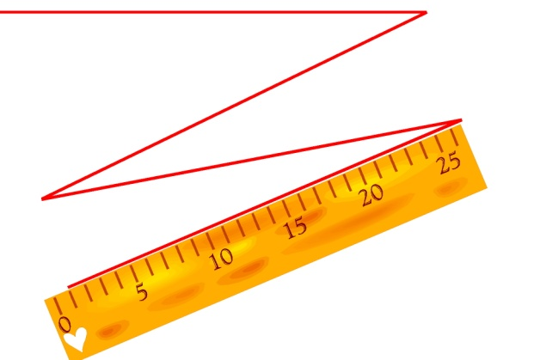

C:\Users\Виктория\Desktop\изображения\J0095668.GIF

|  |  |  |  |  |
| --- | --- | --- | --- | --- |
| класс  четверть | 1 класс | 2класс | 3класс | 4класс |
| I |  |  |  |  |
| II |  |  |  |  |
| III |  |  |  |  |
| IV |  |  |  |  |

C:\Users\Виктория\Desktop\изображения\J0095669.GIFЛучшие: -контрольные работы;

-проекты;

- творческие работы;

-отзывы

|  |  |  |  |  |
| --- | --- | --- | --- | --- |
| класс  четверть | 1 класс | 2класс | 3класс | 4класс |
| I |  |  |  |  |
| II |  |  |  |  |
| III |  |  |  |  |
| IV |  |  |  |  |

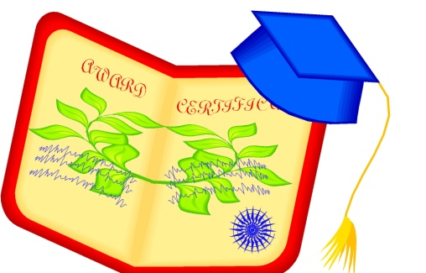

Лучшие: -контрольные работы;

-проекты;

- творческие работы;

-отзывы

|  |  |  |  |  |
| --- | --- | --- | --- | --- |
| класс  четверть | 1 класс | 2класс | 3класс | 4класс |
| I |  |  |  |  |
| II |  |  |  |  |
| III |  |  |  |  |
| IV |  |  |  |  |

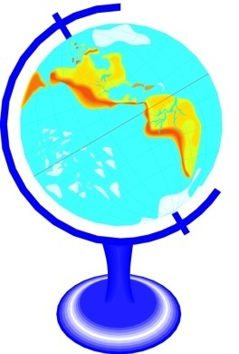

Лучшие: -контрольные работы;

-проекты;

- творческие работы;

-отзывы

|  |  |  |  |  |
| --- | --- | --- | --- | --- |
| класс  четверть | 1 класс | 2класс | 3класс | 4класс |
| I |  |  |  |  |
| II |  |  |  |  |
| III |  |  |  |  |
| IV |  |  |  |  |

Лучшие: -контрольные работы;

-проекты;

- творческие работы;

-отзывы

|  |  |  |  |  |
| --- | --- | --- | --- | --- |
| класс  четверть | 1 класс | 2класс | 3класс | 4класс |
| I |  |  |  |  |
| II |  |  |  |  |
| III |  |  |  |  |
| IV |  |  |  |  |



Лучшие: -контрольные работы;

-проекты;

- творческие работы;

-отзывы

|  |  |  |  |  |
| --- | --- | --- | --- | --- |
| класс  четверть | 1 класс | 2класс | 3класс | 4класс |
| I |  |  |  |  |
| II |  |  |  |  |
| III |  |  |  |  |
| IV |  |  |  |  |

Лучшие: -контрольные работы;

-проекты;

- творческие работы;

-отзывы

|  |  |  |  |  |
| --- | --- | --- | --- | --- |
| класс  четверть | 1 класс | 2класс | 3класс | 4класс |
| I |  |  |  |  |
| II |  |  |  |  |
| III |  |  |  |  |
| IV |  |  |  |  |

bd05105_

Лучшие: -контрольные работы;

-проекты;

- творческие работы;

-отзывы

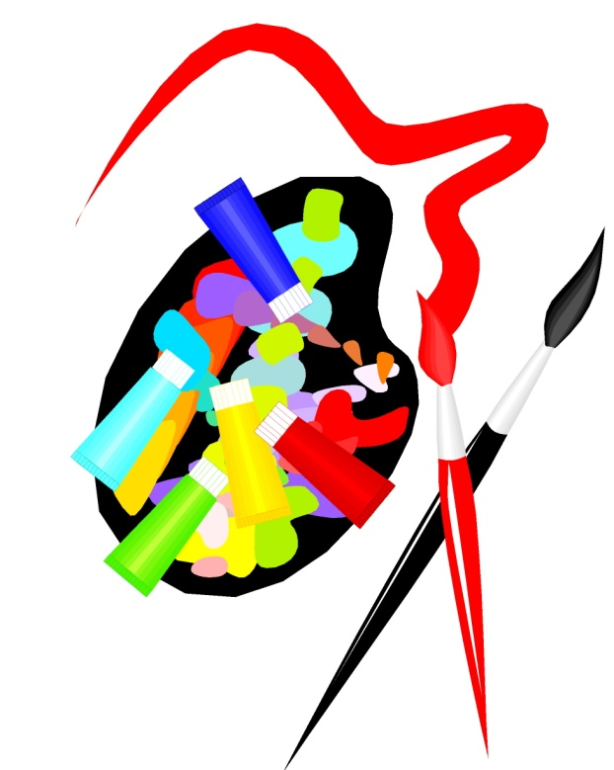

|  |  |  |  |  |
| --- | --- | --- | --- | --- |
| класс  четверть | 1 класс | 2класс | 3класс | 4класс |
| I |  |  |  |  |
| II |  |  |  |  |
| III |  |  |  |  |
| IV |  |  |  |  |

Лучшие: -контрольные работы;

-проекты;

- творческие работы;

-отзывы

SUPER004

|  |  |  |  |  |
| --- | --- | --- | --- | --- |
| класс  четверть | 1 класс | 2класс | 3класс | 4класс |
| I |  |  |  |  |
| II |  |  |  |  |
| III |  |  |  |  |
| IV |  |  |  |  |

Лучшие: -контрольные работы;

-проекты;

- творческие работы;

-отзывы

|  |  |  |
| --- | --- | --- |
| Учебный год | Поручения | Мероприятия |
|  |  |  |
|  |  |  |
|  |  |  |
|  |  |  |
|  |  |  |
|  |  |  |
|  |  |  |
|  |  |  |
|  |  |  |
|  |  |  |
|  |  |  |
|  |  |  |
|  |  |  |
|  |  |  |
|  |  |  |
|  |  |  |
|  |  |  |
|  |  |  |
|  |  |  |
|  |  |  |

Фото



Рисунки

Сказки

Стихи

Информация о мероприятии

Фото

Экскурсионно-познавательные мероприятия

Походы на выставки, в кинотеатры, музеи

D:\изображения\CARTOON\авторалли\STCAR009.WMF

Грамоты

Сертификаты

Дипломы

Благодарственные письма

Аттестационные ведомости

|  |  |  |
| --- | --- | --- |
| Дата | Содержание | Учитель |
|  |  |  |
|  |  |  |
|  |  |  |
|  |  |  |
|  |  |  |
|  |  |  |
|  |  |  |
|  |  |  |
|  |  |  |
|  |  |  |
|  |  |  |
|  |  |  |
|  |  |  |
|  |  |  |
|  |  |  |
|  |  |  |
|  |  |  |
|  |  |  |

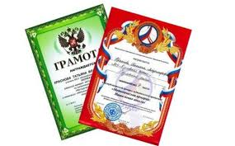 

|  |  |
| --- | --- |
| 1.Мой мир | 3.Моя общественная работа |
| 1.1.Моё имя | 4.Моё творчество |
| 1.2.Моя семья | 5.Мои впечатления |
| 1.3.Моё село | 6.Мои достижения |
| 1.4Мои друзья | 7.Отзывы и пожелания |
| 1.5.Моя школа | 8.Работы, которыми я горжусь |
| 1.6.Школьные предметы |  |
| 1.7.Мои увлечения |  |
| 2.Моя учёба |  |
| 2.1.Русский язык |  |
| 2.2.Математика |  |
| 2.3.Чтение |  |
| 2.4.Окружающий мир |  |
| 2.5.Технология |  |
| 2.6.Физкультура |  |
| 2.7.Английский язык |  |
| 2.8.Музыка |  |
| 2.9.Изобразительное искусство |  |
| 2.10.Информатика |  |