London, GB
October, 29th
Dear Friends!
I’m really glad to tell you about our amazing plan. I’d like to invite you to visit London at Christmas time. So I want to send the invitation-letters to you all. I think it’ll be great if you come to England these days.
Our summer trip to Russia was brilliant! We all enjoyed the holidays, now we often remember the days we spent together in the capital of Russia. Moscow, we liked it there very much! It is one of the most beautiful and interesting cities in the world. It’s really a good chance to learn more about Russian culture and traditions. Whatever your interests –Moscow has something special for you!
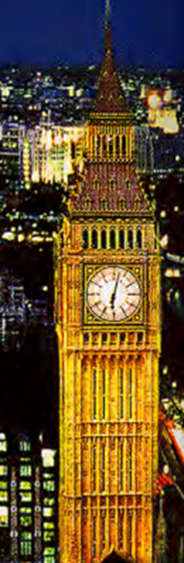
I think it was a great idea to visit Moscow. We did a lot of sightseeing and the most important we made friends with you. It is wonderful to have such true friends like you.

Let me tell you about our journey from Moscow to London. We were travelling by plane with BRITHISH AIRWAYS. Our flight was long but we were all having a great time. I was watching a very exciting film during the flight. Jane and Pat were talking about the visit to the Bolshoi Theater and the Tretyakov Gallery. Simon was reading his book about Russian tsars. Bill and George were doing their favourite crosswords. Henry and Rick were swapping their Russian souvenirs. The others were sleeping tight.

I hope your return journey to Ukhta was fine. How was your flight? What were you doing on board the plane? Did you enjoy your Moscow holidays?

Give my best wishes to your teachers and parents.
Write me soon.
Jack

HERE ARE SOME TASKS FOR YOU :
TASK 1. Read the invitation – letter and answer the questions:
- Who is the author of the letter? Where is he from?
- Whom is this letter written to?
- Where did Jack and his classmates go last summer?
- Did they go to Moscow or to St. Petersburg?
- Did they enjoy their summer holidays?
- How did they come back to London, by plane or by bus?
- What airline did they use to get to London from Moscow?
- What were Jack and Simon doing during the flight to London?
TASK 2. Fill in the gaps and complete the sentences:
- Jack wants us to come to ___________ at Christmas time.
- Jack and his mates spent summer holidays in __________, the capital of Russia.
- In Moscow the group of English pupils did a lot of _________ and made _________.
- During the return flight to London Jane and Pat were talking about ____________.
- On board the plane Henry and Rick were __________________________________.
TAK 3. Write True or False
- This letter is from London.
- The letter was written in September.
- Jack would like to invite us to America to spend Christmas holidays.
- Our English friends came to Russia to spend their summer holidays in St. Petersburg.
- They liked it in Moscow very much.
- Jack and his mates didn’t visit the Bolshoi Theater
- They returned to London by bus.
- During the flight home they all were sleeping tight.
TASK 4 . Make up your own sentences in Past Progressive Tense from the parts in the box.
Answer the question: What were you doing during the flight to Ukhta from Moscow?
During the fight home  On board the plane to Ukhta | - I  - We  - Polina  - Ann and Kate  - Makar  - My mates | was  were | - play  - read  - dream about  - write  - listen to  - draw  - talk to  - watch  - learn  - drink  - do  - have  - make | - a favourite English book.  - a friend.  - a report about Moscow sights  - an interesting video film.  - new English words.  - a tasty meal.  - lemonade and juice.  - crosswords.  - a picture.  - favourite music.  - a limerick.  - computer games.  - next summer holidays

