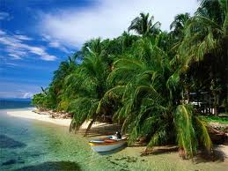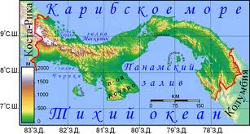

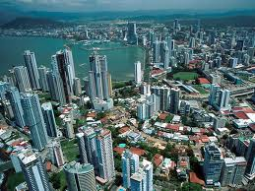**Панама**

_______________________________________________________________________________________

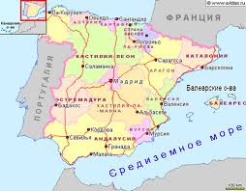

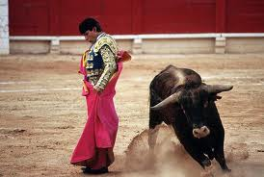**Испания**

_______________________________________________________________________________________

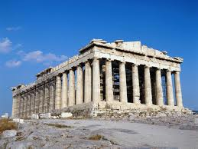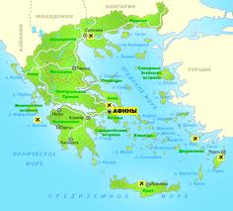

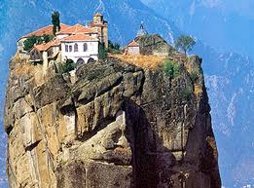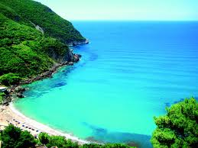**Греция**

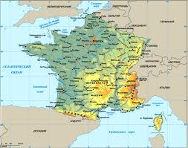

** Франция**

_________________________________________________________________

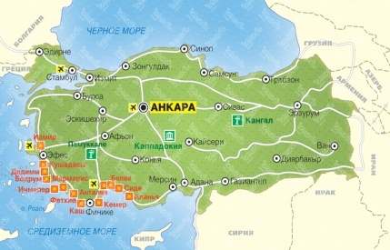

**Турция**

