**Фото кроссворд: «Листопад».**

|  |  |  |  |  |  |  |  |  |  |  |  |
| --- | --- | --- | --- | --- | --- | --- | --- | --- | --- | --- | --- |
|  | | | | | | 1 |  | | | | |
|  | | 2 | 3 |  |  |  |  |  |  | | |
|  |  |  | |  |  | 4 |
|  |  |  |  | |
|  | 5 |  |  | 6 |  |  |  |  |  |  |
| 7 |  |  |  | |  | |  |  | |
|  |  | | 8 |  |  |  |  |
|  |  |  | |  | | | |  |  | |

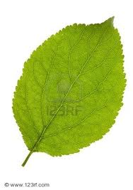 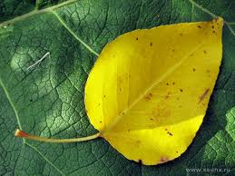 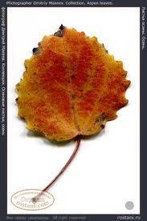 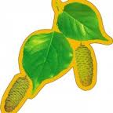 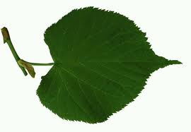

**5**

**3**

**6**

**8**

**1**

**2**

**4**

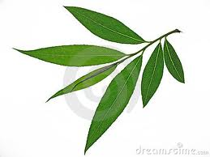 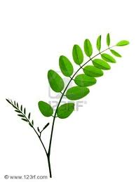

**7**

**Ответы.**

По горизонтали: 2. Тополь. 6. Каштан. 7. Ива. 8. Осина.

По вертикали: 1. Слива. 3. Ольха. 4. Акация. 5. Липа.