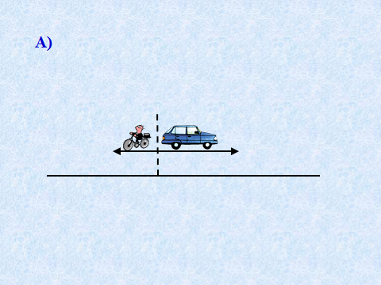

а)

___________________________________________________________________________________________________

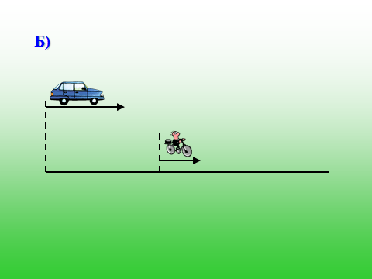

в)

б)

___________________________________________________________________________________________________

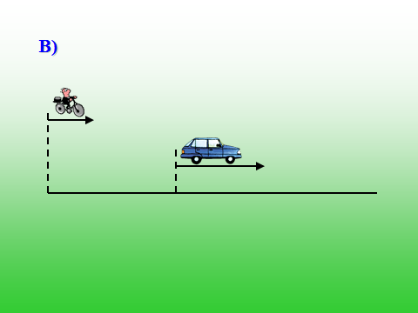

___________________________________________________________________________________________________

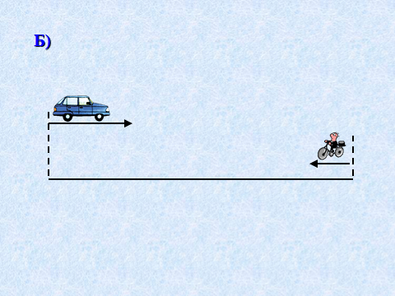

г)

___________________________________________________________________________________________________

**Виды задач на движение.**