=

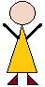

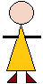

= |  | 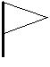 | 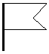

=

=

=

++

-- | 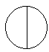 | 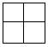 | 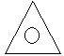
 | 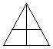 | 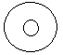
 | 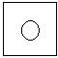 | 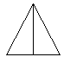
==

--

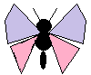
==

==

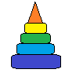  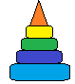 | 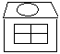 | 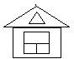 | 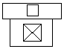
 | 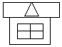 | 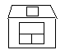 | 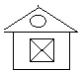
 | 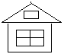 | 


