http://x-lines.ru/icp/bcW08/e40c0c/1/40/RbuduwiIPmuZCina.png

http://x-lines.ru/icp/bcW08/f50a1a/1/36/iliPkakPpravilxno.png

http://x-lines.ru/icp/bcW08/eb0a0a/1/36/vospitqvatxPmalxCika.png

[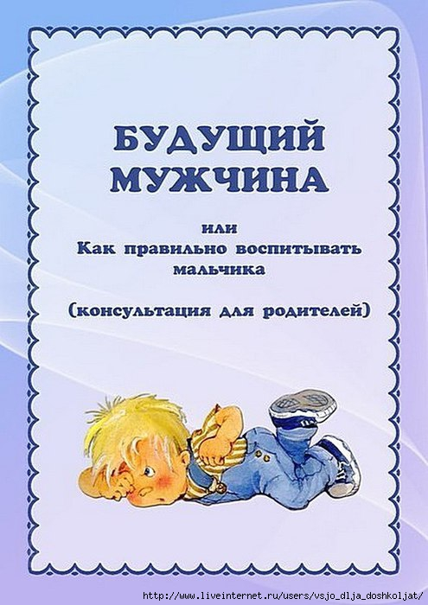](http://img1.liveinternet.ru/images/attach/c/9/105/299/105299033_large_5111852_m1.jpg)

[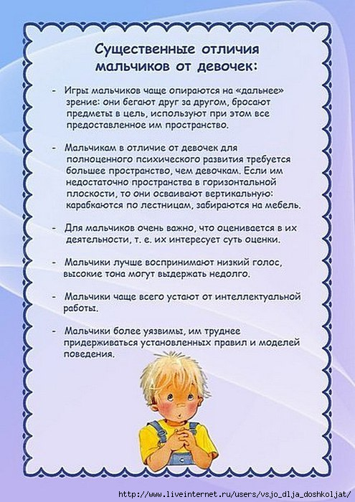](http://img1.liveinternet.ru/images/attach/c/9/105/299/105299035_large_5111852_m2.jpg)

[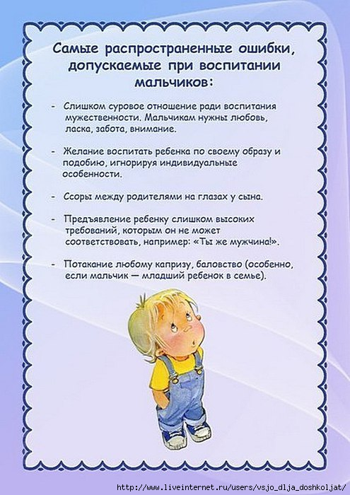](http://img0.liveinternet.ru/images/attach/c/9/105/299/105299036_large_5111852_m3.jpg)

[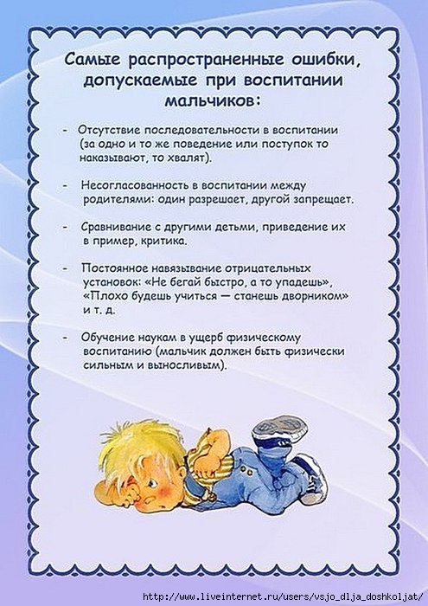](http://img1.liveinternet.ru/images/attach/c/9/105/299/105299037_large_5111852_m4.jpg)

[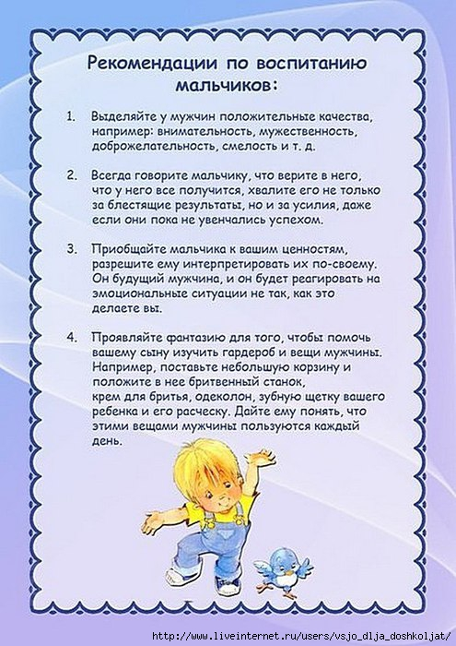](http://img0.liveinternet.ru/images/attach/c/9/105/299/105299038_large_5111852_m5.jpg)

[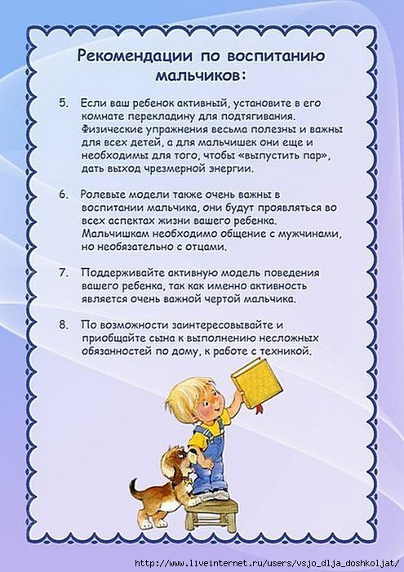](http://img1.liveinternet.ru/images/attach/c/9/105/299/105299039_large_5111852_m6.jpg)