[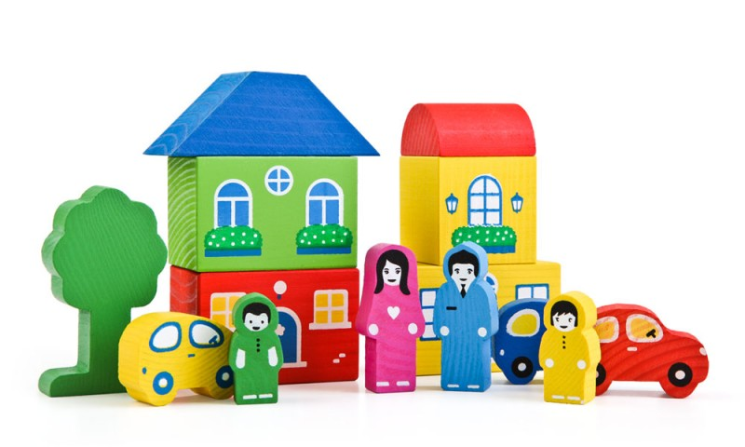](http://images.yandex.ru/yandsearch?p=15&text=%D1%81%D1%85%D0%B5%D0%BC%D1%8B%20%D1%81%D1%82%D1%80%D0%BE%D0%B8%D1%82%D0%B5%D0%BB%D1%8C%D1%81%D1%82%D0%B2%D0%B0%20%D0%B8%D0%B7%20%D0%B4%D0%B5%D1%82%D1%81%D0%BA%D0%BE%D0%B3%D0%BE%20%D0%B4%D0%B5%D1%80%D0%B5%D0%B2%D1%8F%D0%BD%D0%BD%D0%BE%D0%B3%D0%BE%20%D0%BA%D0%BE%D0%BD%D1%81%D1%82%D1%80%D1%83%D0%BA%D1%82%D0%BE%D1%80%D0%B0&pos=457&uinfo=sw-755-sh-647-fw-765-fh-448-pd-1&rpt=simage&img_url=http://i.pixs.ru/storage/2/1/2/ccoloredto_5798437_6363212.jpg)

*СХЕМЫ ПОСТРОЕК ИЗ ДЕРЕВЯННОГО КОНСТРУКТОРА*

[](http://images.yandex.ru/yandsearch?p=2&text=%D1%80%D0%B0%D0%BC%D0%BA%D0%B8%20%D0%B4%D0%BB%D1%8F%20%D1%82%D0%B5%D0%BA%D1%81%D1%82%D0%B0%20%D0%B4%D0%B5%D1%80%D0%B5%D0%B2%D1%8F%D0%BD%D0%BD%D1%8B%D0%B5&pos=61&uinfo=sw-1349-sh-712-fw-1124-fh-506-pd-1&rpt=simage&img_url=http://www.colourbox.com/preview/2119107-806431-brown-wooden-photo-frame-isolated-on-white-with-empty-space-for-text-photo-or-picture.jpg)

[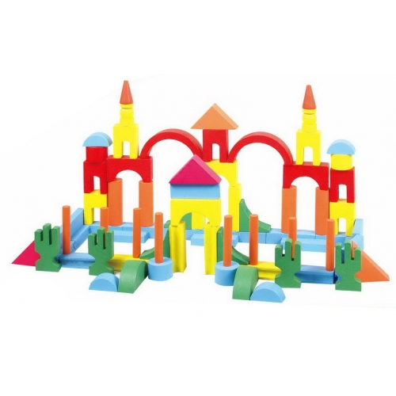](http://images.yandex.ru/yandsearch?text=%D1%81%D1%85%D0%B5%D0%BC%D1%8B%20%D1%81%D1%82%D1%80%D0%BE%D0%B8%D1%82%D0%B5%D0%BB%D1%8C%D1%81%D1%82%D0%B2%D0%B0%20%D0%B8%D0%B7%20%D0%B4%D0%B5%D1%82%D1%81%D0%BA%D0%BE%D0%B3%D0%BE%20%D0%B4%D0%B5%D1%80%D0%B5%D0%B2%D1%8F%D0%BD%D0%BD%D0%BE%D0%B3%D0%BE%20%D0%BA%D0%BE%D0%BD%D1%81%D1%82%D1%80%D1%83%D0%BA%D1%82%D0%BE%D1%80%D0%B0&pos=23&uinfo=sw-1349-sh-712-fw-1124-fh-506-pd-1&rpt=simage&img_url=http://www.nshar.ru/img/big/5157-500x500.jpg)

[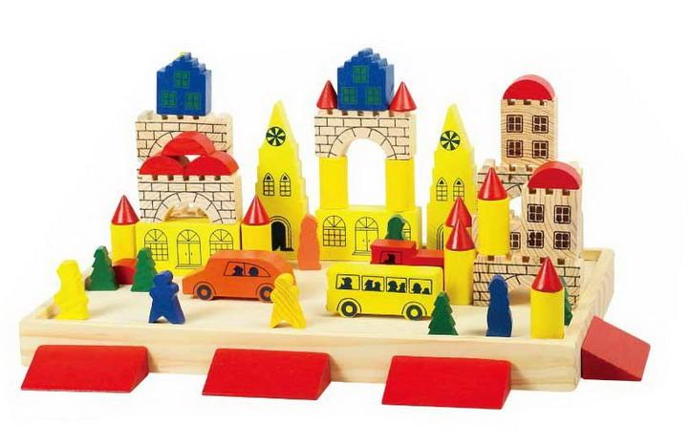](http://images.yandex.ru/yandsearch?p=3&text=%D1%81%D1%85%D0%B5%D0%BC%D1%8B%20%D1%81%D1%82%D1%80%D0%BE%D0%B8%D1%82%D0%B5%D0%BB%D1%8C%D1%81%D1%82%D0%B2%D0%B0%20%D0%B8%D0%B7%20%D0%B4%D0%B5%D1%82%D1%81%D0%BA%D0%BE%D0%B3%D0%BE%20%D0%B4%D0%B5%D1%80%D0%B5%D0%B2%D1%8F%D0%BD%D0%BD%D0%BE%D0%B3%D0%BE%20%D0%BA%D0%BE%D0%BD%D1%81%D1%82%D1%80%D1%83%D0%BA%D1%82%D0%BE%D1%80%D0%B0&pos=93&uinfo=sw-1349-sh-712-fw-1124-fh-506-pd-1&rpt=simage&img_url=http://i.bambiniya.ru/pics/product/200/77615.jpg)

[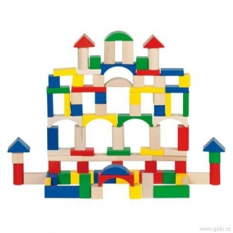](http://images.yandex.ru/yandsearch?p=3&text=%D1%81%D1%85%D0%B5%D0%BC%D1%8B%20%D1%81%D1%82%D1%80%D0%BE%D0%B8%D1%82%D0%B5%D0%BB%D1%8C%D1%81%D1%82%D0%B2%D0%B0%20%D0%B8%D0%B7%20%D0%B4%D0%B5%D1%82%D1%81%D0%BA%D0%BE%D0%B3%D0%BE%20%D0%B4%D0%B5%D1%80%D0%B5%D0%B2%D1%8F%D0%BD%D0%BD%D0%BE%D0%B3%D0%BE%20%D0%BA%D0%BE%D0%BD%D1%81%D1%82%D1%80%D1%83%D0%BA%D1%82%D0%BE%D1%80%D0%B0&pos=107&uinfo=sw-1349-sh-712-fw-1124-fh-506-pd-1&rpt=simage&img_url=http://lalatoys.ru/picture/variation/opg03nexxaesim8m8135/c/58669goki.jpg)

[](http://images.yandex.ru/yandsearch?p=3&text=%D1%81%D1%85%D0%B5%D0%BC%D1%8B%20%D1%81%D1%82%D1%80%D0%BE%D0%B8%D1%82%D0%B5%D0%BB%D1%8C%D1%81%D1%82%D0%B2%D0%B0%20%D0%B8%D0%B7%20%D0%B4%D0%B5%D1%82%D1%81%D0%BA%D0%BE%D0%B3%D0%BE%20%D0%B4%D0%B5%D1%80%D0%B5%D0%B2%D1%8F%D0%BD%D0%BD%D0%BE%D0%B3%D0%BE%20%D0%BA%D0%BE%D0%BD%D1%81%D1%82%D1%80%D1%83%D0%BA%D1%82%D0%BE%D1%80%D0%B0&pos=116&uinfo=sw-1349-sh-712-fw-1124-fh-506-pd-1&rpt=simage&img_url=http://jili-bili.ru/files/nasha/medium/76141.jpg)

[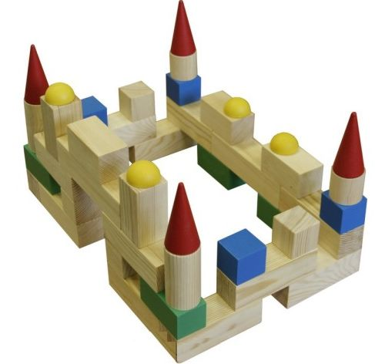](http://images.yandex.ru/yandsearch?p=12&text=%D1%81%D1%85%D0%B5%D0%BC%D1%8B%20%D1%81%D1%82%D1%80%D0%BE%D0%B8%D1%82%D0%B5%D0%BB%D1%8C%D1%81%D1%82%D0%B2%D0%B0%20%D0%B8%D0%B7%20%D0%B4%D0%B5%D1%82%D1%81%D0%BA%D0%BE%D0%B3%D0%BE%20%D0%B4%D0%B5%D1%80%D0%B5%D0%B2%D1%8F%D0%BD%D0%BD%D0%BE%D0%B3%D0%BE%20%D0%BA%D0%BE%D0%BD%D1%81%D1%82%D1%80%D1%83%D0%BA%D1%82%D0%BE%D1%80%D0%B0&pos=383&uinfo=sw-1349-sh-712-fw-1124-fh-506-pd-1&rpt=simage&img_url=http://www.bambinos.ru/upload/iblock/89f/89f2a4d9378806c89eceab0d901da441.jpg)

[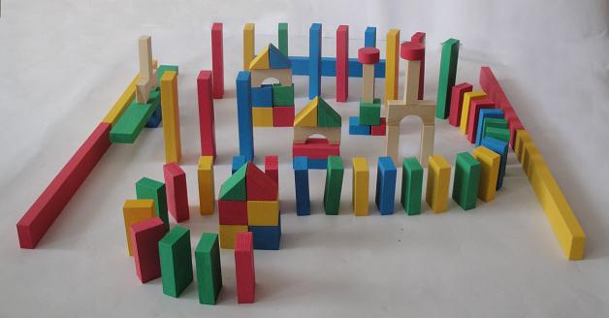](http://images.yandex.ru/yandsearch?p=8&text=%D1%81%D1%85%D0%B5%D0%BC%D1%8B%20%D1%81%D1%82%D1%80%D0%BE%D0%B8%D1%82%D0%B5%D0%BB%D1%8C%D1%81%D1%82%D0%B2%D0%B0%20%D0%B8%D0%B7%20%D0%B4%D0%B5%D1%82%D1%81%D0%BA%D0%BE%D0%B3%D0%BE%20%D0%B4%D0%B5%D1%80%D0%B5%D0%B2%D1%8F%D0%BD%D0%BD%D0%BE%D0%B3%D0%BE%20%D0%BA%D0%BE%D0%BD%D1%81%D1%82%D1%80%D1%83%D0%BA%D1%82%D0%BE%D1%80%D0%B0&pos=258&uinfo=sw-755-sh-647-fw-765-fh-448-pd-1&rpt=simage&img_url=http://pervouralsk.sverdlovskaya-oblast.doski.ru/i/17/36/173665s.jpg)