H:\Program Files\Microsoft Office\MEDIA\CAGCAT10\j0090386.wmfH:\Program Files\Microsoft Office\MEDIA\CAGCAT10\j0090386.wmfH:\Program Files\Microsoft Office\MEDIA\CAGCAT10\j0090386.wmfH:\Program Files\Microsoft Office\MEDIA\CAGCAT10\j0090386.wmfH:\Program Files\Microsoft Office\MEDIA\CAGCAT10\j0090386.wmfH:\Program Files\Microsoft Office\MEDIA\CAGCAT10\j0090386.wmfH:\Program Files\Microsoft Office\MEDIA\CAGCAT10\j0090386.wmfH:\Program Files\Microsoft Office\MEDIA\CAGCAT10\j0090386.wmf

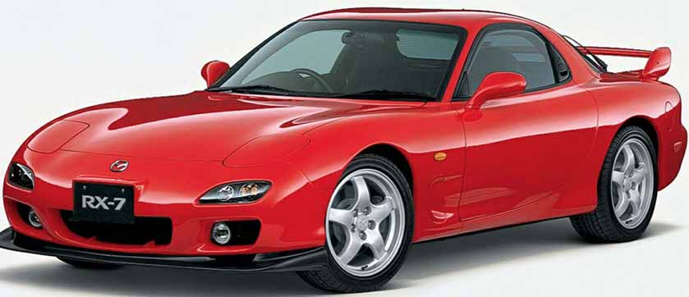

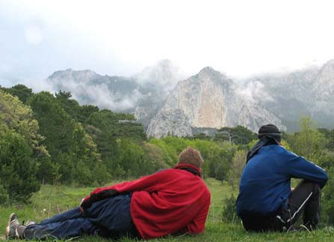



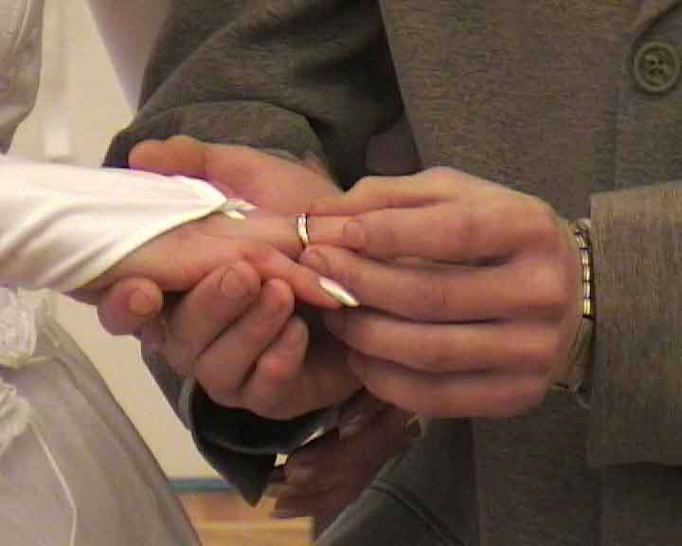



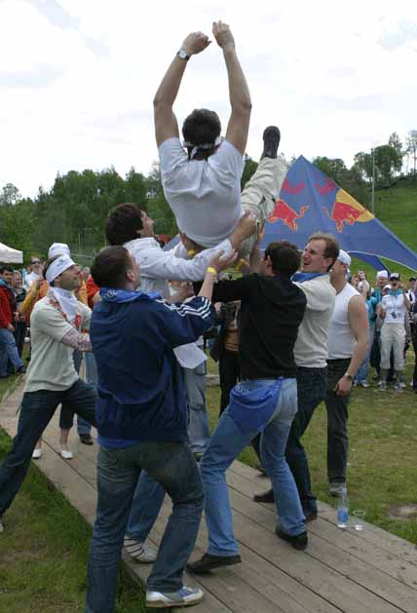

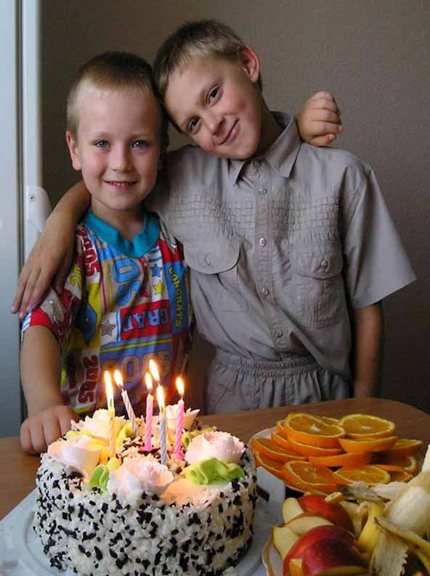



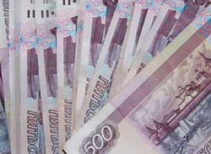

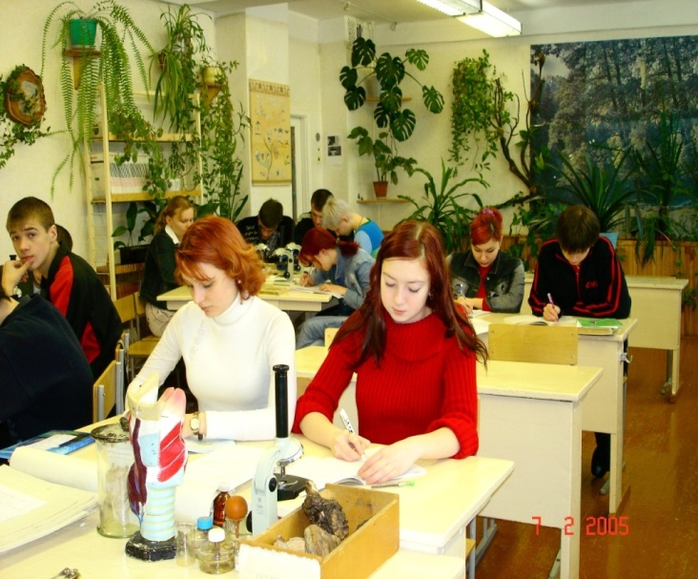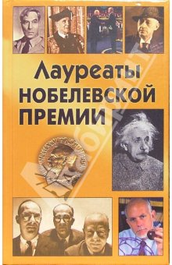H:\Program Files\Microsoft Office\MEDIA\CAGCAT10\j0090070.wmfH:\Program Files\Microsoft Office\MEDIA\CAGCAT10\j0090070.wmf

H:\Program Files\Microsoft Office\MEDIA\CAGCAT10\j0090070.wmfH:\Program Files\Microsoft Office\MEDIA\CAGCAT10\j0090070.wmfH:\Program Files\Microsoft Office\MEDIA\CAGCAT10\j0090070.wmfH:\Program Files\Microsoft Office\MEDIA\CAGCAT10\j0090070.wmfH:\Program Files\Microsoft Office\MEDIA\CAGCAT10\j0090070.wmfH:\Program Files\Microsoft Office\MEDIA\CAGCAT10\j0090070.wmf



H:\Program Files\Microsoft Office\MEDIA\CAGCAT10\j0216724.wmfH:\Program Files\Microsoft Office\MEDIA\CAGCAT10\j0216724.wmfH:\Program Files\Microsoft Office\MEDIA\CAGCAT10\j0216724.wmfH:\Program Files\Microsoft Office\MEDIA\CAGCAT10\j0216724.wmfH:\Program Files\Microsoft Office\MEDIA\CAGCAT10\j0216724.wmfH:\Program Files\Microsoft Office\MEDIA\CAGCAT10\j0216724.wmfH:\Program Files\Microsoft Office\MEDIA\CAGCAT10\j0216724.wmf

H:\Program Files\Microsoft Office\MEDIA\CAGCAT10\j0216724.wmfH:\Program Files\Microsoft Office\MEDIA\CAGCAT10\j0234657.wmfH:\Program Files\Microsoft Office\MEDIA\CAGCAT10\j0234657.wmfH:\Program Files\Microsoft Office\MEDIA\CAGCAT10\j0234657.wmfH:\Program Files\Microsoft Office\MEDIA\CAGCAT10\j0234657.wmfH:\Program Files\Microsoft Office\MEDIA\CAGCAT10\j0234657.wmfH:\Program Files\Microsoft Office\MEDIA\CAGCAT10\j0234657.wmfH:\Program Files\Microsoft Office\MEDIA\CAGCAT10\j0234657.wmfH:\Program Files\Microsoft Office\MEDIA\CAGCAT10\j0234657.wmfH:\Program Files\Microsoft Office\MEDIA\CAGCAT10\j0233018.wmfH:\Program Files\Microsoft Office\MEDIA\CAGCAT10\j0233018.wmfH:\Program Files\Microsoft Office\MEDIA\CAGCAT10\j0233018.wmfH:\Program Files\Microsoft Office\MEDIA\CAGCAT10\j0233018.wmfH:\Program Files\Microsoft Office\MEDIA\CAGCAT10\j0233018.wmfH:\Program Files\Microsoft Office\MEDIA\CAGCAT10\j0233018.wmfH:\Program Files\Microsoft Office\MEDIA\CAGCAT10\j0233018.wmfH:\Program Files\Microsoft Office\MEDIA\CAGCAT10\j0233018.wmf





        
        
        
        
        
        
        
        
        