
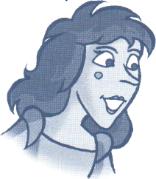


Sister 1:
Sister 2:
Mother:
Cinderella:
Mother:
Sister 1:
Sister 2:
Sisters:
Mother:
Cinderella:
Mother:
Sister 1:
Sister 2:
All:
Mother:
Sister 2:
Sister 1:
Mother:
Cinderella:
Mother:
Cinderella:
Sister 1:
Sister 2:
All:
Cinderella:
Sister 2:
Sister 1:
Mother:
I love you, Cinderella.
She is beautiful.
My darling Cinderella ...
Oh, it was only a dream!
The table isn't ready for tea. What time is it?
It's four o'clock.
It's tea time.
What's happening?
Where is she?
I'm here. I had a lovely dream.
You had a dream? This room is a nightmare!
We want our tea!
We want our biscuits!
They want their tea! They want their biscuits!
Look at this teapot! It's dirty! Clean it now! '
Mummy, the table's dirty.
Mummy, I want my tea.
Oh, my poor girls!
I'm sorry, Mother. I'm really sorry.
I'll make you feel sorry, you lazy girl.
I'm sorry, Mother. I'm really sorry.
Where's the food?
Where's the turkey?
Where's the food? Where's the turkey?
I'm coming, I'm coming. Here you are.
It's my turkey!
No, it's my turkey!
Girls! Stop fighting. We've all got turkey for tea.

The Turkey Song

Turkey! Turkey!
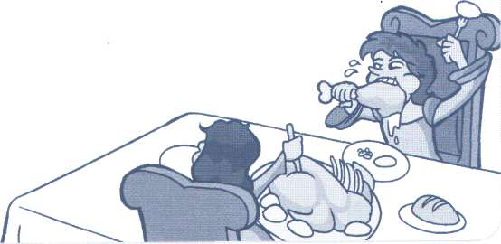
Yummy, yummy big fat turkey!
Turkey for tea.
I want it for breakfast.
Turkey for tea.
I want it for lunch.
With carrots and peas.
Crunch, crunch, crunch!
Turkey for tea.
I want it for dinner.
Turkey for tea.
I want it for tea.
Big fat turkey for you and me!

Mother: Cinderella: Sister 1: Sister 2: Sister 1: Sister 2:
All:
Sister 1: Mother: Sisters:
All:
Cinderella: Mother: Cinderella:
Sister 2: Sister 1:
Mother:

Sisters:
All:
Perkins:

Sisters: Sister 2:
Cinderella, clear the table at once. I must read Father's letter.
Yes, Mother. Of course, Mother.
Where is Father?
Father is in Paris.
Where is Paris?
Paris is in France, silly!
Paris is in France, silly!
Why is he in Paris?
He's buying beautiful clothes for you.
Yes! Lovely! (Sreat!
Great!
Is he buying me clothes?
Cinderella, clean the kitchen and be quiet!
Yes, Mother. I'm sorry, Mother.
Mummy, I want her to clean my room first!
No, Mummy, she'll clean my room first, or I'll put frogs in her bed.
Girls! Stop fighting, please! I'm reading this letter. Perkins! There's somebody at the door!
Who is it? Who is it?
Who is it? Who is it?
There's a strange man at the door. He says that he's from the palace.
What palace?
Do you mean the Palace Cinema?

Mother:
Perkins:
Mother:
All:
Messenger:
All:
Perkins:
Messenger:
Perkins, sisters
and Mother:
Messenger:
No, silly!
I mean the palace. You know the palace. Prince Richard lives there.
Well, let him in. Let him in!
Let him in!
Stop, Silver! Stop! Will you stop? Somebody help me!
Somebody stop Silver!
Whoa! Whoa! Here's some sugar.
Thank you. Ladies and gentlemen ...
Yes? Yes?
Prince Richard invites you all to the palace on Saturday night at
eight o'clock for a big, big, big, big, big, party.

Chant 1
A party at the palace on Saturday night. All right, all right, on Saturday night.
Messenger: Here are your invitations.
Sister 1: Here! That's for me!
Sister 2: No, it's for me!
Perkins: Wait a minute, wait a minute everybody ...
Mother: Well? Are you going to stay here all day?
Messenger: Giddy up, Silver! Giddy up! So!
Sister 1: Cinderella, what are you doing? Come here!
Sister 2: Cinderella, come and help us get ready!
Cinderella: Ready? Now? Today?
Sisters: Yes! Now! Today!
Cinderella: But the party is on Saturday.
Sisters: And we're getting ready today!
Cinderella: OK. Today.
Mother: Cinderella, bring a bowl of water to wash their feet. They are smelly!
All: Pooh!
Sister 1: I want to wear the red dress.
Sister 2: Oh, no, you don't!
Sister 1: Oh, yes, I do!
Mother: Girls, please stop this! I am going to wear the red dress.
Sisters: OK, Mummy.

Cinderella: Sister 1: Sister 2: Sister 1: Sister 2: Sister 1: Sister 2: Mother: Sister 1: Sister 2:
Sister 1: Sister 2: Sister 1: Sister 2:
All right, who's first?
Cinderella, wash my feet!
Cinderella, brush my hair!
Sive me the towel!
Sive me the mirror!
Paint my nails!
Blow my nose!
Get them ready, Cinderella. Let's go, Perkins. Cinderella, help me!
When Prince Richard looks into my eyes, he will die.
Exactly! He will die. When Prince Richard dances with me, he will
want to marry me.
No, he'll marry me or I will die!
No, he won't!
Oh, yes, he will!
Oh, no, he won't!

Chant 2
Mouse and mice and foot and feet. Fish. Fish. Person. People.

Cinderella: Mice: Cinderella:
What's this? Am I dreaming?
No, Cinderella. You aren't dreaming.
Who are you?

Three Nice Mice

We're three nice mice. Three nice mice.

See how we run. See how we run.
We're three nice mice. We can cook and talk. We're three nice mice. We can run and walk. We can do magic. And help our friends. We're three nice mice.

Cinderella:
Mice:
Cinderella:
Mice:
Cinderella:
Mice:
Cinderella:
Mice:
Cinderella:
All:
Mice:
You are nice! But I am very sad.
Why are you sad?
Because everybody is going to the party and I'm not.
Do you want to go to the party?
Oh, yes. Very, very much.
We can help you.
Can you really?
Yes, we can. We can find your fairy godfather.
My fairy godfather?
Her fairy godfather?
Yes. We can find him for you. Look!

Chant 3
Fairy Godfather, where are you? Fairy Godfather, we need you. Fairy Godfather, we know you are near. Fairy Godfather, please come here.
Fairy Godfather: How can I help you?
Cinderella: I want to go to the party.
Fairy Godfather: That's easy my girl, don't cry. Now

The Cinderella Song
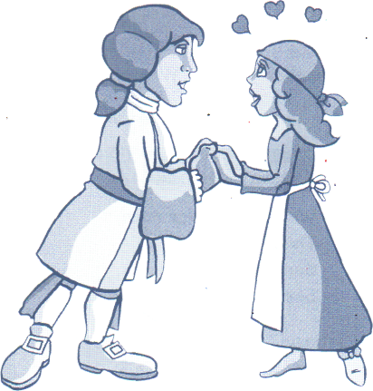
Cinderella will have a chance. Cinderella will go to the dance. Cinderella will find romance.
Cinderella will have a chance. Cinderella will go to the dance. Cinderella will find romance.
Cinderella will have a chance. Cinderella will go to the dance. Cinderella will find romance.

Fairy Godfather: Poor Cinderella. She's sad. She wants to go to the party. Children,
do you want Cinderella to go to the party?
All: Yes!
Fairy Godfather: Will you help me, please?

All:
Fairy Godfather:
All:
Fairy Godfather:
Mice:
All:
Mice/Coachmen:
All:
Fairy Godfather:
Mice/Coachmen: Fairy Godfather: Mice/Coachmen: Fairy Godfather: All:
Yes!
We need some magic here. We must make a wish. Are you ready?
Yes!
Now close your eyes. Yes, that's right. Now ... 1,2,3 WISH! Now,
Cinderella. Turn around and around and around. Come on. Make
your wish!
One, two, three! Abracadabra!
Abracadabra!
Cinderella, you are beautiful. Very, very beautiful.
Very, very beautiful!
Cinderella, you're going to the party. You'll be the prettiest girl
at the palace.
Yes! The prettiest girl at the palace!
But remember, remember, twelve o'clock.
But remember, remember, twelve o'clock.
At twelve o'clock, you must leave the palace.
Twelve o'clock. Twelve o'clock.

Prince Richard:
Mother:
Prince Richard:
Mother:
Sister 1:
Prince Richard:
Sister 2:
Prince:
Sisters:
Prince Richard:
Sister 1:
Sister 2:
Mother:
All:
Prince Richard:
Cinderella:
All:
Cinderella:
Messenger:
Prince Richard:
All:
Good evening. I am Prince Richard.
Good evening, your Highness. Pleased to meet you.
I am pleased to meet you too. Where are your beautiful daughters?
They're coming now. Girls! Girls! This is Prince Richard.
Well, hello handsome. Are you married?
No, I'm not.
Do you want to get married?
Yes, I do.
Have you got lots of money?
Oh, yes. Lots and lots of money! Good evening.
Look at her!
Who is she?
Who is she? She's beautiful!
Who is she? Who is she? ,
Can I dance with you?
Yes, your Highness. Where's the door?
It's over there!
Thank you very much! Bye!
Hey! Your shoe!
What's your name? Come back! I'm going to find that girl!
He's going to find her. Who is she? Who is she?

Mice:
Cinderella:
All:
Mice:
Cinderella:
All:
Mice:
Cinderella:
Mice:
Sister 1:
Sister 2:
Mother:
Cinderella:
All:
Sister 1:
Sister 2:
Cinderella:
Messenger:
Prince Richard:
Messenger:
Prince Richard:
Messenger:
All:
Mother:
Messenger:
Sister 1:
Messenger:
Sister 2:
Messenger:
All:
Prince Richard:
Messenger:
Sisters and
Mother:
Messenger:
Mother:
Messenger:
Prince Richard:
Bravo! Bravo! You're very happy this morning.
Yes, I am. I've got a secret.
She's got a secret!
A secret? A secret?
Well ... I can tell you. I'm in love!
She's in love!
You're in love? Fantastic! Fantastic! Who is it? Who is it?
It's Prince Richard.
Prince Richard! Wow!
Cinderella is crazy!
Look at her!
We all know that Cinderella is crazy. Cinderella, coffee please.
Coffee, lovely coffee.
Coffee, lovely coffee!
I've got a headache. Bring me a glass of water.
Bring me 10 glasses of water!
Of course, my darling sisters.
Ladies! Ladies! Try on this shoe. Please try on this shoe.
It doesn't fit.
Please try on this shoe.
It doesn't fit.
Let's go, Prince Richard. No luck here. Open the door! It's
Prince Richard!
Open the door! It's Prince Richard!
Prince Richard is at the door! Perkins, open the door!
Ladies, try on this shoe. Please try on this shoe.
Oh no! It doesn't fit.
Please try on this shoe.
Oh no! It doesn't fit.
Please try on this shoe. Oh! It doesn't fit.
It doesn't fit!
Oh dear, oh dear! I will never find her!
Is there anybody else in the house?
No! Nobody.
Nobody? Who is that?
Nobody.
Is that nobody?
I think it's somebody.

All:
Sisters and
Mother:
Messenger:
Prince Richard:
Cinderella:
Mother:
Sisters:
All:
Prince Richard:
Cinderella:
Prince Richard:
Messenger:
All:
Cinderella:
Sisters:
It is somebody!
It's only Cinderella!
Be quiet!
Please try on this shoe!
Yes, your Highness. I will try on this shoe.
This is not happening.
The shoe fits!
Yes! The shoe fits!
It's your shoe!
Yes, it is.
You are my princess.
You are his princess.
She is his princess.
Yes, I am.
They are going to get married!

