INTERACTION TECHNIQUES
Information Gap
Aims:
to transfer/acquire information one student possesses,
the other doesn't to communicate in real-life situation
Stages:
Practice
Guided
Speaking
Patterns of interaction:
groups, pairs

Examples:
Variant 1, Restoring the table
the teacher gives the students one and the same task but
each student gets an incomplete version of it and has to find
out the necessary information from the other student in
order to get a complete version of a table.

Student 1
Animals in danger | What has happened to them
Elephants
Tigers | disappear
Dolphins
Spiders | their number /rise
Giraffes
Flamingoes | people/hunt for profit
Student 2
Animals in danger | What has happened to them
Elephants | become less in number
Tigers
Dolphins | their number/fall
Spiders
Giraffes | people/not save them
Flamingoes
S1: What has happened to elephants?
S₂: They have become less in number. And what has happened to tigers?
S3: Many tigers have disappeared.

Variant 2. One-way gap
Students are given different information.
Student A is to find out information about Jack's plans for the
nearest future.

Student A

This evening
Tomorrow morning
Tomorrow afternoon
Tomorrow evening

Student В
Tonight Jack is going to stay at home, because he wants to write a
letter to a friend. Tomorrow morning he has classes as usual at
school, but he has the afternoon free, so he's going to take his
cousin to the seaside. In the evening he's been invited out to a
party.

Variant 3. Restoring a text

Students find out the necessary information from each other in

order to get a complete version of a text.

E-mail Message
Student A

Your mum wrote a message to you and your cousin describing how

to get to the zoo, but something went wrong and you cannot read

some words in the E-mail. Telephone your cousin and clarify what

is not clear.

Hi, Honey!
I'm sorry, but I can't go with you to the zoo as we planned. You have
to get there on your own. Your cousin will help you. Meet him at the
Drama Theatre and decide how you'll get to the zoo. You can go by
taxi, but it's expensive. Or you can also get there by bus. For
instance, you can take bus……………………... It will take you 15
minutes to get there. You'll get there very quickly but I personally
believe that it is very dangerous because you'll have to cross two
roads and I do not recommend you this way.

You can also go to the bus stop which is in front of the Central Post

Office. But, please, use the subway crossing the street. There you

can take bus № 109 or № 82 which will take you to the bus station

on the left bank. It is rather far, ……………………………….

But from my point of view, the best way is to go by………………….
because you don't have to cross the roads. The bus stop is to the
right of the Drama Theatre. First, you should go there and catch
bus № 103 and get off at ………………………………. .You

………………………………. change there. Take trolleybus №

7, 9, or 16 and it will take you to the bus station. The zoo is ……….

it. I really think you would do well to choose this way.

Take care. See you. Mum.

Student В

Your aunt wrote a message to you and your cousin describing how

to get to the zoo, but something went wrong and you cannot read

some words in the E-mail. Telephone your cousin and clarify what is

not clear.

Hi, Honey!
I'm sorry, but I can't go with you to the zoo as we planned. You
have to get there on your own. Your cousin will help you. Meet him
at the Drama Theatre and decide how you'll get to the zoo. You
can go by ……., but it's expensive.
Or you can also get there by bus. For instance, you can take bus
№ 210. It will take you …… to get there. You'll get there very
quickly but I personally believe that it is very dangerous because you'll
have to cross two roads and I do not recommend you this way.

You can also go to the bus stop which is in front of the Central Post

Office. But, please, use the subway crossing the street. There you

can take bus № …….. which will take you to the bus station on

the left bank. It is rather far, about 10 stops.

But from my point of view, the best way is to go by trolleybus

because you don't have to cross the roads. The bus stop is

…………of the Drama Theatre. First, you should go there and

catch bus № …… and get off at Victory Park. You have to

change there. Take trolleybus ……………… and it will take you

to the bus station. The zoo is behind it. I really think you would do

well to choose this way.

Take care. See you. Aunt Maggie.

Variant4. Restoring the map
Variation 1
Students work in pairs and exchange the information.

Student 1 acts as a tourist who is staying in London for a few days and wants to go sightseeing. He/ She has heard about some famous sights of London but has no idea of others. Не/She goes to the Tourist Information Office to ask about places which he/she could visit.
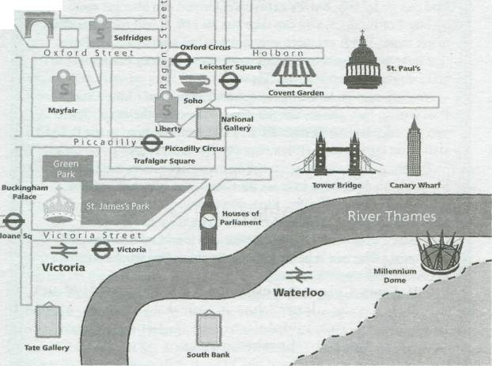

Student 2 acts as a tourist agent who is to help a visitor to plan his/her sightseeing tour around Central London.

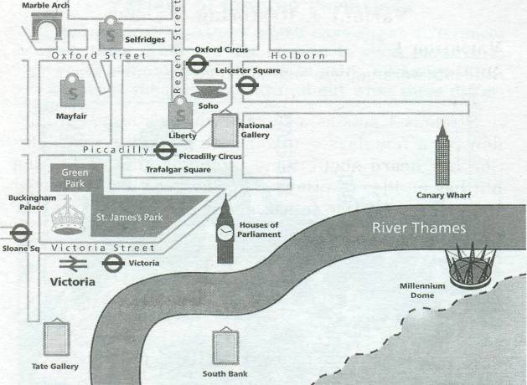

S1: Excuse me. Are there any famous sights by the river?
S2: Yes, of course. There's one of the most famous bridges in the
world — Tower Bridge across the Thames. And have you already
visited St. Paul's Cathedral?

S1: No, I haven't. Where is it?

.
Variation 2

Student 1 has an incomplete drawing of the weather map of Great
Britain. Student 2 has a complete version and is to help the partner
to complete his/hers.
Student 1 is allowed to ask questions but he/she must not look at the
map of Student 2.

S1: What is the weather like in the south of Northern Ireland?

S2: It's rainy there with short intervals of sunshine.

Variant 5. Finding deviations

Students are given pictures which have slight differences between
them. They are not allowed to show pictures to each other and are
asked to work in pairs, exchange information about the pictures and
find out what these differences are.
Student 1

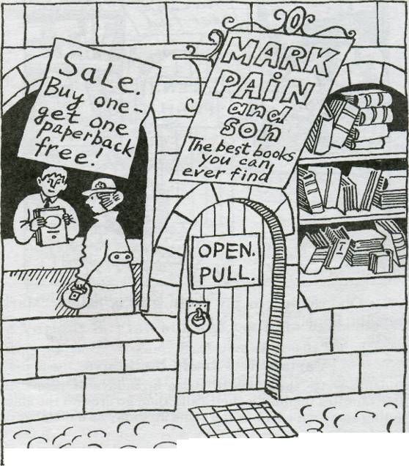
S1: There's a shop in my picture. It's called "Mark Pain and Son".

Student 2

S₂: Oh, really? In my picture it is called Mark Pain and Sons".
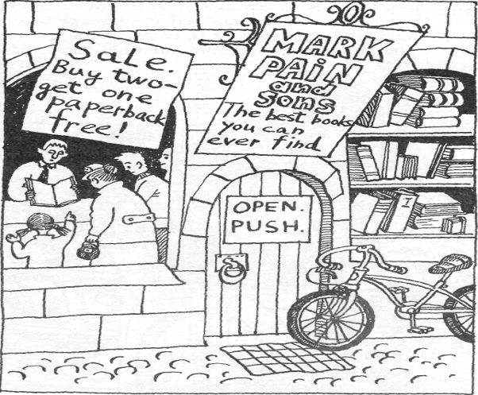

Variant 6. Family birthdays

Students write the dates of three birthdays of people in
their families including theirs and then go around the class
finding someone who has the same birthday as a member of
their family.

S1: When is your birthday?
When is your mother’s birthday?
When is your father’s birthday?
When is your grandmother’s birthday?

Variant 7. Specifying prices

Students have a list of things they'd like to buy, but they
don't know how much some of them cost. They are to ask
each other and to find out the missing information.

Student 1.

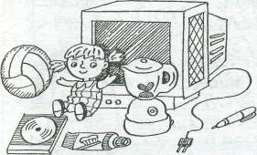
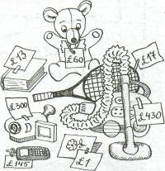

Student 2.
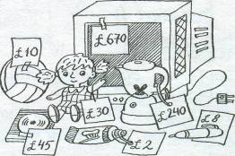
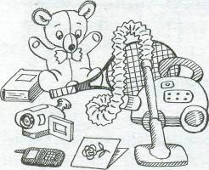

S1: How much is the CD?

S2: It's £45.00.

S1:Thank you.

S2:And how much is the teddy bear?

S1:It's £ 60.00.

Technique - Interview
Aims:
to ask for/give information about opinions, ideas,
plans, etc.

to practise language

Stages:
practice, production
guided speaking, free speaking
pre-writing
post-reading, post-listening, post-writing
Patterns of interaction:
whole class, groups, pairs
Examples:
Variant 1. Group interview
Variation 1
Having gathered information about a famous person any student acts as this person. The other classmates interview him as if at a press conference.

How many children have you got?
In what films have you starred?
What do you prefer for breakfast?
Etc.

Variation 2
One person interviews several people.
.
How many times a week do you meet?
Do you celebrate holidays together?
Have you common hobbies? Etc.

Variant 2. Tell us more about it
One person in the class starts telling something interesting about
himself/herself. The task of the class is to interview this student about
the event/situation/person he/she mentioned.

E.g.

S: My parents and I travelled last year to Egypt during winter holidays.

Cl: How long did you stay there? What places of interest did you visit? Did you go to see the famous pyramids?
or
S: My friends and I went to a rock concert last weekend.

Cl: Who did you go with?
Were the tickets expensive?
Did you like it? Why?
Etc.

Variant 3. The best gift

One student is interviewed about his likes/dislikes, priorities
and interests in life. Other classmates should think of the best
gift for him afterwards.

E.g.

Do you prefer watching TV to reading books?
What books/films do you like? Etc.

Variant 4. Journalists

Using the given chart students are to work out questions for
the interview which they will conduct in the classroom finding
out information about their classmates' parents/ relatives.

E.g.

NAME | What's your brother's name?
AGE | How old is your brother?
PLACE OF WORK (school)
WORKING HOURS (lessons)
PLACE OF LIVING
HOBBIES

PETS

Afterwards they are to write a short article or report describing the person they have learnt about.
E.g.

Mike's brother, Winston, is 14 years old. He works at a neighbourhood supermarket on Saturdays. He starts stocking the shelves at eight and, after the store opens at nine, he wheels trolleys out to customers' cars in the car park and sometimes to nearby houses.
Winston likes working. "I enjoy earning money. I make 8 pounds a day. I'm saving for a good camera." Taking pictures of people he likes and places he visits is his hobby. Besides, the supermarket he works for is not far from his house.
Winston lives with his parents and his brother...

Variant 5. Practising structures
Students are given a structure with content hints using
which they should ask for information.

E.g.
Can you remember what you were doing when:
— your first tooth fell out?
— someone invited you out on your first date?
— you first understood what people were saying in English?

Variant 6. Interview on a letter
Having written a letter of application students imagine
that they are invited for an interview to get a job.

E.g.
- You wrote that you like to look after children. Have you had lots of
experience in it? Do you have little brothers or sisters? Etc.

Technique Jig-saw
Aims:
to transfer/acquire information one student possesses, the other doesn't in order to get a complete picture of split information
Stages:
while-reading, while-listening, while-writing
Patterns of interaction:
groups, pairs
Examples:
Variant 1
Variation 1. Jig-saw reading

Two students are given different halves of one and the same text
which they are to read and then tell the information to each other to
restore the whole text.
Student A.
Little Rabbit lives in the forest. He likes to run and jump. He can read well. He is clever and cunning, but he is not brave and strong.
Student B
He has a lot of (много) friends. They play with him in the forest. His friend Winnie has breakfast with him today.

Variation 2. Jig-saw listening
Students listen to different parts of one text, and then tell them to ach other.
Variant 2. Jig-saw puzzle
Students are given 2 pieces of a puzzle. They should convey information to each other, ask questions on the content and personal opinion, and try to find a solution together.

E.g.
A
John lives with his family in a new block of flats two miles from a town centre. From their flat, they have a very nice view of the town.
Every weekday, he leaves his flat at 8.05, and gets in the lift on the
24th floor. He gets out of the lift, says "Good morning" to the man
selling newspapers, goes to the bus stop and gets on a bus.

B
In the afternoon, John gets a bus about 4.15 and gets back to his
block of flats at about 4.45. He usually stops off at the shop to buy
some sweets or chocolate and a newspaper.Не gets in the lift and
he presses the button for the 14th floor, he gets out, and walks up the stairs to the 24th floor. If there is someone
else in the lift, he gets out at the 24th floor.
Key: He was very short/a dwarf.

Variant 3. Jig-saw pictures
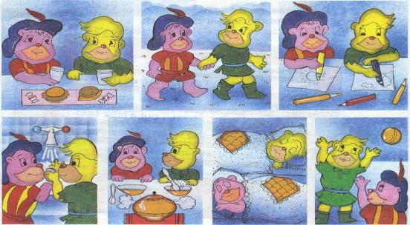
Variation 1
Students are given 2 sets of pictures illustrating one story.
They are to describe them to each other (without showing the
pictures) in order to restore the whole story.

After that students may show pictures to each other and workout the correct order of the pictures.
.

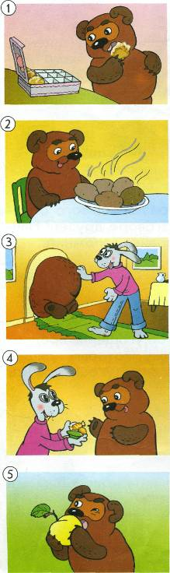

Variation .2
The teacher divides the students into the groups according to the
number of pictures illustrating some story. Each group works out
the description of events in their picture. After that groups split
and members of different groups gather into one group. Then
students are asked to assemble their events into one story and
to write it down.

Variant 4. Using the underlined words

The teacher prepares the text which is divided into two parts.
Students are divided into two groups: A and B. Students of group
A receive the first part of the text and students of group В receive
the second part of the text.

A
Once upon a time there was a small deer named Kancil, who lived in the woods. He was very proud of himself. He thought he was the smartest animal and the fastest runner. All the other animals in the woods did not like him because he often made fun of them. He liked to laugh at the turtle who always walked slowly. One day Kancil asked Turtle to have a race with him. The one who came first to the big tree in the middle of the woods would be the winner. After thinking for a moment, Turtle said "yes."
B
Once upon a time there was a small deer named Kancil, who lived in the woods. He was very proud of himself. He thought he was the smartest animal and the fastest runner. All the other animals in the woods did not like him because he often made fun of them. He liked to laugh at the turtle who always walked slowly. One day Kancil asked Turtle to have a race with him. The one who came first to the big tree in the middle of the woods would be the winner. After thinking for a moment, Turtle said "yes."

Variant 5. Jig-saw groups
Students are sitting in a circle, each having a short piece of one ext.
The number of pieces should correspond to the number of
students in a group. In turns they tell the information of their
passage to the whole group and at the end everyone knows the
content of he whole text.
Variation
Students can be divided into А, В, С, D groups and given different
arts of one text. They read their parts, group into pairs A + В,
С +D and exchange the information. They should be very attentive
and memorize as much of the partner's information as possible.
After that they regroup: A + С, В + D, and tell the extract they've
Read and the extract they've been told, thus restoring the whole text.

- The one who comes first to the big tree in the middle of the woods will be the winner.

- One day Kancil asks Turtle to have a race with him.

- . He likes to laugh at the turtle who always walks slowly.

- All the other animals in the woods do not like him because he often makes the fun of them.

- He think he is the smartest animal and the fastest runner.

- Once upon a time there is a small deer named Kancil, who lives in the woods.

- After thinking for a moment, Turtle says "yes."

- He is very proud of himself

Technique Mapped Dialogue
Aims:
to practice language
to practice functional language
to use the acquired language meaningfully
Stages:
production guided speaking
Patterns of interaction:
pairs
Examples:
Variant 1. Functional map
Students are given a map of a conversation on a certain topic,
containing only instructions, using which students produce a
dialogue.
In a shop.
Greet a shop-assistant. Offer help to the customer.
Say what you want to buy. Say if you have this item in
your shop.
Ask about the price. Give information about a
price.
Decide if you want to buy Thank the customer and
this object. say goodbye.
Variant 2. Pictorial map
Students are given a series of pictures where a
conversational situation is depicted. They are to think of
phrases the people in the picture might say to each other
and produce a dialogue.

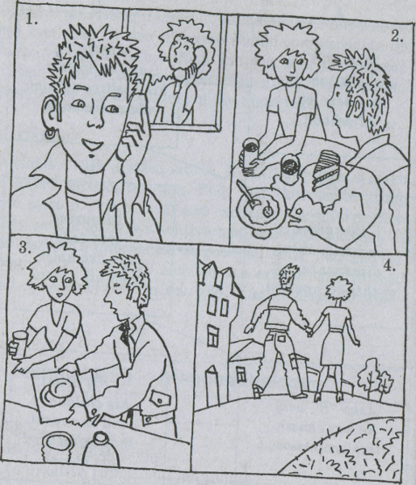
S1: Hello, Larry. Do you mind coming today? We could have lunch together.
S2: Oh! That's a good idea, Mary. When shall I come?
S1: Does 11 o'clock sound all right?
S2: That suits me fine!

Variant 3. Mapped dialogue with some ready-made phrases
Students are given a map of a conversation with instructions and ready-
made phrases. They are to compose a dialogue.
Example:
Make up dialogues. Use:
— Can I help you?
— He's not in. Can you phone back?

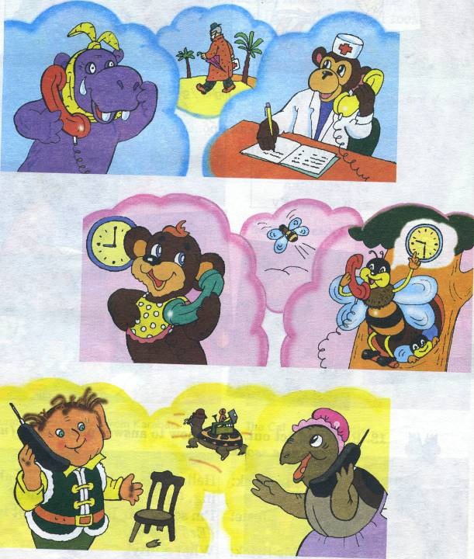

Variant 4. Functional cues

Students get a card with a skeleton of a dialogue where instead of
ready-made cues only functions are given. Students are to make up a
dialogue but not to use the words in italics.

A is renting a flat.
B is the landlord.
A: (Ask when it's necessary to pay the rent.)
B: (Say strongly it's very important to pay.)
A: (Ask for permission to keep a dog.)
B: (Apologise, but say pets are prohibited.)

Technique Role-play
Aim:
to use acquired language for real communicative purposes

Stages:
free speaking
post-reading, post-listening, post-writing

Patterns of interaction:
groups, pairs
Examples:
Variant 1. Act out a situation
Students are to role-play the situation.
E.g.
Role card A:
You are a customer in a cake shop. You want a birthday cake for a friend. He/she is very fond of chocolate.
Role card B:
You are a shop assistant in a cake shop. You have many kinds of cakes, but not a chocolate cake.

Variant 2. Mind your tone
Students in pairs act out the given situations bearing in mind the
tone of voice (angry, sad, happy, etc.).

E.g.
1.S1: You are a teenager. Ask your mother/father if you can have a motorbike.
S₂: You are the mother or father.
2.S1: You are a teacher.
S₂: You ask your teacher if you can leave school early to take part in a basketball match.
3.S1: You are staying with your aunt and uncle. Ask if you can phone a friend in Australia.
S₂: You are the aunt or uncle.
4.S1: You are a teenager. You have planned to go out with your friends on Saturday night.
S₂: You are the mother or father. You want your elder son/daughter to baby-sit on Sunday night while you are at the cinema.
Variant 3. Play a role
Students work in pairs. They read a job advertisement from a
newspaper together and then they read the information in the
individual cards assuming the roles of an employer and employee.
REQUIRED
A secretary for Tavistock House North
Suit responsible people with a Higher Diploma
in Administrative and Secretarial Procedures
at Advanced Level and
experience of work.
Familiar with word processor.
fax. Refs required.
Tel: 0171 387 6005

CARD 1 JOB DESCRIPTION
Job — to take care of administrative tasks for executives
Hours — 8 a.m.—6 p.m. with one hour lunch break
Duties
To prepare documents, to prepare room for negotiations (necessary papers, stationery, devices, beverages and snacks if necessary), to contact other organizations, to file all the business information in order, to make arrangements and agenda for an executive, to keep confidential information secret.
Qualities
- responsible
- active
- with pleasant manners
- sociable
- knowledge of German and French
- industrious
Pay Starting with $10,000 per month

CARD 2 PERSONAL INFORMATION
Age — 30
Occupation — Farm Secretary at Kemp-ston Farm, in Warwickshire
Pay — $11,000 per month minimum
Experience
i) worked with all kinds of documents
ii) able to work with word processor, network, fax, photocopier, overhead projector
iii) knowledge of German and Spanish
iv) before Kempston Farm had been working for 2 years as a legal secretary for the Institute of Agricultural Secretaries and Administrators in Warwickshire
Qualification — Diploma of Institute of Agricultural Secretaries and Administrators in Warwickshire; NVQ diploma at level 4
References
Can supply good references
Extra information
Married, 1 child (a boy of 6)
Can't get up very early

Variant 4. Detailed hints
Students act out the situation they have watched on video. Sample of role
cards:
FAST FOOD A
You are a tourist travelling with your friend around London. You have already been here before. You've dropped into a fast food near the Tower of London to have a bite. You're planning to go to Trafalgar Square.
You should:
— ask if B has ever been to Trafalgar Square;
- express your opinion about possible ways to get
there (taxi/underground/bus/on foot);
- express your opinion about how long it takes to get
there by bus (15 minutes);
— try to change B's opinion about the means of
transport;
- offer to go on foot and ask B's opinion about it.
Don't forget:
- that bus ticket prices depend on distance;
- that going by taxi is expensive;
— that there is no underground in your home city
and you can get lost there;
- that you should check understanding all the time
because you and your friend are chewing hamburgers.

FAST FOOD B
You are a tourist travelling around London with your friend who has already been here before. You've dropped into a fast food near the Tower of London to have a bite. You're planning to go to Trafalgar Square.
You should:
- say that you would like to go there;
- ask for A's opinion about the ways to get there;

- offer to go by bus;
- ask about ticket prices;
- ask about the time it takes to get there by bus;
- try to change A's opinion about the means of
transport;
offer to go by underground and ask A's opinion
about it;
— agree to go on foot.
Don't forget:
- that going on foot takes much time and you have
to hurry up;
- that you should check understanding all the time
because you and your friend are chewing hamburgers.

Variant 5. More than two roles
Students get role-cards of members of a special committee, which has been
formed to consider the problems of the environment such as:
- rubbish in the streets;
- pollution of the air by cars, trucks and buses;
- esthetic view of yards near blocks of flats.
E.g.
Environmental Scientist
You have analyzed the situation in the streets of the city and come to frustrating conclusions. You are very aggressive towards all that transport which spoils the air. Give a brief report on the percentage of gas in the air.
Mayor of the City
You are eager to help your city. But there are some reasons due to which you can't prohibit trucks to cross the city. There are some agreements with business and industry. You believe some compromise may be found. The main responsibility is on the Chief Director of the Environment Protection.
The Chief Director of the Environmental Protection Agency
You are very lazy and don't like to be disturbed. You like to promise but not fulfil your duties. You can't report on what has been already done in the city to protect it. But you must show your interest in the problem.

Environmental Health Officer
You and your colleagues have produced an experiment on how the air polluted by cars influence people's lungs. The results are terrific. But you have some suggestions on how to improve the situation.
Representative of Students Movement
Many students want to help in environment protection of their city but they don't know how. They consider that something should be done with the transport which overloads the streets.
Journalist
You are very aggressive towards the executives. You consider that they occupy their seats in vain and do not fulfil their responsibilities. You are for strict rules for the drivers and for the introduction of the system of big fines.

Technique Simulation
Aims:
to use acquired language meaningfully and freely in a particular style or register
to use functional language (sharing opinion, suggesting, giving reasons, persuading, agreeing/disagreeing)
to use acquired language in a new situation
Stages:
production
free speaking
post-reading, post-listening, post-writing
Patterns of interaction:
groups, pairs
Examples:
Variant 1. How to behave?/What to say?
Students are introduced to some social situations and are to decide how to behave and what language to use according to whom they are speaking to and the situation itself.
E.g.
1)Someone offers you a ticket to the concert. Refuse politely.
S: Thank you very much. That is very kind of you. Unfortunately, I cannot go. I am going to the cinema tonight.
- You want your friend to help you spell the word photograph, but at the moment she's reading. Interrupt her.
- You are not sure how to pronounce the word naughty. Interrupt the teacher, who is talking to an other student.
- Your brother tells you he's failed the exam.
- What do you say?
Etc.
Variant 2. Finding out the necessary information
Students imagine that one of them is going to visit the other, but he/she
doesn't know where the other lives. He/She should ask how he/she can
get there and make arrangements about the visit.
Variant 3. Changing plans
Students are asked to write a personal letter to make arrangements about a
holiday which they are going to spend with a friend. After that they work
in pairs acting out a conversation by telephone as if their plans have
changed and they are to rearrange their holiday.
Variant 4. Invitation
Teacher gives out the role cards at random and asks students to find out
someone to spend the evening with.

You are going to a party tonight. Find someone to go with you.

You are going to a rock concert tonight and have a spare ticket. Find someone to go with you.
You have nothing to do tonight. You'd love to go to a party, but you don't really want to go to a film or a concert.
You have nothing to do tonight. You don't want to go to a party or see a film. You'd like to go to a rock concert.
You are going to see a film tonight.
Variant 5. Making people do what you want
Variation 1
Students are asked to act out a telephone conversation as if they have just returned home from school.
Student A
Imagine that you are watching your favourite film and at the most exciting moment your friend calls you. Let him/her know that you are busy but try to be as polite as you can.
Student B
Imagine that you are waiting for guests and cooking a cake but you are not sure about the ingredients and procedure. You know that your friend can help you. Ring him/her up and try to find out about it by all means.
Variation 2
Students are introduced to a situation according to which they are to make up a conversation.
A
You are a tourist. You are at the Haven Hotel. You want to go to Marks & Spencer and then to Sports Center. You have stopped a passer-by with a map. He can help you but he is in a hurry and has only 4 minutes for such a conversation.
B
You are a passer-by. You want to help a stranger. You have a map but it is a bit spoilt by your dog. Help if you can and refuse if you have no information.
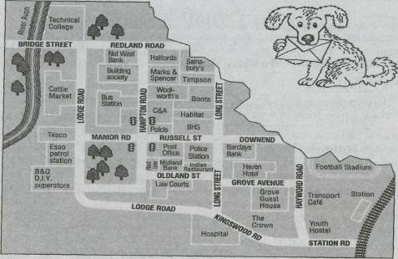

Technique Survey (Opinion Poll)
Aims:
to practice language
to practice functional language (asking for/giving information, asking for/giving opinion, etc.) to summarize in one's own words to communicate in real-life situation
Stages:
practice, production
guided/free speaking
pre-writing
post-reading, post-listening Patterns of interaction:
whole class (mingling), groups, pairs Procedure:
- Students are suggested or make their own
choice of the survey topic (e.g. Keeping dogs in urban
areas; Smoking in public places; Roles and responsi
bilities in the family; No right to strike for teachers).
- Students work out a questionnaire.
- The survey is carried out. In an English-speak
ing environment students can interview host fami
lies, local contacts, people in the street, etc. In non-
English-speaking situation they can interview mem
bers of their own class and other classes.
- Groups discuss the information they have man
aged to collect and write a report of their results,
with conclusions:
e.g. Almost everybody reported that …….. The majority of
people said that … The minority of people thought that …
Only a few people complained that … most of us/most people,
nearly all of us/nearly everybody, none of us/nobody, hardly any
of us/hardly anybody, a few people/some of us, about half/a
quarter/a third, etc.

Examples:
Variant 1. Class records
Each student in the group is given one question. They are to go around the
class and find out how many times everyone in the class had done some
things. When they have all finished, the information can be displayed on a
poster.

Find out how many times people in the group have been abroad.
Find out how many times people in the group have broken their arms.
Find out how many times people in the group have fallen in love.
Find out how many times people in the group have been to a rock concert.
Find out how many times people in the group have won something in the lottery.
Find out how many cities people in the group have visited.
Find out how many times people in the group have been shown on TV.
Find out how many times people in the group have got useless presents for birthday.

Variant 2. TV survey
Students complete the questionnaire, compare their answers and draw
a graph to show the results.

1) Which programmes do you like best?
Quiz shows I I News I I Cartoons I I
Soap operas I I Music programmes I I
Reason …………………………………….
2) Which programmes do your parents like?
Quiz shows I I News | I Cartoons I I
Music programmes I_I Soap operas I_I
Reason ……………………………….
3) Which programmes would you like to see more of and why?
Quiz shows I I News I I Cartoons I I
Soap operas I I Music programmes I I
Reason ……………………………………
4) Which programmes do you dislike and why?
Quiz shows | I News I I Cartoons I I
Soap operas I I Music programmes I I
Reason …………………………………..

Variant 3. Food survey
Variation 1
Students work in groups of equal size. Each group receives one topic of the
opinion poll (e.g. Breakfast, Food hates, Favourite meals, Cooking, etc.).
Students in a group agree on two or three questions they want to ask about
their topic. Each group member prepares a sheet with these questions. He
should fill in his own answers first.

What food do you hate?

Name | Food | Drink
me | raisins, bacon, lamb, marmalade, whole wheat bread | coffee, grapes juice

Then the groups are rearranged so that there is one member from each
group in each new group. If there were six groups (e.g. breakfast, drinks,
eating out, favourite dish, food hates, weight-watching) with five
members each, then there are now five new groups which have six
members each (one from each group). Each member of the new group has to
get the answers to his questions from all the other members of the group.
This means that in order to fill in his sheet each person has to talk to
everybody else in the group.
After that the original groups reassemble to organize their data. Each
group presents the results either in the form of a short talk or by
putting up lists, tables, etc. on the wall (or overhead projector), so that
everybody can have a look.

Variation 2
Students' task is to do a survey about eating. They are to find out about
the people in the class using the given questionnaire. Students are free to
cross out or add any questions they like, depending on what they think
the important and interesting issues are.

E.g.
Healthy food
- Have you ever thought of being a vegetarian?
- Do you ever count calories?
- Do you have a lot of sugar with your tea?
- Do you take vitamins regularly?
- Do you try to avoid fat food?
- Have you ever been on a slimming diet?
- Do you like to have snacks?
- Do you eat while watching TV/doing home tasks?
Having surveyed the classmates students draw a graph to show the number of students who answered Yes to each of the questions in the survey. After that they write a short report using the information they have collected.
E.g.
In a survey of …. (say how many) people from …. (say which classes) on (say what the survey was about) we found that ………….(give a brief summary of the results).

Variant 4. Find someone who...
Students are given a form using which they are to find out the necessary
information from their classmates.

Find someone who: | Name
— can speak three languages
— can draw a dragon-fly
— can't sing
— can't use a computer
— can cook

Variant 5. Music survey
Students work in groups of four and find out from each other the
necessary facts.

 | Student 1 | Student 2 | Student 3 | Student 4
1. Do you play any musical instruments?
2. If the answer to (1) is "yes", which ones?
3. If the answer to (1) is "no", would you like to learn?
4. Do you like to attend concerts of instrumental music?
5. Where did you last listen to classical music?

Technique Asking/Answering
Questions
Aims:
to check comprehension
to give/elicit information
Stages:
guided speaking, free speaking
pre-reading, pre-listening, pre-writing
while-reading, while-listening
Patterns of interaction:
groups, pairs, individually
Examples:
Variant 1. Questions to the text
Variation 1
Students read a text and answer questions.
Harold Stassen, who has died aged 93, became famous for his repeated attempts to become president of the United States. He stood a total of nine times between 1948 and 1992, only giving up his bid for the White House at the age of 85. But although his perpetual candidacy turned him into a national joke, Stassen was no crackpot or self-publicist, said The Economist: he was a serious politician who "believed it was his destiny to run America."
Born in Minnesota in 1907, Stassen was the son of immigrant Norwegian
farmers. He trained as a lawyer, and burst on to the political scene in1938
when, at the age of 31, he became the youngest governor of Minnesota in
the State's history.
In 1971, the commentator Stewart Alsop coined a new verb stassenised. "A stassenised politician," he explained, "is one who feels an ungovernable compulsion to become presidential candidate even when it is inconceivable that he will ever become president." Stassen found the jokes hurtful. "I sometimes wish people would ask not how many times I've run a campaign, but how many times I've been right on the big issues."
(Abridged from press)
Questions:
- At what age did Harold Stassen die?
- At what age did he have his last campaign?
- What was the dream of his life?

Variation 2
Students listen to the text and answer questions.
E.g.
Dick had bad marks. Father said, "If you learn well, I'll buy you a bicycle." "All right!" said Dick. "I'll learn well." And Dick began to learn better and father bought him a bicycle. In a month Dick got bad marks again. Father asked him, "Dick, what's the matter? You have got bad marks again. What did you do this month?" "I was busy with my bicycle," answered Dick.
What didn't father like about Dick?
- his business
- his studies
- his bicycle
- his friends
Variant 2. Open-ended questions
The teacher asks the students questions which do not presuppose the only correct answer and demand personal reflection, pondering and reasoning.
E.g.
Why do serious people sometimes do silly things?
Variant 3. Answers before questions
Before reading/listening to a text students are given a list of answers. Their task is to write questions for them.
E.g.
a) Who wrote it?
Virginia Woolf
b) ……………..
In the seventies.
c) ………………
It's fiction.
Variant 4. Clearing up and finding out
Students get the task to invent some machine and make a sketch of it on a
sheet of paper or a poster. No word should appear on the sketch.
Classmates ask one student questions until they find out what he has invented and how it should be used.


S1: Is it a kind of a spoon?
S2: Yes, it is.
S1: Is it for people with extra-sensitive teeth who need to clean them right
after they have eaten something?
Variant 5. Questioning for specific purpose
The teacher gives the students cards with a task to ask or answer a question only on some certain topic.
E.g.
Somebody in your class will ask you a question about your hobby.
Answer it. Reject questions on other topics.
Somebody in your class will ask you a question about your dreams for the future. Answer it. Reject questions on other topics.
Somebody in your class will ask you a question about holidays. Answer it. Reject questions on other topics.
Somebody in your class will ask you a question about your family. Answer it. Reject questions on other topics.
Ask your classmate a question about his hobby.
Ask your classmate a question about his dreams for the future.
Ask your classmate a question about his holidays.
Ask your classmate a question about his family.
Variant 6. Questions for writing
Students are given a list of questions using which they compose a piece of writing.
E.g.
Have you ever been in an embarrassing situation? Can you describe it?
Where did it happen? Why did it happen? What were the consequences?
Who was with you? How did you find the way out? Etc.

Technique Communicative games
Aims:
to get involved into real communication
to use acquired language meaningfully and freely
Stages:
production
guided speaking, free speaking
post-reading, post-listening, post-writing
Patterns of interaction:
whole-class (mingling activity), groups, pairs, individually
Examples:
Variant 1. Who is who?
The teacher tells the students to cut out a badge in the shape and colour
they want. Then the students write or draw some personal information on
the card.
E.g.
— name or nickname (if the student has one);
— the animal they admire most;
— the sport they enjoy;
— the meals they prefer; etc.
The students walk around for a few minutes and read the
information on the other students' badges. The teacher may play
music during this stage. When the teacher stops the tape or gives a
pre-arranged signal, each student asks those around him/her about
the information on their badges (e.g. How often do you go to the
hockey matches? Do you prefer to play hockey or to watch TV?). This
can be repeated several times.

Variant 2. Wheels
Students stand in 2 circles: inner and outer, face to face.
o
o o o o o
o o o o o
o
The teacher gives some stimulus (a topic for discussion/recycling or
information to find out). The students communicate in pairs for 1
minute. Then the teacher claps/signals and the outer circle students
make one step to the left. The teacher gives another stimulus. This
activity provides a real-life communication with different partners
and lets a number of students communicate simultaneously.

Variant 3. Fishy story
One half of the class is asked to write down five true and five false statements
about themselves on slips of paper. The other half of the class does not know
that the students have been asked to write untruths as well as truths. The
teacher collects the slips, and for each student mixes up the truths with the
untruths. The slips are handed out to the other half of the class who must
interview the writers of the slips to check the truthfulness of their
statements. The aim is to catch the person in a lie.
E.g.
S₁ (the slip of paper says S₂ has a twin-brother): Are you sure you have a twin-brother?
S₂: Well, yes, I am.
S₁: Why haven't we ever seen him?
S₂: He lives in another city.
S₁: That can't be true, as I know for sure that you are an only child in your family.
Etc.

Variant 4. Evidence
A "detective" is standing with his/her back to the blackboard. The teacher
writes about an incident on the blackboard. Others are "witnesses" and
suggest evidences.

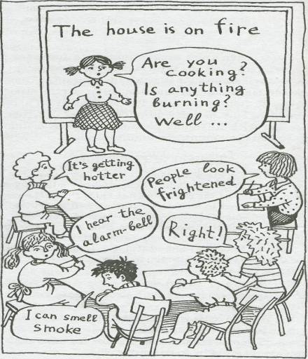

Variant 5. Alibi
The teacher announces that a crime has been committed by at least two
people at a specified time and place, e.g.: railway station, Wednesday,
between 6 and 8 p.m. Two students take on the roles of police
investigators. It is their job to find out who the prime suspects are. Most of
the other class members are given alibi cards which describe their actions at
the time the crime was committed. Some of the alibi cards are identical —
two people were together and so can confirm each other's alibi. The
remaining students are given witness cards which conflict with the other
cards, e.g. "You saw Maria walking past the Post Office at 6.30 p.m." when
Maria's card says: "You were in the pub with Juan between 5.30 and 9
p.m." The investigators question each person about his/her actions and
come to the conclusion about the most possible criminal.

E.g.
Samples of alibi cards:
1. You were at home all the day long.
2. You were in the pub with Alice.
3. You had a chat with Debbie in the pub.
Samples of witness's cards:
- You know Jeff was at home at 6 p.m. because you rang him up to ask about the result of the football match you've missed.
You saw Kevin running
- You saw Kevin running down Marble Street.

Variant 6. Crazy compliments
The teacher sticks a card on the back of each student in the class. The
students must not see their own cards. They walk around the class, read
the instructions on their friends' backs and follow these instructions. The
task is to guess the message on your back within the time limit the teacher
sets. The first one to guess is the winner.
TELL ME SOMETHING NICE ABOUT MY ENGLISH!
TELL ME SOMETHING NICE ABOUT MY SMILE!
TELL ME HOW YOU LIKE MY JOKES!
SAY SOMETHING NICE ABOUT MY CLOTHES!

Variant 7. Interrupting game
The teacher (or a volunteer student) starts to talk on a topic. Anyone in
the classroom can interrupt him/her using phrases like: "Excuse me for
interrupting...", "May I ask a question...", etc. The speaker must respond
and then get back to the topic. The class members' aim is to sidetrack the
speaker whilst his/her aim is to finish the narrative despite all the
interruptions.

Variant 8. Market place
Each student writes three ideas on a given topic on three slips of paper
and goes around the class trying to "sell" them. He/She comes up to any
students of the class and explains his/her idea. If the other student likes
it, he/she may buy the idea (take the slip of paper with the idea written on
it and put his/her surname on it). Time limit should be provided. The
winner is the one whose idea was supported by most of the students.

Литература

1.Пассов Е.И., Кузовлев В.П., Коростелев В.С. Цель обучения иностранному языку на современном этапе развития общества. Общая методика обучения иностранным языкам. Хрестоматия / Ред. Леонтьев А.А. М., 1991.

2.Leo van Lier. The Classroom and the Language Learner. Longman; New York, 1988.

3.Баграмова Н.В. Интерактивный подход в обучении иностранным языкам.

4.Леоньев А.А. Психология общения. М., 1999.

5.Парыгин Б.Д. Анатомия общения. СПб, 1999.

6.Маркова А.К. Психологическая концепция учебной деятельности // Сб. науч. тр. МГПИИЯ им. М.Тореза. Bып. 162. 1980. C. 3-
7.T.Oschepkova, M. Prolygyna, D. Starkova Tech-Pack collection of up-to-date classroom techniques.

