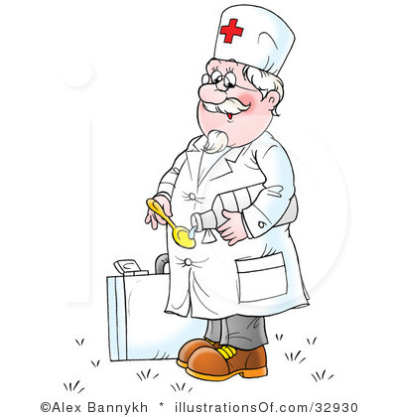

Look at these pictures . Can you answer these questions?

-What is he/she?

-What does he/she look like?

-What is he/she wearing?

-What kind of person is he/she?

-What is he/she doing?

-How do you feel about doing this kind of thing?

-Why?

Приложение 1.

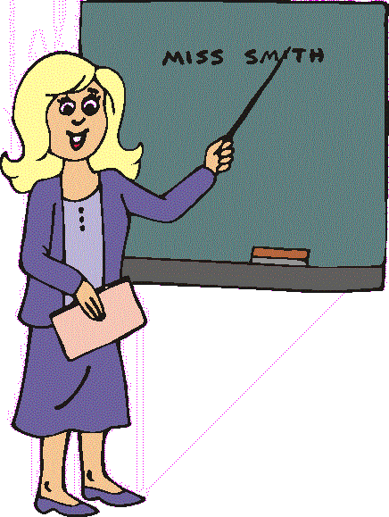

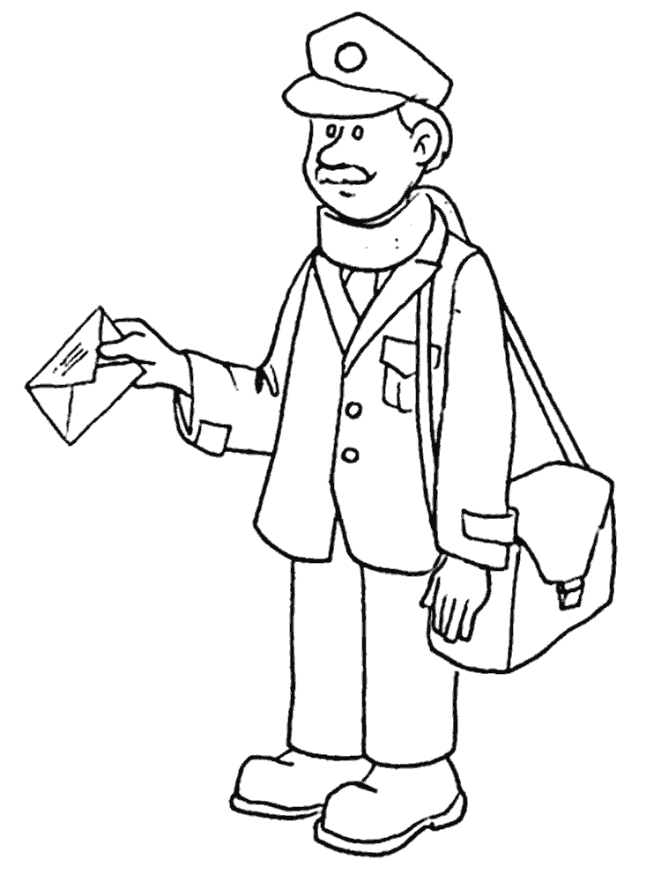

Приложение 2.

Look at these pictures .Compare and contrast them. Which of the products here do you find the healthy ones? Do you use any of these products? Do you ever refuse to use something out of it? Why?

|  |
| --- |
| http://s54.radikal.ru/i143/1007/a3/9961449ff8b5.jpg |
| http://www.astronim.com/i/portfel/lays_pachka_500.gif |
| http://www.si-7.com/uploads/product/148.jpg |
| http://cndru.durovloh.ru/umedia/142000/141759/720878.jpg |

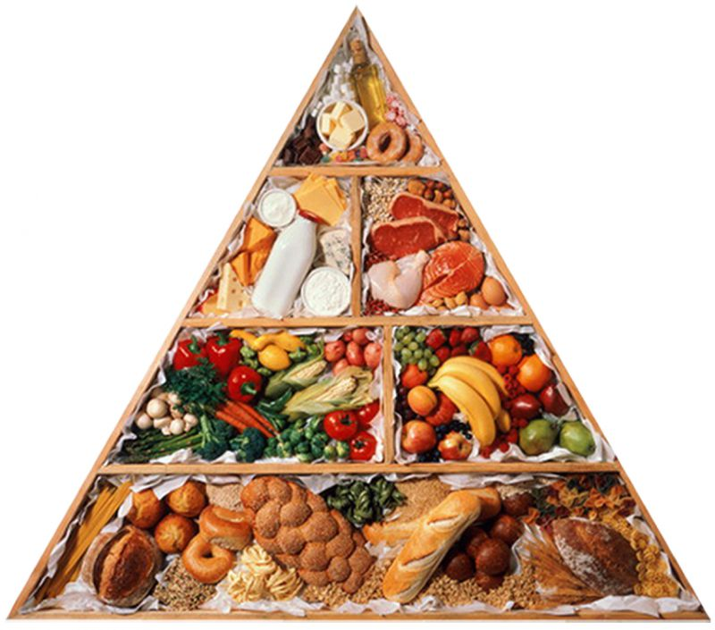

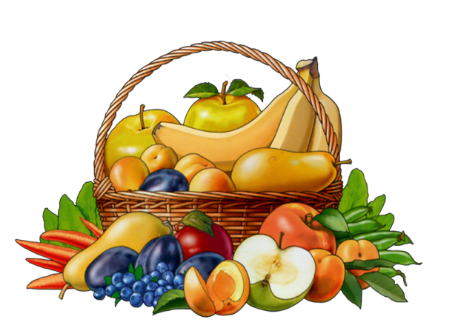

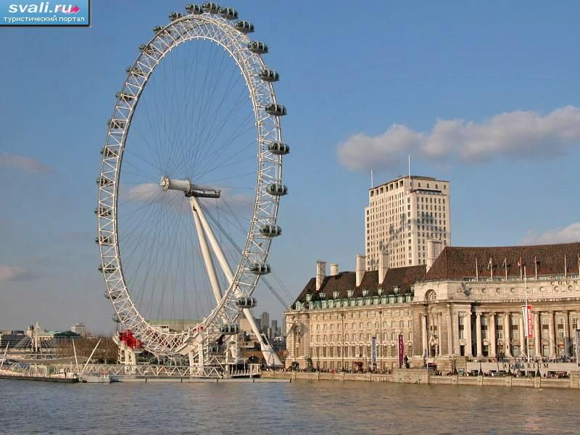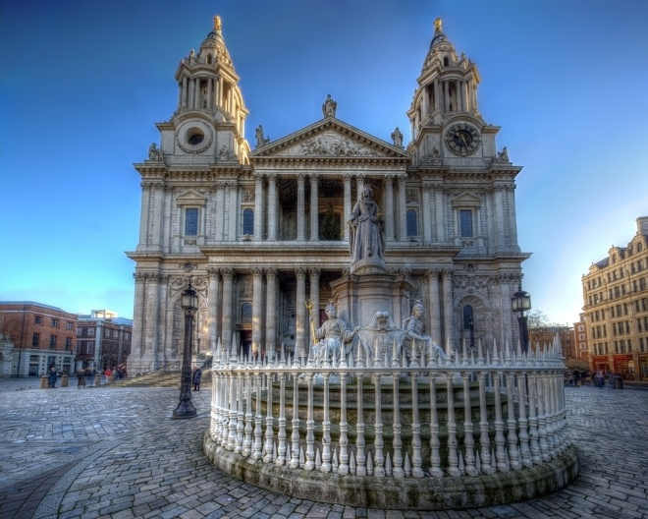Imagine that you have a chance to visit the UK. What would you like to see? Why? Do you know the history of it?

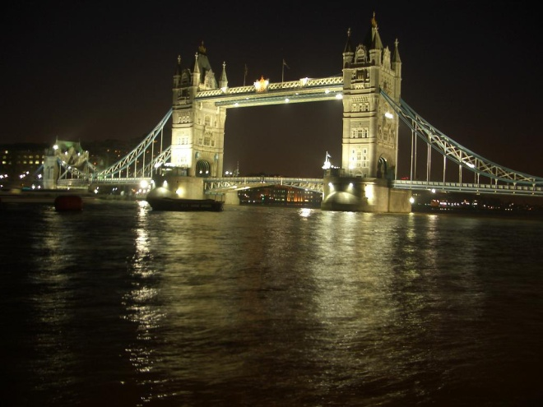

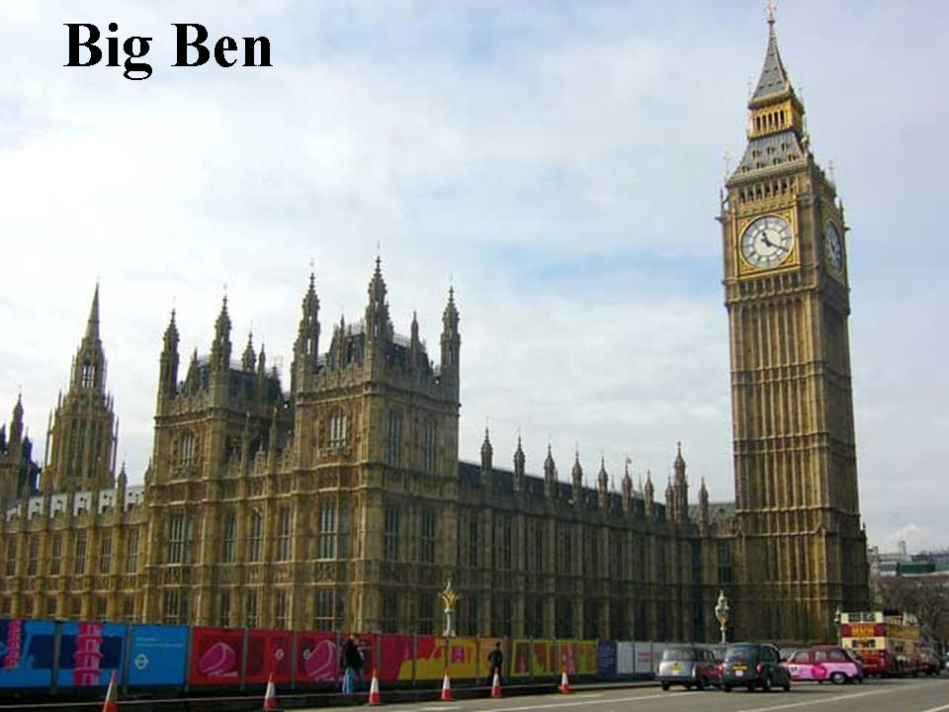Приложение 3.

Why is it so popular among the tourists? Where is it? What is the historic value of this place? Why are the British people so proud of it?

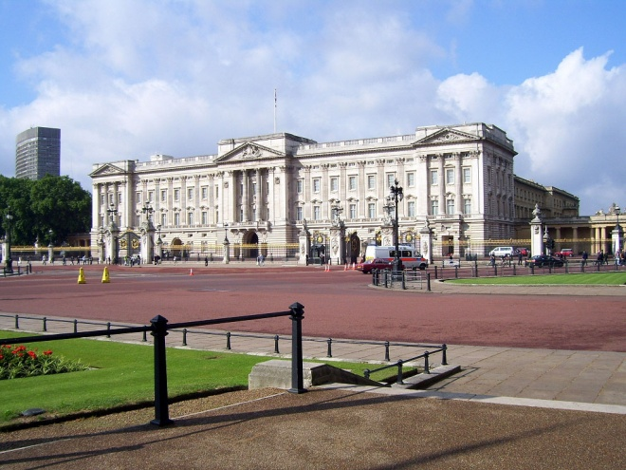

Приложение 4.

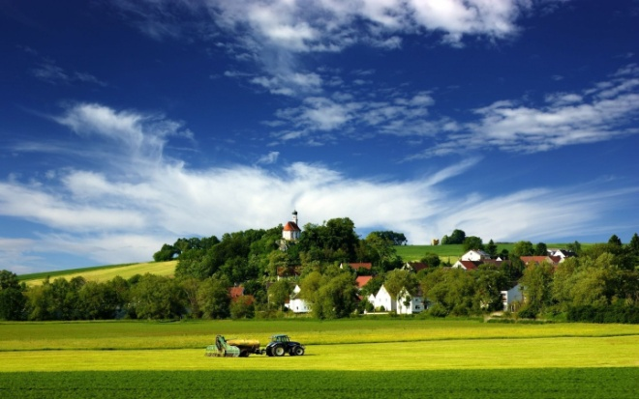



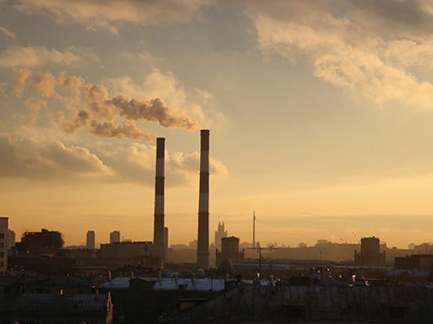

You have a set of pictures. Your task is to make up a story based on these pictures.

These questions help you.

-What was at the beginning?

-What was then?

-What was after that?

-What happened finally?

