План-конспект внеклассного мероприятия
для 4 и 5 классов
« Travelling with Chuckles»

Цели мероприятия:
1.Образовательная: Расширение эрудиции учащихся.
2.Развивающая: Развитие языковых, познавательных способностей учащихся.
3. Воспитательная: Формирование познавательной активности учащихся, а также их интереса к изучению языка. Воспитание чувства товарищества, взаимопомощи и ответственности.
Оборудование:
Плакат паровоза с вагонами, изображение Чаклза, раздаточный материал, маски, искусственные продукты, наглядность.
Ход мероприятия:
- Организационный этап. Объяснение целей.
  - Dear boys and girls, I’m very glad to see you. I hope you are ready to work and have a fun. Sit down, please. Today we’ll have a competition between two teams. We’ll travel with Chuckles. We will have some interesting stations, which will check how well you know English. Are you ready? Ok. Let’s begin.
- Introduction.
Look at Chuckles. He is on the first station. It name is lexicon. At first each team should choose the leader and think the name. Then the members of the teams will ask the questions to each other. We’ll see who is the most skillful in this.

  - What’s your name?
  - Where are you from?
  - How old are you?
  - Have you got a sister?
  - What's your favorite subject?
  - Do you like to play computer games?

You are great! Thank you very much!
III.
- Now, the following task is « Can you find the odd word? »
- Math ,pencil, PE, History
- Desk, teacher, blackboard, bike
- Year, month, week, pupil
- Whale, seal, hippo, room
- Angry, hungry, classroom, sad
- « Put the words in the correct order»
- Yesterday Marry and I were at the cinema.
- Last week they were at the theatre.
- The food was really delicious!
- The film was really interesting!
`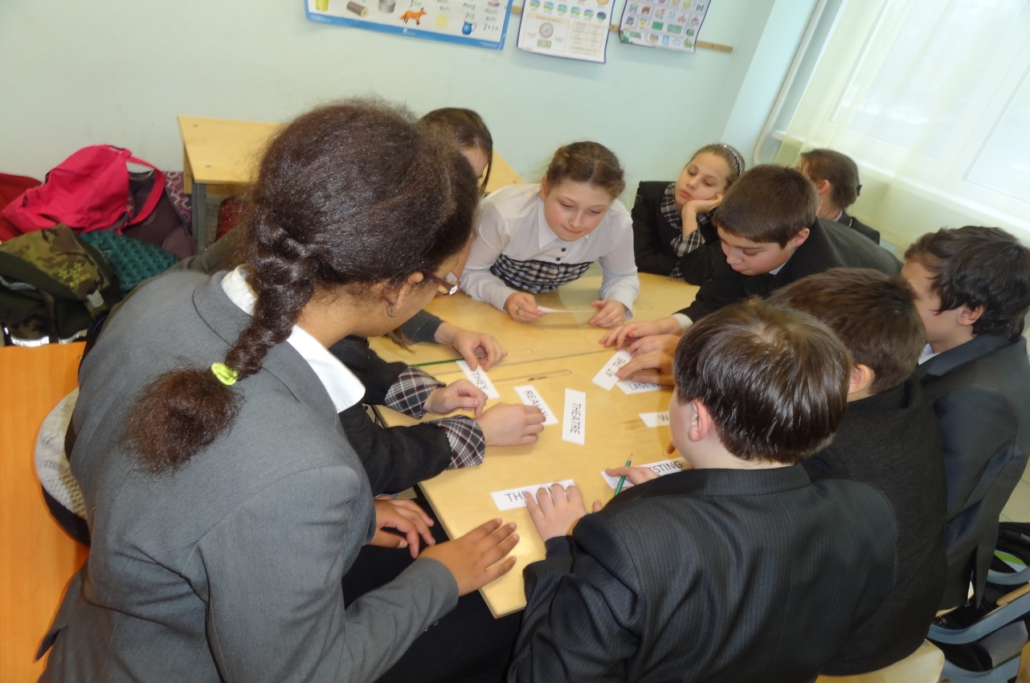

You've have coped with task excellent . Good for you!

- «Riddles»
Boys and girls, I see Chuckles wants to make puzzle for you. Our station is «Riddles»
  - I have four legs, but I can't walk.
  - I’m tall and green, I’m in the garden.
  - It doesn’t have legs, but it goes.
  - It isn’t man, it isn’t woman, but it teaches us.
  - I’m black and red and blue. I draw a picture for you.
  - I don’t Know ABC, but I’m writing as you can see.
( a chair)
( a tree)
( a watch)
( a book)
( a pencil)
- Chuckles is sure you know animals well, isn’t he?
This station is «Animals»
- What are the missing letters?
s..a.. w..al..
d..lp..i.. l..z..r..
h..pp.. g..r..f….
t….ge.. b..a..
- Show the animals without any words.
(Ребята изображают животное так, чтобы команда догадалась)
- Crossword
(find 6 animals, who’s faster? )
- Describe the animal using has got/hasn’t got/can/can’t
( It’s a small animal. It has got four legs. It can swim and jump, but it can’t run. )
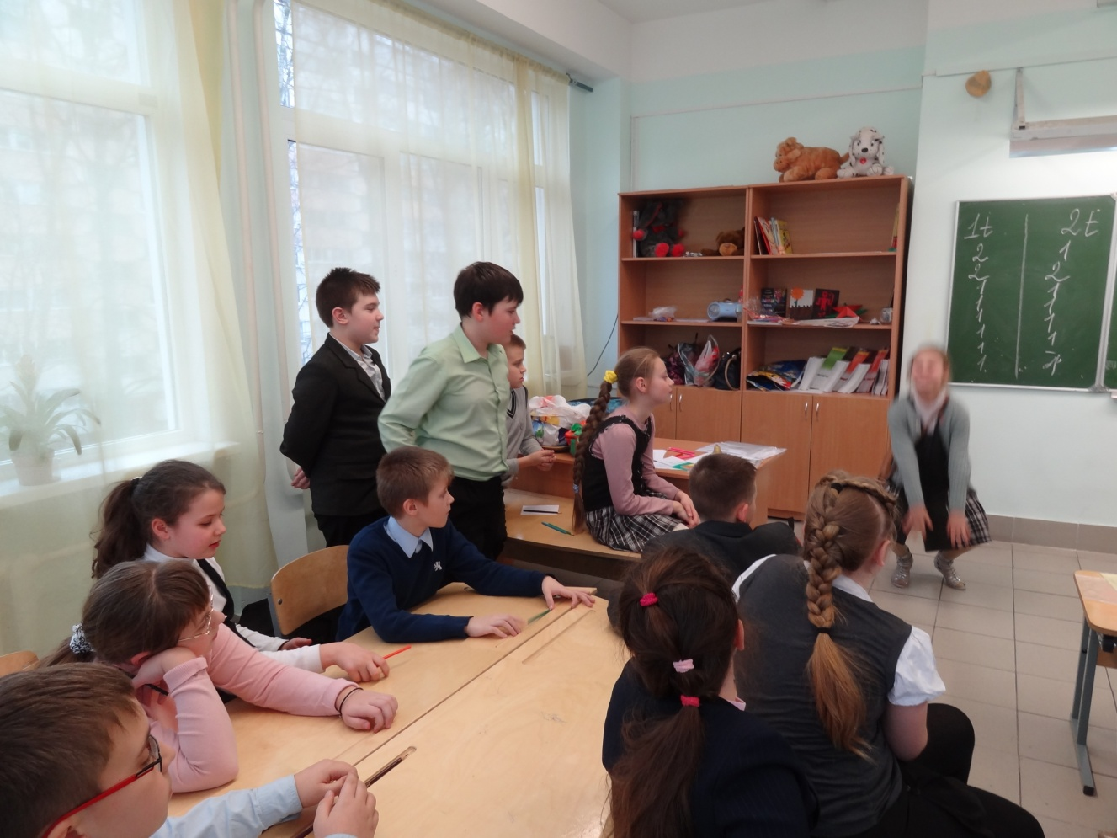
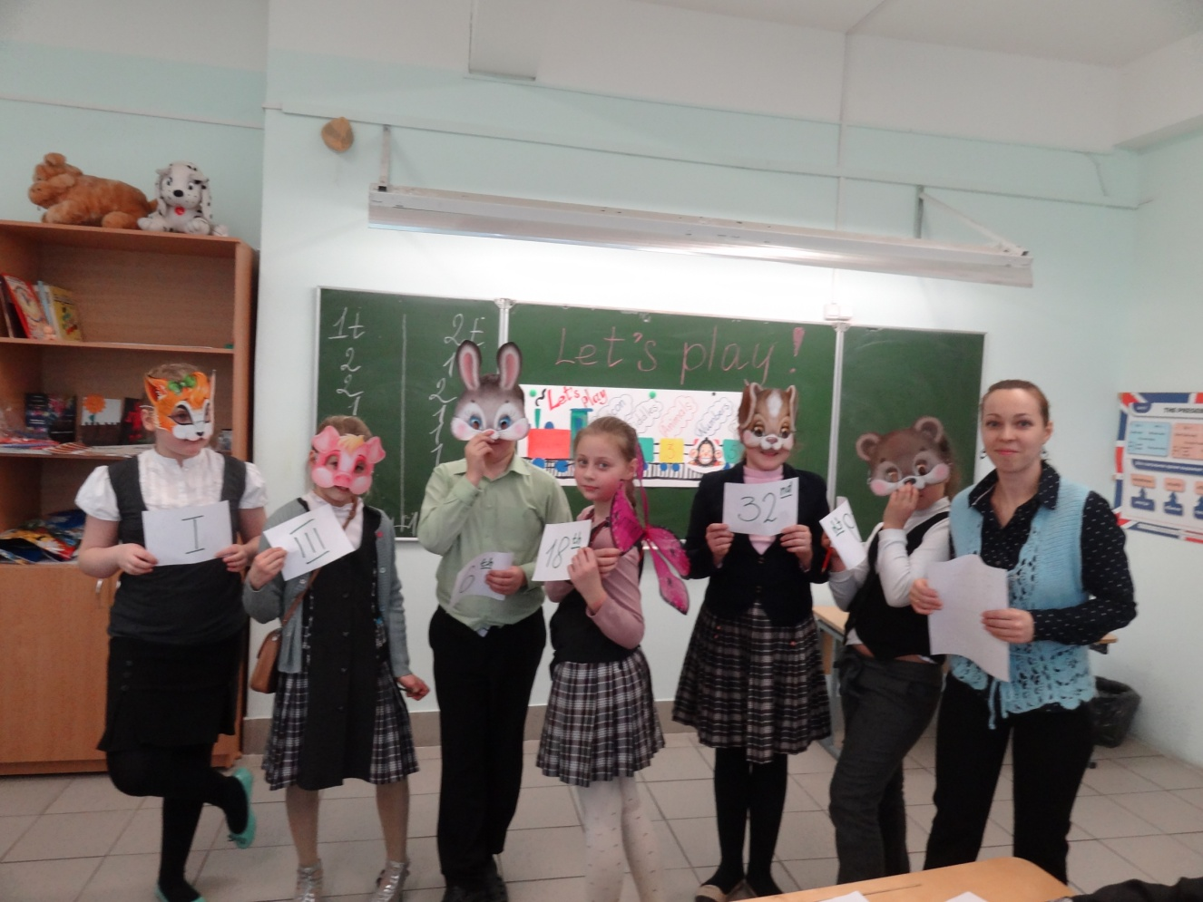
- The following station is «Numbers»
Can you count? You have got some masks. Put the animals in the right order. Count, please.
- The hare is the third. The tiger is the nineteenth. The pig is the thirty-first. The bear is the sixty-fifth. The butterfly is the eightieth. The dog is thirteenth.
- Write the dates.
( 8 Марта, 1 Сентября, 31 Декабря, 23 Февраля, 9 Мая )
- Good for you, children. Are you hungry? Chuckles likes the following station. Let's play in interesting game.
- You should put this food in three bags. They are fruits/vegetables/food. Who will be faster and correct?
( Это командное соревнование на время. Проверяется знание продуктов.)
- The following task cheks your memory. Look at the picture for 1 minute. Then answer on my question. If you guess and answer correct you’ll get 1 point.
( Ребята смотрят на картину, где изображены продукты. Их задача-максимально точно ее запомнить и правильно ответить на вопросы.)
How many bananas are there?
How much sugar is there?
- You are great! Thank you! But look at Chuckles, he wants to finish our traveling and supposes to visit last station, which names Drawing.
I’ll give you a paper and some different pencils. Then both of teams listen to me and draw a picture. The team which drew more correct won. Are you ready?

I've got a small room. There is one yellow table in the middle of my room. There are red apples and green pears on the table. The window is in front of the door in my room. There is my bed next to the window where my cat likes to sleep. I like reading and I’ve got many books on the shelf next to the door. But I like play with my ball as well. It is under the shelf and it’s look like an orange.

Now let’s count your points. Chuckles is very glad, he liked our traveling. And what about you? Did you like it? Thank you for interesting game, it was really amazing! See you later.

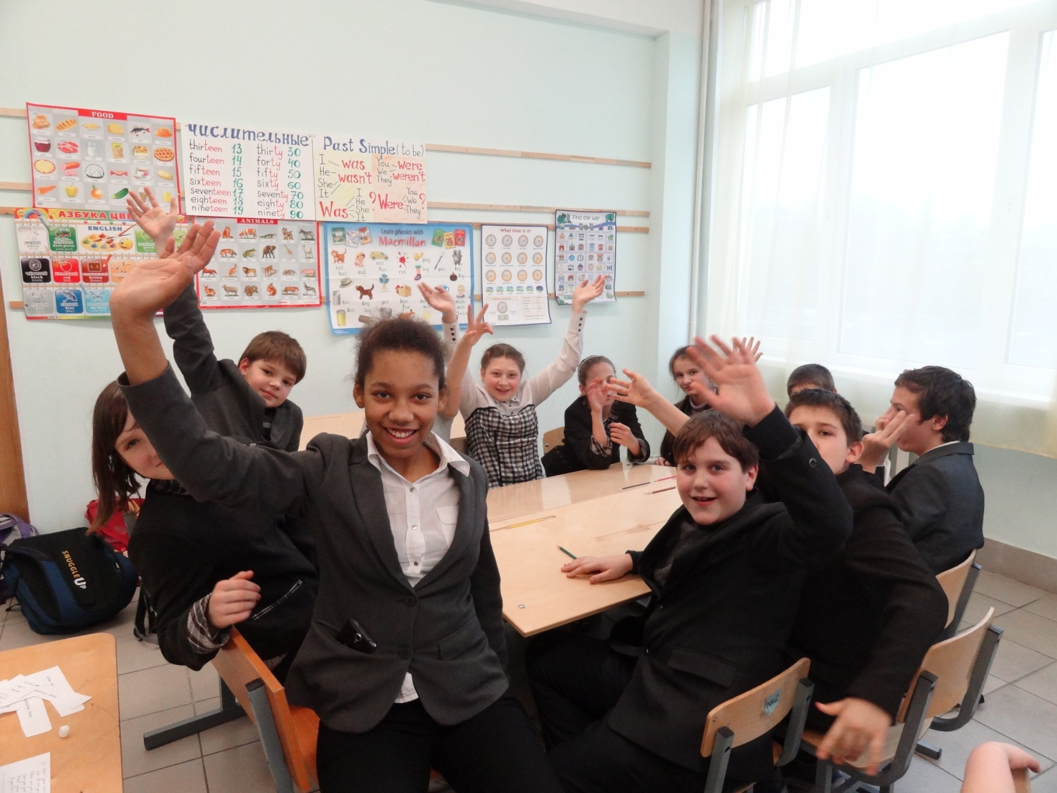

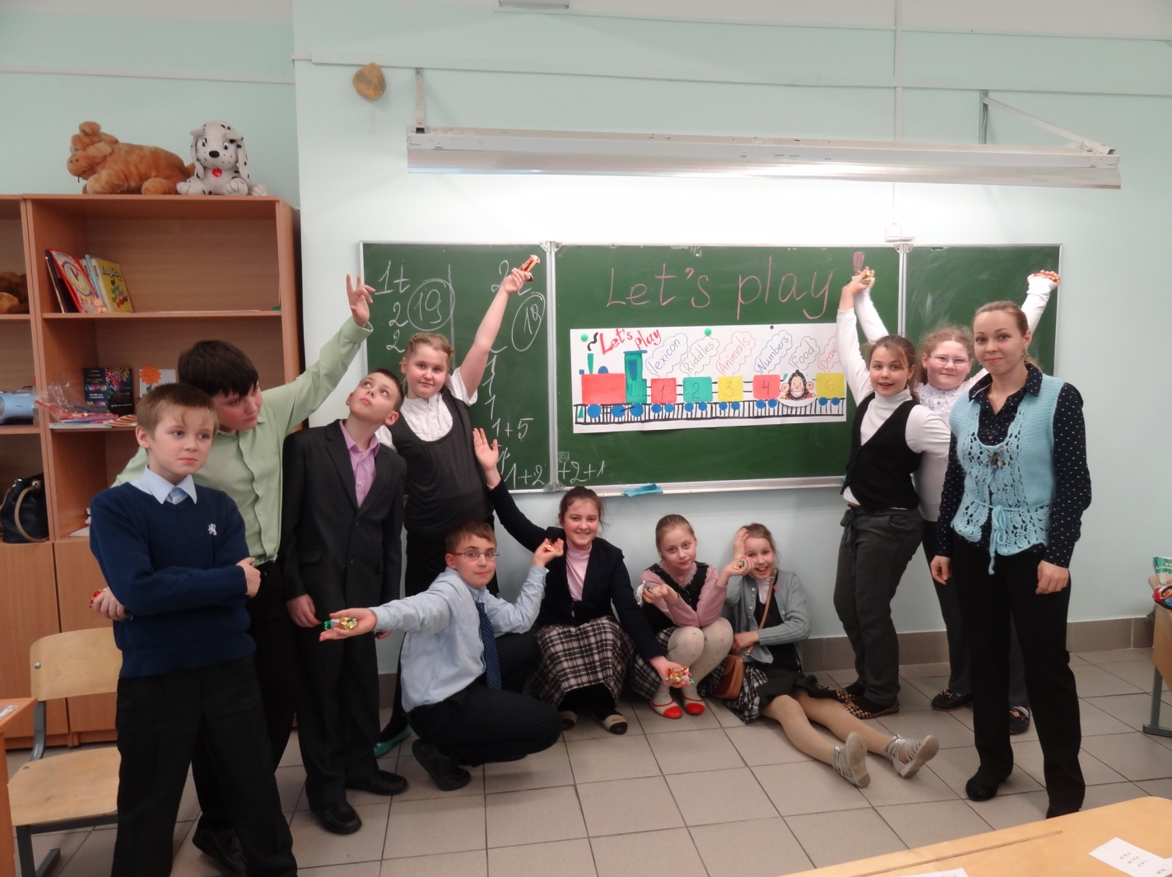

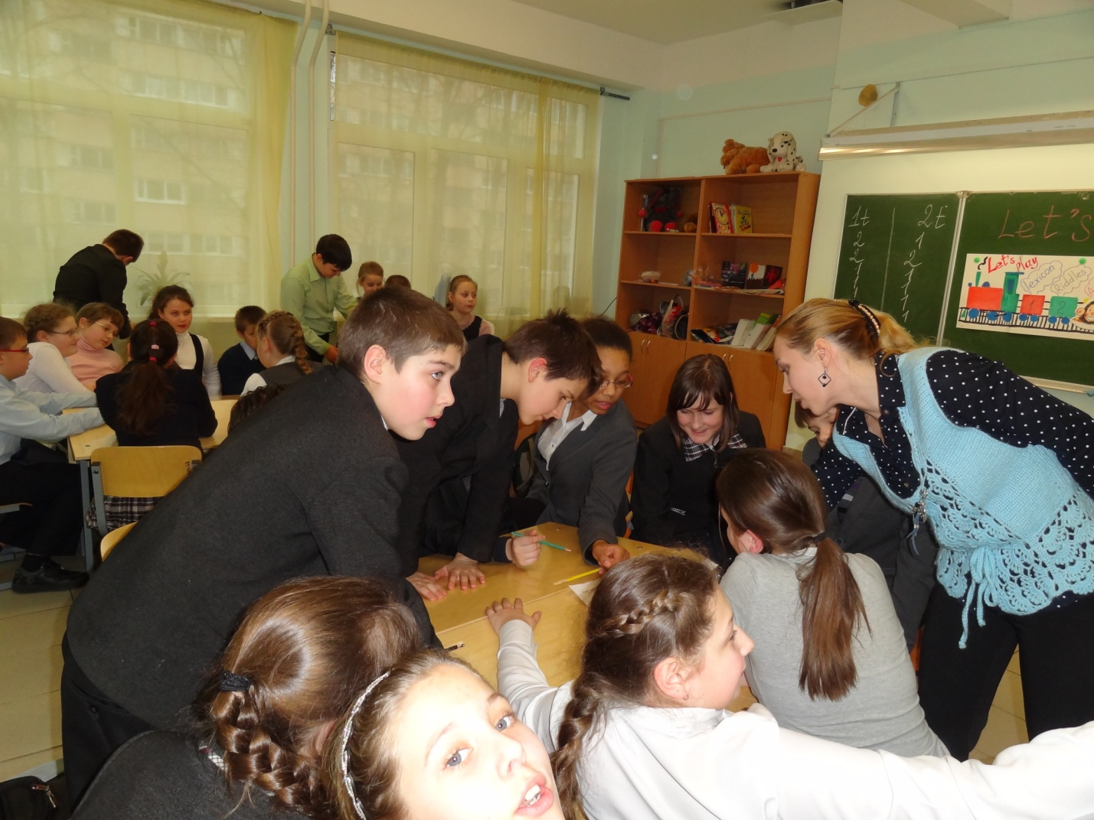
V.

