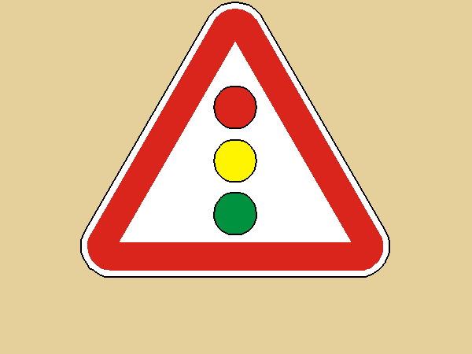

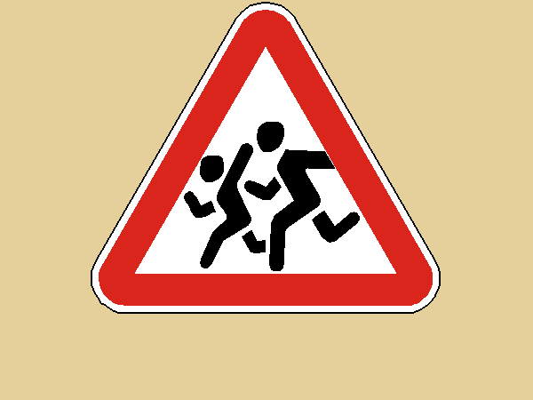

&Ocy;&Bcy;&ZHcy; 1 &kcy;&lcy;&acy;&scy;&scy;, &Pcy;&Dcy;&Dcy;: &dcy;&ocy;&rcy;&ocy;&zhcy;&ncy;&ycy;&iecy; &zcy;&ncy;&acy;&kcy;&icy;.
 &Zcy;&acy;&pcy;&rcy;&iecy;&shchcy;&acy;&yucy;&shchcy;&icy;&jcy; &zcy;&ncy;&acy;&kcy; 3.9 &Dcy;&vcy;&icy;&zhcy;&iecy;&ncy;&icy;&iecy; &ncy;&acy; &vcy;&iecy;&lcy;&ocy;&scy;&icy;&pcy;&iecy;&dcy;&acy;&khcy; &zcy;&acy;&pcy;&rcy;&iecy;&shchcy;&iecy;&ncy;&ocy; &Kcy;&acy;&rcy;&tcy;&icy;&ncy;&kcy;&icy; &dcy;&lcy;&yacy; &ncy;&acy;&chcy;&acy;&lcy;&softcy;&ncy;&ocy;&jcy; &shcy;&kcy;&ocy;&lcy;&ycy; &vcy; 1 &kcy;&lcy;&acy;&scy;&scy;&iecy;. &Ucy;&chcy;&iecy;&bcy;&ncy;&acy;&yacy; &pcy;&rcy;&ocy;&gcy;&rcy;&acy;&mcy;&mcy;&acy; &ocy;&bcy;&shchcy;&iecy;&ocy;&bcy;&rcy;&acy;&zcy;&ocy;&vcy;&acy;&tcy;&iecy;&lcy;&softcy;&ncy;&ocy;&jcy; &shcy;&kcy;&ocy;&lcy;&ycy;; &icy;&zcy;&ocy;&bcy;&rcy;&acy;&zhcy;&iecy;&ncy;&icy;&yacy; &kcy; &rcy;&acy;&zcy;&dcy;&iecy;&lcy;&ucy; &Scy;&icy;&mcy;&vcy;&ocy;&lcy;&ycy; &icy; &zcy;&ncy;&acy;&kcy;&icy;; &kcy; &dcy;&iecy;&tcy;&scy;&kcy;&icy;&mcy; &icy;&gcy;&rcy;&acy;&mcy; &dcy;&lcy;&yacy; &ucy;&rcy;&ocy;&kcy;&ocy;&vcy; &pcy;&rcy;&icy;&rcy;&ocy;&dcy;&ocy;&vcy;&iecy;&dcy;&iecy;&ncy;&icy;&yacy; &icy; &ocy;&kcy;&rcy;&ucy;&zhcy;&acy;&yucy;&shchcy;&iecy;&gcy;&ocy; &mcy;&icy;&rcy;&acy;

