**1 в.**

**1.** Подчеркни в задаче синей чертой условие и красной чертой вопрос. Составь схему и реши задачу.

*Миша вырезал 3 снежинки, а Рита – 2. Сколько снежинок вырезали ребята вместе?*

|  |  |  |  |  |  |  |  |  |  |  |  |  |  |  |  |  |  |  |  |  |  |  |  |  |
| --- | --- | --- | --- | --- | --- | --- | --- | --- | --- | --- | --- | --- | --- | --- | --- | --- | --- | --- | --- | --- | --- | --- | --- | --- |
|  |  |  |  |  |  |  |  |  |  |  |  |  |  |  |  |  |  |  |  |  |  |  |  |  |
|  |  |  |  |  |  |  |  |  |  |  |  |  |  |  |  |  |  |  |  |  |  |  |  |  |
|  |  |  |  |  |  |  |  |  |  |  |  |  |  |  |  |  |  |  |  |  |  |  |  |  |
|  |  |  |  |  |  |  |  |  |  |  |  |  |  |  |  |  |  |  |  |  |  |  |  |  |

**2.** Напиши знаки >, < или =

5...4 3+1...4 8...7+2

6...8 3+2...4 9...10-1

3...3 6-2...5 4...2+2

**3.** Составь запись по рисунку.

|  |  |  |  |  |  |  |  |  |  |  |  |  |  |  |  |  |  |  |  |  |  |  |  |  |
| --- | --- | --- | --- | --- | --- | --- | --- | --- | --- | --- | --- | --- | --- | --- | --- | --- | --- | --- | --- | --- | --- | --- | --- | --- |
|  |  |  |  |  |  |  |  |  |  |  |  |  |  |  |  |  |  |  |  |  |  |  |  |  |
|  | О | О | О | ∅ | ∅ |  |  |  |  | Δ | Δ | Δ | ♦ |  |  |  |  | ° | ° | • | • | • | • |  |
|  |  |  |  |  |  |  |  |  |  |  |  |  |  |  |  |  |  |  |  |  |  |  |  |  |
|  |  |  |  |  |  |  |  |  |  |  |  |  |  |  |  |  |  |  |  |  |  |  |  |  |

**4.**

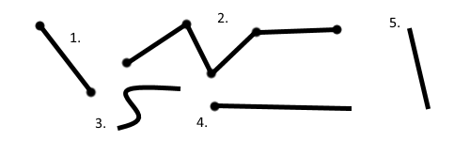

Напиши:

Номер отрезка .....

Номер луча .....

Номер ломаной .....

Номер кривой .....

Номер прямой .....

Посчитай у ломаной количество:

Звеньев ..... Вершин .....

**2 в.**

**1.** Подчеркни в задаче синей чертой условие и красной чертой вопрос. Составь схему и реши задачу.

*В миске лежало 8 груш.2 груши в обед съели. Сколько груш осталось в миске?*

|  |  |  |  |  |  |  |  |  |  |  |  |  |  |  |  |  |  |  |  |  |  |  |  |  |
| --- | --- | --- | --- | --- | --- | --- | --- | --- | --- | --- | --- | --- | --- | --- | --- | --- | --- | --- | --- | --- | --- | --- | --- | --- |
|  |  |  |  |  |  |  |  |  |  |  |  |  |  |  |  |  |  |  |  |  |  |  |  |  |
|  |  |  |  |  |  |  |  |  |  |  |  |  |  |  |  |  |  |  |  |  |  |  |  |  |
|  |  |  |  |  |  |  |  |  |  |  |  |  |  |  |  |  |  |  |  |  |  |  |  |  |
|  |  |  |  |  |  |  |  |  |  |  |  |  |  |  |  |  |  |  |  |  |  |  |  |  |

**2.** Напиши знаки >, < или =

7...8 7-1...6 5...7+2

6...3 7-2...6 8...10-2

5...5 4+2...5 3...2+2

**3.** Составь запись по рисунку.

|  |  |  |  |  |  |  |  |  |  |  |  |  |  |  |  |  |  |  |  |  |  |  |  |  |
| --- | --- | --- | --- | --- | --- | --- | --- | --- | --- | --- | --- | --- | --- | --- | --- | --- | --- | --- | --- | --- | --- | --- | --- | --- |
|  |  |  |  |  |  |  |  |  |  |  |  |  |  |  |  |  |  |  |  |  |  |  |  |  |
|  | О | О | О | ∅ | ∅ | ∅ |  |  |  | Δ | Δ | Δ | ♦ | ♦ |  |  |  |  | ° | • | • | • | • |  |
|  |  |  |  |  |  |  |  |  |  |  |  |  |  |  |  |  |  |  |  |  |  |  |  |  |
|  |  |  |  |  |  |  |  |  |  |  |  |  |  |  |  |  |  |  |  |  |  |  |  |  |

**4.**

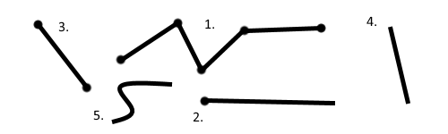

Напиши:

Номер отрезка .....

Номер луча .....

Номер ломаной .....

Номер кривой .....

Номер прямой .....

Посчитай у ломаной количество:

Звеньев ..... Вершин .....