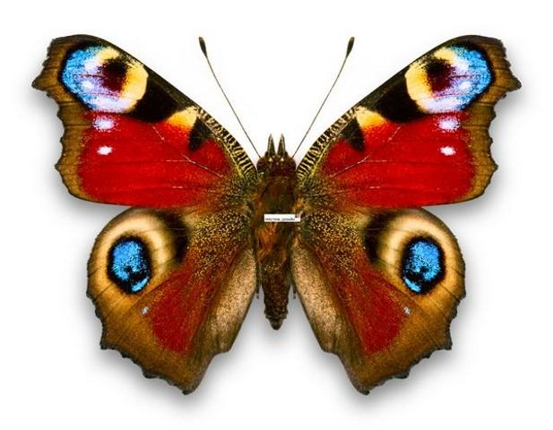

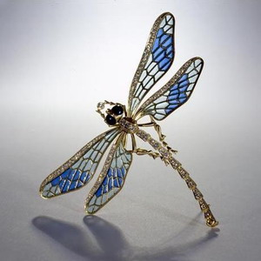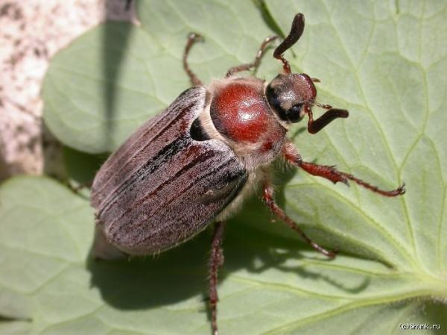

**один раз отмерь Семь раз отрежь**

|  |  |  |
| --- | --- | --- |
| 5 |  | 5 |
|  |  |  |
| 6 |  | 6 |
|  |  |  |
| 7 |  | 7 |

|  |  |  |
| --- | --- | --- |
| 5 |  | 6 |
|  |  |  |
| 6 |  | 7 |
|  |  |  |
| 7 |  | 5 |

|  |  |  |
| --- | --- | --- |
| 5 |  | 7 |
|  |  |  |
| 6 |  | 5 |
|  |  |  |
| 7 |  | 6 |

|  |  |
| --- | --- |
| **7** | |
| **1** |  |
| **2** |  |
| **3** |  |
| **4** |  |
| **5** |  |
| **6** |  |
| **7** | |
| **1** | **6** |
| **2** | **5** |
| **3** | **4** |
| **4** | **3** |
| **5** | **2** |
| **6** | **1** |

|  |  |
| --- | --- |
| **7** | |
|  |  |
|  |  |
|  |  |
|  |  |
|  |  |
|  |  |

**7я**