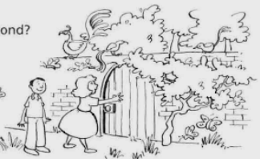
Describing setting
Read the beginning of the story.
Anna and Tom passed a big house on their way home from school every day. Who lived there? No one knew. All around the house there was a high wall. Through the gate they could only see the beginning of the garden.
One day the children were bored. They decided to have an adventure and explore the garden. Anna and Tom climbed the high wall and jumped down on the other side. They stopped and looked and listened…

Now imagine what they could see, hear, smell and feel there. Continue the story and describe the setting.
_____________________________________________________________________________________________________________________________________________________________________________________________________________________________________________________________________________________________________________________________________________________________________________________________________________________________________________________________________________________________________________________________________________________________________________________________________________________________________________________________________________________________________________________________________________________________________________________________________________________________________________________________________________________________________________________________________________________________________________________________________________________________________________

