Besides IWB is used for reading books on it. Reading aloud to and with the children is really important and at an early stage of LL oral language need to be supported by print. It is helpful to point to the words while reading – something that can’t be done with a real book.
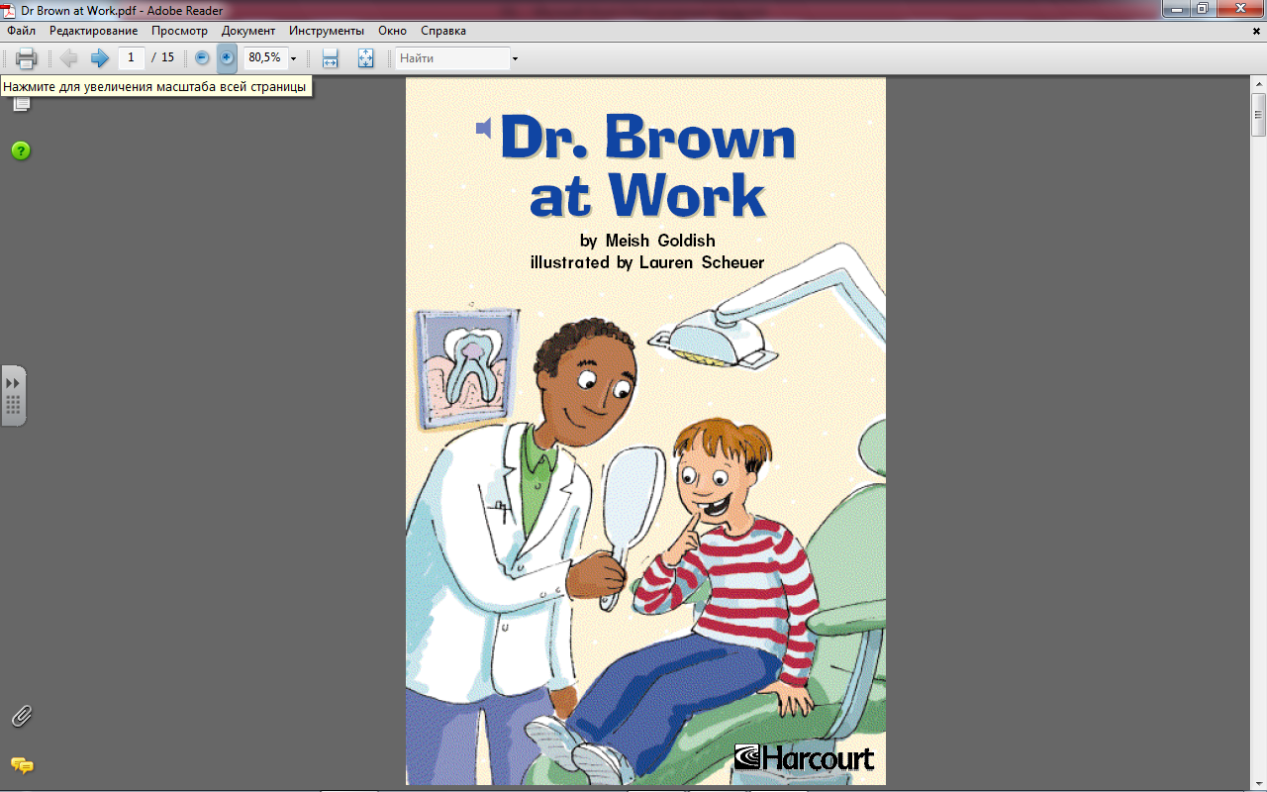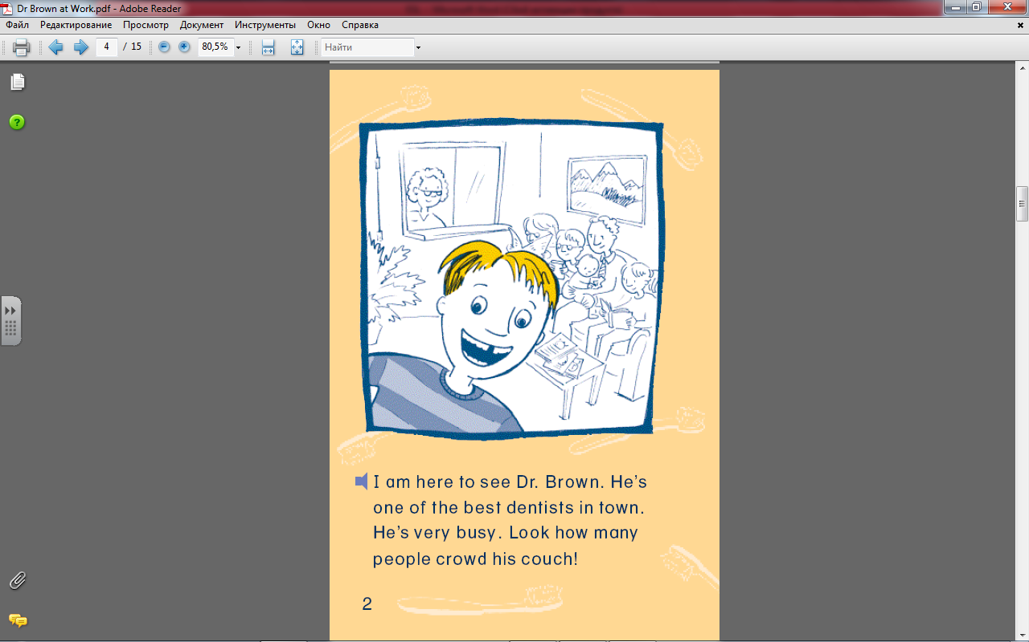

So, pictures, pictures should be present all the time. Visual images help young learners to feel through the task. Emotion is the on/off switch for learning and positive emotional response is extremely important on the way to educational success and enjoyment in learning.

Having children from different countries it is really important to learn some information about their language and culture. There may be a place for great communicative differences.
- Korean students
- Japanese students
- Russian students

Language transfer errors are very frequent for beginning EAL. Some sentences that are produced by Korean/Japanese Russian students may sound horrible but they are the result of linguistic differences. The child does not intend to irritate the teacher keeping up doing the same mistakes, he or she only builds sentences according to the structure common for the first language.

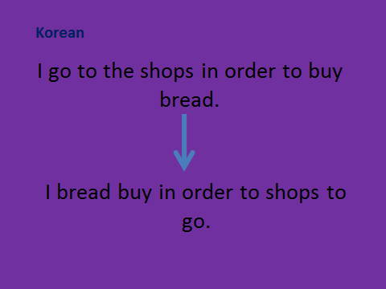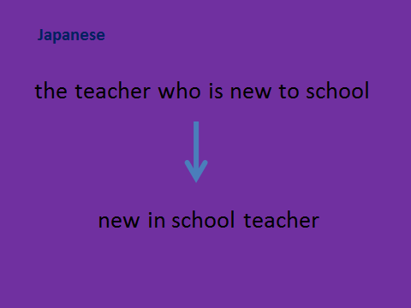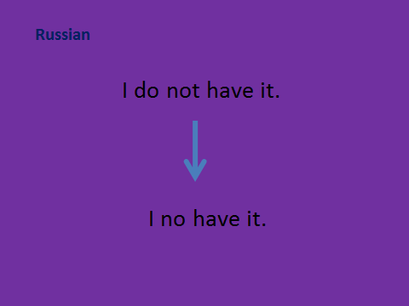

Final point is the way teacher speaks to EAL students. Talking slowly, repeating, paraphrasing, using synonyms and trying to avoid slang and idioms. Still, sometimes even common classroom language can be confusing to children, as in case of using phrasal verbs.
The teacher gives some basic instructions to the children that seem easy to understand but he gets no reaction back as they only know the primary meaning of the verbs being used.

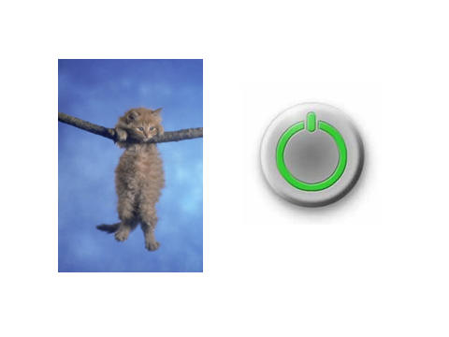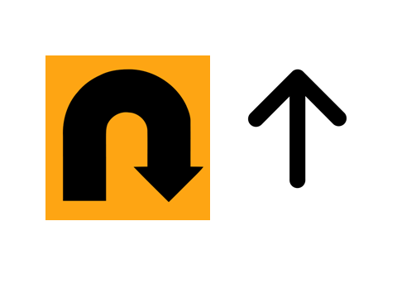
“hang on” “turn up”

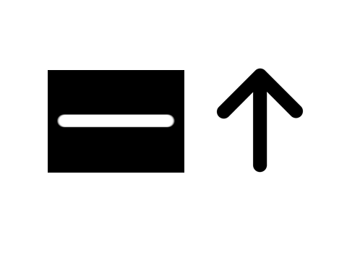
“line up” “take down”

