4th form Unit 2 Test yourself
Pupil ______________________
- Look at the picture and mark the sentences below T(true) or F(false):
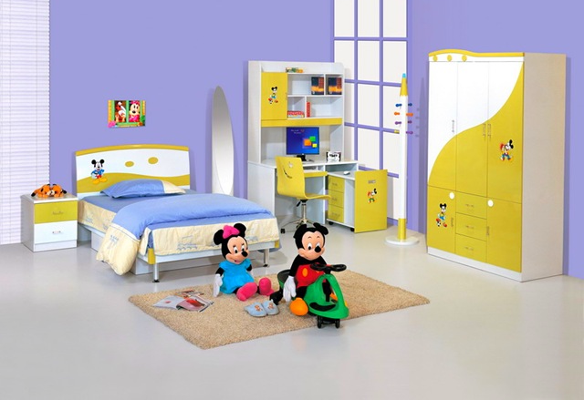

- It is a bedroom. ______
- It is not a kitchen._______
- There is a desk in the right corner. _____
- There are some shelves above the desk. _____
- There is a computer under the desk. ______
- There is no wardrobe in the room. ______
- You can see a nice lamp between the bed and the desk. _____
- They have got a clock on the wall. _____
- There are two pictures above the bed. _____
- There is a carpet on the floor. _____
- Fill in is or are:
- Behind the door there …. a green sofa.
- There … a clock on the shelf in the corner.
- There … a lot of pupils in the classroom.
- There … ten pencils and two pens in the pencil box.
- There … no fireplace in the living room.
- There … no windows in the pantry.

- There … three doors in the house.
- There … a big round mirror in the hall.
- There … many books on the shelves.
- There … a table in the kitchen.
- There … four candles on the table
- Match the Russian and the English sentences:

- There is a big armchair at the table.  - There are no books on the shelves.  - There is a nice brown table in the middle of the room.  - There is a fireplace between the window and the sofa.  - There is no carpet in the left corner of the living room. | - Между окном и диваном есть камин.  - В середине комнаты красивый коричневый стол.  - У стола большое кресло.  - На полках нет книг.  - В левом углу гостиной нет ковра.

4th form Test 2 Variant 1
Pupil ______________________
- Translate into Russian:
1) above the shelf _______________
2) on the floor __________________
3) between the armchairs ______________
4) in the left corner ___________________
5) behind the sofa ____________________

2. Fill in are or is:
1. There … no fireplace in the corner of the living-room.
2. In the middle of the hall there … a small carpet.
3. There … many posters on the walls in Jim’s room.
4. … there any flowers on the window?
5. … there a table and chairs in the kitchen?

3. Choose the best preposition:
- You can see a wardrobe behind/above/in the corner of the bedroom.
- We’ve got two beds in/on/above our room.
- There is a TV under/behind/next to the sofa.
- There is a lamp between/on/in the sofa and the table.

- Ask questions to the answers:
- …?
– Yes, there is a clock on the wall.
- …?
– Yes, there are a lot of books on the shelves.
- …?
– No, there is no piano in the bedroom.
- …?
– There are two armchairs next to the window.
- …?
– There is a carpet in the middle of the room.

- Fill in the correct pronoun (me, you, him, her, it, us, them):
- I have got a sister and I share a room with … .
- Our grandma and grandpa live in Tomsk and we write letters to … .
- My dad helps … with my homework.
- My friend plays chess well and we like to play … on Sundays.

4th form Test 2 Variant 2
Pupil _______________________
- Translate into Russian:
1) under the shelf ________________
2) on the wall ___________________
3) behind the table _______________
4) in the right corner ______________
5) above the sofa _________________

2. Fill in are or is:
1. There … no pictures in the living room.
2. In the left corner of the hall there … a nice big lamp.
3. There … a lot of toys in Jill’s room.
4. … there any pens and pencils on the desk?
5. … there a computer in the kitchen?

3.Choose the best preposition:

- There are bookshelves between/on/in the sofa and the window.
- You can see a TV behind/above/in the corner of the living room.
- We’ve got two lamps in/on/above our room.
- There is a big wardrobe under/above/next to the sofa.

4. Ask questions to the answers:
- …?
– Yes, there is a picture on the wall.
- …?
– Yes, there are a lot of books on the shelves.
- …?
– No, there is no fireplace in the bedroom.
- …?
– There are three flowers on the window.
- …?
– There is a table in the middle of the room.

5. Fill in the correct pronoun (me, you, him, her, it, us, them):
- I have got a brother and I share a room with … .
- Our grandma and grandpa live in Tomsk and they often write letters to … .
- Jim’s and Jill’s dad helps … with their homework.
- My friend Kate plays chess well and I like to play with … on Sundays.

