Олимпиадная работа по английскому языку 3 класс

1. Crossword. Guess the words and write.
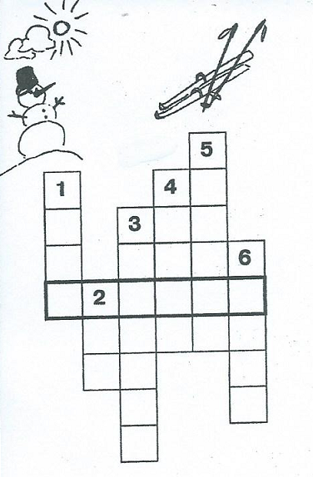
- _____________ is white and cold. We can ski on it.
- _____________ is frozen water. We can skate on it.
- _____________ is the first month of the year.
- He likes to ski and to ________________________.
- _____________is a game played on ice.
- It’s very cold today. There’s a _________________.

2. Put the sentences in the correct order.
□ His mother works in a supermarket near that hospital.
□ He wants to be a doctor.
□ He works a local hospital.
□ Rick is a student.
□ His father is a doctor, too.
□ She is a shop assistant.

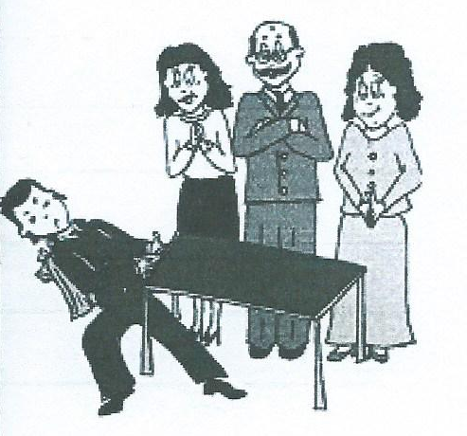
3. Read the text. Find the mistakes.
My name is Nick. I am a schoolgirl. Every day I take my books, my exercise-books, a pen, colour pencils, a rubber, a ruler, a desk and put them into my schoolbag. I go to school with my teachers. At the lessons we read, we draw and we write in our books. I like my school very much.
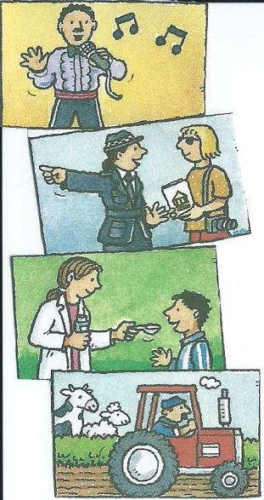
4. Write and match.
1. I’m _______________. I always help people. I never get lost!
I wear a uniform and a hat.
2. I’m a ______________. I always drive a tractor.
I never drive a taxi. I work with animals.
3. I’m a ______________. I work in a hospital. I always give
the children nice medicine. I never give The children horrible medicine.
4. I’m a ______________. I sing every day.
I always sing happy songs. I never sing sad songs.

5. Read, choose and write.
1. What is the _______animal in the family?
a) big b) bigger c) biggest
2. Her brother is________ engineer.
a) a b) the c) an
3. She is an English teacher. She ………….. English
a) can read b) can’t read c) can’t speak
4. My brothers help people. They are ____________.
a) policemen b) policeman c) policeman’s
5. She is a ballerina. She can ………
a) dance b) fly c) play.
6. ______ you want to be a teacher?
a) Does b) Are c) Do

6. Read the dialogue and choose the correct picture.
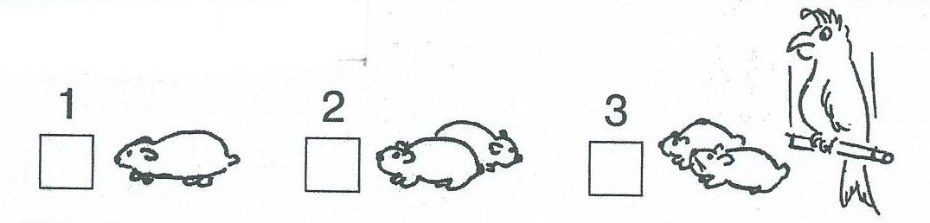
Dave: Have you got a pet, Tim?
Tim: I’ve got two pets, two hamsters. Their names are Larry and Pete. And my cousin Ann has got a parrot.
Where are Tim’s pets?

7. Guess the word and read it.
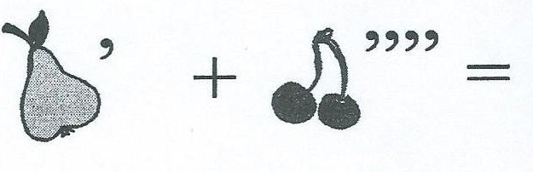____________________________________

8. Read and draw.
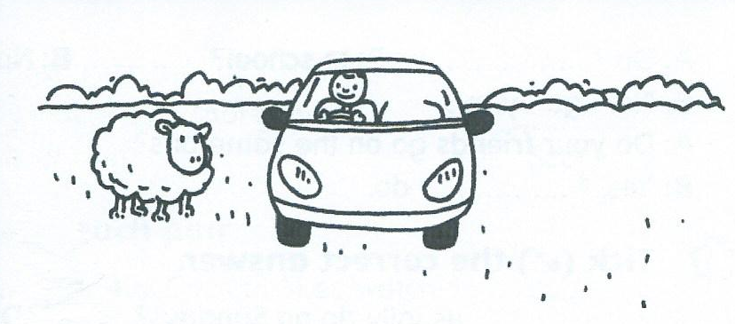
1. There’s a man in the car.
2. There’s a dog in the car.
It’s next to the man.
3. There’s a tree behind the car.
4. There’s a ball under the car.
5. There’s a river in front of the car.
6. The car is between two sheep.

Олимпиадная работа по английскому языку 3 класс
Ответы.
1. Кроссворд. Отгадай слово и запиши.
- Snow is white and cold. We can ski on it.
- Ice is frozen water. We can skate on it.
- January is the first month of the year.
- He likes to ski and to skate.
- Hockey is a game played on ice.
- It’s very cold today. There’s a frost.

2. Pасположи предложения в правильном порядке.
5. His mother works in a supermarket near that hospital.
2. He wants to be a doctor.
4. He works a local hospital.
1. Rick is a student.
3. His father is a doctor, too.
6. She is a shop assistant.

3. Прочитай текст. Найди ошибки.
My name is Nick. I am a schoolgirl. Every day I take my books, my exercise-books,
a pen, colour pencils, a rubber, a ruler, a desk and put them into my schoolbag.
I go to school with my teachers. At the lessons we read, we draw and we write
in our books. I like my school very much.

4. Прочитай и соедини.
1. I’m policeman. I always help people. I never get lost! I wear a uniform and a hat.
2. I’m a driver. I always drive a tractor. I never drive a taxi. I work with animals.
3. I’m a doctor. I work in a hospital. I always give the children nice
medicine. I never give The children horrible medicine.
4. I’m a singer. I sing every day.
I always sing happy songs. I never sing sad songs.

5. Прочитай, выбери и запиши.
1. What is the biggest animal in the family?
a) big b) bigger c) biggest
2. Her brother is an engineer.
a) a b) the c) an
3. She is an English teacher. She can read English
a) can read b) can’t read c) can’t speak
4. My brothers help people. They are policemen.
a) policemen b) policeman c) policeman’s
5. She is a ballerina. She can dance.
a) dance b) fly c) play.
6. Do you want to be a teacher?
a) Does b) Are c) Do

6 Прочитай диалог и выбери правильную картинку.
Картинка (2)

7. Отгадай слово и запиши.
Peach

8. Прочитай и нарисуй.
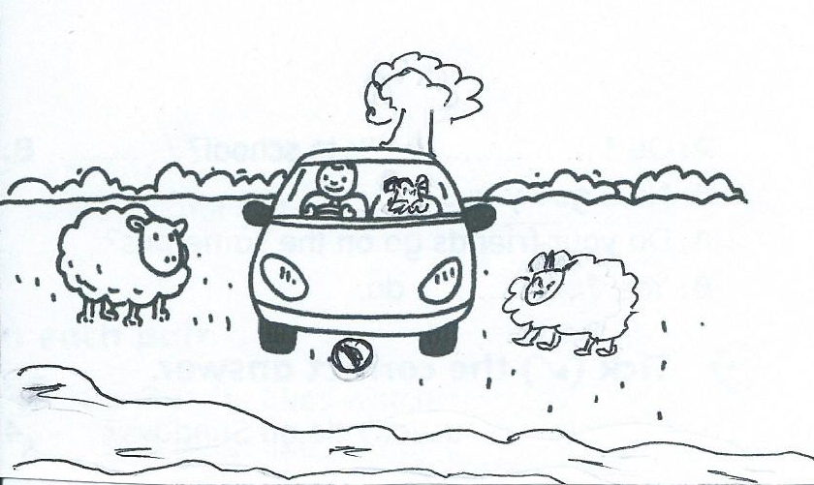

1. В машине мужчина.
2. В машине собака. Рядом с мужчиной.
3. Позади машины дерево.
4. Под машиной мячик.
5. Перед машиной река.
6. Между двумя овцами машина.

