Олимпиадная работа по английскому языку 4 класс

- Crossword. Translate from Russian into English.
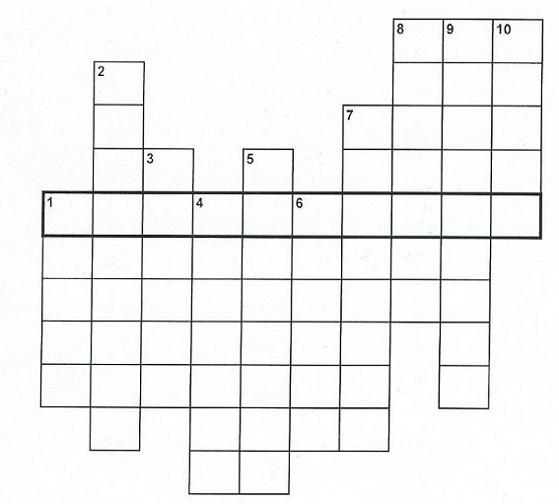
По горизонтали: По вертикали:
- Бутерброд 1. Конфеты
5. Завтрак 2. Ужин
6. Мясо 3. Пирог, торт
9. Масло 4. Вода
10. Варенье 5. Печенье
11. Яйцо 7. Чай
12. Рыба 8. Хлеб
13. Обед

2. Read the dialogue. Guess and write the season.
Polly: Do you buy presents for uncle Jim?
Mother: I don’t know what to buy for him.
Polly: Perhaps a book.
Mother: A good idea! A book from Santa Claus.
Polly: Let’s decorate the tree tomorrow.
Mother: I agree. I hope you dad and you will help me with the holiday dinner
The season: _________________

3. Guess the words and read.
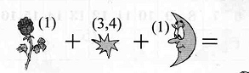__________________________
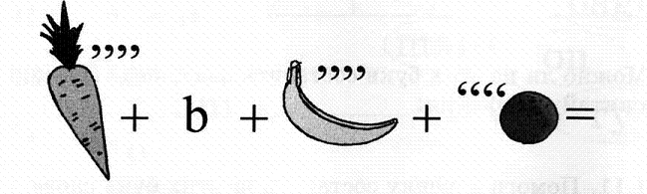_____________________________
4. Read, choose and write.
1. Tigers are _______dangerous than cats.
a) more b) big c) most
2. They _______ read the book next month.
a) won’t b) aren’t c)don’t
3. We usually _______ football in the park;
a) play b) plays c) played
4. ______ she get up before 7 in the morning?
a) Does b) Are c) Do
5. Where is Zoe? I can’t see ______
a) she b) her c) him
6. Don’t eat the sweets. ___________ bad for you.
a) they are b) there are c) are there

5. Complete the answers. Use prepositions of place.

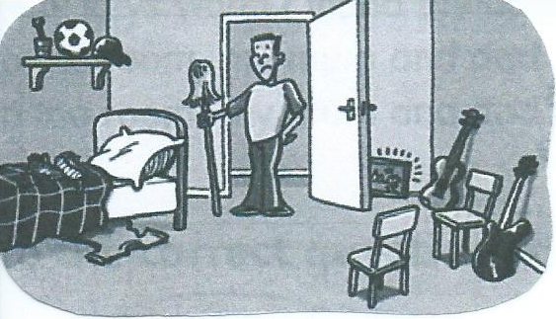
1. Where are the chairs? They’re ………………. the bag.
2. Where’s Pete’s laptop? It’s ……………….. the door.
3. Where are his shoes? They’re …………. the bed.
4. Where’s his T-shirt? It’s …………. the bed.
5. Where’s his football? It’s …………. the toothbrush and the cap.
6. Fill in the gaps.
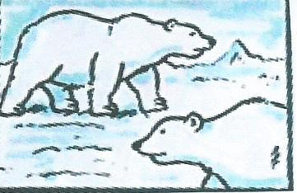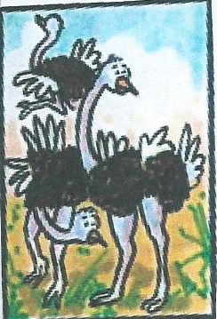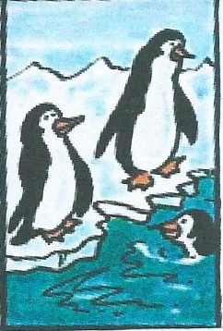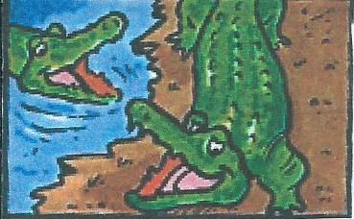

neck black white legs tail birds

Crocodiles have got big teeth, a long ………
and short ……….. . They live in rivers and eat fish and meat.
Penguins are birds. They swim very well. Penguins are …………
and white. They live in cold places and eat fish.
Ostriches are very big ……….. . They’ve got a very long …………
and very long legs. They are brown or black. Ostriches eat grass.
Polar bears have got strong legs and a short tail. They are ………… .
Polar bears live in cold places and eat fish and meat.

7. Read the dialogue and choose the correct picture.

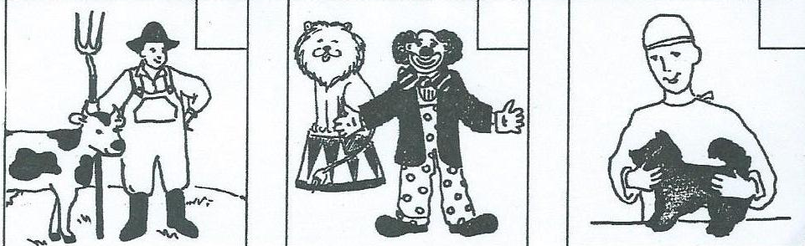

Ted: Hi! Where are you going to?
Bill: To my father’s work.
Ted: Where does he work?
Bill: He works with animals. It’s very interesting.
Ted: Is he a vet?
Bill: No, he isn’t.
Ted: Is he a farmer?
Bill: No, He works in a circus us a lions’ trainer.

8. Fill in the gaps.
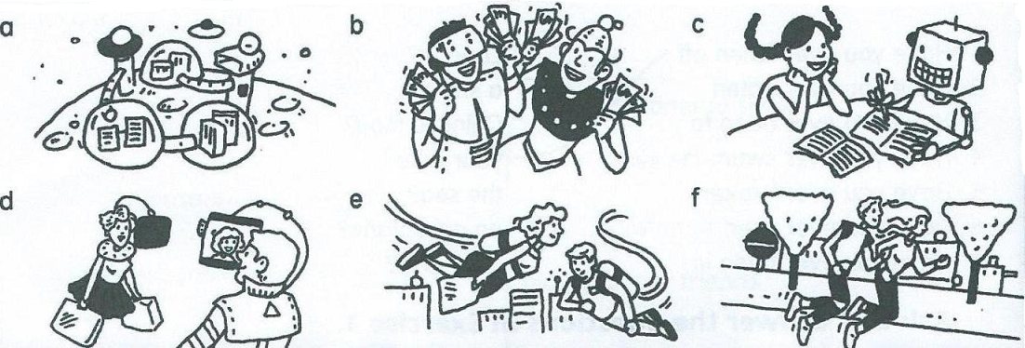

1. People won’t read books. ………
2. Every will have a lot of money. ………
3. People will be more healthy. ………
4. There will be cities on the moon. ………
5. There won’t be any cars. ………
6. Robots will do children’s homework. ……...

Олимпиадная работа по английскому языку 4 класс

Ответы

- Кроссворд. Переведи с русского на английский.
По горизонтали: По вертикали:
2. sandwich 1. sweets
5. breakfast 2. supper
6, meat 3. cake
9. butter 4. water
10. jam 5. biscuit
11. egg 7. tea
12. fish 8. bread
13. dinner

2. Прочитай диалог. Отгадай и запиши время года.
The season: winter

3. Отгадай слова и запиши.
farm, cabbage

4. Прочитай, выбери и напиши.
1. Tigers are more dangerous than cats.
a) more b) big c) most
2. They won’t read the book next month.
a) won’t b) aren’t c)don’t
3. We usually play football in the park;
a) play b) plays c) played
4. Does she get up before 7 in the morning?
a) Does b) Are c) Do
5. Where is Zoe? I can’t see her.
a) she b) her c) him
6. Don’t eat the sweets. They are bad for you.
a) they are b) there are c) are there

5. Дополни ответы. Используя предлоги места.
1. Where are the chairs? They’re opposite the bed.
2. Where’s Pete’s laptop? It’s behind the door.
3. Where are his shoes? They’re on the bed.
4. Where’s his T-shirt? It’s under the bed.
5. Where’s his football? It’s between the toothbrush and the cap.

6. Заполни пропуски.
Crocodiles have got big teeth, a long tail and short legs. They live in rivers and eat fish and meat.
Penguins are birds. They swim very well. Penguins are black and white. They live in cold places
and eat fish. Ostriches are very big birds . They’ve got a very long neck and very long legs. They
are brown or black. Ostriches eat grass. Polar bears have got strong legs and a short tail. They are
white. Polar bears live in cold places and eat fish and meat.

7. Прочитай диалог и выбери верную картинку.
Картинка (2) – clown

8. Заполни пропуски.
1. People won’t read books. d
2. Every will have a lot of money. b
3. People will be more healthy. f
4. There will be cities on the moon. a
5. There won’t be any cars. e
6. Robots will do children’s homework. c

