Урок английского языка по теме «Еда» 3 класс
Учитель английского языка Шульгина В.В.
МАОУ «Лицей №8»г. Пермь

Тема «Food»
Цель: Обобщение лексико-грамматических материала по темам «Еда», «Здоровый образ жизни»
Задачи:
- Обучающие:
- совершенствовать лексические навыки и закрепить грамматические структуры I like/ I don’t like…
- совершенствовать навыки аудирования
- повторить употребление модального глагола – must –
-отрабатывать навыки чтения про себя
2. Развивающие:
- развивать мотивацию к изучению иностранного языка
-развивать навыки языковой догадки
-совершенствовать навыки внимания
3. Воспитательные:
-развивать умение работать в группах
-создавать условия для формирования ясных представлений школьника о здоровом питании
Оборудование на уроке: компьютерная презентация, вербальные опоры, дидактический материал, учебник М.З. Биболетовой «Enjoy English» для 3 класса.
ХОД УРОКА.
- Warming – up
T. –Good afternoon, children! I’m glad to see you. How are you today? (P1-P2-P3) Are you fine?
- I’m glad that you are fine today and you can say – “Hello”- to each other.

-Say “Hello” (P-s: Hello)
And clap your hands (ученики хлопают)
Don’t say “No!” (P-s “No”)
And, please, say “Yes” (P-s “Yes”)
Let’s start our lesson.

- Сообщение целей урока:
T: Today on the way to school I visit our shop and buy a lot of things. Try to quess what things I have bought?
(ученики угадывают)
P1- tea?
P2 – bread? (e.t.c.)
- T: You are right. What do you think, children? What will we speak today about? (О чем мы сегодня будем говорить?)
- Фонетическая зарядка
T: At first let’s remember sounds and the words with these sounds. Tell please the sounds and words
[n] –
[b] –
[k] –
[s] –
[i:] –
[i] –
(P1-P2-P3)
T: -Good! And now the game “Clever parrot”. What is the extra word in a chain of words:
- Carrots, cabbages, potatoes, apples
- Banana, grape, tomato, apple
- Meat, juice, milk, tea
- Cheese, milk, juice, sweets
T: Well done! You are brilliant!
- Активизация лексико – грамматических навыков
T: Dear children. Imagine that you must cook dinner. Now you choose different kinds of food. Each group put the food into the basket.
1 гр. – салат овощной (carrot, cabbage, tomato)
2 гр. – салат фруктовый (apple, bananas, orange)
З гр. – салат овощной (meat, carrot, potato, cabbage)
Примерный ответ: We must take … for…
- Физкультпауза (игра «Съедобное/несъедобное»)
- T: Are you tired? Let’s play. Clap your hands if you can eat it. Stamp your feet if you can’t eat it.
- Let’s return to our lesson. Remember please the food I have bought today in the shop. Let’s devide it into 2 groups.
-Who can explain the rule? (исчисляемые и неисчесляемые существительные)
VI. Практика чтения.
- T: We devide into 3 groups. Each group has a text and some pencils and pictures on the tables. Your task is on the sheets of paper. Read it. Each group has its own task. I give you 5 min. to prepare the task.
I group. - What is the problem of the text?
II group. – Healthy and unhealthy food. What mustn’t you do?
III group. – What must you do to be healthy?
T: От каждой группы выступает 1-2 человека, представляя свои проекты.
- Защита проектов – 5 минут
- Подведение итогов урока
Рефлексия. (разные фрукты)
Its time to finish our lesson. I’m pleased with your work. I’m happy to have such brilliant pupils.
I
You are not healthy. You like to eat! You like to eat sweets, much honey, chips. That is why you are fat. You must not sleep in the morning. You must not eat butter and much bread for breakfast. You must drink milk and eat fish. You must run in the park and skate. You must swim, skip and jump. You must be strong, but must not be fat.

Задание: What is the problem of the text?

II

You are not healthy. You like to eat! You like to eat sweets, much honey, chips. That is why you are fat. You must not sleep in the morning. You must not eat butter and much bread for breakfast. You must drink milk and eat fish. You must run in the park and skate. You must swim, skip and jump. You must be strong, but must not be fat.

Задание: What is healthy food? What is unhealthy food?

III
You are not healthy. You like to eat! You like to eat sweets, much honey, chips. That is why you are fat. You must not sleep in the morning. You must not eat butter and much bread for breakfast. You must drink milk and eat fish. You must run in the park and skate. You must swim, skip and jump. You must be strong, but must not be fat.

Задание: What must you do to be healthy?

Мне было скучно, неинтересно, я работал неактивно, урок был не понят.  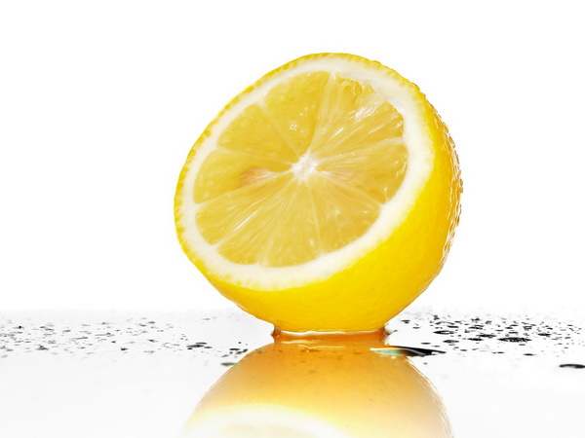 | Я доволен своей работой, я активно работал. Урок был понятен и интересен для меня  