Exit test (4B)
Name ……………………………………………………………………………………………….……

Class ……………………….. Date……………………….……………. Mark ………………………

- Vocabulary

- Look, read and match.
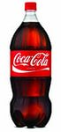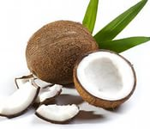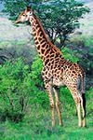
A B C D

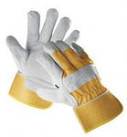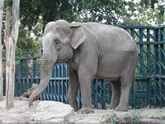
E F G

1.TOMATO 2.A BOTTLE OF COKE 3.ELEPHANT 4. GLOVES 5.DOCTOR 6.COCONUT 7. GLOVES

- Write numbers
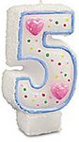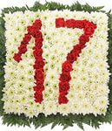
1………………… 2……………… 3 …………………. 4……………………

- Grammar

- Read and choose.

1. He …….. swimming in the pool now. 2. ………. I go out, please?
a) Am b) Is c) Are a) Must b) Has c) May

3. How …………. lemons do you need? 4. Pupils ……….. wear uniform at school.
a) Many b) Much c) A lot of a) Have to b) Has to c) Have

5. She ….. to school every day. 6. He always …. a cake for the birthday party.
a) Go b) Is going c) Goes a) Is baking b) Bakes c) Are baking

7. Mary never ……….football. 8. You …….. listen to your teacher.
a) Is playing b) Play c) Plays a) Must b) Mustn’t c) Must not

9. Elephants are …… than dogs. 10. He ….. in the cinema yesterday.
a) Big b) Biger c) Bigger a) Was b) Were c) Be

- Communication
- Read and match ( 24 marks)

- When was Pam’s party? A. No, he isn’t.
- Is your uncle from England? B. It was yesterday.
- What time is the basketball game? C. Yes, I can.
- May I taste the apple pie, please? D. At three o’clock.
- Can I have a kilo of tomatoes, please? E. Yes, you may.
- What’s your sister doing? F. She’s reading a book.
- What is your favourite season? G. Yes, here you are. It’s $3.
- Can you jump? H. My favourite season is winter

- Reading
- Read and write YES or NO. (20 marks)

Animals
There are a lot of animals in the world. Some of them live on farms: hens, cows, ducks, and horses. Other animals live in houses. They are called pets: dogs, cats, parrots, turtles, hamsters. Some animals live in zoos and safari parks: bears, lions, tigers, monkeys, crocodiles, hares. A lot of animals live in London Zoo. Zoo keepers feed them.

1. Cows are farm animals
2. Horses live in houses.
3. Crocodiles live in zoos.
4. Zookeepers don’t feed animals.

