**Exit test (4A)**

|  |
| --- |
| **Name ……………………………………………………………………………………………….……**  **Class ……………………….. Date……………………….……………. Mark ………………………** |

* **Vocabulary**

1. **Look, read and match. (14 marks)**

 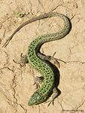  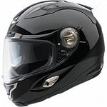

**A B C D**

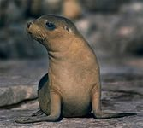 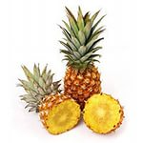 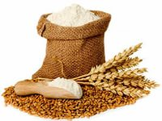

**E F G**

**1.**HELMET **2.**A CARTON OF MILK **3.**FLOUR **4.** SEAL **5.**LIZARD **6.**PINEAPPLE  **7.** WAITER

1. **Write numbers (12 marks)**

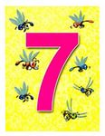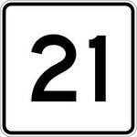

**1………………… 2………….…………… 3 …………….…………. 4………………..………**

* **Grammar**

1. **Read and choose. ( 30 marks)**

**1.** Look! That boys ……... playing football. **2.** Kate is the ………. girl in her class.

a) Am b) Is c) Are a) Tallest b) Tall c) Taller

**3.** How …………. butter do you need? **4.** Pupils ……….. wear uniform at school.

a) Many b) Much c) A lot of a) Have to b) Has to c) Have

**5.** He ….. shopping every Sunday. **6.** She always …. a cake for the birthday party.

a) Go b) Is going         c) Goes a) Is baking b) Bakes c) Are baking

**7.** Mary never ………up late. **8.** You …….. listen to your teacher.

a) Is waking b) Wake c) Wakes a) Must b) Mustn’t c) Must not

**9.** Whales are …… than dogs. **10.** My mother ….. in the cinema yesterday.

a) Big b) Biger c) Bigger a) Was b) Were c) Be

* **Communication**

1. **Read and match ( 24 marks)**
2. When was Pam’s party? A. It was yesterday.
3. Is your uncle from England? B. At quarter past seven.
4. What time is the basketball game? C. No, I can’t.
5. May I taste the apple pie, please? D. Yes, he is.
6. Can I have a kilo of tomatoes, please? E. Not yet. It’s still very hot!
7. What’s your sister doing? F. I like summer and winter.
8. What are your favourite seasons? G. Yes, here you are. It’s $3.
9. Can you skate? H. She’s reading a book.

* **Reading**

1. **Read and write YES or NO. (20 marks)**

I’m Mary. I’m from Oxford. Oxford is in England. I speak English. My favourite poet is Shakespeare. He is a great English poet.   
I like English tales. They are very interesting. I have got a turtle as a pet.   
It is funny. I’d like to have a parrot.   
My favourite dish is pudding. It is so tasty! I like cooking in my spare time.   
Dad and Mum like my dishes.

1. Mary is from England.  
2. Oxford is in the USA.   
3. Her favourite poet is Shakespeare.  
4. Mary has got a parrot.  
5. Her favourite dish is pudding.