***
A Happy New Year for me!
A Happy New Year for you,
A Happy New Year for everyone!
That’s what I want to wish – I do…
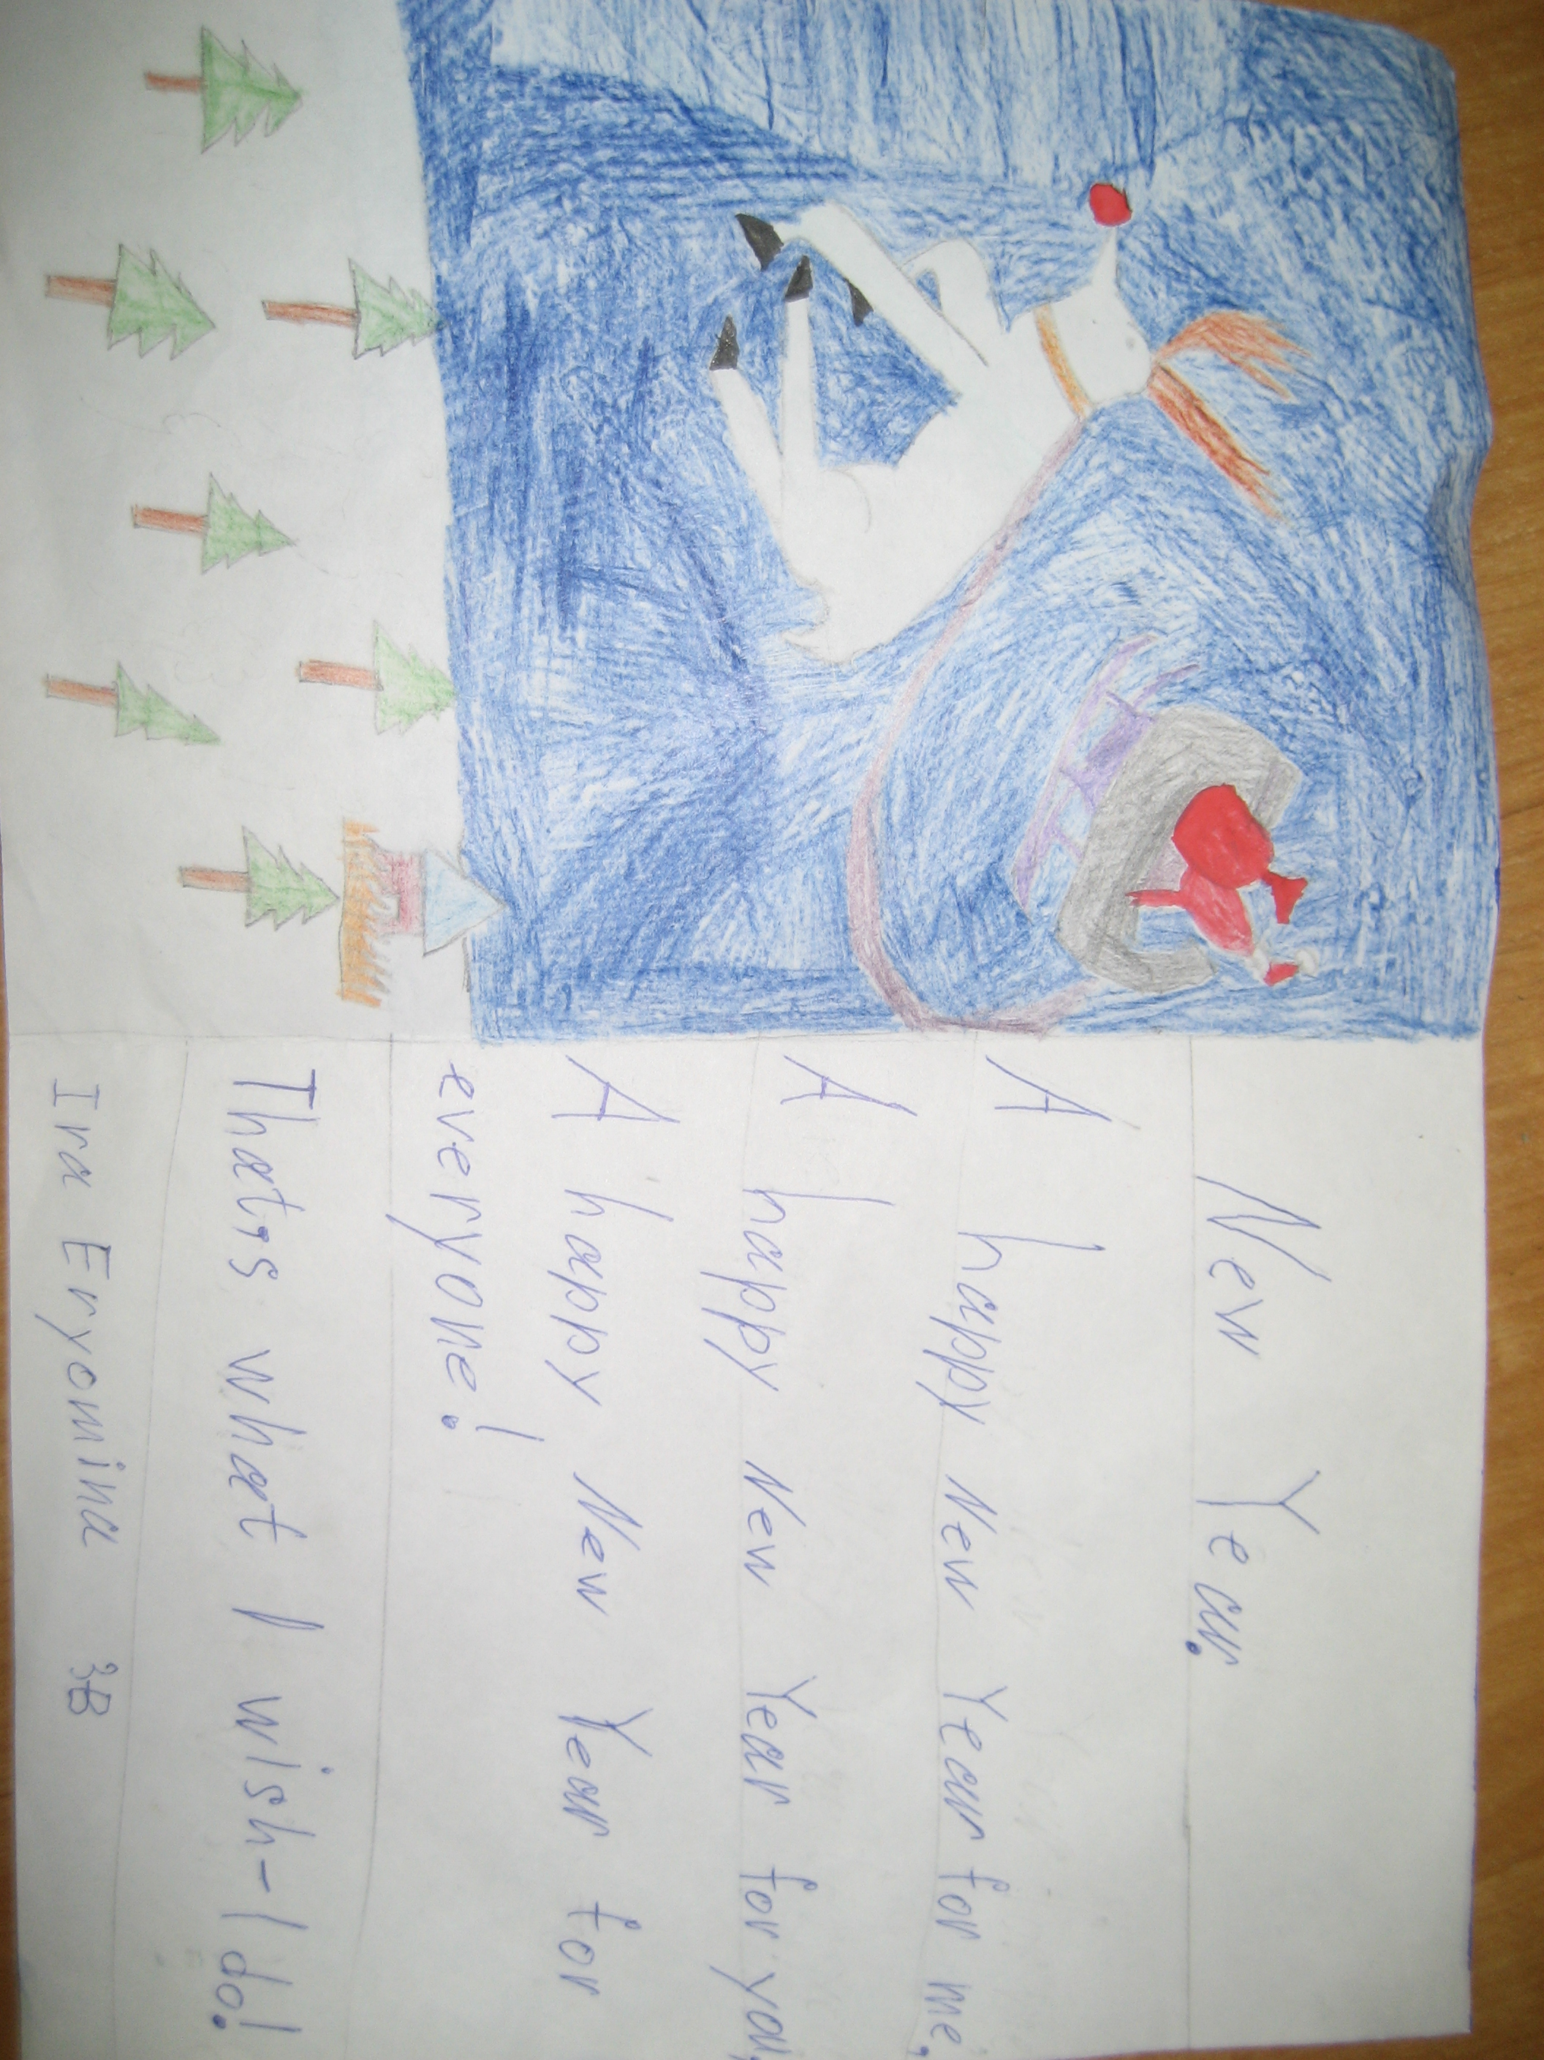
HAPPY NEW YEAR!!!

