**Reading**

**Read these postcards and answer the questions.**

1.Who is the first (second, third) postcard from?

2. Where does Alice (Susan, Dan) live?

3. What is the weather like in London (Canberra, Miami)?

4. Do you know what country London (Canberra, Miami) is in?

5. How do the children begin the postcard?

6. What do they write at the end of the postcard?

***Dear Mum and Dad,*** 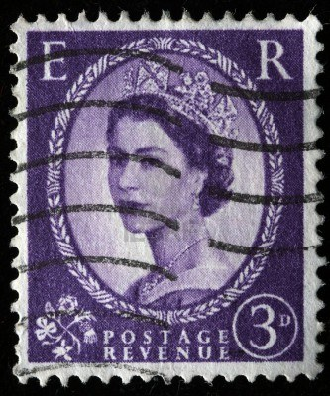

***Greetings from London. It’s windy***

***today and it is rainy. The children are***

***in the living-room.They are not happy***

***because they can’t go to the picnic.***

***We miss you a lot.***

***Love,***

***Susan***

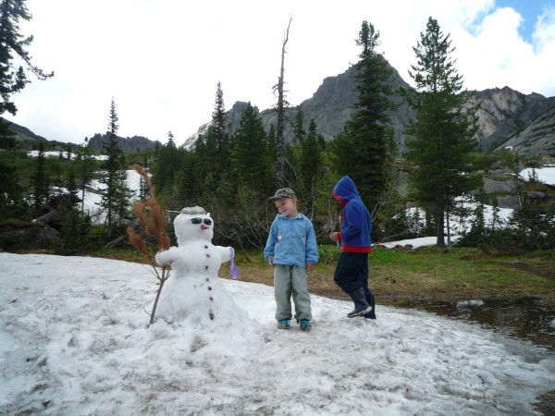



*Dear Sally,* 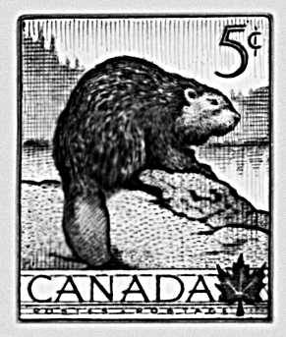

*Just a short note to say – Happy Birthday!*

*I hope you have a wonderful day. You can’t imagine*

*how cold it is in Canberra! It’s snowy. So we can go*

*and make a snow man in the park.*

*Hope to see you soon.*

*Best wishes,*

*Alice*

***Dear uncle Tom,*** 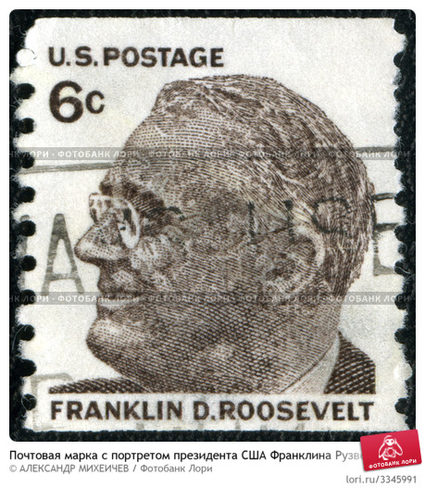

***Season’s greetings from Miami. The***

***Weather is fantastic today and we are on***

***thebeach.It’s very hot and sunny. There***

***are a lot of people on the beach today.***

***We enjoy the good weather.***

***Come and see us soon!***

***Lots of love,***

***Dan***

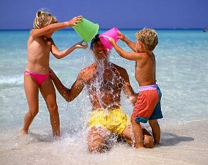

**Test**

1. **Label the cards with the names of the seasons:**

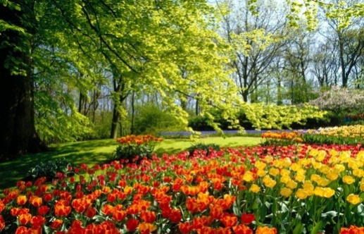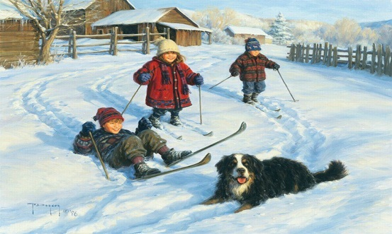

**A____________________ B ______________________**

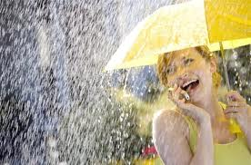**C______________________ D_______________________**

1. **Listen to the teacher and match the sentences to the cards. Two of them don’t match any of the cards.**

**Test**

1. **Label the cards with the names of the seasons:**

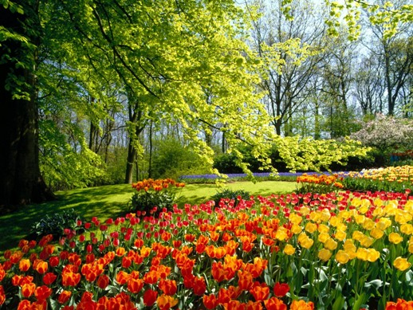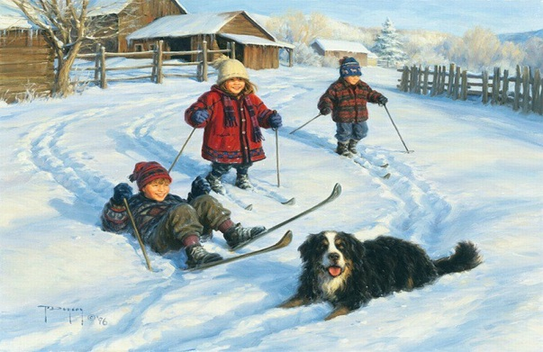

**A____________________ B ______________________**



**C______________________ D_______________________**

1. **Listen to the teacher and match the sentences to the cards. Two of them don’t match any of the cards.**

**Test card**

Name______________________________Form _________

**Task 1.**

1. A
2. B
3. C
4. D

**Task 2.**

1. 2. 3.

4. 5. 6.

**Your mark is**

**______________________________________________________________**

**Test card**

Name______________________________ Form _________

**Task 1.**

1. A
2. B
3. C
4. D

**Task 2.**

1. 2. 3.

4. 5. 6.

**Your mark is**