**Приложение № 1**

[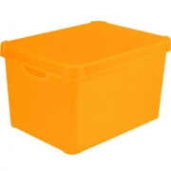](http://images.yandex.ru/yandsearch?p=1&text=%D0%BA%D0%BE%D1%80%D0%BE%D0%B1%D0%BA%D0%B0%20%D0%B4%D0%BB%D1%8F%20%D0%B8%D0%B3%D1%80%D1%83%D1%88%D0%B5%D0%BA%20%D0%B6%D0%B5%D0%BB%D1%82%D0%B0%D1%8F&fp=1&pos=34&uinfo=ww-1349-wh-613-fw-1124-fh-448-pd-1&rpt=simage&img_url=http://www.gladim.com/images/product_images/thumbnail_images/30117_0.jpg) [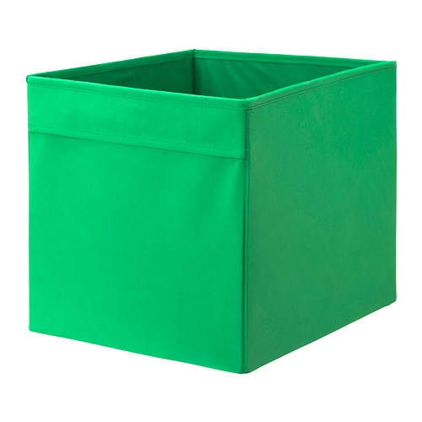](http://images.yandex.ru/yandsearch?p=1&text=%D0%BA%D0%BE%D1%80%D0%BE%D0%B1%D0%BA%D0%B0%20%D0%B4%D0%BB%D1%8F%20%D0%B8%D0%B3%D1%80%D1%83%D1%88%D0%B5%D0%BA%20%D0%B7%D0%B5%D0%BB%D0%B5%D0%BD%D0%B0%D1%8F&fp=1&pos=51&uinfo=ww-1349-wh-613-fw-1124-fh-448-pd-1&rpt=simage&img_url=http://ikea.real-com.net/goodspic/1/33/502331/thumbs_260/g_image_4ffc02b482dce.JPG)

[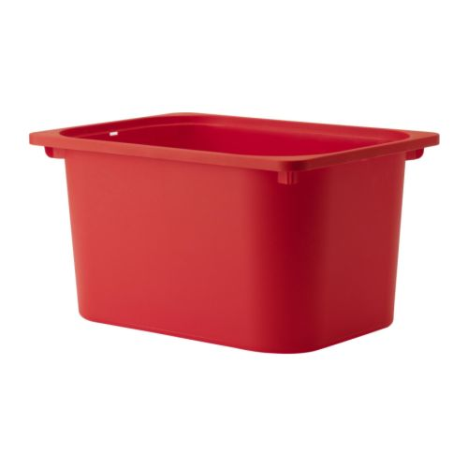](http://images.yandex.ru/yandsearch?p=3&text=%D0%BA%D0%BE%D1%80%D0%BE%D0%B1%D0%BA%D0%B0%20%D0%B4%D0%BB%D1%8F%20%D0%B8%D0%B3%D1%80%D1%83%D1%88%D0%B5%D0%BA%20%D0%BA%D1%80%D0%B0%D1%81%D0%BD%D0%B0%D1%8F&fp=3&pos=92&uinfo=ww-1349-wh-613-fw-1124-fh-448-pd-1&rpt=simage&img_url=http://i073.radikal.ru/1202/e5/8ef2b8922188.jpg)[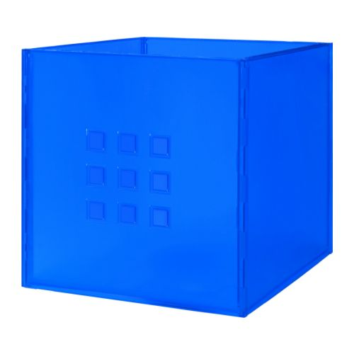](http://images.yandex.ru/yandsearch?p=17&text=%D0%BA%D0%BE%D1%80%D0%BE%D0%B1%D0%BA%D0%B0%20%D0%B4%D0%BB%D1%8F%20%D0%B8%D0%B3%D1%80%D1%83%D1%88%D0%B5%D0%BA%20%D1%81%D0%B8%D0%BD%D1%8F%D1%8F&fp=17&pos=514&uinfo=ww-1349-wh-613-fw-1124-fh-448-pd-1&rpt=simage&img_url=http://www.ikea.com/ru/ru/images/products/lekman-kontejner__0087840_PE217750_S4.JPG)

**Приложение № 2**

[](http://images.yandex.ru/yandsearch?text=%D0%BA%D0%B0%D0%BF%D1%83%D1%81%D1%82%D0%B0%20%D1%80%D0%B0%D1%81%D0%BA%D1%80%D0%B0%D1%81%D0%BA%D0%B0&fp=0&pos=6&uinfo=ww-1349-wh-613-fw-1124-fh-448-pd-1&rpt=simage&img_url=http://122012.imgbb.ru/user/49/492588/1/cb2ed9bcfb467ba8f5a6210148f648b7.gif)

[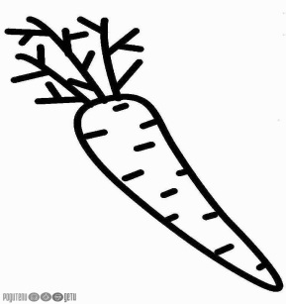](http://images.yandex.ru/yandsearch?p=4&text=%D0%BC%D0%BE%D1%80%D0%BA%D0%BE%D0%B2%D0%BA%D0%B0%20%D1%80%D0%B0%D1%81%D0%BA%D1%80%D0%B0%D1%81%D0%BA%D0%B0&fp=4&pos=127&uinfo=ww-1349-wh-613-fw-1124-fh-448-pd-1&rpt=simage&img_url=http://parents-kids.ru/media/k2/items/cache/57df6a0f34180006582f429068c6ac21_S.jpg) [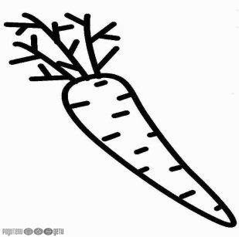](http://images.yandex.ru/yandsearch?p=4&text=%D0%BC%D0%BE%D1%80%D0%BA%D0%BE%D0%B2%D0%BA%D0%B0%20%D1%80%D0%B0%D1%81%D0%BA%D1%80%D0%B0%D1%81%D0%BA%D0%B0&fp=4&pos=127&uinfo=ww-1349-wh-613-fw-1124-fh-448-pd-1&rpt=simage&img_url=http://parents-kids.ru/media/k2/items/cache/57df6a0f34180006582f429068c6ac21_S.jpg) [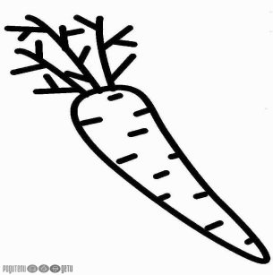](http://images.yandex.ru/yandsearch?p=4&text=%D0%BC%D0%BE%D1%80%D0%BA%D0%BE%D0%B2%D0%BA%D0%B0%20%D1%80%D0%B0%D1%81%D0%BA%D1%80%D0%B0%D1%81%D0%BA%D0%B0&fp=4&pos=127&uinfo=ww-1349-wh-613-fw-1124-fh-448-pd-1&rpt=simage&img_url=http://parents-kids.ru/media/k2/items/cache/57df6a0f34180006582f429068c6ac21_S.jpg)

[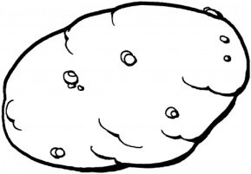](http://images.yandex.ru/yandsearch?p=1&text=%D0%BA%D0%B0%D1%80%D1%82%D0%BE%D1%88%D0%BA%D0%B0%20%D1%80%D0%B0%D1%81%D0%BA%D1%80%D0%B0%D1%81%D0%BA%D0%B0&fp=1&pos=47&uinfo=ww-1349-wh-613-fw-1124-fh-448-pd-1&rpt=simage&img_url=http://webcommunity.ru/wp-content/uploads/2011/06/kartofel.jpg) [](http://images.yandex.ru/yandsearch?p=1&text=%D0%BA%D0%B0%D1%80%D1%82%D0%BE%D1%88%D0%BA%D0%B0%20%D1%80%D0%B0%D1%81%D0%BA%D1%80%D0%B0%D1%81%D0%BA%D0%B0&fp=1&pos=47&uinfo=ww-1349-wh-613-fw-1124-fh-448-pd-1&rpt=simage&img_url=http://webcommunity.ru/wp-content/uploads/2011/06/kartofel.jpg) [](http://images.yandex.ru/yandsearch?p=1&text=%D0%BA%D0%B0%D1%80%D1%82%D0%BE%D1%88%D0%BA%D0%B0%20%D1%80%D0%B0%D1%81%D0%BA%D1%80%D0%B0%D1%81%D0%BA%D0%B0&fp=1&pos=47&uinfo=ww-1349-wh-613-fw-1124-fh-448-pd-1&rpt=simage&img_url=http://webcommunity.ru/wp-content/uploads/2011/06/kartofel.jpg) [](http://images.yandex.ru/yandsearch?p=1&text=%D0%BA%D0%B0%D1%80%D1%82%D0%BE%D1%88%D0%BA%D0%B0%20%D1%80%D0%B0%D1%81%D0%BA%D1%80%D0%B0%D1%81%D0%BA%D0%B0&fp=1&pos=47&uinfo=ww-1349-wh-613-fw-1124-fh-448-pd-1&rpt=simage&img_url=http://webcommunity.ru/wp-content/uploads/2011/06/kartofel.jpg)

[](http://images.yandex.ru/yandsearch?p=2&text=%D0%BB%D1%83%D0%BA%20%D1%80%D0%B0%D1%81%D0%BA%D1%80%D0%B0%D1%81%D0%BA%D0%B0&fp=2&pos=64&uinfo=ww-1349-wh-613-fw-1124-fh-448-pd-1&rpt=simage&img_url=http://raskras-ka.com/wp-content/uploads/2012/08/raskraski-ovoshti-1.gif) [](http://images.yandex.ru/yandsearch?p=2&text=%D0%BB%D1%83%D0%BA%20%D1%80%D0%B0%D1%81%D0%BA%D1%80%D0%B0%D1%81%D0%BA%D0%B0&fp=2&pos=64&uinfo=ww-1349-wh-613-fw-1124-fh-448-pd-1&rpt=simage&img_url=http://raskras-ka.com/wp-content/uploads/2012/08/raskraski-ovoshti-1.gif)

**Приложение №3**[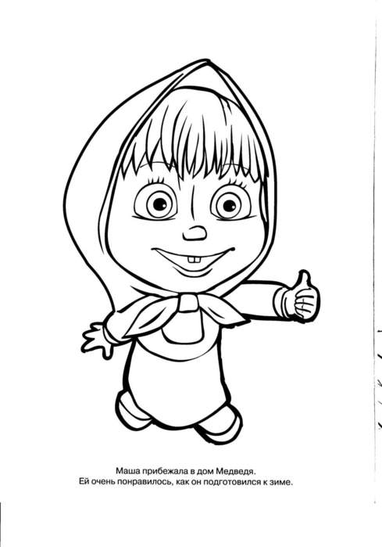](http://images.yandex.ru/yandsearch?source=wiz&fp=7&uinfo=ww-1349-wh-613-fw-1124-fh-448-pd-1&p=7&text=%D0%BA%D0%B0%D1%80%D1%82%D0%B8%D0%BD%D0%BA%D0%B8%20%D0%BC%D0%B0%D1%88%D0%B0%20%D0%B8%20%D0%BC%D0%B5%D0%B4%D0%B2%D0%B5%D0%B4%D1%8C&noreask=1&pos=220&rpt=simage&lr=213&img_url=http://www.pic4you.ru/allimage/4614/305452-thumb.gif)