Вариант 2
- Вставить Future Simple or Future Progressive
1) David (work) overtime on Saturday, he won’t be able to go to the cinema with his friends.
a) will work; b) will be working.
2) He (work) from 8 to 9 p.m. on Saturday.
a) will work; b) will be working.
3)I (do) my homework quickly and go for a walk.
a) will be doing; b) will do.
4) I think I (do) my homework for half an hour.
a) will do; b) will be doing.
2. Вставить Present Progressive or Present Perfect Progressive?
- What... you (do)? — I (learn) English.
  - are ... doing, am learning;
  - are ... doing, have been learning.
- How long ... he (study) German? — He (study) German for five years.
  - is... studying, has been studying;
  - have ... been studying , have been study
- Look through the window. It (snow).
  - is snowing;
  - are snowing;
  - has been snowing.
3.Прочитайте приведённые ниже предложения. Преобразуйте слова, напечатанные заглавными буквами в конце строк,, обозначенных номерами 1-3 так, чтобы они грамматически соответствовали содержанию текста. Заполните пропуски полученным и словами
- Thousands of men and _____________dream of such a job." | WOMAN
2. 2.You will have to take the next flight. You________in New York at about midnight." | ARRIVE
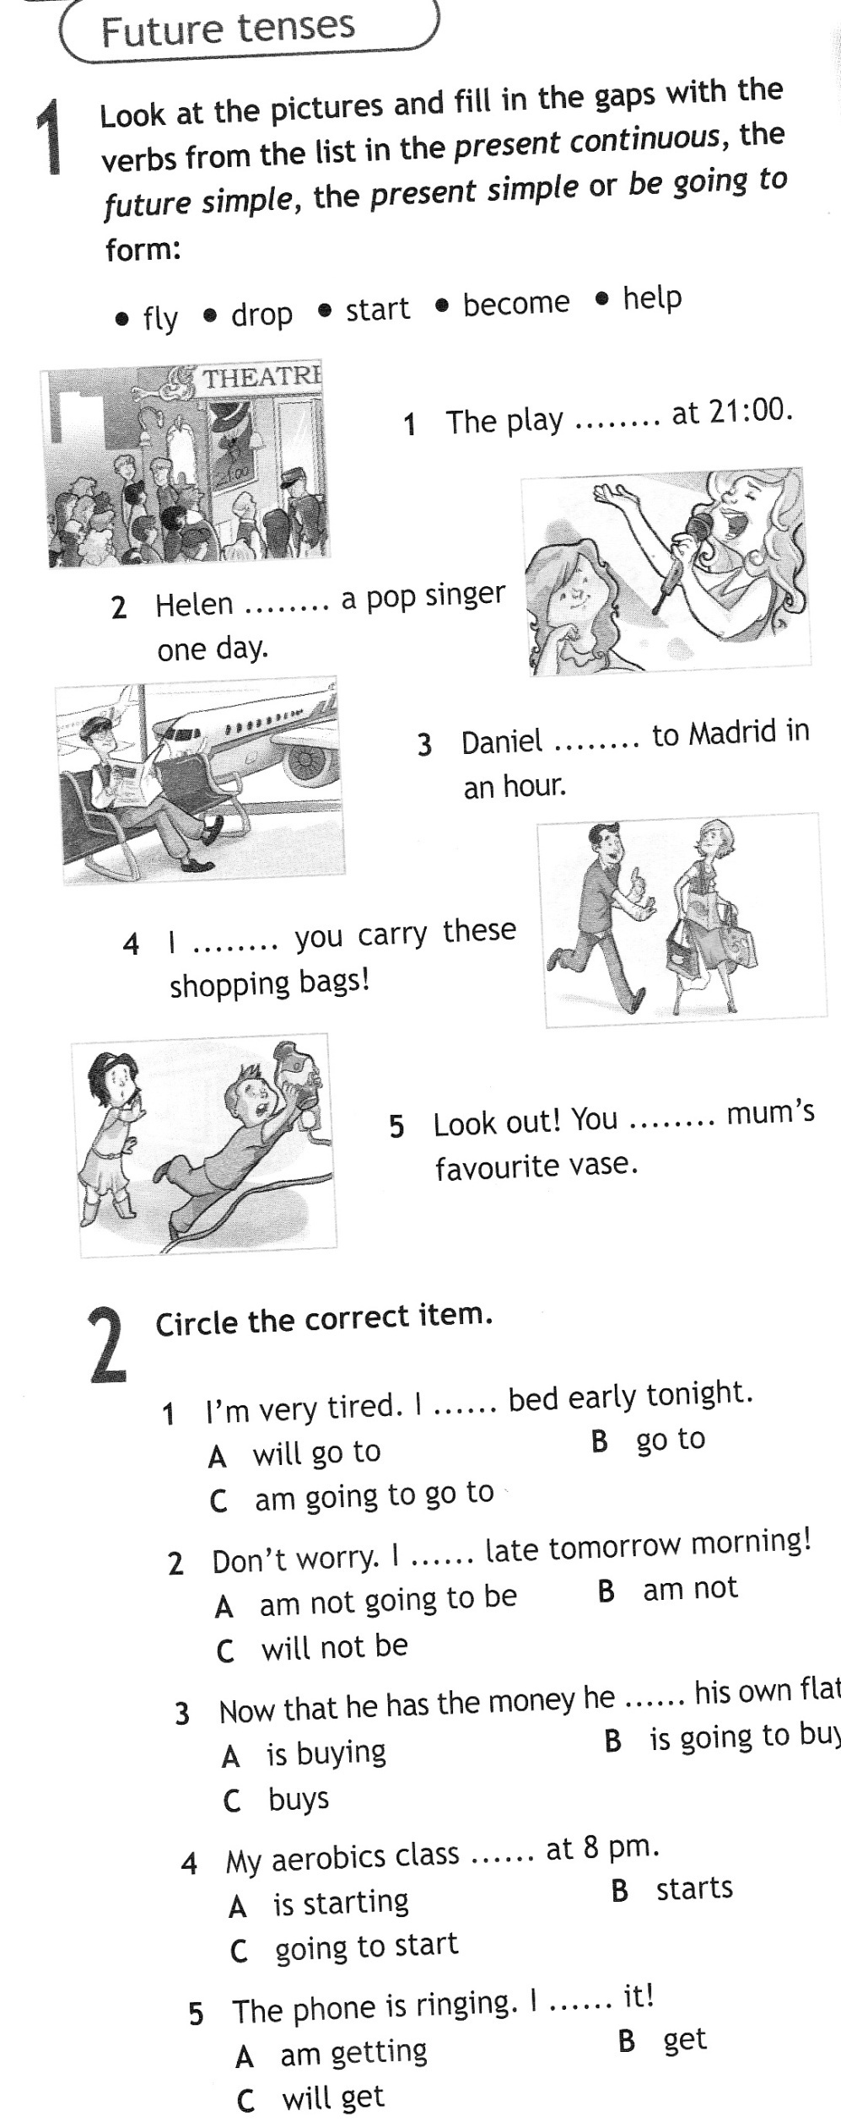  3. For the ____________ time in his life Allan felt really disappointed. | ONE
4.

Вариант 1
- Вставить Future Perfect or Future Perfect Progressive
- I... the new rules by 5 o'clock.
  - will have learnt;
  - will have been learning.
- I ... English for fifteen years by the year 2015.
  - will have learnt;
  - will have been learning.
- Jack ... 500 meters by the lunchtime.
  - will have swum;
  - will have been swimming.
2. Вставить Present Progressive or Present Perfect Progressive?
1.What... you (do)? — I (learn) English.
a)are ... doing, am learning;
b) are ... doing, have been learning.
2.How long ... you (learn) English? — I (learn) English for seven years.
a)are ... learning, have been learning;
b)have ... been learning, have been learning.
3.Look through the window. It (rain).
a)is raining;
b) are raining;
c) has been raining.
3.Прочитайте приведённые ниже предложения. Преобразуйте слова, напечатанные заглавными буквами в конце строк,, обозначенных номерами 1-3 так, чтобы они грамматически соответствовали содержанию текста. Заполните пропуски полученным и словами
1. Alla n didn't know what to do. He realized that he_____  to call the company manager and tell him that he would not come. | HAVE
- My uncle who is a_______ ,  says that he waters his vegetables and fruit trees a lot in dry weather  . | FARM
- For the ______ time in his life Allan felt really disappointed. | ONE
- Past Progressive or Past Perfect Progressive

1)What ... you (do) at 7 o'clock yesterday? I (write) a letter.
              - were ... doing, was writing; were ... doing, have been writing.
2) Ann (study) at the University for five years before she took her present job.
a) was studying; b)had been studying.
3) I (walk) along the street when I met my friends. They (smile) at me.
a)had been walking, were smiling; b)was walking, were smiling.

