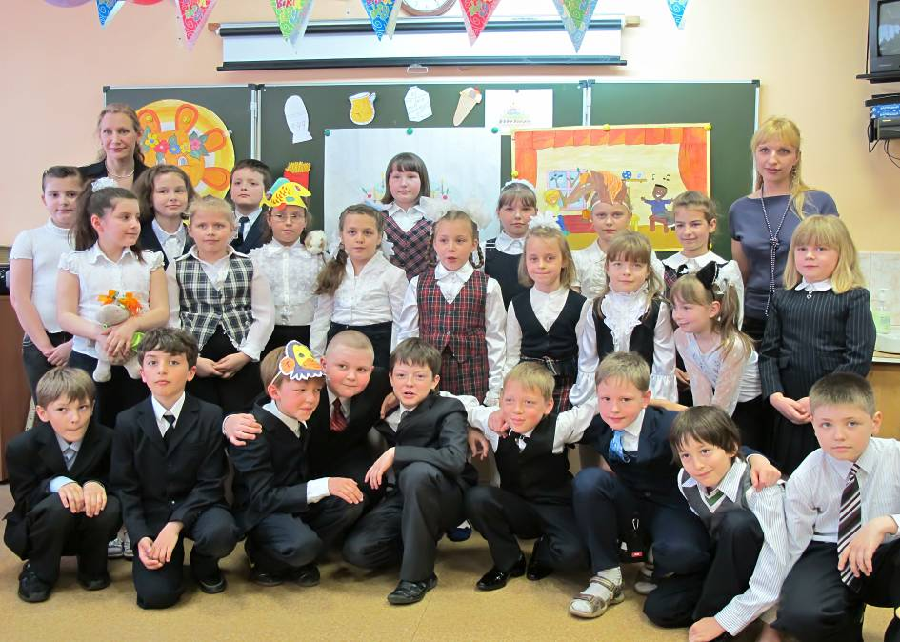
ШКОЛЬНАЯ ПЬЕСА:
Учителя английского языка: Дудина Елена Сергеевна, Зыкова Наталья Александровна.
Цель: Развитие языковой компетентности учащихся.
Задачи
Образовательные: Совершенствование навыков чтения; развитие речевого умения: монологическая и диалогическая формы общения.
Развивающие: Развитие способностей к догадке по аналогии с родным языком, по картинке, по контексту; развитие у учащихся межкультурной компетенции; развитие внимания, памяти, воображения, творческих способностей.
Воспитательные: Воспитание интереса к культуре других стран, желания расширять кругозор, способности представлять собственную культуру, повысить мотивацию к обучению английскому языку.
Оборудование: учебник «Spotlight 2», магнитофон, телевизор, CD, DVD , костюмы для действующих лиц пьесы.

Действующие лица: Ученики 2 «В»
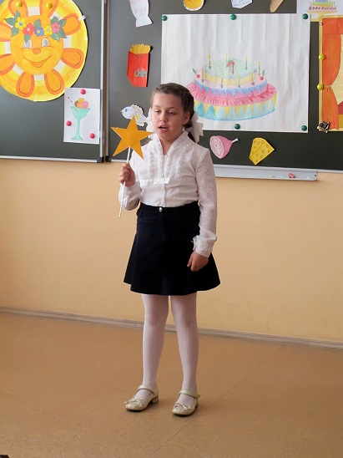
Ход пьесы:

Child 1:
Star light, star bright,
First star I see tonight.
I wish I may, I wish I might,
Have the wish I wish tonight!
Oh! I wish my toys were alive!

Teacher:

At midnight in the playroom,
When everyone's asleep,
Out come all the toys
And around the room they creep!
The ballerina points her toes
And dances one-two-three!

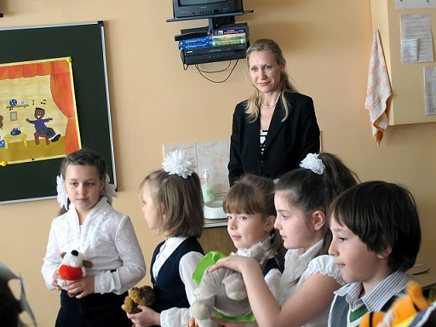The jack-in-the-box jumps up
and down
And shouts 'Hey, look at me!
The teddy bears have a picnic,
The dolls pour out the tea,
The soldier marches one-two-three
And the puppet shouts 'Yippee!'

All:
Toys for me,
Toys for you,
Toys for everyone!
A pink ballerina,
A blue toy soldier,
We're all having fun!
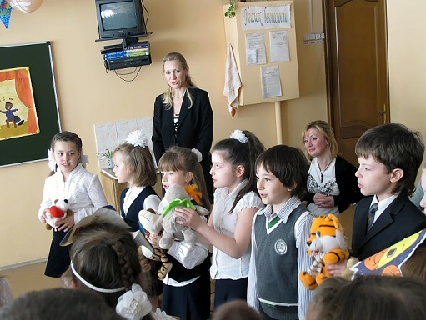
Toys for me,
Toys for you,
Toys for everyone!
A brown teddy bear,
A yellow doll,
We're all having fun!

Child 2:
Star light, star bright,
First star I see tonight.
I wish I may, I wish I might,
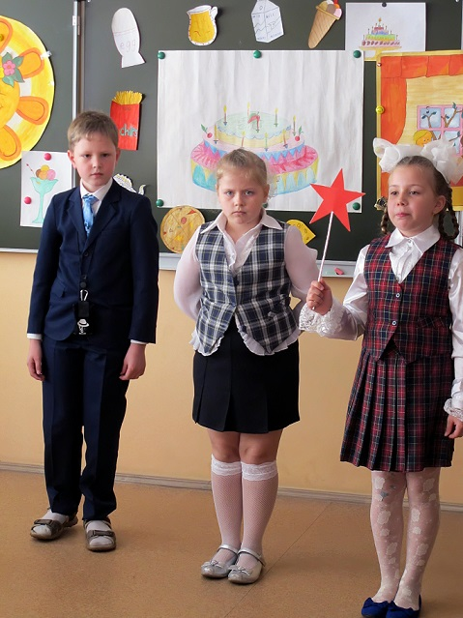Have the wish I wish tonight!
Oh, my wish is for a big
birthday party!
Child 2:
Hurry, hurry, come and see,
Today there's a party
Just for me!

Child 3:
With burgers and biscuits
And bananas too!

Child 4:
There's lots to eat
For me and you!

Child 3:
Pizza and chips
And sandwiches!

Child 4:
And candles on a cake
To make a wish!

Children:
Hooray! Happy Birthday!

Child 3:
Look - I've got a present for you.

Child 2:
What is it?
Child 3:
It's chocolate!

Children:
Yummy, yummy chocolate!
Yummy, yummy chocolate,
That's what I like!
Chocolate on a biscuit,
Chocolate on a cake!
I don't like eggs
And I don't like cheese!
But yummy, yummy chocolate,
Ooh, yes, please!

Child 5:
Star light, star bright,
First star I see tonight.
I wish I may, I wish I might,
Have the wish I wish tonight!
I wish I had a tree house!
Child 5:
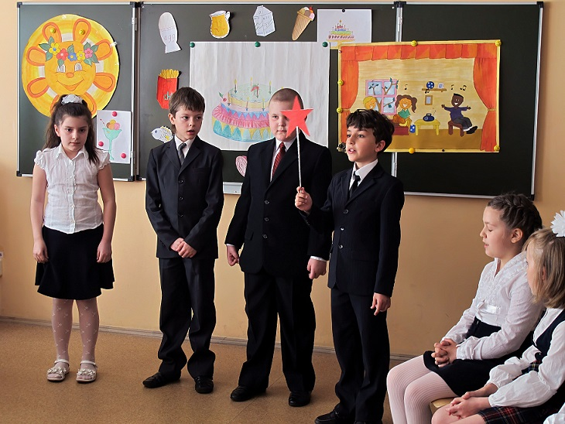In my tree house,
In my tree,
There are lots of colours
For you to see!

Child 6:
Red and yellow,
Green and blue!
Lots of colours
For me and you!

Child 5:
In my tree house,
In my tree,
There are lots of things
For you to see!

Child 7:
A table, a chair,
And a bed, you see,
And a radio
For you and me!

Child 6:
Is this your house?
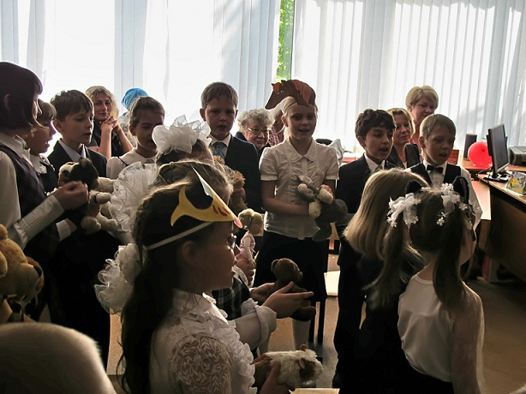
Child 5:
Yes, it is!

Child 6:
It's great!

All join in:
This is my house,
This is the door!
The windows are clean,
And so is the floor!
Outside there's a chimney,
As tall as can be,
With smoke that goes up,
Come and see!

Child 7:
Look, footprints - footprints everywhere!

All:
Footprints in the kitchen,
Footprints in the hall,
Footprints on the floor,
Footprints on the wall!
Footprints in the living room,
Footprints on the stairs,
Footprints in the bedroom,
Footprints on the chairs!
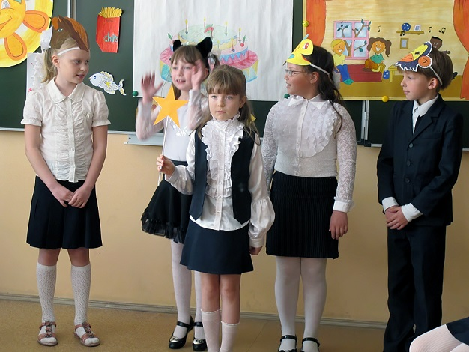
Footprints in the bathroom,
But where is naughty Chuckles?
Footprints in the bath,
He's there with all the bubbles!

All:
Oh, Chuckles!
Act 4
Star light, star bright,
First star I see tonight.
I wish I may, I wish I might,
Have the wish I wish tonight!
I wish I had lots of animals!

Horse:
I'm a horse! I'm a horse!
And I can jump, of course!
Look at me! Look at me! I'm a cat!

Cat:
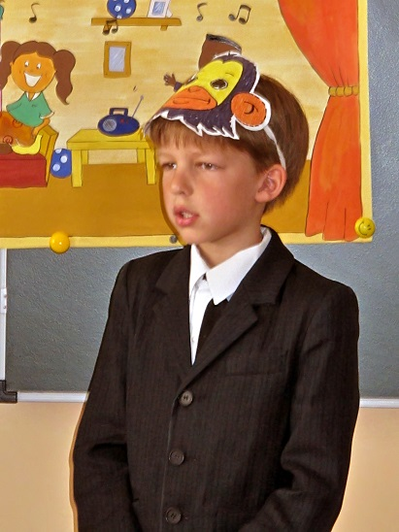I'm a cat! I'm a cat!
And I can climb like that!
Look at me! Look at me!

Fish:
I'm a fish! I'm a fish!
And I can swim, splish, splish!

Chimp:
Look at me! Look at me!
I'm a chimp! I'm a chimp!
And I can climb and swing!
Look at me! Look at me!

Child 8:
Hey, come on! Let's go to the circus.

All:
At the circus
In the town,
There's a very funny clown!
The clown can run,
And the clown can jump,
Run and jump all day, hey!

At the circus
In the town,
There's a very funny chimp!
The chimp can climb,
And the chimp can swing,
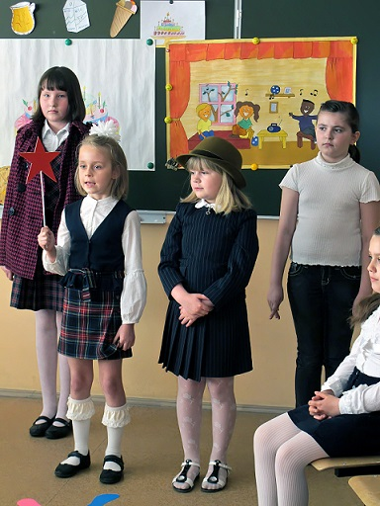Climb and swing all day, hey!

Child 9:
Star light, star bright,
First star I see tonight.
I wish I may, I wish I might
Have the wish I wish tonight!
I wish I had a sailing boat!

Child 10:
I'm wearing my jeans
And my favourite T-shirt!

Child 11:
I'm wearing my hat
And my favourite skirt!
I'm wearing my jacket.

Child 12:
I'm wearing my coat.

All:
We're sailing away
In our sailing boat!
Take off your socks,
Take off your shoes,
We're sailing away
On a magic cruise!
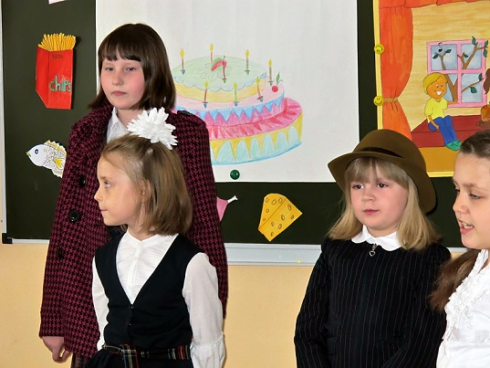
Child 9:
Come on, everybody! Let's set sail!

All:
Set sail with us,
Join us, please!
Set sail with us
For English!
Set sail with us
Upon the sea
And swim with all the starfish!

We love to sing,
We love to play,
We love to talk together!
Set sail with us,
Set sail today
And be our friend forever!

We've got some rhymes
And stories too,
We've got lots of things to do!
So get on board,
Set sail today!
We're waiting here for you!

