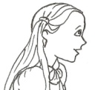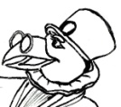
Class ………… Mark…………… Date……………………………
Name……………………….……………………….

1. Соотнеси противоположные по значению слова:

large | black
thin | sad
white | bad
happy | small
good | thick
new | fat
slim | Good bye!
short | old
hot | cold
Hello! | tall

2. Напиши предлоги места :
on, in, at, under, behind

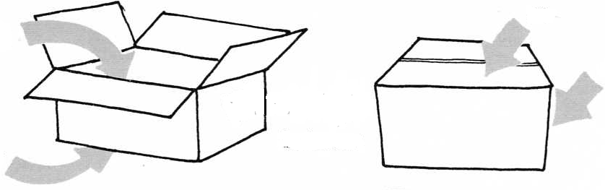

3. Робинзон перепутал буквы в словах. Составь из букв слово и переведи его на русский язык.

badowerr | -
carmahri | -
afso | -
fehls | -
baelt | -
ltaf | -
sdek | -
sogolcbah | -
moro | -
kdes | -

4 . Прочитай текст и дорисуй недостающие предметы.
This is my desk.
There are two pens on the desk.
There is a thin book under the desk.
There are socks on the chair.
There is a ball behind the chair.
There is a lamp at the thick book.

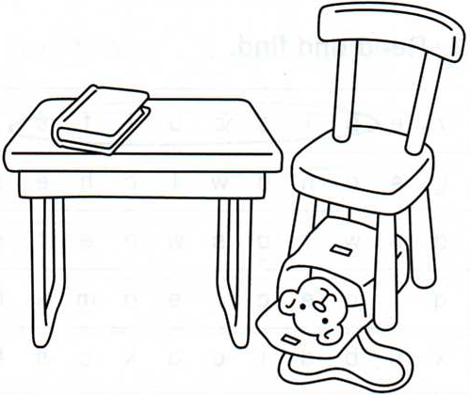

5.Ответь на вопросы, используя получившуюся у тебя картинку.
Is there a TV in my room?
a) Yes, it is. b) No, there isn’t. c) No, I can’t

Are there socks on the chair?
a) Yes, they are. b) No, there aren’t. c) Yes, there are.

Is there a teddy bear in the bag?
a) Yes, there is. b) Yes, there are. c) No, there isn’t.

What is there under the chair?
a) There is a schoolbag.
b) There is a lamp.
c) There are two pens.

What is there on the desk?
a) There are socks.
b) There is a thick book.
c) There is a ball.

