………………………………………………..

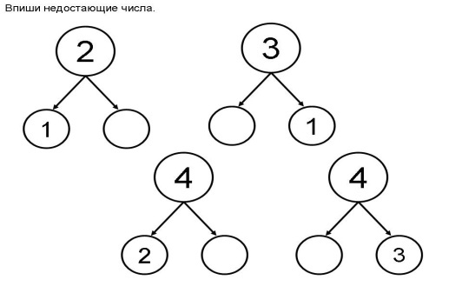

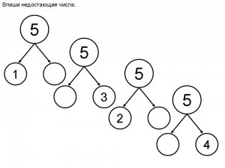

3 +1= 6 -1= 7 -1 -1 =

5 +1= 7 -1= 9 -1 -1=

6 +1= 9 -1 = 4 +1 +1=

7 +1 = 2 – 1= 5 +1 +1=

5 – 0 = 3 +0 = 2 – 2=

………………………………………………………….

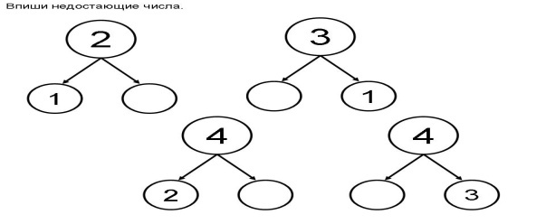



3 +1= 6 -1= 7 -1 -1 =

5 +1= 7 -1= 9 -1 -1=

6 +1= 9 -1 = 4 +1 +1=

7 +1 = 2 – 1= 5 +1 +1=

5 – 0 = 3 +0 = 2 – 2=

………………………………………………………….

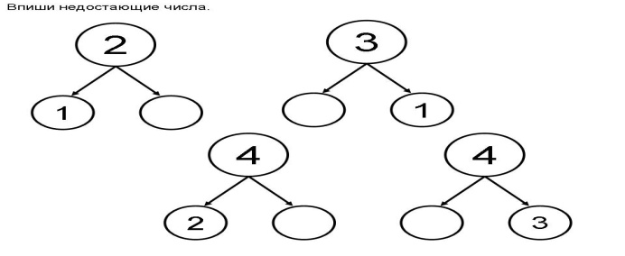



3 +1= 6 -1= 7 -1 -1 =

5 +1= 7 -1= 9 -1 -1=

6 +1= 9 -1 = 4 +1 +1=

7 +1 = 2 – 1= 5 +1 +1=

5 – 0 = 3 +0 = 2 – 2=

………………………………………………………….





3 +1= 6 -1= 7 -1 -1 =

5 +1= 7 -1= 9 -1 -1=

6 +1= 9 -1 = 4 +1 +1=

7 +1 = 2 – 1= 5 +1 +1=

5 – 0 = 3 +0 = 2 – 2=

Самостоятельная работа. Вариант №1

………………………………………………..

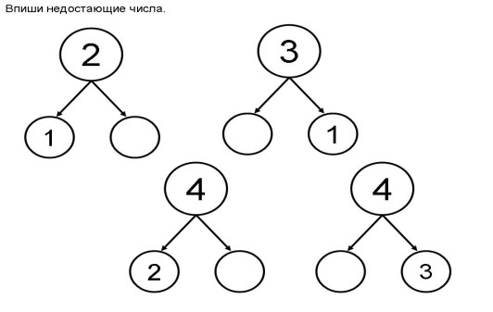



4 +1= 5 -1 = 4 +1 +1=

3 +1 = 2 – 1= 5 -1 -1=

5 – 0 = 3 +0 = 3– 3=

Самостоятельная работа. Вариант №1

………………………………………………..

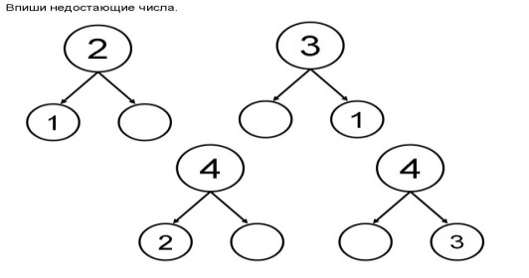



4 +1= 5 -1 = 4 +1 +1=

3+1 = 2 – 1= 5 -1 -1=

5 – 0 = 3 +0 = 3– 3=

Самостоятельная работа. Вариант №2

…………………………………………………………………………..

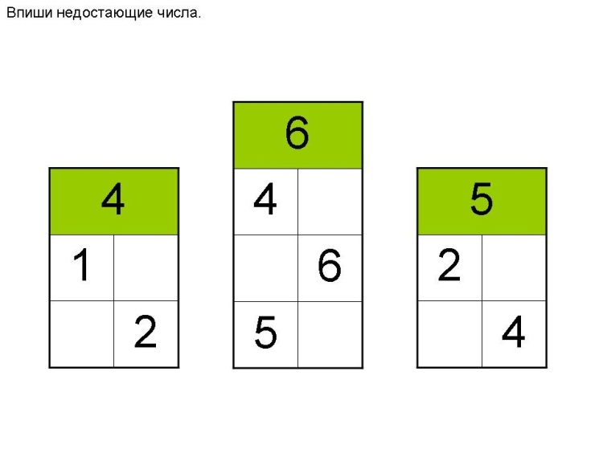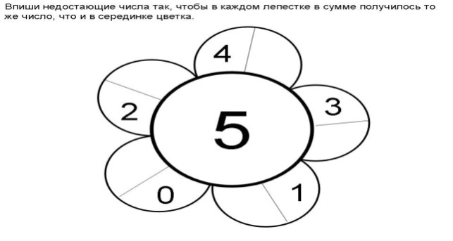

8 +1= 6 -1= 7 -1 -1 =

5 +1= 7 -1= 9 -1 -1=

6 +1= 9 -1 = 4 +1 +1=

7 +1 = 2 – 1= 5 +1 +1=

5 – 0 = 3 +0 = 9 – 9=

Самостоятельная работа. Вариант №2

…………………………………………………………………………..



8 +1= 6 -1= 7 -1 -1 =

5 +1= 7 -1= 9 -1 -1=

6 +1= 9 -1 = 4 +1 +1=

7 +1 = 2 – 1= 5 +1 +1=

5 – 0 = 3 +0 = 9 – 9=

Потренируйся.

………………………………………………………………………………..

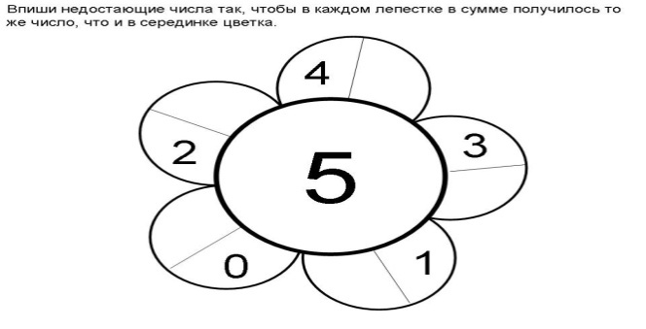

**5 + 1 +1 = 6 + 2 = 7 – 2 =**

**7 – 1 – 1 = 8 – 2 = 2 + 2 =**

**3 + 1 + 1= 3 + 2 = 5 – 2 =**

**6 + 0 = 8 – 0 = 3 – 3 =**

**+ 2 = 4 5 - = 3**

**+2 = 3 3 - =2**

Потренируйся.

………………………………………………………………………………..

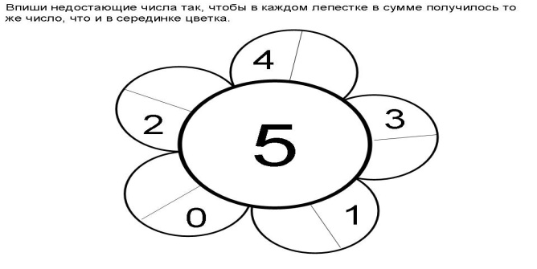

**5 + 1 +1 = 6 + 2 = 7 – 2 =**

**7 – 1 – 1 = 8 – 2 = 2 + 2 =**

**3 + 1 + 1= 3 + 2 = 5 – 2 =**

**6 + 0 = 8 – 0 = 3 – 3 =**

**+ 2 = 4 5 - = 3**

**+2 = 3 3 - =2**

Потренируйся.

………………………………………………………………………………..



**5 + 1 +1 = 6 + 2 = 7 – 2 =**

**7 – 1 – 1 = 8 – 2 = 2 + 2 =**

**3 + 1 + 1= 3 + 2 = 5 – 2 =**

**6 + 0 = 8 – 0 = 3 – 3 =**

**+ 2 = 4 5 - = 3**

**+2 = 3 3 - =2**

Потренируйся.

………………………………………………………………………………..



**5 + 1 +1 = 6 + 2 = 7 – 2 =**

**7 – 1 – 1 = 8 – 2 = 2 + 2 =**

**3 + 1 + 1= 3 + 2 = 5 – 2 =**

**6 + 0 = 8 – 0 = 3 – 3 =**

**+ 2 = 4 5 - = 3**

**+2 = 3 3 - =2**