Весёлый конкурс по английскому языку по теме «Досуг в семье» в 4 классах

Составила: Мелешко О.Г.

Цели:

Организовать тренировку и контроль лексики по теме «Семья»; активизация грамматических навыков по теме прошедшее и настоящее время; повышение мотивации учащихся.

Ход мероприятия

**I. Организационный момент**

Ученики делятся на 2 команды (вытягивают фишки с изображением животного). По очереди говорят название («cats», «dods») и девиз («Mew» или «"Woof-woof"»).

**II. Речевая зарядка**

Игра «Назови члена семьи»

Now try and guess who they are.

She is the daughter of my mother. She is my ... .

She is the sister of my mother. She is my ... .

He is the son of my mother. He is my ... .

He is the brother of my mother. He is my ... .

She is the sister of my father. She is my ... .

He is the father of my father. He is my ... .

She is the mother of my mother. She is my ... .

She is the mother of my sister. She is my ... .

He is the father of my brother. He is my ...

She is the daughter of my grandmother. She is my … .

**III . Конкурс «Разгадай кроссворд»**

Обе команды должны разгадать кроссворд, побеждает та, которая выполнит задание быстрее

Кроссворд по теме «Члены семьи»

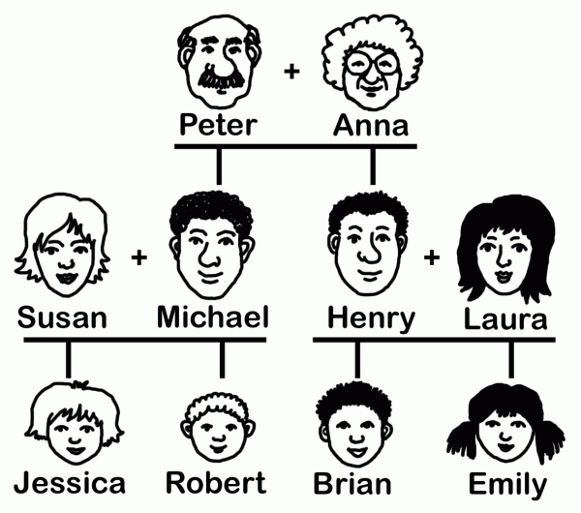

**Down:**

1. Anna is Brian's …………………

2. Jessica is Susan's …………………

3. Michael is Robert's …………………

4. Henry is Laura's …………………

5. Emily is Brian's …………………

6. Henry is Robert's …………………

7. Brian is Henry's …………………

8. Robert is Henry's …………………

**Across:**

1. Peter is Jessica's …………………

2. Robert is Brian's …………………

3. Anna is Peter's …………………

4. Laura is Emily's …………………

5. Laura is Jessica's …………………

6. Emily is Michael's …………………

7. Brian is Emily's …………………

|  |  |  |  |  |  |  |  |  |  |  |  |  |  |  |  |  |  |  |
| --- | --- | --- | --- | --- | --- | --- | --- | --- | --- | --- | --- | --- | --- | --- | --- | --- | --- | --- |
|  |  | **1** |  |  |  |  |  |  |  |  |  |  | **6** |  |  |  |  |  |
|  |  |  |  |  |  | **3** |  |  |  |  |  |  |  |  |  |  |  |  |
| **1** |  |  |  | **2** |  |  |  | **4** |  |  |  |  | **2** |  |  | **7** |  | **8** |
|  |  |  |  |  |  |  |  |  |  |  | **5** |  |  |  |  |  |  |  |
|  |  |  |  |  |  |  |  |  |  | **3** |  |  |  |  |  |  |  |  |
|  |  |  |  |  |  |  |  |  |  |  |  |  |  |  |  |  |  |  |
|  | **4** |  |  |  |  |  |  | **5** |  |  |  |  |  | **6** |  |  |  |  |
|  |  |  |  |  |  |  |  |  |  |  |  |  |  |  |  |  |  |  |
|  |  |  |  |  |  |  |  |  |  | **7** |  |  |  |  |  |  |  |  |
|  |  |  |  |  |  |  |  |  |  |  |  |  |  |  |  |  |  |  |
|  |  |  |  |  |  |  |  |  |  |  |  |  |  |  |  |  |  |  |

Answer Key:

|  |  |  |  |  |  |  |  |  |  |  |  |  |  |  |  |  |  |  |
| --- | --- | --- | --- | --- | --- | --- | --- | --- | --- | --- | --- | --- | --- | --- | --- | --- | --- | --- |
|  |  | **g** |  |  |  |  |  |  |  |  |  |  | **u** |  |  |  |  |  |
|  |  | **r** |  |  |  | **f** |  |  |  |  |  |  | **n** |  |  |  |  |  |
| **g** | **r** | **a** | **n** | **d** | **f** | **a** | **t** | **h** | **e** | **r** |  |  | **c** | **o** | **u** | **s** | **i** | **n** |
|  |  | **n** |  | **a** |  | **t** |  | **u** |  |  | **s** |  | **l** |  |  | **o** |  | **e** |
|  |  | **d** |  | **u** |  | **h** |  | **s** |  | **w** | **i** | **f** | **e** |  |  | **n** |  | **p** |
|  |  | **m** |  | **g** |  | **e** |  | **b** |  |  | **s** |  |  |  |  |  |  | **h** |
|  | **m** | **o** | **t** | **h** | **e** | **r** |  | **a** | **u** | **n** | **t** |  |  | **n** | **i** | **e** | **c** | **e** |
|  |  | **t** |  | **t** |  |  |  | **n** |  |  | **e** |  |  |  |  |  |  | **w** |
|  |  | **h** |  | **e** |  |  |  | **d** |  | **b** | **r** | **o** | **t** | **h** | **e** | **r** |  |  |
|  |  | **e** |  | **r** |  |  |  |  |  |  |  |  |  |  |  |  |  |  |
|  |  | **r** |  |  |  |  |  |  |  |  |  |  |  |  |  |  |  |  |

**Down:**

1. grandmother, 2. daughter, 3. father, 4. husband, 5. sister, 6. uncle, 7. son, 8. nephew

**Across:**

1. grandfather, 2. cousin, 3. wife, 4. mother, 5. aunt, 6. niece, 7. brother.

**IV. Конкурс знатоков прошедшего времени**

**1. Назови 1 и вторую форму глаголов:**

1команда: учить, узнавать, рисовать, пить, ушибить, делать, находить, приходить, приносить, давать.

2команда: встречать, ловить, ходить, класть, брать, смотреть, забывать, приносить, летать.

**2. Употребите was или were. Команды по очереди называют правильные варианты.**

* Nick…… at summer camp last summer.
* My mum ……. happy because I got a good mark.
* My dad …… sad because he cut his finger.
* Alice and Jack …… at school yesterday.
* He …. busy yesterday.
* The children …. in Moscow last year.
* We …. In Great Britain last spring.
* You …. In Africa a year ago.

**3. Составьте как можно больше вопросительных предложений. Командам дается по 2 утвердительных предложения.**

My sister watered the flowers last Tuesday.

Bill and Pam went to the Green School a year ago.

I played football in the yard last summer.

Alex repaid the bike last Monday.

**VI. Подведение итогов**