Aa

Bb

Bye!

Bye-bye!

Bless you!

Cc

Cheer up! Say cheese!

Can you (tell me the time), please?

Certainly.

Could you tell me… ?

Dd

Ee

Excuse me.

Ff

Fine, thank you.

Forget about it!

Fortunately, … .

Gg

Good morning!

Good afternoon!

Good evening!

Good night!

Good for you!

Good job!

Go ahead!

Example:

A: May I take your book?

B: Go ahead!

Good bye!

Good luck to you!

Great!

Hh

Have a nice day!

Happy holiday!

Hello!

Here it is.

Here you are.

Hi!

How are you?

How are you doing?

Ii

I’m fine, thank you.

I’m sorry. \ I’m sorry, you are not right.

I’m glad … (to see you).

I think … .

I don’t think … .

Jj

Just fine!

Just great!

Kk

Ll

Look here, … .

Mm

My pleasure.

Nn

Not at all.

Oo

Of course, I can.

Pp

Please…

Pardon me.

Qq

Rr

Right.

Ss

See you!

See you later!

See you soon!

So long!

Tt

Thanks.

Thanks a lot.

Thank you.

Thank you so much.

That’s right.

That’s not right.

Uu

Unfortunately, … .

You are quite right.

Vv

Ww

Well, … .

Well done!

Would you like to … ?

What a pity!

Xx

Yy

You are very welcome.

You are most welcome.

Zz

Задания для урока-игры во 2 классе по теме «АЗБУКА ВЕЖЛИВОСТИ».

1. Прочитайте. Выберете и обведите в кружок вежливые слова:

Like, play football, a snowball, hello, please, a nice dog, good morning, a chicken, bye, skate, a bear, not at all, a hen, excuse me, an apple, father, Willy, fine.

Запишите слова в алфавитном порядке.

abcdefghijklmnopqrstuvwxyz

14 points

1. Найдите 3 вежливых слова :

цаныthanksшщкгктмтыкcertainlyнпыдушйwelcomeщвм

( thanks, certainly, welcome)

3 points

1. Поставьте буквы в таком порядке, чтобы получилось вежливое слово:

Cesxeu em (excuse me)

Yorsr (sorry)

Eollh (hello)

Ellw onde (well done)

Enfi (fine)

Ctraylnei (certainly)

6 pionts

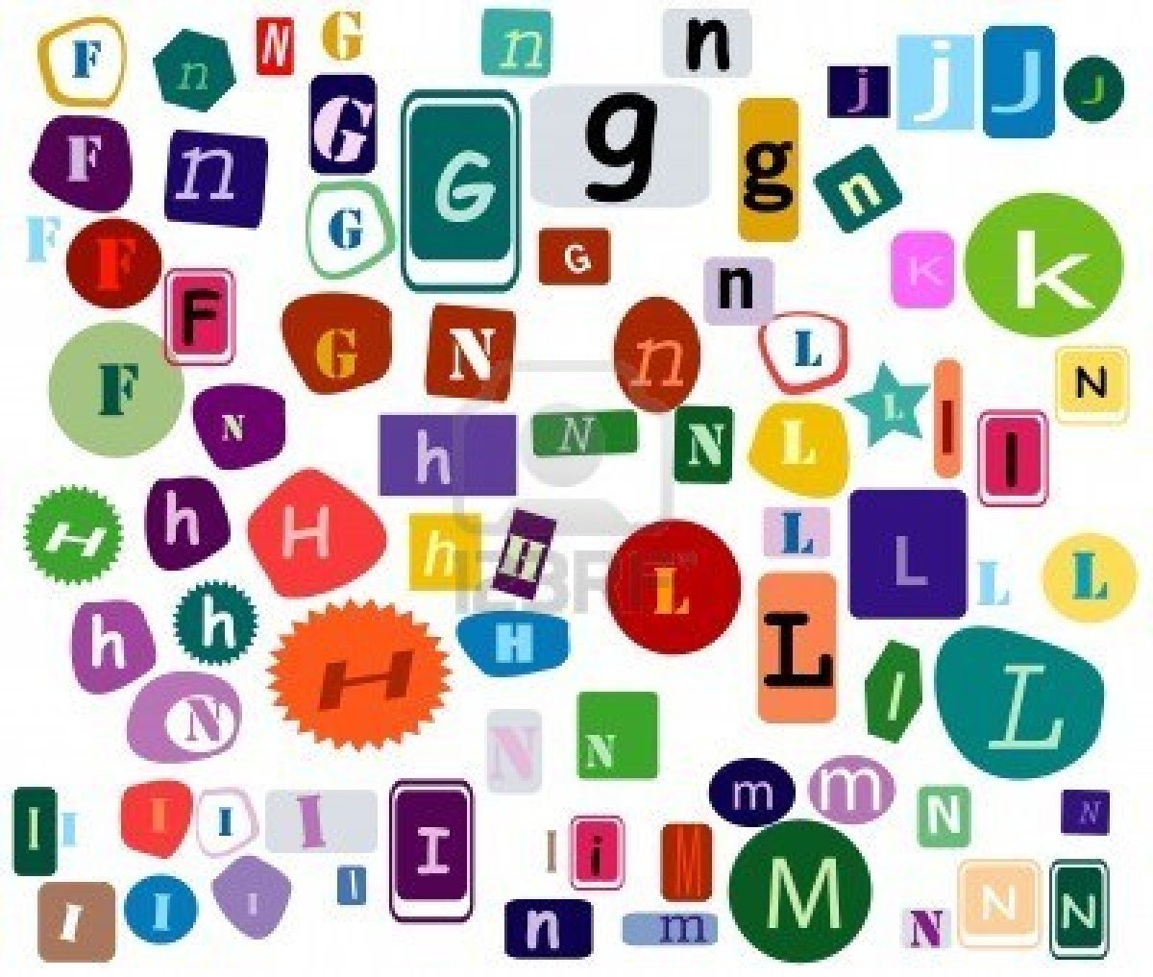

1. Разгадайте кроссворд:

По горизонтали:

1. «Здравствуйте»
2. Так говорит учитель, когда ученик что-то сделал очень хорошо
3. «Отлично», ответ на вопрос «Как поживаешь?»
4. «Извини»

По вертикали:

1. «Привет», так говорят друзьям
2. «Как поживаешь?»
3. «Не за что»

|  |  |  |  |  |  |  |  |  |  |  |  |  |  |
| --- | --- | --- | --- | --- | --- | --- | --- | --- | --- | --- | --- | --- | --- |
|  |  |  | |  | 6 |  |  |  |  |  |  | |  |
| 5 |  |  | | | | 7 |  | | |
| 1 |  |  |  |  |  |  |  | | |
|  |  | | | 2 |  |  |  |  |  |  |  |  | |
|  |  | | | |  |  |  | |  |  |  | | |
|  |  |  |
|  | 3 |  |  |  |  |  |
|  |  | | | |  |  | | |  |
|  |  | | 4 |  |  |  |  |  |  |
|  |  |  |  |  | | | |  |

**Ответы**

|  |  |  |  |  |  |  |  |  |  |  |  |  |  |
| --- | --- | --- | --- | --- | --- | --- | --- | --- | --- | --- | --- | --- | --- |
|  |  |  | |  | 6 |  |  |  |  |  |  |  | |
| 5 | h |  | | | | 7 |  | | |
| 1 | h | e | L | l | o | n |  | | |
|  |  | | | 2 | w | e | l | l | d | o | n | | e |
|  |  | | | | a |  |  | |  | t |  | | |
| a |
|  | r | T |
|  | 3 | f | I | n | e | a |
|  |  | | | | y |  | | | l |
|  |  | | 4 | s | o | r | r | y | l |
|  |  |  | u |  | | | | |

14 points

5)Вставьте пропущенные слова: Hello, Hi, fine, Thank you, thanks.

A: … , George! How are you?

B: …, Peppa! I’m fine, … . What about you?

A: I’m … , too. … .

5 points

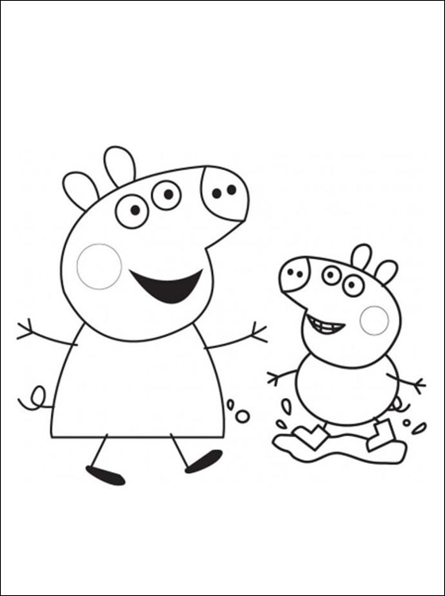

6) Просмотр мультика «Peppa Pig.Picnic».

Задание: Внимательно посмотрите мультфильм и ответьте на вопроc: «Какие вежливые слова говорят герои мультика?»

Ответы:

Sorry

Thank you

You are most welcome

Good bye

Bye

See you (next time)

6 points

7)Составьте диалог.

Yes.

Certainly. It’s 10.10.

Not at all.

Thanks.

Excuse me.

Can you tell me the time, please?

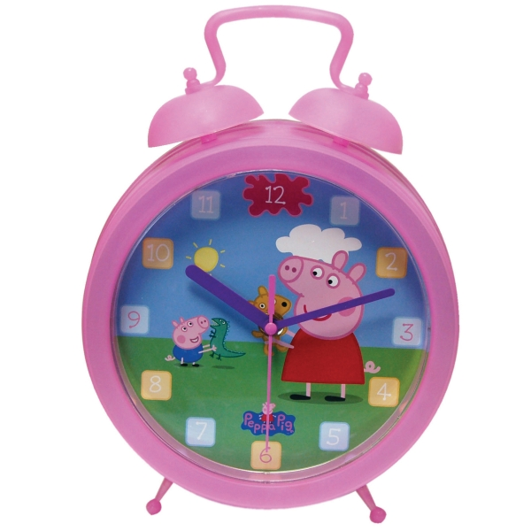

Ожидаемый результат:

A: Excuse me.

B: Yes.

A: Can you tell me the time, please?

B: Certainly. It’s 10.10.

A: Thanks.

B: Not at all.

Разыграйте диалог.

12 points

Итого 60 points