Внеклассное мероприятие по английскому языку для учащихся 3 класса (2-ой год обучения)
Предлагаю Вам поставить необычный спектакль: русская народная сказка «Кот и Лиса» на английском языке. Учитывая небольшой словарный запас учащихся 3 класса, я постаралась упростить обороты и минимизировать количество лексики, чтобы юные актеры осознанно произносили текст и не утомлялись от зубрежки непонятных еще слов и конструкций.
Изюминкой постановки является то, что актеры озвучивают и водят фигуры персонажей, находясь за специальным подсвеченным белым экраном. Силуэты фигур (см.приложение 4) изготавливаются из картона и окрашиваются в черный цвет (см.приложение 1), держатели к фигурам сделаны из разрезанного на полоски ламинированного листа ( чтобы не было отсвета на экран!) (см.приложение 2), для экрана использована коробка из-под телевизора или холодильника. (см. приложение 3).
Продолжительность постановки около 10 минут. На просмотр можно пригласить учащихся начальной школы, изучающих английский язык.
Что у нас получилось, можно посмотреть здесь.

Сценарий театрализованного теневого спектакля
на английском языке
«The Fox and the Cat»

The characters: Presenter 1
Presenter 2
Cat
Fox
Wolf
Bear
Hare

Presenter 1: Once upon a time there is an old man. He has got a cat.
The cat is very naughty. The old man takes the cat to the forest.
The poor cat walks and walks in the forest and sees the Fox.

Fox: - Oh, what a strange animal! Who are you?
Cat: - Don’t you know me? I’m the Great Cat! Now I’m the Commander here.
Fox: - Oh, of course, you are the Great Cat! Would you like to come and live with me, please?

Presenter 2: The Cat is happy and they live together.
One day the Fox goes to the shops and sees the Wolf.

Wolf: - Oh, hello, Foxie! How are you?
Fox: - Hello! I’m fine. I’m very fine. We have got a new commander now. It’s the Great Cat. And I’m his wife.
Wolf: - Really? Oh, can I look at him?
Fox: - Well, you can, but he’s very, very angry. Come and bring a present for him or he can eat you up!
Wolf: - OK.

Presenter 1: The Fox goes on and sees the Bear.

Bear: - Oh, hello, Foxie! How are you?
Fox: - Hello! I’m fine. I’m very fine. We have got a new commander now. It’ s the Great Cat. And I’m his wife.
Bear: - Really? Oh, can I look at him?
Fox: - Well, you can, but he’s very, very angry. Come and bring a present for him or he can eat you up!
Bear: - OK.

Presenter 2: Some time later the Bear meets the Wolf.
The have a lot of big presents for the Great Cat.

Wolf: - Hello, Bear!
Bear: - Hello, Wolfie!
Wolf: - So, where the Fox and her husband?
Bear: - I don’t know. Go and tell the Fox we are here.
Wolf: - Oh, no, I’m afraid. You go.
Bear: - No, no, I’m afraid too.

Presenter 1: Suddenly they see the Hare.

Bear: - Hey, Hare! Stop! Come here!
Hare: - Yes, Bear. What would you like?
Bear: - Do you see the Fox’s house?
Hare: - Yes, I do.
Bear: - Go and tell the Fox: “The Bear and the Wolf are here. They’ve got a lot of presents for the Great Cat.”
Hare: - OK.

Presenter 2: The Hare jumps away but the Bear and the Wolf are afraid.
They want to hide.

Bear: - I’m afraid. Oh, I can climb a tree.
Wolf: - I’m afraid too, but I can’t climb f tree. Help me, Bear!
Bear: - Go under the tree. Hide there!

Presenter 1: They put the presents and hide.
Now go the Fox and the Cat. The Bear sees the Cat and says.

Bear: - Oh, Wolfie! Look at that Great Cat! He’s so little!

Presenter 2: The Cat sees the presents and says.

Cat: - Oh, mew-mew!

Presenter 1: But the Bear hears: “So few, few!”

Bear: - Oh, he says he’s got few presents. He’s so angry and greedy. He can eat us up!

Presenter 2: The Wolf wants to see the Cat too.

(The Wolf gets up)
Cat: - Oh, a mouse! I’ll catch it!

(The Cat jumps at the Wolf)

Presenter 2: The Wolf is afraid of the Cat and runs away.
Presenter 1: The Cat is afraid of the Wolf and climbs a tree.
Presenter 2: The Bear is afraid of the Cat and falls down and runs away.

(The Bear falls down the tree, howls and runs away)

Fox: - Go away! Go away! The Great Cat will catch you! The Great Cat will eat you!

Presenter 1: The animals in the forest are afraid of the Cat now.
Presenter 2: But the Cat and the Fox have got a lot of presents and are very happy together.

Приложение 1.

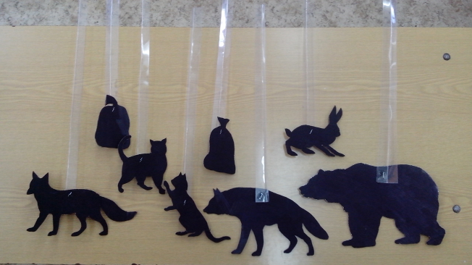

Приложение 2.
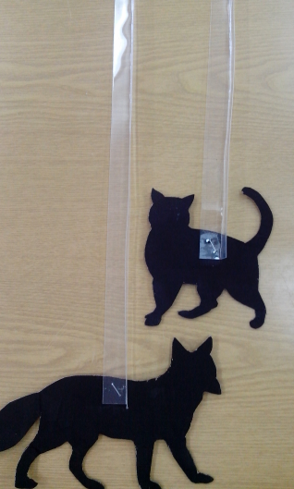

Приложение3.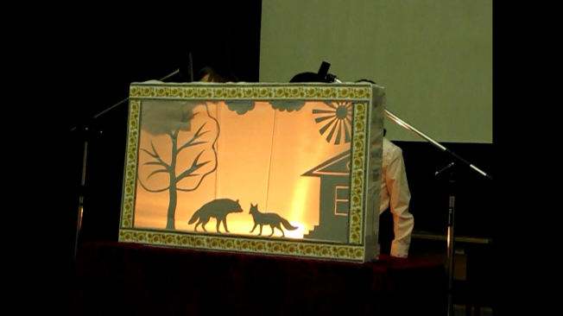

Приложение 4.

