Ex. 1. Match the time.
1. It’s three o’clock. |  | a. 12.25
2. It’s a quarter past eight. |  | b. 8.05
3. It’s ten thirty. |  | c. 11.25
4. It’s five to five. |  | d. 1.58
5. It’s nine tewenty five. |  | e. 8.15
6. It’s twenty-five to eleven. |  | f. 4.55
7. It’s two to two. |  | g. 10.35
8. It’s eleven twenty-five. |  | h. 9. 25
9. It’s five past eight. |  | i. 10.30
10. It’s twelve thirty-five. |  | j. 3.00

Ex. 2. What time is it? Write in numbers.

1. It’s seven thirty - ………………….. 6. It’s ten past eleven-…………………….
2. It’s five to ten - …………………….. 7. It’s a quarter to three- ………………
3. It’s one to one - ……………………. 8. It’s four thirty-five - ………………….
4. It’s a quarter past three - ………. 9. It’s twelve o’clock - …………………….
5. It’s eight forty-five - ……………… 10. It’s two fifty-five. - …………………
Ex. 3. What’s the time. Draw.
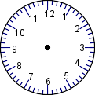
It’s eleven o’clock. | It’s a quarter past six. | It’s ten to seven.
It’s twelve fifty-five. | It’s twenty to nine. | It’s three thirty.

Ex. 4. What’s the time ? Write sentences.

- 1. 00 - …………………………………… h. 8. 35 - ……………………………………
- 2.05 - ……………………………………. i. 9. 40 - ……………………………………
- 3.10 - ……………………………………. j. 10.50 - ……………………………………
- 4.15 - ……………………………………. k. 11.55 - ……………………………………
- 5. 20 - …………………………………… l. 12. 56 - ……………………………………
- 6.25 - ……………………………………. m. 1.58 - ……………………………………
- 7. 30 - ……………………………………. o. 3.00 - ……………………………………

Ex. 5. Look at the clocks and write the time.

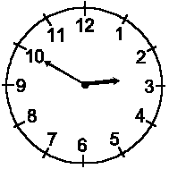 | 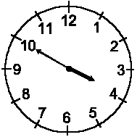 | 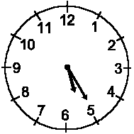
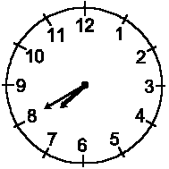 | 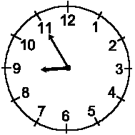 | 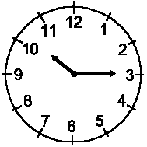
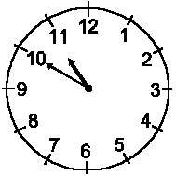 | 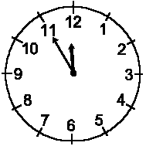 | 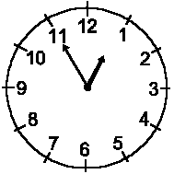

Ex. 6. Ask about the time.
know, time (3x), tell, what, please, got,
A) What's the ……………….? B) ………….. time is it?
C) Have you ………….. the ………………. by any chance?
D) Do you have the ……………., please? E) Sorry, could you ……… me the time, please?
- F ) What's the time,……………………? G) Do you …………..what the time is?

