ГОРОДСКАЯ ОЛИМПИАДА ПО АНГЛИЙСКОМУ ЯЗЫКУ 2014г.

Часть 1 Аудирование

Задание № 1 Послушай 5 диалогов и подчеркни нужный ответ. В бланк ответов запиши слово.

Пример: What is Ann good at? dancing / swimming / running
- What is John’s father? fireman / policeman / mechanic
- How old is Jane’s nephew? 15 / 12 / 20
- When did Bill go to the cinema? last year / last week / last month
- What does Harry like to read? books / magazines / stories
- What day does Paul go to his piano lesson? Wednesday / Thursday / Tuesday

Задание № 2 Послушай разговор двух мальчиков и запиши недостающую информацию. В бланк ответов запиши слово или цифру.

- (1) name: Peter Jones
- (2) age: ______________
- (3) home: a flat in ______________ Street
- (4) brothers / sisters: two ______________
- (5) hair: short and ______________
- (6) hobbies: painting and ______________

Часть 2 Лексика и грамматика

Задание № 3 Выбери правильный вариант. В бланке ответов напиши букву ответа.

- He … go to the theatre next month.

- won’t
- isn’t
- doesn’t

- You must … your teeth twice a day.

- clean
- to clean
- cleans

- I don’t like this story. It is … story in the book.

- bad
- worse
- the worst

- Let’s watch … movie.

- two
- second
- the second

- … flat is very comfortable.

- Jack
- Jack’s
- Jacks’

- It … winter now.

- was
- will be
- is

- The pupils have five lessons today, …?

- aren’t they
- don’t they
- didn’t they

- She … hard last week.

- work
- works
- worked

- My friend … an actor.

- am
- is
- are

- Her new dress … wonderful.

- was
- were
- am

- Where is the chair? - … is in the dining room.

- He
- They
- It

- Wolves eat …

- sheep
- sheeps
- sheepes

- … are my cousins.

- This
- These
- That

- There … an old car in the garage.

- am
- is
- are

- Pupils don’t go to school … Sundays.

- in
- at
- on

- … is the capital of Russia? – It is Moscow.

- Why
- Where
- What

- I … Mr. Green the day before yesterday.

- meet
- met
- meeted

- My parents bought a nice sofa …

- next year
- tomorrow
- two days ago

- How … glasses of juice can you drink?

- many
- much
- a lot of

- Look at these …

- puppy
- puppies
- puppys

Задание № 4 Прочитай рассказ о питомце, и вставь в пропуски подходящие по смыслу слова из рамочки. В бланк ответов напиши слова.

love park meat tail big

My dog is called Sam and it is three years old. Is is black and _________ (32) and it has got a long ___________ (33). It has got big ears too.
I must take Sam for a walk every day. I take it to the _______________ (34) with my dad. Sam can run fast, but it can’t catch balls. Sam must eat a lot of _____________ (35), but it must not eat ice cream. It must drink lots of water too. It sleeps in my bedroom.
I _______________ (36) Sam because it is friendly and clever. When I’m sad, Sam makes me happy again!
Часть 3 Чтение

Задание № 5 Посмотри на картинку и напишите, кто чем занят. В бланк ответов напиши имена.

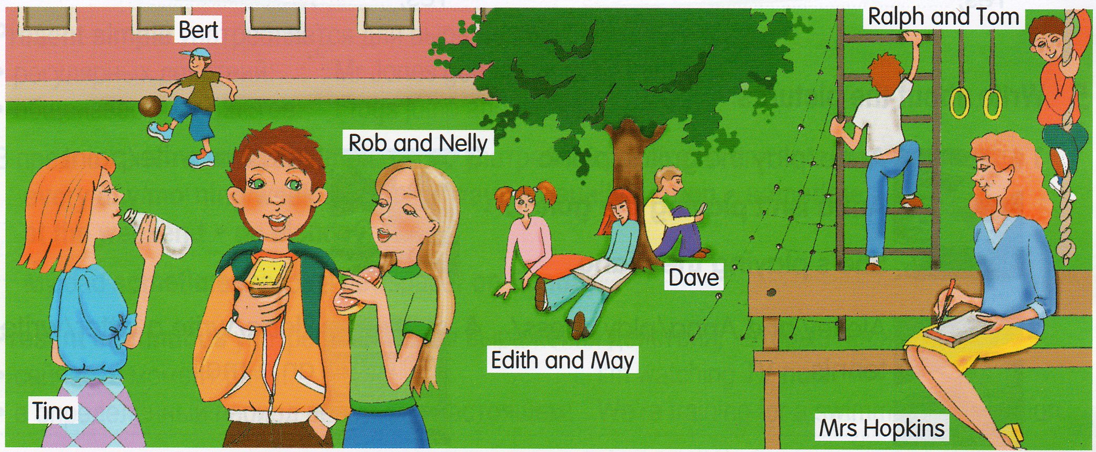

- She's drinking water.
- He’s sitting under the tree.
- He’s kicking a ball.
- She’s writing.
- They’re reading.
- They’re climbing.
- They’re eating sandwiches.
____________________________
____________________________
____________________________
____________________________
____________________________
____________________________
____________________________

Задание № 6 Прочитай рассказ о том, как девочки ходили в кафе и напишите, верны ли предложения после текста. В бланк ответов запиши T (верно) или F (неверно).

At Joe’s Café

Hello! My name is Lucy. Last Sunday I had lunch at Joe’s Café. It’s near the library in the city center. I went with my best friend, Daisy.
First, we got some drinks because we were very thirsty. We wanted some juice but there wasn’t any. I had some lemonade and Daisy had a glass of water. Then we asked for some food. I had some great sausages and chips. Sausages are my favourite food. Daisy didn’t want any sausages. She had a very big pizza. She didn’t like it much, but she liked the ice cream we had later. It was very nice!
I think Joe’s Café is a nice place to eat. The food is nice and the people are very friendly! Also, it isn’t expensive. I’d like to go there again.

- Lucy and Daisy went to Joe’s Café on Sunday. _______
- There wasn’t any lemonade. _______
- Lucy had sausages and chips. _______
- Daisy didn’t like her pizza. _______
- Lucy and Daisy ate ice cream. _______
- Lucy didn’t like Joe’s Café. _______

Часть 4 Письмо

Задание № 7 Прочитай письмо от твоей новой подруги по переписке. В бланке ответов напиши ей о себе и ответь на три ее вопроса.
Dear friend,
Hi! My name is Fiona. I am from the USA. I live in New York. I am ten years old. How old are you?
I go to school. I love my school and I am a very good pupil. My favourite lessons are English and Sports. Are you a good pupil?
I have got a lot of friends. My best friend’s name is Fiona. She is eleven years old. We like to draw together. Fiona is funny and good. What is your best friend’s name?
I hope to hear from you soon!
Yours,
Fiona

