МОУ Арефинская СОШ

Исследовательская работа

Выполнила: Гайдар Ольга
ученица 10 класса
Руководитель: Ефимова Т. Н.

Арефино 2008
Who doesn’t know the past that doesn’t value the present.
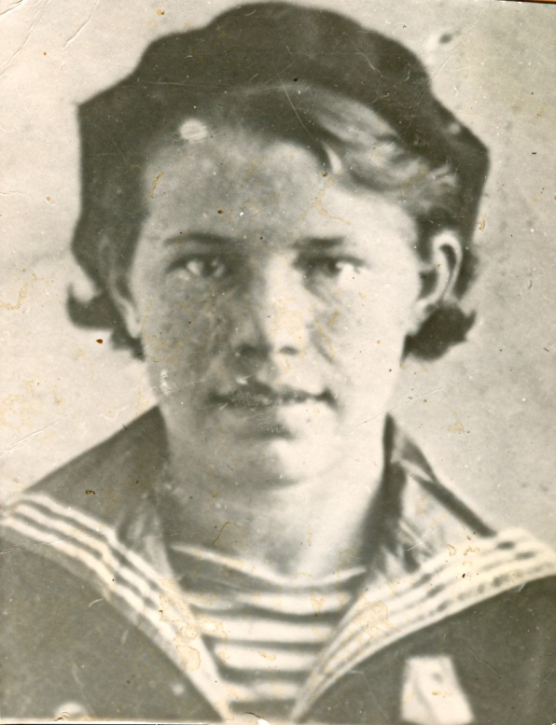

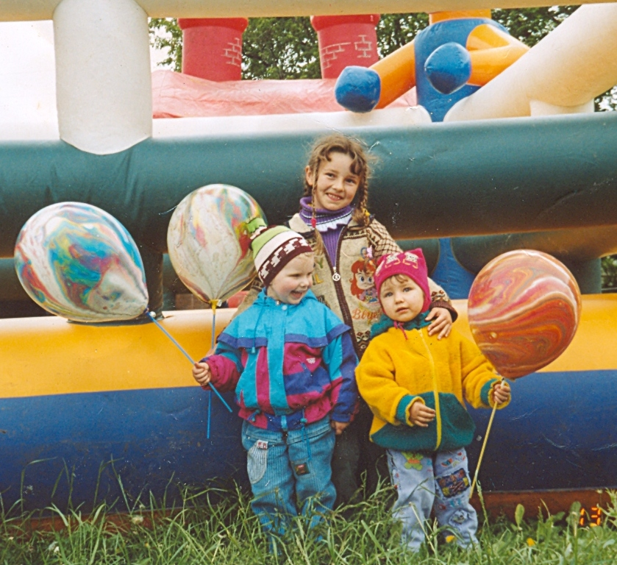

Invaluable purchase for your family is knowledge of the roots. Who were your ancestors - noblemen or peasants, merchants or workers? A costly present for the person with family values – as your patrimonial name, what it’s historical and cultural roots were formed. Not any person knows, how call its great-grand mother or the great-grand father. And all the matter is that at its ancestors were not opportunities or desires to make genealogic tree. But we with you shall be clever and we shall give descendants all information necessary to them.
I’d like to tell a story about one great family living in my native place. As a title for my project I have chosen the Russian proverb «The tree is strong with its roots». I’ll try to tell about three generation of one family and their full relatives.
The Shcherbakovs are an ordinary family, but on the other hand they are absolutely unique. The main root of this family was Nina Vasiljevna Shcherbakova. Her son Nikolai Fyodorovich is the head of the family now. It is wife Antonina Petrovna is the heart of the family. Their children and grand children are the leaves and blossoms of the family tree.
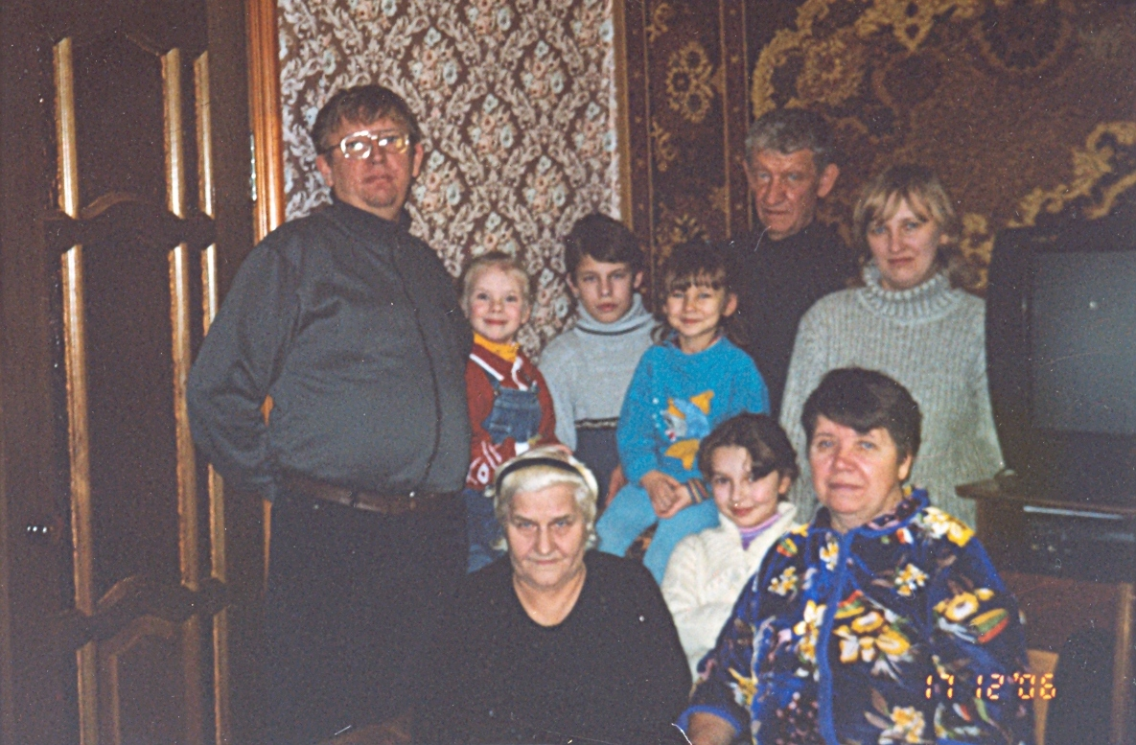
The family is very important as a unit on our society. Nothing else but family can be an emotional center of people’s life; can be a transmitter of culture and raising children. Every mother feels great affection for her children and tries to bring them up in a proper way. There are a lot of friendly and good families in Arefino. But I have chosen a family; I’d like to tell about very fast, because I’m sure that the Shcherbakovs are a great family. I asked Katya Grusdeva «What is a family for you? » She answered «Family in my opinion is someone who loves you and whom you love either, I asked her to draw their Family Tree. You can see it. 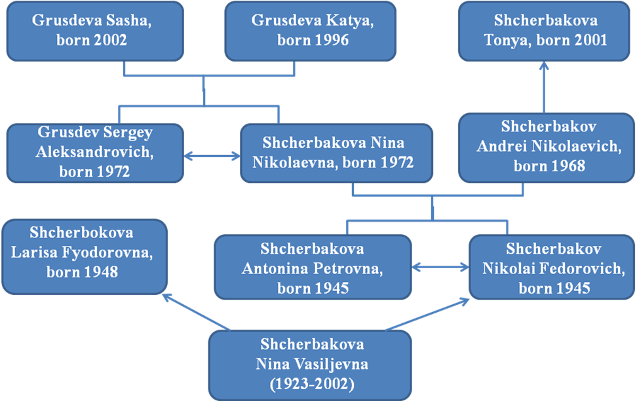Katya told us that the family for her is also her great-grandmother, her grandfathers, grandmothers, aunts, uncles. Every family of course has a long history of generations. Sometimes we can’t remember the member of it, the name and occupation. But it is really interesting to know who lived before you. And when we begin to ask our parents about fore fathers, we find for ourselves a lot of interesting things. So Katya did. Her grand father Nikolai Fyodorovich Shcherbakov told her a lot of interesting facts about his mother and Katya’s great-grandmother Nina Vasiljevna Shcherbakova.
Nina Vasiljevna was born in 1923. She graduated from Arefinskaya secondary school. She entered the courses for tractor driver with her husband. It was short before the war. Nina was always very responsible woman. She could always give people moral support and a good advice. When the Great Patriotic War began her husband went to the army and fought near Moscow and was killed there. In a year Nina Vasiljevna went to the army and she was sent to Leningrad. She was a sea soldier.
Everybody in Russia knows what Blockade of Leningrad means. It was cold, no food, and no rest. Hungry people had been working for 10-12 hours to help the army. Nina Vasiljevna and a lot of other girls made equipment for the ships. They carried items weighing 100-120 kg. After the war Nina returned home to Arefino. She worked at school as a pioneer leader. Then she worked in the Artel «The First Pyatiletka». All her life she studied and worked. She received a lot of medals for her hard work during the piece life and for her service in the Navy during the war. She alone brought up her son Nikolai and daughter Larisa. They always spent their time doing something together. Nikolai appreciated mother’s care and love.
We asked Nikolai Fyodorovich: «What does the family mean for you». These are his words: «If you have someone who can do every thing for you and you can do the same – you are lucky you have a family».
Nikolai Fyodorovich is the main person in the family. He is sure that nothing else but the family can be an emotional center of people’s life, can be a transmitter of culture and raising children. Understanding between the members of the family and consideration for others are very important in family relation ship. Tenderness, warm – heartedness and respect is always present in Sherbakov’s family. A lot of activities help members of the to be on friendly terms: discussing all the family plans together, working in the garden together, visiting interesting places, sharing the same joys and sorrows. In Sherbakov’s family everybody thinks of the others in the family. They show their love and attention to each other every day. Nikolai Fyodorovich says that it is very important to visit relatives on holidays, on birthdays, on anniversaries and develop close relationship. We feel more affection for our relatives when we are parted from them. The proverb says, «Absence makes the heart grow fonder». When the family like the Shcherbakovs is friendly, children have the warmed feelings of returning home where dear father and mother are waiting for them. Nikolai Fyodorovich is an excellent father and grandfather. He was born in 1945, graduated from Arefinskaya secondary school. After school he entered Gorkovskiy Polytechnic Institute. He is very experienced and skilled. He worked as an engineer a chief engineer and a director of the plant. He was elected a deputy of the Low Assembly of Vachskaya district. Nikolai Fyodorovich has a lot of prizes, medals for his hard work. People respect him for his high personal qualities and professionalism. Now he is a pensioners, but he is going on working. All his life he has been serving his plant and district.
We asked Antonina Petrovna «How is the family important for you?» she said: «I think that the family is one of the most important things in our life, and people who have no family are always lonely and more over nobody takes care of them. It’s wrong to think that your family is only your father and mother. Your family consists of all the dearest people».
Antonina Petrovna has an opinion that parents should be patient, strict and understanding. The Shcherbakovs don’t have such problems as misunderstanding between the members of the family. And it is due to the Antonina Petrovna. She is the heart of the family. She is ruling the family wise and hard. She is kind, clever and responsible woman. Her children are dedicated to their home, they give their parents much love and care. The proverb «There is no place like a home» is about the Shcherbakovs.
Antonina Petrovna was born in 1945 in a village Pavlovo, Urenskiy district. She graduated from the Gorkovskiy Pedagogical Institute and was sent as a Physics teacher to Vachskiy district. All her life she had been working at Arefinskaya secondary school. She was a teacher, a director assistant and a director of the school. She was a skilful and wise ruler. She organized the work of a school collective properly. She always supported people in trouble and helped them to solve their problems.
Antonina Petrovna is respected and loved by her ex-pupils. Everybody was keened on Physics. They understood and knew the subject very well. And now her pupil’s remember her lessons with great pleasure and they are very proud that their Physics teacher was Antonina Petrovna. She was awarded the title «The well-deserved teacher of the Russian Federation». She also has the title «An excellent worker of Education». Antonina Petrovna was elected a deputy of Vachskiy District. People of our village and our district look up to Antonina Petrovna Shcherbakova for her hard work and achievements.
Antonina Petrovna and Nikolai Fyodorovich have brought up a son and a daughter. Their son Andrei was born in 1968. He graduated from Arefinskaya secondary school excellently. Andrei like his mother is fond of Physics and Math. We asked him: «What is the family for you now, when you have you own family? ». He said: «My family is my parents, my wife and my children, my sister and her family. To say about family like a child and father and mother it’s always the warm of home and kindness of parents». After school Andrei Nikolayevich entered Moscow Physics-Technical Institute. Now he is working as a chief engineer at the plant. He is mainly interested in his job, computers and family. Andrew has taken part in training courses according to the Program of the President. He had practice in Japan and Poland.
Nina Nikolaevna is the youngest in the family. She was born 1972. She is married and has her own family. I asked her: «How is a family important for you? » She told me: «Every mother feels great affection for her children and tries to bring them up in proper way. Understanding between the members of the family and consideration for others are very impotent in family relationship. » Nina Nikolaevna graduated from Arzamasskiy Pedagogical Institute. Her profession is a teacher. Her best supports at school were Math and Physics. That’s why she is teaching Mathematics at school. She and her husband are bringing up two nice daughters: Katya and Sasha. From her point of view children shouldn’t be punished. Fear and punishment will lead to selfishness, cruelty and lies. But «love and kindness will save the world». There is no misunderstanding between Nina Nikolaevna and her daughters and pupils. She has a good sense of humor and always tries to bee in a good mood. Everybody respects Nina Nikolaevna for her deeds and active life position.
I am sure that such families like the Shcherbakovs are playing a great role in the development of our Vachskiy district.

