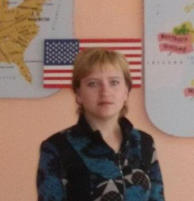**Snow White**

(A Theatrical Performance)

**И.В.Купреева,**

**учитель английского языка Большеизюмовской СШ**

**The aims:** *to enrich the students’ vocabulary; to develop students’ reading, speaking and listening skills; to enrich their knowledge about English fairy-tales; to develop students’ acting skills.*

**Author**: Once upon a time there was a princess. Her name was Snow White. *(Белоснежка выходит на сцену, осматривается и уходит. Появляется мачеха. Она садится на стул, берет зеркало и начинает любоваться собой.)* She had no mother. She had a stepmother, who was a queen. The step mother was beautiful and cruel. She had a magic mirror.

**Stepmother**: Mirror, mirror, on the wall, who is the fairest of us all?

**Mirror (*голос*)**: You are very beautiful, but Snow White is more beautiful than you are.

**Stepmother**: *(бросает зеркало в стену, вскакивает и топает ногой)* What? Very well. *(поворачивается к двери и зовет)* Hunter! Hunter! Come at once!

**Hunter***: (заходит и кланяется)* I’m here, my queen.

**Stepmother**: Take the princess away into the forest and kill her.

*(Охотник уходит, мачеха идет за ним. На сцене появляются декорации леса.)*

**Author**: The hunter took the princess away into the forest.

**Hunter**: *(подводит Белоснежку к дереву)* I must kill you.

**Snow White:**  *(плачет)* Oh, no! Please don’t do that!

**Hunter**: Run into the forest, and don’t return to the castle.

*(Белоснежка убегает, Охотник уходит. Белоснежка возвращается. На сцене – домик. Она заглядывает в окно и заходит)*

**Author**: Snow White was alone in the forest. She saw a little cottage. In the cottage everything was small. In the middle of the room there was a long table. On the table there were: seven plates, seven knives, seven spoons and seven glasses. Snow White was very hungry. She began to eat a little from each plate. After that, she fell asleep across the beds.

*(Белоснежка видит стол, садится на стулья, ест и пьет. Затем ложится на кровать и засыпает. Заходят карлики, все осматривают.)*

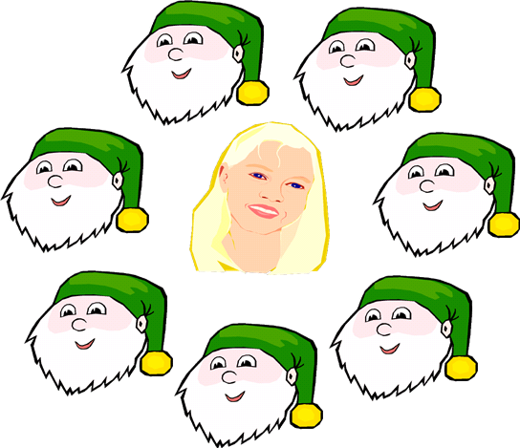**Dwarf 1**: Who has been sitting in my chair?

**Dwarf 2**: Who has been eating from my plate?

**Dwarf 3**: Who has been eating my bread?

**Dwarf 4**: Who has been eating my vegetables?

**Dwarf 5**: Who has been drinking from my glass?

**Dwarf 6**: Who is lying in my bed?

**Author:** The seven dwarves discovered Snow White. Snow White awoke. She saw the seven dwarves.

**Snow White:** Oh, I am glad to see you. May I live with you?

**Dwarf 7:** Will you keep our house?

**Snow White:** Yes, I will.

*(Карлики уходят. Белоснежка убирает в доме.)*

**Author:** They lived very well together. Snow White kept the house and the dwarves went hunting. But soon an old woman came to the cottage. It was the stepmother but Snow White didn’t recognize her.

**Snow White:** Old woman! Are you tired? Sit down, have a rest!

**Stepmother:** Thank you, good girl! Take this nice apple!

**Snow White:** Oh, it is so sweet! *(Откусывает кусочек яблока, роняет его и падает)*

**Author**: The apple was poisoned. Snow White was dead.

**Dwarves:**  *(Подбегают к Белоснежке)* Snow White! What happened?

**Author**: The seven dwarves were sad. They carried Snow White in a coffin, but they stumbled. The apple came out of Snow White’s mouth. She awoke. They were very happy.

*(Белоснежка просыпается. Все радуются. Поют веселую песенку)*

*Северо-Казахстанская область,*

*Тайыншинский район*



***Внеклассное мероприятие***

***«Неделя Языков»***

A Theatrical Performance

Form: **7**

Teacher: **Kupreyeva I.V.**

School: **Bolshoy Izyum secondary**

Year: **2011-2012**