Colours and Numbers
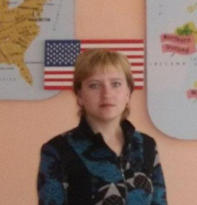
(primary classes)

И.В.Купреева,
учитель английского языка Большеизюмовской СШ

Мақсат: обобщение употребления названий цветов и цифр от 1 до 10
Оқыту мен тәрбиелеудің міндеттері
- Повторить названия цветов;
- Повторить знания учащихся слов предыдущих уроков (животные);
- Практиковать в употреблении изученных слов и структур;
- Повторить цифры от 1 до 10, счет;
- Развивать навыки устной речи, чтения;
- Учить устной речи, произношению;
- Воспитывать вежливость в общении, уважение друг к другу.
Құрал-жабдықтар, көрнекті құралдар интерактивная доска, Флипчарт 4-5-21, электронный учебник.
Сабақ түрі комбинированный
Әдіс-тәсілдер беседа, игра, работа с интерактивной доской.

Сабақ барысы:

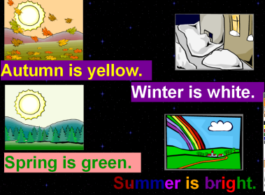
- Greeting. Speaking with the class: What is your name? How are you? Where are you from?
1 Pronunciation practice
- Warm up. Pronunciation practice. Phonetic drill.
Autumn is yellow.
Winter is white.
Spring is green.
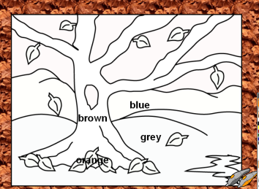
Summer is bright.

- Listening. What colour are they? (e-book) Pronunciation practice.
(учащиеся слушают текст ) What colour are they? A green crocodile, a yellow giraffe, a grey elephant, a brown monkey, an orange tiger, a white horse, a pink rabbit, a red fox, a blue wolf, a violet snake, a black bird.
Now answer my question: What colours were named in the text?
- Task 1. Colour the pictures. (Game 1 “The Great Painter”)
Colours: brown, blue, grey, orange.
- Revising numbers. Match the number with the word. Numbers from one to five.

1
2
3
4
5
Five
Three
One
Four
two

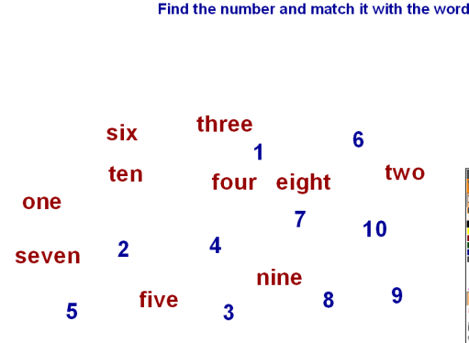
- Task 2. Counting and writing: Count ducks, dogs, kittens, dogs and rabbits, cats, rats, elephants, pigs (showing picture slides with animals). How many kittens (pigs, cats etc) are there in the picture?
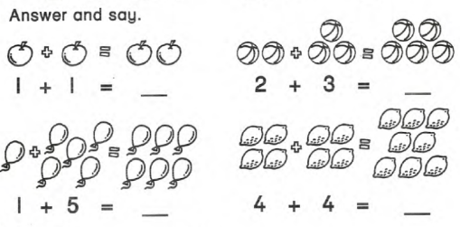
Now comment on the picture.
One plus one is …
One plus five is …
Two plus three is …
Four plus four is…

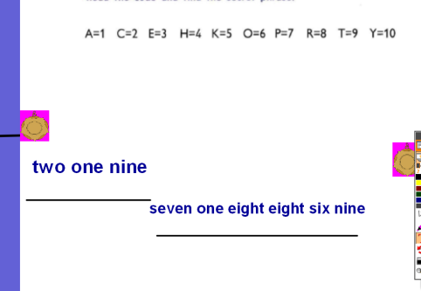
- Task 3. Find the number and match it with the word. Numbers from one to ten.
- Task 4. Read the code and find the secret word.
A=1; C=2; E=3; H=4; K=5; O=6; P=7; R=8; T=9; Y=10
Word 1: Two, one, nine (cat)
Word 2: Seven, one, eight, eight, six, nine (parrot)
Потянув за «медаль», дети вытаскивают изображение зашифрованного животного.
- Task 5. Colour the picture.
- Task 6. Listening. Game 2. Help Pooh to find his toys.`
Where is my yellow ball?
Where is my toy snake?
Where is my doll?
Where is my car?
Where is my green ball?
Where is my book?
Thank you. Bye.
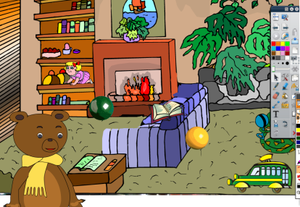
- Task 7. Count and match. Count and write.
- Task 8. Game 3. Find colours in the Letter-box: Orange, brown, black, red, pink, blue, yellow, white, violet.
o | w | v | i | o | l | e | t | g
r | b | l | a | c | k | j | f | l
a | r | l | d | r | e | d | o | p
n | o | n | u | w | h | i | t | e
g | w | k | y | e | l | l | o | w
e | n | p | i | n | k | l | m | a

- Singing the song “Good bye!”
Boys and girls,
How are you?
I’m sad, I’m sad, I’m sad, too.
Boys and girls,
How are you?
Good-bye, good-bye,
Good-bye to you.

- Conclusion.
Үйге тапсырма беру to revise words

Северо-Казахстанская область,
Тайыншинский район.

